**F411-NTE**

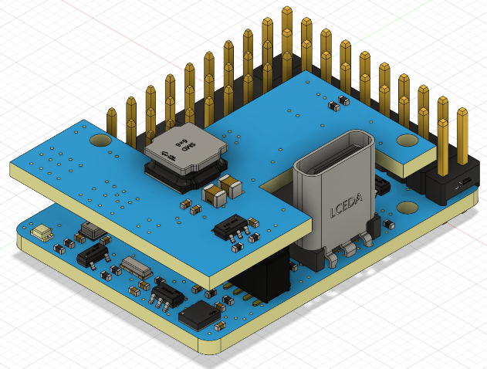**FC Specifications**

* MCU: 100MHz STM32F411CEU6
* IMU: BMI270 (SPI)
* Baro: SPL06-001 (I2C)
* OSD: AT7456E (SPI)
* Blackbox: No
* 2x Uarts
* 2x Full Softserial
* 6x PWM outputs (2x Motors, 4x Servos)
* 1x I2C
* 2x ADC (VBAT, Current)
* 2x LEDs for FC STATUS (Blue, Red)
* BEEP
* 1x RGB LED (WS2812)
* Built in inverter on UART2-RX for SBUS input
* PPM receiver: not supported

**Power**

* 6~28V DC IN (2~6S LiPo)
* 50A Current Sense
* BEC 5V 3A for FC & Peripherals
* BEC S5V 3A for servos
* Vbat for VTX and camera
* LDO 3.3V 500mA
* Battery Voltage Sensor: 1k:10k

**FC Firmware**

* INAV Target: MATEKF411NTE ( INAV4.1 or newer, Use private FW)

**Physical**

* Dimensions: 36 x 26 x 12 mm
* 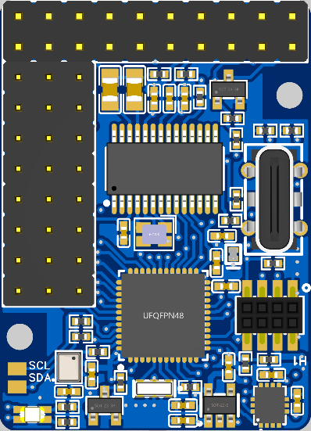Weight: 10g

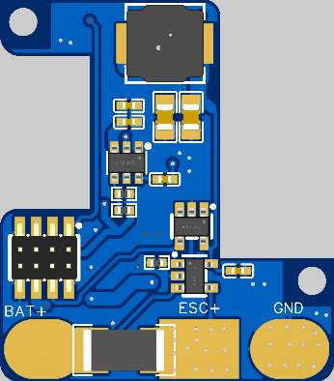

**Signals**

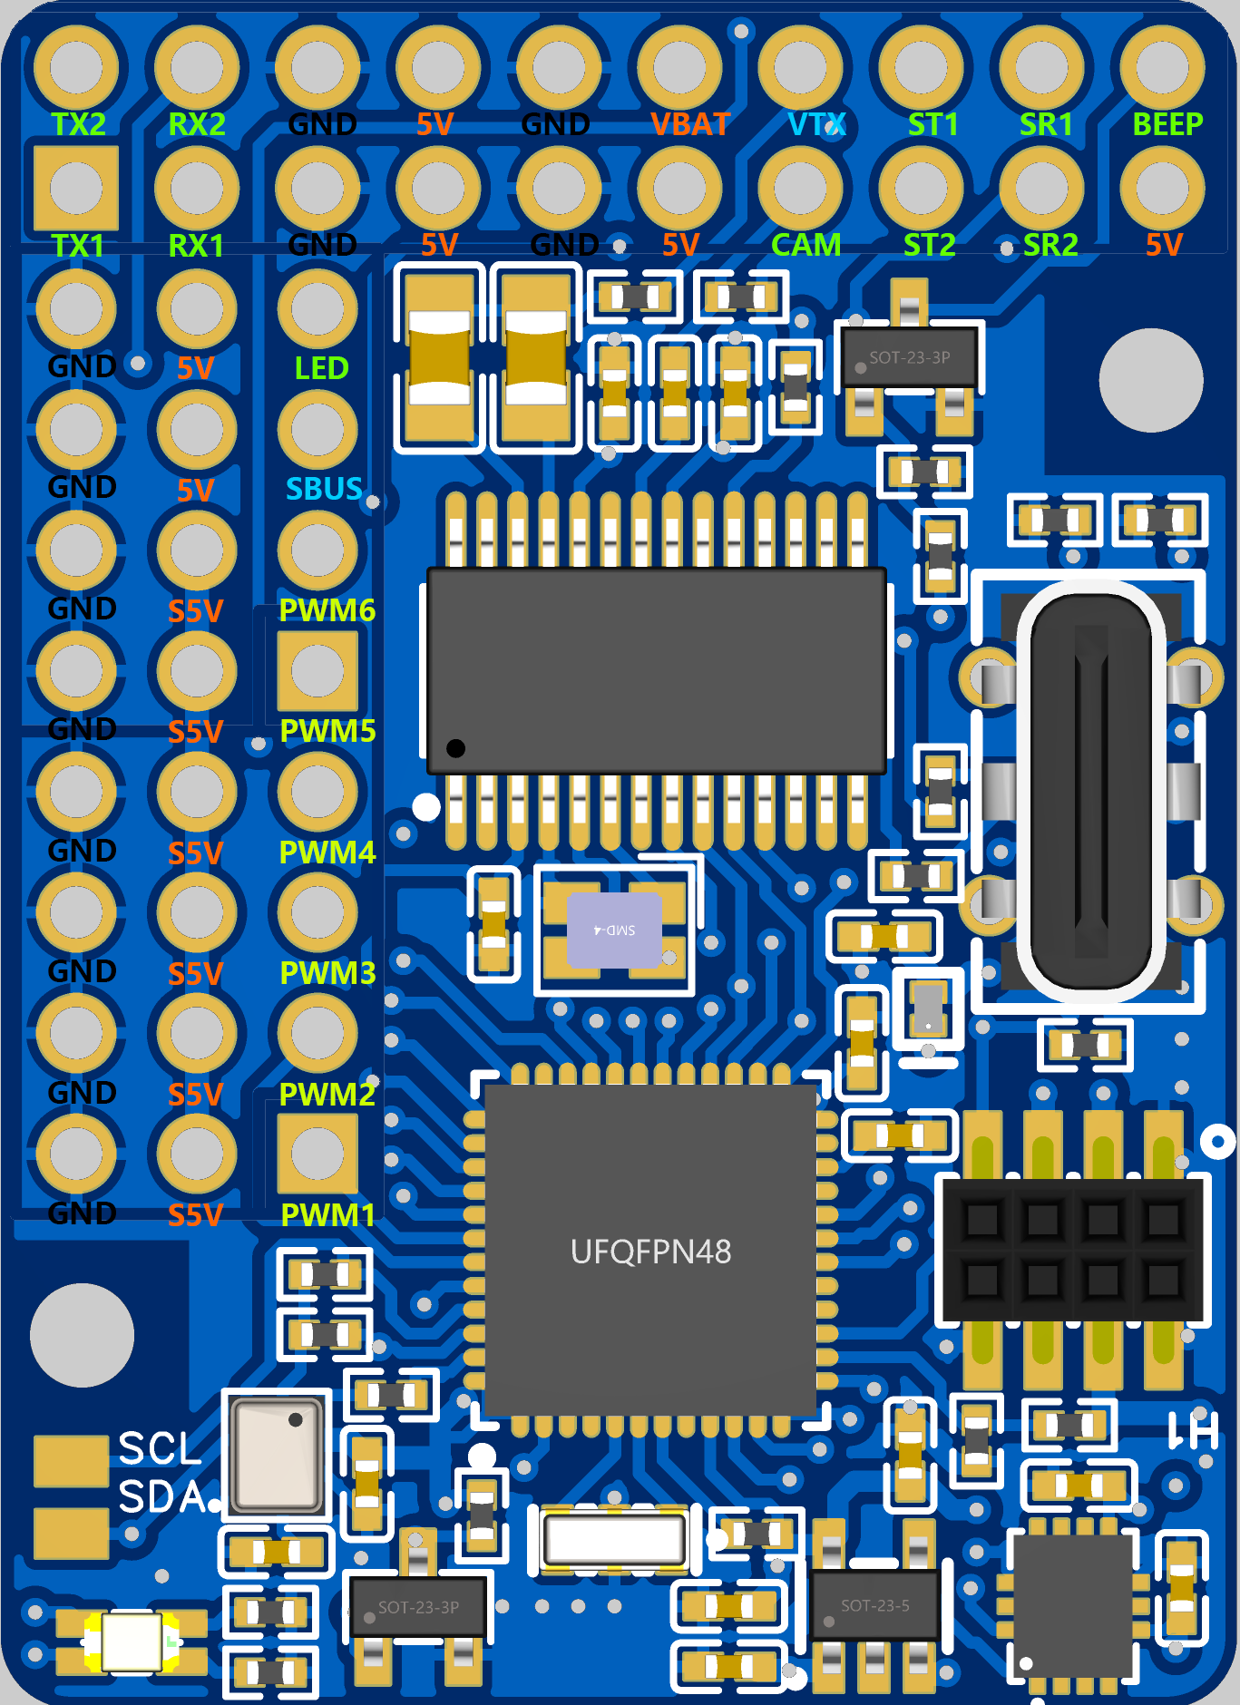

**5V:** BEC 5V. Max. 3A

**S5V:** BED 5V. Max. 3A

**VBAT:** Battery voltage

**GND:** Power Ground

**TX2/RX2:** Uart2-TX / RX

**SBUS:** RX2 with inversion for SBUS input

**TX1/RX1:** Uart1-TX / RX

**SCL/SDA:** I2C bus for OLED, AirSpeed, Compass.

**ST1/SR1:** Softserial1_Tx/Rx

**ST2/SR2:** Softserial2_Tx/Rx

*** Support GPS, DJI/AVATA/SA/TR VTX

**VTX:** Video out for video transmitter

**CAM:** Camera video IN

**LED:** WS2812 single output

**BEEP:** General active 5V buzzer

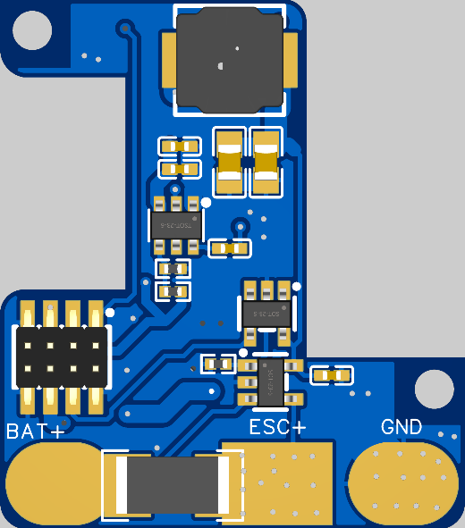

**Button:** DFU mode button

**BAT+:** Battery input **+**

**ESC+:** ESC input **+**

**GND:** Battery & ESC Ground