**Metadata**

**OPEN SOURCE ASSERTION:** The ‘Yukon River Chemistry Model’ was approved for Open-Source Assertion on 4/9/2025 and assigned #**O4870**

**Points of Contact:**

**Repository manager**: Dr. Georgina Anne Gibson

**Affiliation**: Scientist, CCS-2 Division, Los Alamos National Laboratory (LANL)

**Email**: ggibson@lanl.gov

**Model Developer**: Dr. Amadini Mendis Jayasinghe

**Affiliation\***: Consultant Senior Lecturer, CINEC Campus, Malabe, Sri Lanka

**Email**: amadini.mj@gmail.com

* Amadini Mendis Jayasinghe developed the model while serving as a Postdoctoral Research Associate at Los Alamos National Laboratory (LANL), CCS-2 Division, Los Alamos, NM, USA.

**Funding Source:** This research was supported by the Regional and Global Model Analysis (RGMA) component of the Earth and Environmental System Modeling (EESM) program of the U.S. Department of Energy's Office of Science, as a contribution to the HiLAT-RASM project.

## Abstract

Riverine dissolved organic carbon (DOC) is a critical biogeochemical component that transmits information from Arctic soils to the Arctic Ocean, significantly influencing carbon dynamics in this unique ecosystem. As DOC travels downstream, it undergoes transformations that alter its composition and fate. The Yukon River serves as an effective testbed for modeling these dynamics, offering sufficient scale to capture key biogeochemical processes, simpler hydrology than other major Arctic rivers, and access to long-term DOC data for model validation. To investigate DOC transformations during transit, we adapted our Arctic Riverine Organic Macromolecular Model by applying regional-specific parameterizations. Our model simulates the transport and transformation of 15 organic macromolecules, including CDOM (Coloured Dissolved Organic Matter), proteins, polysaccharides, lipids, lignin phenols, and humic substances. Initial DOC concentrations were derived from surrounding observed soil organic carbon stocks, while chemical transformations and hydrological dynamics were modeled along the river’s course. Sensitivity and uncertainty analyses were conducted using a Monte Carlo approach under two experimental setups. Results revealed that variability in DOC and CDOM concentrations at the river mouth were predominantly driven by initial DOC concentration (~70% of variability explained) and dilution at confluence points (~10%). The refractory fraction of DOC explained 21-88% of the variability in 14 macromolecular concentrations. River velocity, which determines residence time, explained 8-47% of the variability in protein, polysaccharide, lipid, pigments, and lignin phenols at the river mouth. In contrast, chemical turnover times contributed only 1–5% to output variability. Our findings underscore the need for improved land-specific headwater observations, including seasonal soil moisture and lateral transport dynamics that control the initial tributary-specific DOC inputs. With accelerated permafrost thaw and increasing river discharge, extending our model to other Arctic River systems and seasons will enhance understanding of Arctic riverine carbon fluxes and their contributions to the Arctic Ocean.

**Keywords:** Yukon River, Alaska, Arctic Rivers, Subarctic Regions, Yukon Watersheds

**Study Location:** Yukon River Basin, Alaska, USA

**Bounding Coordinates:**

Northernmost Latitude: 68.0°N

Southernmost Latitude: 60.0°N

Westernmost Longitude: -165.0°W

Easternmost Longitude: -130.0°W

### Geographic Coverage Description:

### Although no new field samples were collected directly by the authors for this work, all data used in this file pertain to the Yukon River Basin in Alaska, USA. The data were compiled from previously published literature and publicly available experimental portals, including observational and biogeochemical datasets relevant to this region. Although the data originated from various sources, they all describe environmental or geochemical conditions within the specified region.

**Github link:**

[***https://github.com/ggibson-LANL/AROMM***](https://github.com/ggibson-LANL/AROMM)

**Project Summary*:***

This project focused on modeling and analyzing the transport and transformation of Dissolved Organic Carbon (DOC) and its macromolecular composition in Arctic rivers, with a particular emphasis on the Yukon River. A central goal was to develop a process-based river model capable of simulating the reactivity and fate of dissolved organic components under conditions characteristic of Arctic river systems. The specific objectives were to: (1) model the chemical reactivity of DOC components; (2) parameterize the model to reflect the physical and biogeochemical characteristics of the Yukon River; (3) estimate DOC and it’s macromolecular component concentrations at the river mouth; and (4) evaluate spatial and temporal changes in chemical concentrations along the river continuum.

The AROMM model developed under this project simulates the evolution of dissolved organic chemicals along the river, from the headwater to the river mouth.

Model code is written in Python and runs on Mac OS. The model should be compatible with any operating system. **Python ≥ 3.9** is required, along with the following Python packages:

Numpy - Numerical operations

Pandas - Data handling and input/output

Satplotlib - Plotting and visualization

Scipy - Statistical distributions and optimization

pyDOE -Design of experiments (Latin Hypercube Sampling, content, and the structure of the model)

***Folder Organization***

The model code is located in:

../Yukon River Model V1/Model Code/Yukon_River_Model_Code/

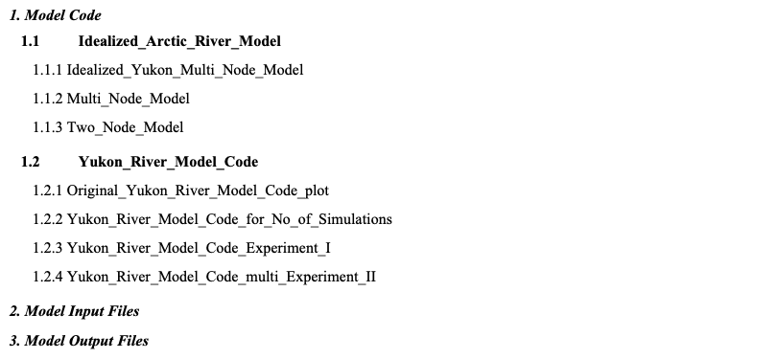

The main model folder contains four subdirectories, each of which includes model code designed to simulate the transformation of Dissolved Organic Carbon (DOC) components in the Yukon River. Each subdirectory serves a specific purpose:

There are detailed readme files in each subdirectory with additional information on file contents

**../Yukon_River_Model_Code/Original_Yukon_River_Model_Code_plot**

**Purpose:** This directory contains the original version of the river model, which is used as a reference baseline.

**Key Features:**

* Simulates DOC transformation along the Yukon River.
* Generates plots of DOC concentration versus river distance.

**Usage:** Use this model when comparing new developments against the original implementation or when visual outputs are needed for DOC trends along the river.

**../Yukon_River_Model_Code/Original_Yukon_River_Model_Code_for_No_of_Simulations**

**Purpose:** Designed to perform Monte Carlo simulations with user-defined numbers of iterations.

**Key Features:**

* Outputs simulation results for varying numbers of Monte Carlo runs.
* The number of simulations must be manually adjusted before each run.

**Usage:** Use this model when performing sensitivity analyses or uncertainty assessments requiring different simulation counts.

**../Yukon_River_Model_Code/Original_Yukon_River_Model_Code_Experiment_I**

This model code creates outputs for a fixed number of Monte Carlo simulations and initial values that are related to Experiment I

**Purpose:** Implements Experiment I, using a fixed number of Monte Carlo simulations and a specific set of initial conditions.

**Key Features:**

* Tailored for reproducible runs of Experiment I.
* Inputs and settings are predefined and consistent.

**Usage:** Use this model to generate results specific to Experiment I or when reproducing previously reported findings from that experiment.

**../Yukon_River_Model_Code/Original_Yukon_River_Model_Code_Experiment_II**

This model code creates outputs for a fixed number of Monte Carlo simulations and initial values that are related to Experiment II

**Purpose:** Implements Experiment II, similar in structure to Experiment I but using a different set of initial conditions.

**Key Features:**

* Runs Monte Carlo simulations with fixed settings related to Experiment II.

**Usage:** Use this version for analyses specific to Experiment II or when comparing outcomes between experimental configurations.

**Lineage**

The Yukon River model code was developed from the Idealized_Arctic_River_Model, which has been archived for prosperity.

../Yukon River Model V1/Model Code/Idealized_Arctic_River_Model/



**../Idealized_Arctic_River_Model/Idealized_Yukon_Multi_Node_Model**

This directory contains the model code for a multi-node, idealized river chemistry model, which represents the Yukon River as a series of interconnected spatial compartments.

**../Idealized_Arctic_River_Model/One_Node_Model**

This folder includes the single-node version of the idealized river model.

**../Idealized_Arctic_River_Model/Two_Node_Model**

Contains the **two-node version** of the idealized river chemistry model.

**How to run the model**

#### 1. Navigate to the Model Code Folder

Start by navigating to the folder that contains the model scripts. The model is organized as a set of modular scripts, each serving a specific function in the simulation pipeline.

#### 2. Customize Initial Conditions

* To set or modify the initial values for the model (e.g., initial DOC concentrations, reaction rate constants, flow conditions), and the no of simulations, use the script:

**river_initial_monac_code.py**

* This script defines the boundary and initial conditions used by the main simulation and should be edited before each new run if parameter changes are needed.
* This script contains the main parameters for the model simulation:
* Main stem and tributary distance
* No of tributary points
* Number of distance points for each tributary and main stem.
* Velocity values for the main river and the tributaries.
* Dilution factor values for confluence points.
* Initial DOC and macromolecule concentration values.
* Chemical turnover time values.
* Initial production values for macromolecules.
* This file will be called by each tributary file and the main Yukon River file to gain the necessary data.
* This script also performs the Monte Carlo Sensitivity Analysis to generates the random initial values for parameters within the boundaries we have gives for each run.

#### 3. Run the Main Simulation

* After customizing the initial conditions, execute the main model script:

**python Yukon_river.py**

**This script calls all of the tributary scripts (i.e.** Teslin_river.py, Pelly_river.py, White_Donjec_river.py, Porcupine_river.py, Tanana_river.py, Stewart_river.py, and Koyukuk_river.py**) as well as the initial river condition (river_initial_monac_code.py) script**

This script runs the simulation of DOC transport and transformation along the Yukon River, using the inputs defined in **river_initial_monac_code.py**

#### 4. Analyze and Store Model Outputs

* To analyze simulation results and automatically save the output data, run the script:

**Data_Ana_3.py**

* This script will:
  + This will run the model script (yukon_river.py)
  + Extract and analyze the output data from the simulation.
  + Generate summary statistics, plots, or visualizations as needed.
  + Save the processed output files for further review.

#### 5. Optional: Run Sub-basin Models

* If needed, you can also simulate individual tributaries or sub-basins of the Yukon River by running any of the following scripts:
  + Teslin_river.py
  + Pelly_river.py
  + White_Donjec_river.py
  + Porcupine_river.py
  + Tanana_river.py
  + Stewart_river.py
  + Koyukuk_river.py

These can be useful for localized sensitivity analyses or when validating sub-regional hydrological and biogeochemical behavior.

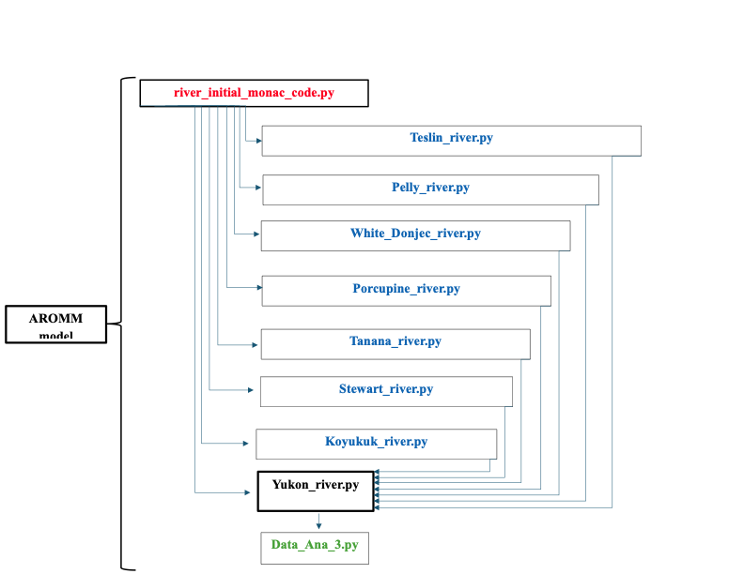

#### Workflow Summary

1. **Edit river_initial_monac_code.py to define your scenario**
2. **Run Yukon_river.py to execute the simulation**
3. **Analyze the output with Data_Ana_3.py**
4. **Optionally simulate individual tributaries with scripts like Teslin_river.py or Tanana_river.py**

**How to customize the model**

The model is customized using the script **river_initial_monac_code.py**, which defines the fundamental structure and initial conditions of the Yukon River system. This script must be configured prior to each simulation run and serves as the central place to define key model parameters.

## Core Model Configuration Parameters

The script allows the user to specify:

* Distances for the **main stem** and **tributaries**
* Number of **tributary points**
* Number of **spatial distance points** for each tributary and the main stem
* **Flow velocity** values for the main river and each tributary
* **Dilution factors** at tributary confluence points
* Initial **dissolved organic carbon (DOC)** concentrations and **macromolecule concentrations**
* **Chemical turnover times** of macromolecular compounds

Additionally:

* The script sets the number of runs for the **Monte Carlo simulation**
* Defines **boundary ranges** for sensitivity analysis
* Performs **Monte Carlo Sensitivity Analysis**, generating randomized parameter values within the defined boundaries for each simulation run

#### *Defining the River Structure*

The river structure defined in **river_initial_monac_code.py** includes:

* **Number of tributaries**  
  Specifies how many major tributaries feed into the main stem (e.g., Pelly, Tanana, Koyukuk).
* **Distances**

Inserted the total length of the main river stem, the length of each tributary, and the length to the each confluence point from the starting point of the main river stem.

* **Confluence points**  
   Indicates the spatial location (along the main stem) where each tributary joins. The length These are critical for simulating dilution and mixing processes.
* **Points of interest**  
   Specific locations along the main stem or tributaries where output data may be recorded or where particular biogeochemical events (e.g., monitoring stations, hotspots) are expected to occur.

We use published literature to obtain the geographical coordinates of key locations in the Yukon River system, including the starting points of the main river and tributary headwaters, the confluence points where tributaries meet the Yukon main stem, and the endpoint of the Yukon main stem.

***Flow Velocity Data***

In **river_initial_monac_code.py**, the river velocities of the main Yukon stem and the input is customized using observational data by calculating the average velocity separately for the main stem and the tributaries.

***Dilution factor Data***

In **river_initial_monac_code.py**, the dilution factors at the river confluence points are customized using observational data of river fluxes from main stem and tributaries.

***Initial DOC Data***

In **river_initial_monac_code.py**, the initial DOC concentration at each tributary headwater is set based on the average soil organic carbon obtained from observational data, which is then converted to dissolved organic carbon through soil processing mechanisms.

***Chemical fraction***

The chemical fractions of DOC components in **river_initial_monac_code.py** are defined using information from the literature and expert judgment. These fractions establish the initial macromolecular composition of DOC at the headwaters.

***Chemical turnover time***

The chemical turnover of macromolecular components in **river_initial_monac_code.py** are defined using information from the literature and expert judgment. These fractions establish the initial macromolecular composition of DOC at the headwaters.

​​

| **Parameter** | **Where It's Set** | **Description** |
| --- | --- | --- |
| **Number of tributaries** | river_initial_monac_code.py | Defines how many major tributaries flow into the Yukon main stem (e.g., Pelly, Tanana, Koyukuk). |
| **Main stem and tributary length** | river_initial_monac_code.py | Total length of the main river and each tributary; includes distances to confluence points. |
| **Confluence point locations** | river_initial_monac_code.py | Distance along main stem where each tributary joins (used for dilution and mixing simulations). |
| **Flow velocity** | river_initial_monac_code.py | Average flow velocity for main river and tributaries. |
| **Dilution factors** | river_initial_monac_code.py | Confluence dilution factors based on river discharge from main stem and tributaries. |
| **Initial DOC concentration** | river_initial_monac_code.py | Based on average soil organic carbon at each headwater, converted to DOC using empirical relationships. |
| **Chemical fractions of DOC** | river_initial_monac_code.py | Defines macromolecular composition of DOC (e.g., proteins, polysaccharides, humics). |
| **Chemical turnover times** | river_initial_monac_code.py | Residence/decay time for each DOC component. |
| **Initial macromolecular production** | river_initial_monac_code.py | Set baseline production rates for each DOC macromolecule type. |
| **Monte Carlo setup** | river_initial_monac_code.py | Sets number of simulation runs and generates random parameters within defined ranges. |
| **Boundary condition ranges** | river_initial_monac_code.py | Parameter limits for random sampling in Monte Carlo runs. |

**Model Input Data and it’s location**

**​​**

| Parameter | Definition Source | Data Source |
| --- | --- | --- |
| **Number of tributaries** | Hardcoded in script | River maps, literature |
| **Main stem and tributary length** | Defined numerically from shapefile | Natural Earth, published river datasets |
| **Confluence point locations** | GIS-derived, inserted manually | Literature and maps |
| **Flow velocity** | Manually inserted from literature/station data | USGS, literature |
| **Dilution factors** | Derived from observed discharge and inserted manually | River discharge data |
| **Initial DOC concentration** | Converted from soil organic carbon values and inserted manually | Soil Organic Carbon Data, Polygon Shape files of tributary watersheds, Soil moisture data, Soil temperature data |
| **Chemical fractions of DOC** | Expert judgement/literature-derived proportions | Literature and expert judgment, past model estimates |
| **Chemical turnover times** | Calibrated from literature values | Literature and expert judgment, past model estimates |
| **Initial macromolecular production** | Model assumption | Expert judgement and model assumptions |
| **Monte Carlo setup** | Number of runs decided via sensitivity test | Model Sensitivity test |
| **Boundary condition ranges** | Defined from Arctic ranges and adjusted via sensitivity | Based on expert range and literature |

| **Parameter** | **Data File/Directory Location** |
| --- | --- |
| **Number of tributaries** | Model_Input/ |
| **Main stem and tributary length** | Model_Input/ |
| **Confluence point locations** | Model_Input/ |
| **Flow velocity** | Model_Input/ |
| **Dilution factors** | Model_Input/ |
| **Initial DOC concentration** | Model_Input/ |
| **Chemical fractions of DOC** | Model_Input/ |
| **Chemical turnover times** | Model_Input/ |
| **Initial macromolecular production** | Model_Input/ |
| **Monte Carlo setup** | Model_Input/ |
| **Boundary condition ranges** | Model_Input/ |

### Model Output

#### concentration_outputs/

#### Description: This folder contains final model-derived concentration outputs, representing DOC and macromolecular concentrations after transport and transformation.

* + River mouth: Final concentrations where the Yukon River drains into the ocean
  + Confluence points: DOC and macromolecular concentrations at key junctions along the main Yukon River stem

**What files are produced when you run the model ?**

**How many ?**

**what file type? CSV**

**Are they self explanatory (in terms of what is in each column etc?)**