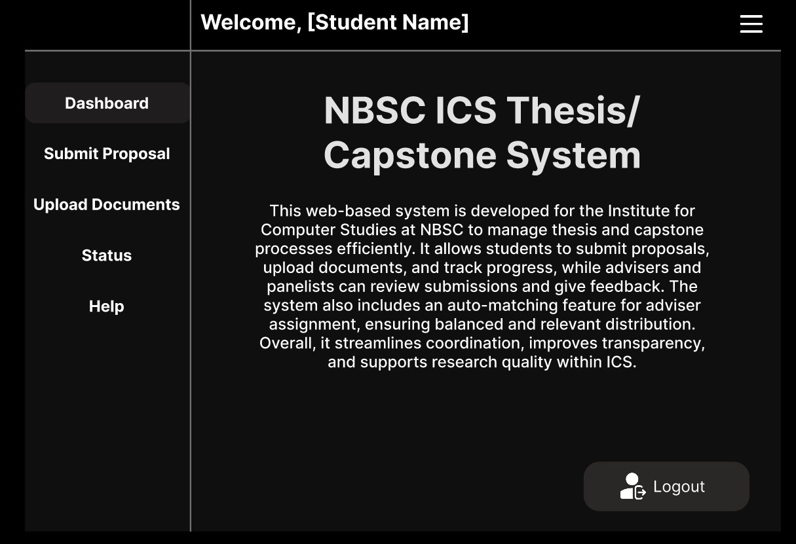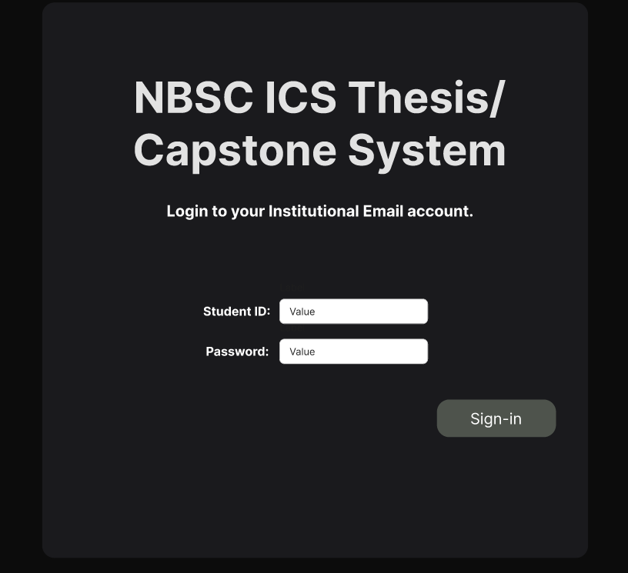

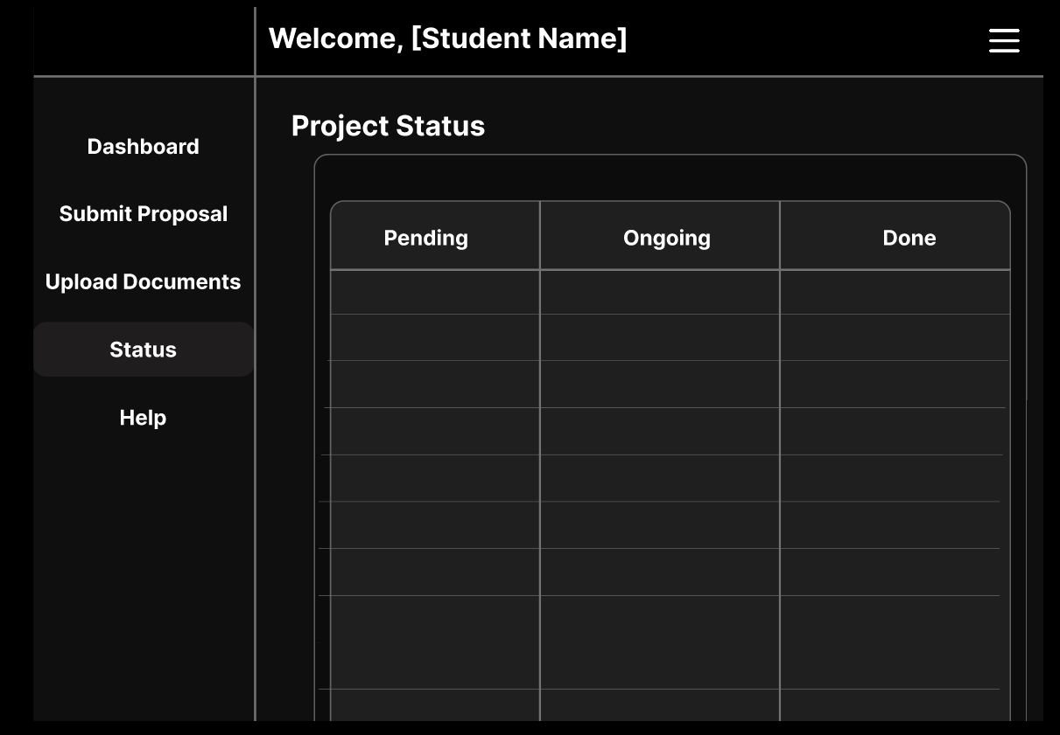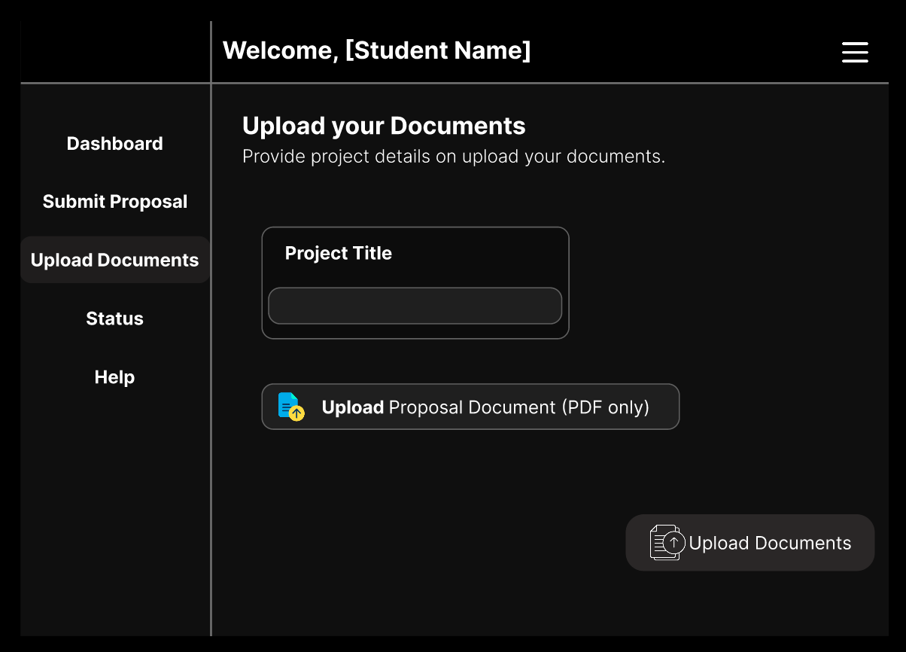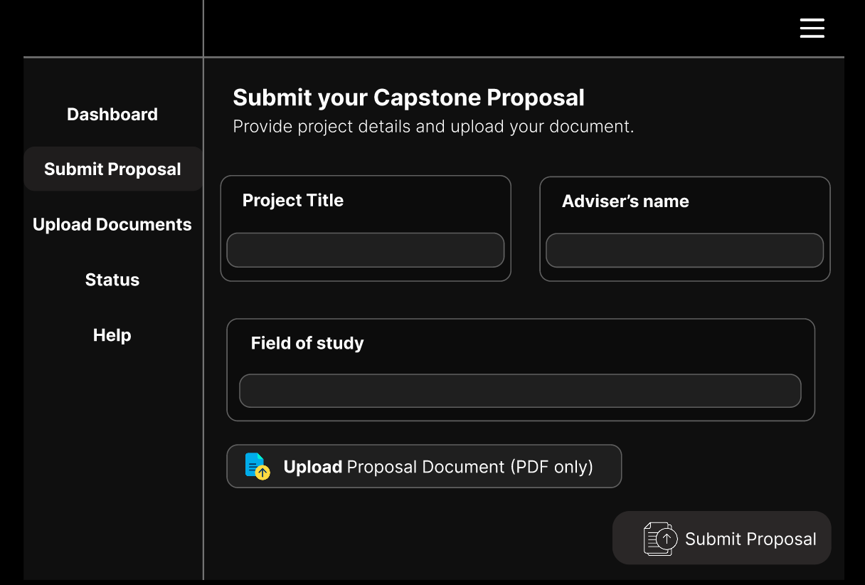

Kihare, Tankulan, Manolo Fortich, Bukidnon

Northern Bukidnon State College

Institute for Computer Studies

Information Management

IT27B

**2nd Semester Final Requirements**

Submitted by:

Manginsay, Auggie John Fred G.

Submitted to:

Faisah Bacarat