DIODE

Geometry description:
The geometry (figure 1) consists of a microstrip above a ground plane with a diode (red surface patch) placed on the mistrostrip surface towards the load end. The microstrip is driven by a sinusoidal source voltage in series with a 50Ω resistance on a wire connecting the strip to the ground plane (yellow wire). At the load end a wire with a 50Ω resistance connects the strip to the ground plane (purple wire).
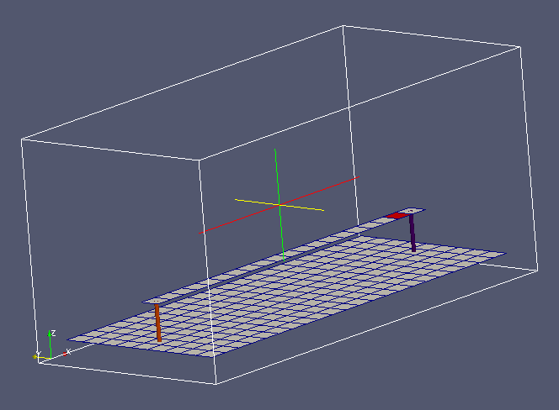
Figure 1. Diode test case.

Material description:
All surfaces are PEC apart from the diode surface.

Diode parameters:
Is=1e-12A
nVt=0.026V
Rs=6Ω
Cj=0.12pF

Mesh:
1cm cell size, 24×11×11 mesh

Excitation:
Sinusoidal voltage source, amplitude 5V, frequency 1MHz

Output:
Current on load end connection wire

Runtime:
5μs (5 cycles of source voltage)

Other Notes:

Post processing:
None

Reference results:
None yet available

GGI_TLM Input file:
Mesh_outer_boundary_dimension
-0.12 0.12 -0.055 0.055 -0.01 0.10

Mesh_cell_dimension
0.010

Outer_boundary_reflection_coefficient
0.0 0.0 0.0 0.0 0.0 0.0

Surface_list
4 Number of surfaces
1 surface_number ! ground plane
zplane
-0.11 -0.045 0.0 0.11 0.045 0.0 surface parameters (n*real)
0.0 0.0 0.0
0.0 0.0 0.0
2 surface_number ! main microstrip
zplane
-0.10 -0.005 0.02 0.08 0.005 0.02 surface parameters (n*real)
0.0 0.0 0.0
0.0 0.0 0.0
3 surface_number ! diode
zplane
0.08 -0.005 0.02 0.09 0.005 0.02 surface parameters (n*real)
0.0 0.0 0.0
0.0 0.0 0.0
4 surface_number ! xmax wire connection
zplane
0.09 -0.005 0.02 0.10 0.005 0.02 surface parameters (n*real)
0.0 0.0 0.0
0.0 0.0 0.0

Line_list
2 Number of lines
1 LINE_NUMBER
straight_line2
-0.095 0.0 0.0 -0.095 0.0 0.02 line parameters (n*real)
0.0 0.0 0.0
0.0 0.0 0.0
2 LINE_NUMBER
straight_line2
0.095 0.0 0.0 0.095 0.0 0.02 line parameters (n*real)
0.0 0.0 0.0
0.0 0.0 0.0

Point_list
4 Number of points
1 POINT_NUMBER
-0.095 0.0 0.0 point coordinates
0.0 0.0 0.0
0.0 0.0 0.0
2 POINT_NUMBER
-0.095 0.0 0.02 point coordinates
0.0 0.0 0.0
0.0 0.0 0.0
3 POINT_NUMBER
0.095 0.0 0.0 point coordinates
0.0 0.0 0.0
0.0 0.0 0.0
4 POINT_NUMBER
0.095 0.0 0.02 point coordinates
0.0 0.0 0.0
0.0 0.0 0.0

Surface_material_list
2 Number of surface materials
1 SURFACE MATERIAL NUMBER
PEC
3 number of surfaces
1 2 4 surface list
1 1 1 surface orientation list
2 SURFACE MATERIAL NUMBER
DIODE
1e-12 0.026 6.0 0.18e-12 Diode Is and nVt values
+x Diode forward direction, infinite imedance in the orthogonal direction
1 number of surfaces
3 surface list
1 surface orientation list

Cable_geometry_list
1 number of cable geometries
1 cable geometry number, Cable geometry type (file name) follows:
CABLE_DIRECTORY/0.1mm_single_wire

Cable_list
2 number of cables
1 CABLE NUMBER
1 cable geometry number
1 number of lines on cable route
1 cable line list
1 end 1 junction number
2 end 2 junction number
2 CABLE NUMBER
1 cable geometry number
1 number of lines on cable route
2 cable line list
3 end 1 junction number
4 end 2 junction number

Cable_output_list
1 number of cable_outputs
1 CABLE OUTPUT NUMBER
1 cable number
4 closest point number

Cable_junction_list
4 number of junctions
1 JUNCTION NUMBER
1 junction point
1 number of internal connection nodes (n_int)
1 number of cables
1 cable list
1 corresponding cable end number list
1 Cable 1 number of external conductors (n_ext)
1 Cable 1 P matrix: matrix (n_int rows* n_ext columns)
1 Cable 1 voltage source function list
50.0 Cable 1 impedance list
0 Number of internal impedances
FACE
-1
2 JUNCTION NUMBER
2 junction point
1 number of internal connection nodes (n_int)
1 number of cables
1 cable list
2 corresponding cable end number list
1 Cable 2 number of external conductors (n_ext)
1 Cable 2 P matrix: matrix (n_int rows* n_ext columns)
0 Cable 2 voltage source function list
0.0 Cable 2 impedance list
0 Number of internal impedances
FACE
-1
3 JUNCTION NUMBER
3 junction point
1 number of internal connection nodes (n_int)
1 number of cables
2 cable list
1 corresponding cable end number list
1 Cable 1 number of external conductors (n_ext)
1 Cable 1 P matrix: matrix (n_int rows* n_ext columns)
0 Cable 1 voltage source function list
50.0 Cable 1 impedance list
0 Number of internal impedances
FACE
-1
4 JUNCTION NUMBER
4 junction point
1 number of internal connection nodes (n_int)
1 number of cables
2 cable list
2 corresponding cable end number list
1 Cable 2 number of external conductors (n_ext)
1 Cable 2 P matrix: matrix (n_int rows* n_ext columns)
0 Cable 2 voltage source function list
0.0 Cable 2 impedance list
0 Number of internal impedances
FACE
-1

Excitation_function_list
1 ! number of excitation functions
1 ! EXCITATION NUMBER
sinusoid
5.0 1e6 0.0

Simulation_time
5e-6

GGI_TLM result
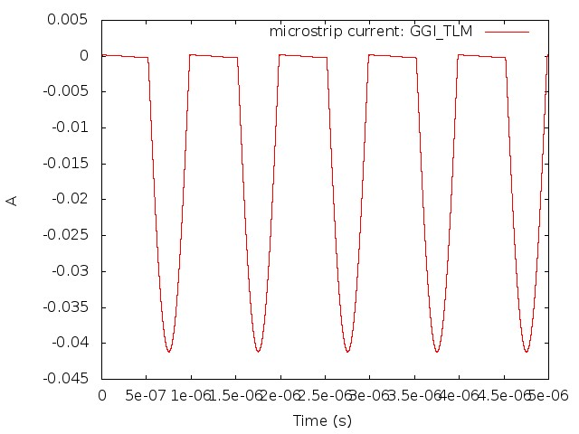
Figure 2. Time domain diode current.

