Coaxial Cable coupling *****NEED TO CHECK RESULT*****

Geometry description:
Two parallel 2m long coaxial cables separated by 2cm. The cables are terminated to PEC plates at either end.
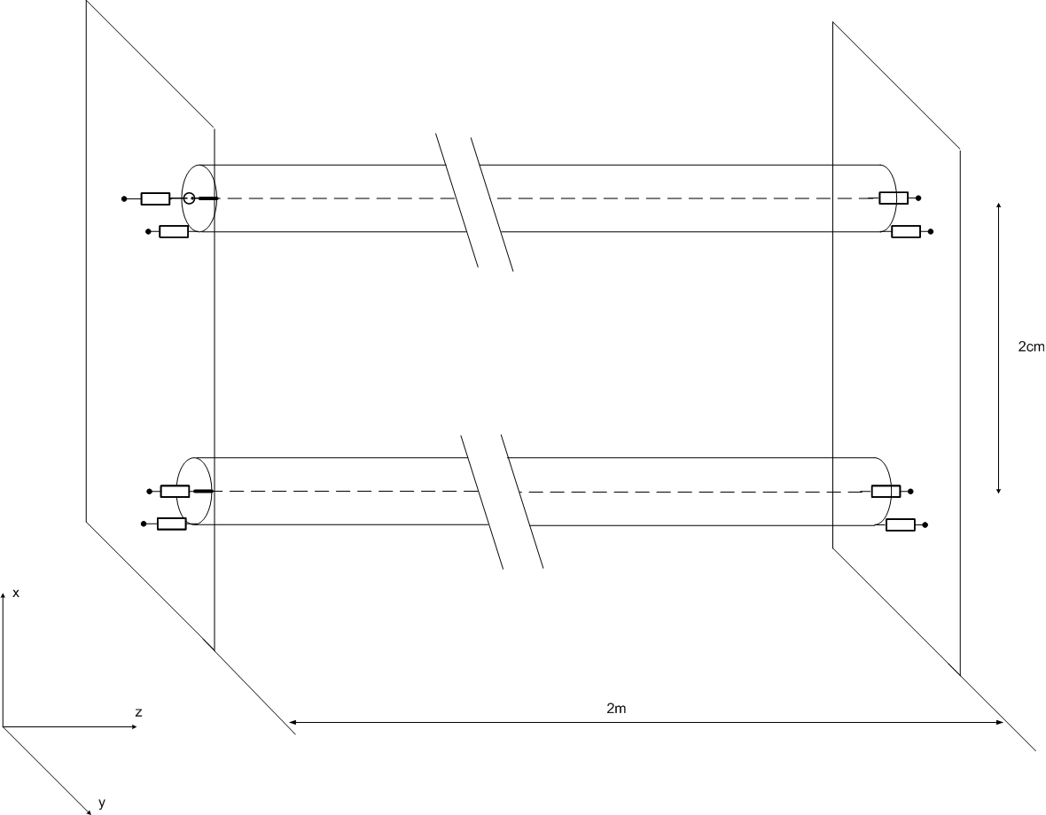

Cable description
The coaxial cables have the following properties:
Radius of core conductor: 0.000421m
Radius of shield: 0.001475m
Relative permittivity: 2.0
Transfer impedance: 0.01 +jω 1.6×10⁻⁹Ω/m
Cable file:
FD_coaxial
2 # number of conductors
5 # NUMBER OF PARAMETERS
0.001475 # parameter 1: shield radius
0.001475 # parameter 2: insulation radius
1.0 # parameter 3: permittivity of outer dielectric
0.000421 # parameter 4: inner radius
2.0 # parameter 5: permittivity of inner dielectric
3 # NUMBER OF FILTERS
# Filter 1: Inner wire series impedance filter
1.0e0 # w normalisation constant
0 # a order
0.0 # a coefficients
0 # b order
1.0 # b coefficients
# Filter 2: Shield series impedance filter
1.0e0 # w normalisation constant
0 # a order
0.0 # a coefficients
0 # b order
1.0 # b coefficients
# Filter 3: Transfer impedance filter
1.0e0 # w normalisation constant
1 # a order
0.10 1.6e-9 # a coefficients
0 # b order
1.0 # b coefficients

Mesh:
41×21×202 cells

Excitation:
A Gaussian voltage source in series with a 50Ω resistor is connected to the core wire of the cable at the source end of coaxial cable 1

Output:
The core current at the zmin end of cable 2.

Runtime:
10⁻⁶s

Post processing:
The excitation voltage and output current are both Fourier Transformed.
Calculate the crosstalk as
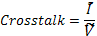
Where ~ denotes Fourier Transformed quantities.

Reference results:
An Analytic solution for the crosstalk is available [reference] and used for comparison with the TLM results.

GGI_TLM Input file:
# Two coaxial cables for crosstalk tests

Mesh_outer_boundary_dimension
-0.215 0.215 -0.115 0.115 -1.01 1.01

Mesh_cell_dimension
0.01

Outer_boundary_reflection_coefficient
0.0 0.0 0.0 0.0 0.0 0.0

Surface_list
2 Number of surfaces
1 SURFACE_NUMBER
rectangle
0.41 0.21 surface parameters
0.0 0.0 0.0
0.0 0.0 1.0
2 SURFACE_NUMBER
rectangle
0.41 0.21 surface parameters
0.0 0.0 0.0
0.0 0.0 -1.0

Line_list
2 Number of lines
1 LINE_NUMBER
straight_line2
-0.01 0.0 -1.0 -0.01 0.0 1.0 ! line parameters
0.0 0.0 0.0
0.0 0.0 0.0
2 LINE_NUMBER
straight_line2
0.01 0.0 -1.0 0.01 0.0 1.0 ! line parameters
0.0 0.0 0.0
0.0 0.0 0.0

Point_list
4 Number of points (integer)
1 POINT_NUMBER (integer)
-0.01 0.0 -1.0 point coordinates (n*real)
0.0 0.0 0.0
0.0 0.0 0.0
2 POINT_NUMBER (integer)
-0.01 0.0 1.0 point coordinates (n*real)
0.0 0.0 0.0
0.0 0.0 0.0
3 POINT_NUMBER (integer)
0.01 0.0 -1.0 point coordinates (n*real)
0.0 0.0 0.0
0.0 0.0 0.0
4 POINT_NUMBER (integer)
0.01 0.0 1.0 point coordinates (n*real)
0.0 0.0 0.0
0.0 0.0 0.0

Surface_material_list
1 Number of surface materials
1 SURFACE MATERIAL NUMBER
PEC
2 number of surfaces
1 2 surface list
1 1 surface orientation list

Cable_geometry_list
1 number of cable geometries
1 CABLE GEOMETRY NUMBER, Cable geometry type (file name) follows:
CABLE_DIRECTORY/Crosstalk_test_cable

cable_list
2 number of cables
1 CABLE NUMBER
1 cable geometry number
1 number of lines on cable route
1 cable line list
1 end 1 junction number
2 end 2 junction number
2 CABLE NUMBER
1 cable geometry number
1 number of lines on cable route
2 cable line list
3 end 1 junction number
4 end 2 junction number

Cable_output_list
4 number of cable_outputs
1 CABLE OUTPUT NUMBER
1 cable number
1 closest point number
2 CABLE OUTPUT NUMBER
1 cable number
2 closest point number
3 CABLE OUTPUT NUMBER
2 cable number
3 closest point number
4 CABLE OUTPUT NUMBER
2 cable number
4 closest point number

Cable_junction_list
4 number of junctions
1 JUNCTION NUMBER
1 junction point
1 number of internal connection nodes (n_int)
1 number of cables
1 cable list
1 corresponding cable end number list
2 Cable 1 number of external conductors (n_ext)
0 0 Cable 1 P matrix: matrix (n_int rows* n_ext columns)
1 0 Cable 1 voltage source function list
50.0 0.0 Cable 1 impedance list
0 Number of internal impedances
FACE
-1
2 JUNCTION NUMBER
2 junction point
1 number of internal connection nodes (n_int)
1 number of cables
1 cable list
2 corresponding cable end number list
2 Cable 1 number of external conductors (n_ext)
0 0 Cable 1 P matrix: matrix (n_int rows* n_ext columns)
0 0 Cable 1 voltage source function list
50.0 0.0 Cable 1 impedance list
0 Number of internal impedances
FACE
-1
3 JUNCTION NUMBER
3 junction point
1 number of internal connection nodes (n_int)
1 number of cables
2 cable list
1 corresponding cable end number list
2 Cable 1 number of external conductors (n_ext)
0 0 Cable 1 P matrix: matrix (n_int rows* n_ext columns)
0 0 Cable 1 voltage source function list
50.0 0.0 Cable 1 impedance list
0 Number of internal impedances
FACE
-1
4 JUNCTION NUMBER
4 junction point
1 number of internal connection nodes (n_int)
1 number of cables
2 cable list
2 corresponding cable end number list
2 Cable 1 number of external conductors (n_ext)
0 0 Cable 1 P matrix: matrix (n_int rows* n_ext columns)
0 0 Cable 1 voltage source function list
50.0 0.0 Cable 1 impedance list
0 Number of internal impedances
FACE
-1

Excitation_function_list
1 ! number of excitation functions
1 ! EXCITATION NUMBER
gaussian
1.0 5e-11 20e-11

Simulation_time
1e-6

GGI_TLM result:
