GGI_TLM TLM Electromagnetic field prediction code

©C. Smartt
University of Nottingham

Contents
1 Introduction 3
1.1 Coordinate systems 3
2 The TLM method 4
2.1 Basic TLM concepts 4
2.1.1 Maxwell’s equations in 1D 4
2.1.2 Constitutive relations 5
2.1.3 Telegrapher’s equation 5
2.2 3D TLM 9
2.2.1 Notation 10
2.2.2 TLM scattering process 11
2.2.3 TLM connection process 15
2.2.4 TLM absorbing boundary conditions 17
2.2.5 TLM modeling of bulk materials 18
2.2.6 TLM modeling of thin layer materials (impedance boundaries) 20
2.2.7 TLM modeling of cables 21
2.2.8 Excitations 22
2.2.9 Outputs 25
3 References 26

Introduction

The GGI_TLM full field electromagnetic prediction code is based on the TLM method [1]
Features:
- Time Domain TLM code
- Uniform cartesian grid.
- Frequency dependent bulk material and thin layer models
- Sub-cell Multi-conductor cable model with self-consistent coupling between cable and field. Shielded cable model with frequency dependent transfer impedance.
- Cable lumped element models
- Excitations: plane wave, field points, cable voltage source
- Outputs: Time domain fields at points, surfaces, volumes in space, cable currents
- Parallel implementation (mpi)

This document discusses the basic TLM algorithm, the manner in which a problem is defined, the possible outputs which can be generated and the performance of the code.
Some examples which illustrate these aspects of the code will be provided.
Details of the material and cable models are described in detail in the accompanying documents [2,3]

Coordinate systems
GGI_TLM uses both Cartesian and spherical polar coordinate systems for the definition of different aspects of the geometry, excitation conditions and observed fields. All dimensions are in metres and angles are defined in degrees.
The Cartesian (x,y,z) and spherical polar (ρ,θ,φ) coordinates are related as shown in figure 1.1 below.
x
z
y
φ
ρ
θ
Figure 1.1 GGI_TLM coordinate systems
The Cartesian coordinates (x,y,z) are related to the spherical polar coordinates by
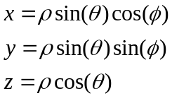

The TLM method

The TLM algorithm is based upon the equivalence between circuit and electromagnetic field quantities in a transmission line network. The TLM method will be introduced using a simple 1D derivation which illustrates this equivalence and introduces a transmission line model which models field propagation. The operation of the TLM algorithm is described for a case which introduces the technique used for modeling the field interaction with materials.
Following this introduction the 3D TLM node is described and the update algorithm described. The manner in which the simple free space TLM node is augmented so as to interact with bulk material and cable models is outlined. Similarly the implementation of impedance boundaries is introduced.

Basic TLM concepts

Maxwell’s equations in 1D

For a plane wave polarised in the y direction propagating in the x direction
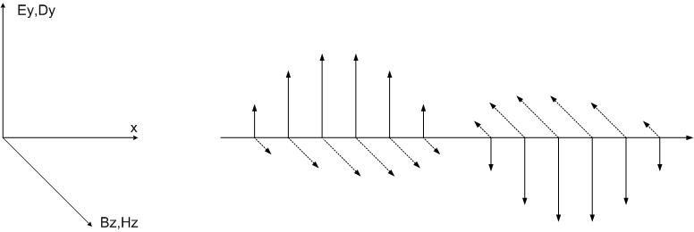
Figure 2.1
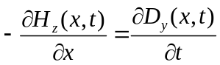
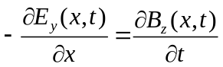

Constitutive relations
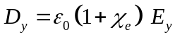
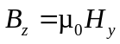
Substituting into Maxwell’s equations gives:
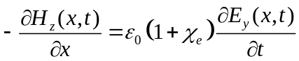
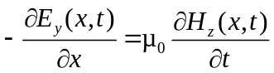
The free space wave impedance, Z₀ and velocity are related to the free space permittivity and permeability by
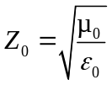
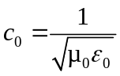

Telegrapher’s equation

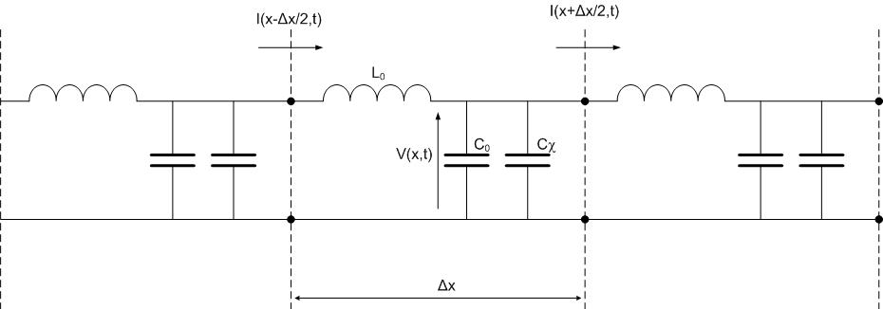
Figure 2.2

Defining:
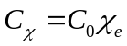

The calculation of voltage and current follow from Kirchoff’s current and voltage laws as follows:
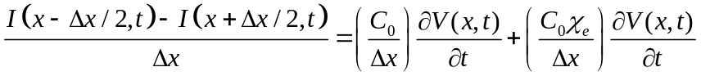
As Δx->0
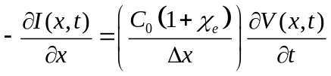
This should be compared with the equation:
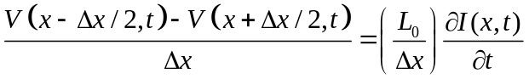
As Δx->0
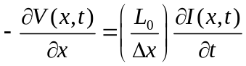
This should be compared with the equation:
If we consider each section of transmission line to model a volume of space Δx×Δy×Δz then we can identify the equivalences between the circuit and field equations as:
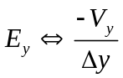
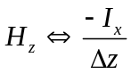
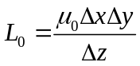
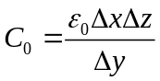
Within each cell the inductance L₀ and capacitance C₀ may be incorporated ito two link transmission line sections, each of length Δx/2 where the impedance of the link lines is Z₀ and transmission time Δt/2 where

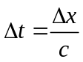
. The additional capacitance associated with the susceptibility is modelled as an additional capacitance at the cell centre giving the transmission line model shown below.
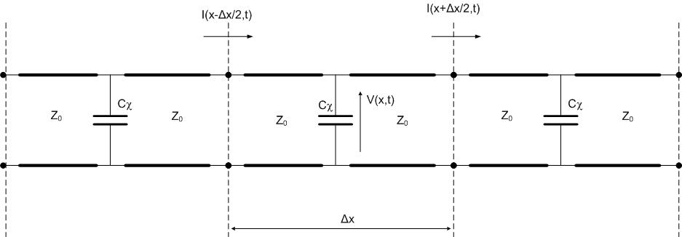
Figure 2.3
To complete the transmission line model the capacitance at the cell centre is modelled as an open circuit stub transmission line with round trip delay time Δt and with the impedance Z_{χ} chosen so as to model the required capacitance.
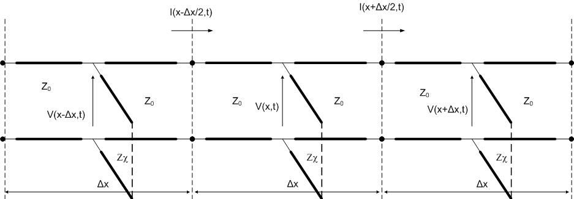
Figure 2.4
An equivalent circuit model for 1D propagation has been developed in which all the circuit elements are modelled as transmission line sections with the same transmission delay. If we excite the transmission line model with an impulse or a sequence of impulses with time separation Δt then all pulse interactions are discrete and synchronised in time.
The TLM algorithm proceeds in two stages. In the first stage at time t, voltage pulses are incident on the cell centre from the link lines and from the capacitive stub transmission line. These pulses scatter from the transmission line junction at the cell centre back into the link and stub lines as shown in the figure below.
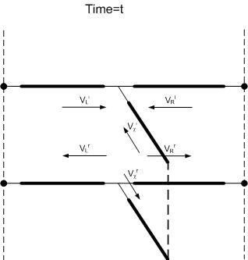
Figure 2.5
At time t+Δt the pulses on the link lines reach the cell faces. In this simple 1D example there is no transmission line discontinuity at the cell face therefore the voltage pulses continue into the adjacent cell. This is termed the connection process.
At the same time the voltage pulse on the stub transmission line reaches the open circuit termination and is reflected back with reflection coefficient +1.

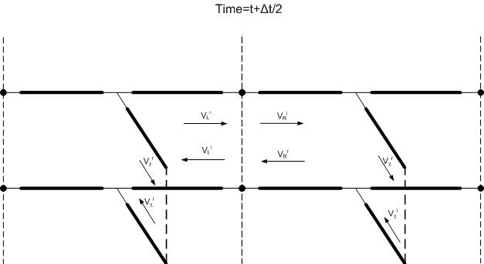
Figure 2.

3D TLM

The TLM algorithm within GGI_TLM is based on the symmetrical condensed node (figure 2.7).
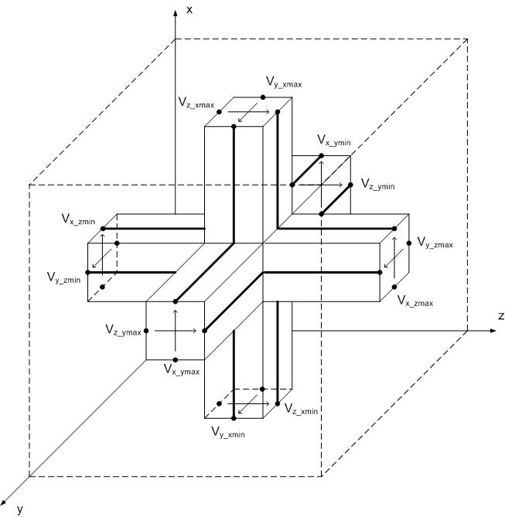
Figure 2.7. Symmetrical condensed node
The basic Symmetrical Condensed Node (SCN) models a cube of free space Δl× Δl× Δl, it has 12 link lines and 12 external ports. The impedance of all the link lines is 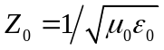and the timestep for the update is 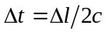. The SCN makes available all 6 field components at the cell centre at the scattering process and at each face 4 tangential field components are available in the scattering process. The 2D TLM update process proceeds in the same way as the 1D example presented above with a scattering process at the cell centre followed by a connection process half a timestep later.

Notation
A number of notations are available for numbering the ports of TLM nodes. For clarity in this report we adopt the notation: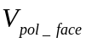 where pol is the polarization (x, y or z) and face is the face where the port is situated (xmin, xmax, ymin, ymax, zmin or zmax).
Voltage pulses have a superscript ‘r’ or ‘i’ which indicates whether a voltage pulse is incident or reflected from the centre of a TLM node.

TLM scattering process
An efficient implementation of the TLM scattering process for the 12 port SCN is implemented in a two stage process, firstly the node centre voltages and currents are calculated.
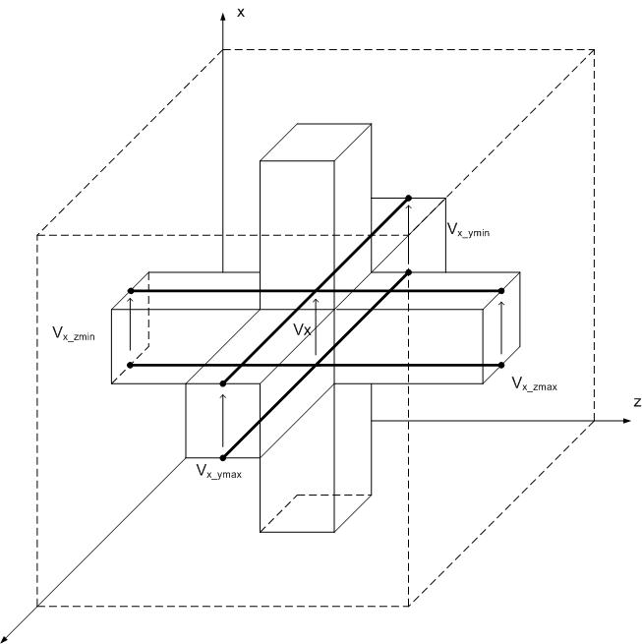
Figure 2.8.

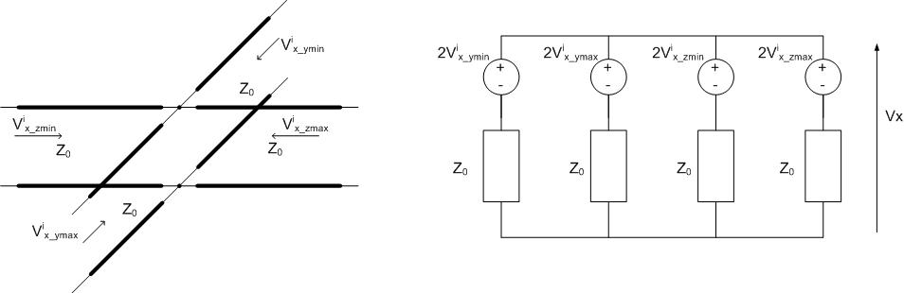
Figure 2.9.
Considering the four parallel connected x polarized voltage ports which contribute to V_{x} (figures 2.8, 2.9) we may calculate V_{x} as:
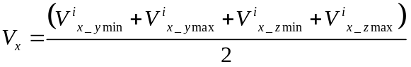
Similarly V_{y} and V_{z} are calculate as
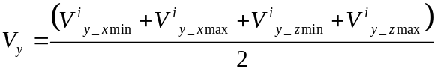
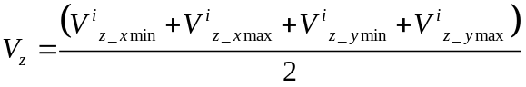
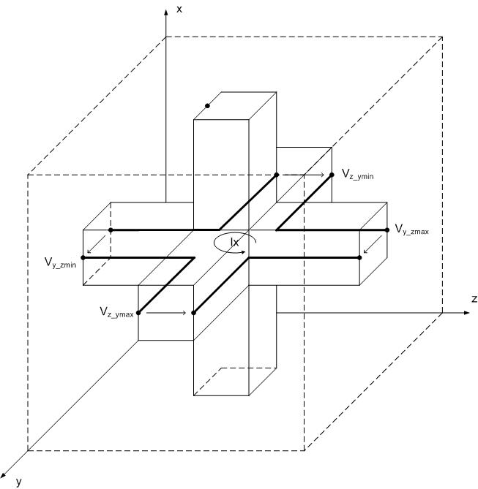
Figure 2.10.
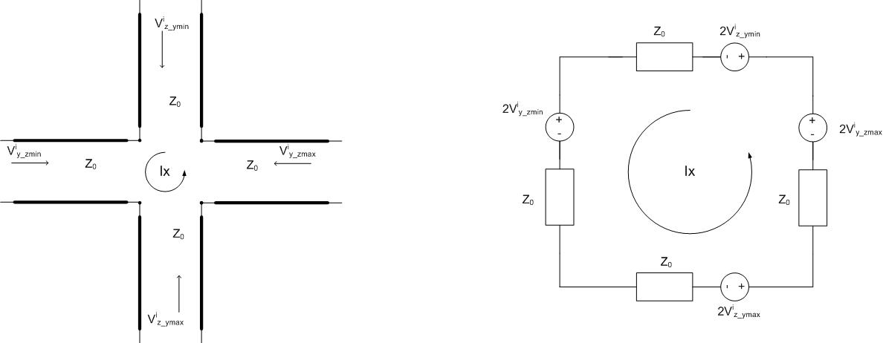
Figure 2.11.

Considering the four series connected voltage ports contributing to I_{x} (figures 2.10, 2.11) we may calculate I_{x} as
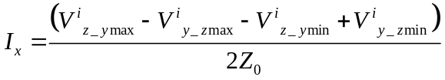
Similarly I_{y} and I_{z} are given by:
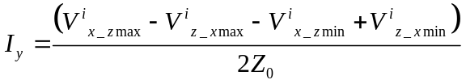
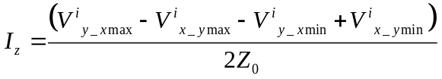
Secondly the scattered voltage pulses are calculated as:
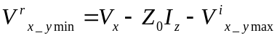
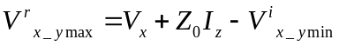
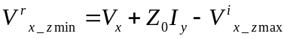
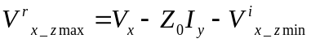
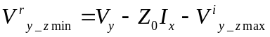
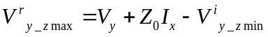
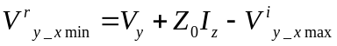
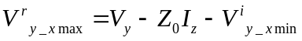
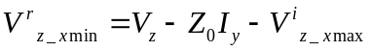
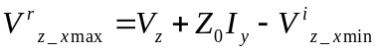
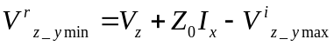
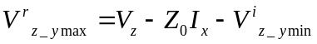

TLM connection process
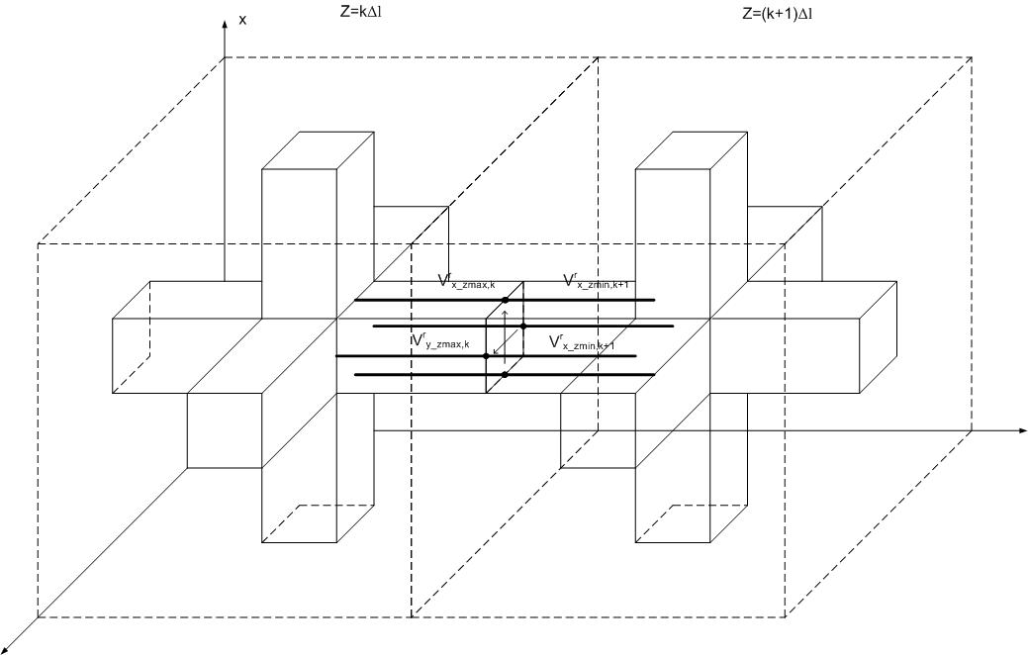
Figure 2.12.
The TLM connection process in the absence of any impedance boundary condition being applied between cells (figure 2.12) is described as follows for a cell I,j,k:
Faces normal to z:
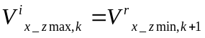
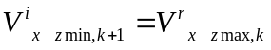
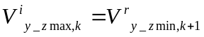
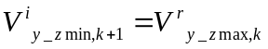
Faces normal to y:
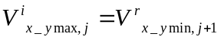
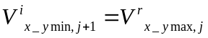
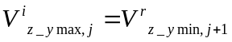
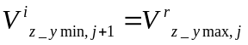
Faces normal to x:
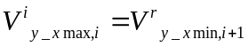
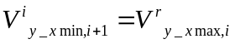
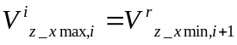
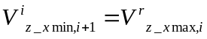

TLM absorbing boundary conditions
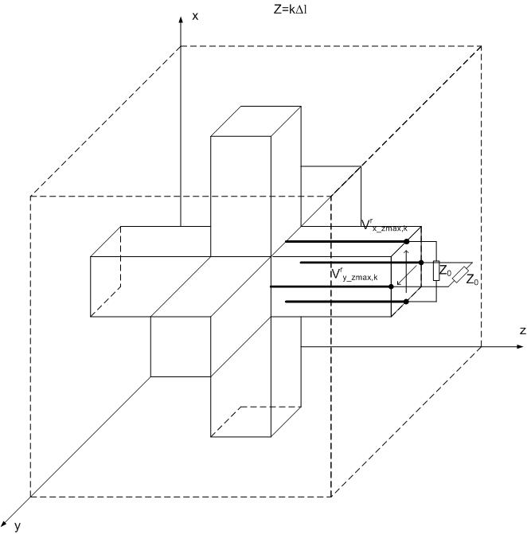
Figure 2.13.
Absorbing boundary conditions are simulated by terminating transmission lines normal to the boundary with the impedance of free space, Z₀ as seen in figure 2.13. The transmission lines are matched and therefore the new incident voltages from a boundary in the +z direction are given by
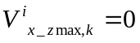
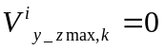

TLM modeling of bulk materials

Dielectric materials
As in the 1dimensional example described above the effect of dielectric materials may be added into the TLM algorithm by the addition of capacitive stubs into the node. If we wish to model a material with permittivity ε₀ε_{r} then we can identify the susceptibility as 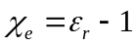. If the TLM node models a volume of Δl× Δl× Δl then the x polarized link lines model a total capacitance of C₀= ε₀ Δl. The additional x polarized capacitance required in the node is therefore C_{χ}= ε₀ (ε_{r}-1)Δl. This capacitance is modeled as an open circuit transmission line with impedance
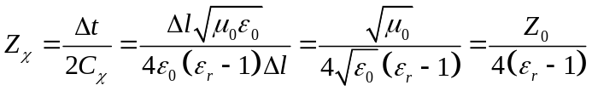
In addition to the permittivity we may also have an electric conductivity, σ. Conductivity loss is modeled as a lumped resistance Z_{σ}. Z_{σ} is identified as the resistance between the opposite faces of the cell and has the value
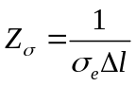
The voltage in the x direction can be calculated from the Thevenin equivalent circuit at the cell centre including the stub as shown in figure 2.14.
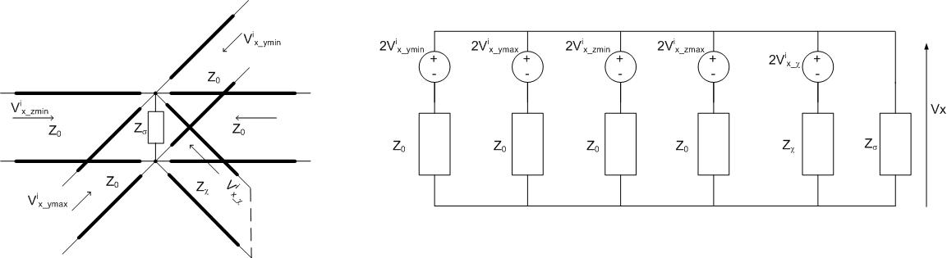
Figure 2.14.

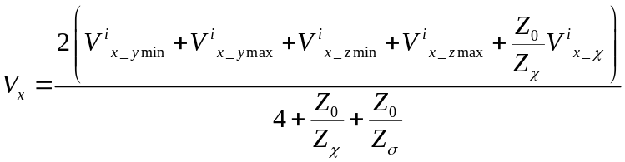
Once Vx has been found the scattering calculation for the link lines is again achieved via equations 2.2.7 to 2.2.18. The voltage scattered back into the capacitive stub is
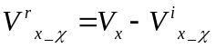
During the connection process the voltage pulse on the capacitive stub is reflected back to the node centre with reflection coefficient +1.
A similar process is applied in the y and z directions.

Magnetic materials
Magnetic materials may be added into the TLM algorithm by the addition of inductive stubs into the node. If we wish to model a material with permittivity µ₀µ_{r} then we can identify the magnetic susceptibility as 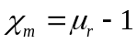. If the TLM node models a volume of Δl× Δl× Δl then the link lines contributing to Ix model a total inductanc of L₀= µ₀ Δl. The additional inductance required in the node is therefore L_{χ}= µ₀ (µ_{r}-1)Δl. This inductance is modeled as a short circuit transmission line with impedance
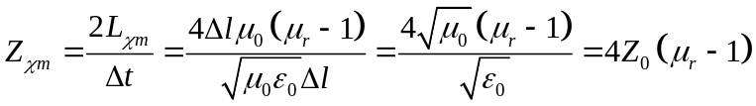
In addition to the permeability we may also have a magnetic conductivity, σ_{m}. Conductivity loss is modeled as a lumped resistance Z_{σm}. Z_{σm} is given by
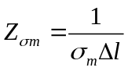
The current in the x direction can be calculated from the Thevenin equivalent circuit at the cell centre including the stub as shown in figure 2.15.
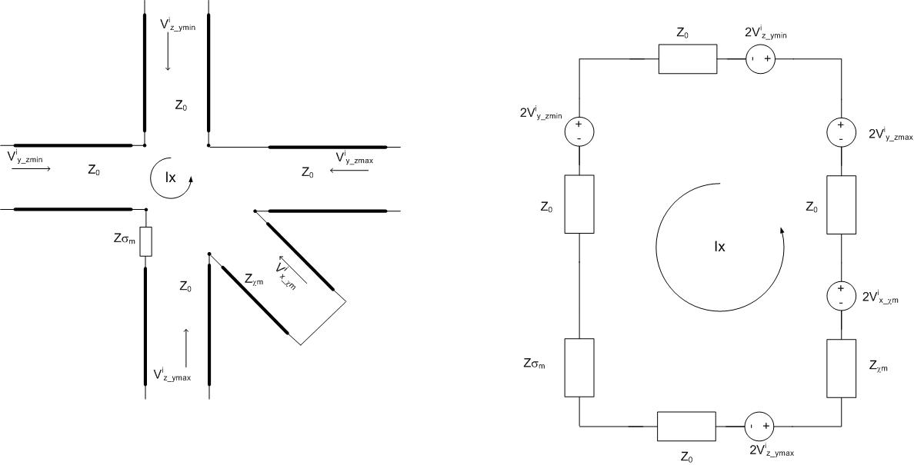
Figure 2.15.

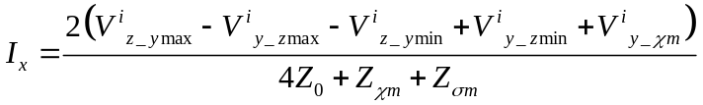

Once Ix has been found the scattering calculation for the link lines is again achieved via equations XXX to XXX. The voltage scattered back into the inductive stub is
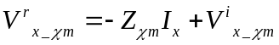
During the connection process the voltage pulse on the inductive stub is reflected with reflection coefficient -1.
A similar process is applied in the y and z directions.

TLM modeling of thin layer materials (impedance boundaries)

In TLM impedance boundaries are placed between cells and therefore the interaction with the field occurs in the connection process. Considering a single polarization only an impedance boundary on a surface normal to z imposes the condition
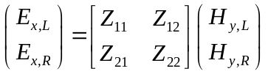
The electric and magnetic field components may be expressed in terms of the voltages scattered from the nodes either side of the boundary at the previous half timestep, t (denoted V^{i}), and those scattered back into the nodes by the impedance boundary (denoted V^{i})
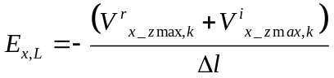
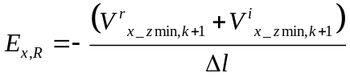
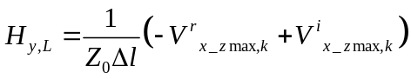
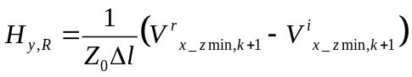

Substituting into the impedance boundary expression gives
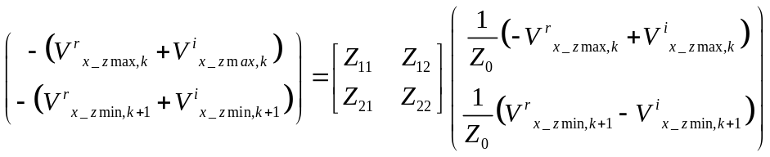
Defining
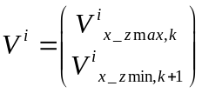
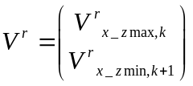
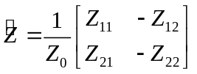
Leads to the system
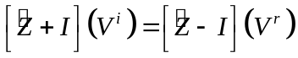
Which is solved for the unknown voltage pulses scattered from the impedance boundary by:
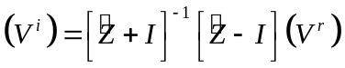

TLM modeling of cables

Cables run from cell centre to cell centre within the TLM mesh. The cable model consists of a 1D multi-conductor transmission line model which models the propagation of signals along the cable. The 1D cable propagation model interacts with the field at the cell centre. Figure 2.16 shows the partial equivalent circuit of a TLM field node and its interaction with a cable junction. The figure shows only the x directed portion of the node. The equivalent circuit of the node is the Thevenin equivalent circuit of the x directed E field sub-circuit. The impedance 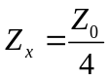 and 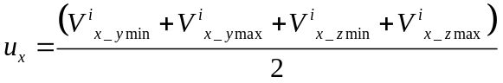. The TLM field node interacts with the conductors through an ideal transformer. This implements a self consistent interaction between the cable and the field, thus radiation from cables and coupling from external illuminating fields onto cables is included in the model. The field does not interact directly with shielded conductors, only cable shields and non-shielded conductors.

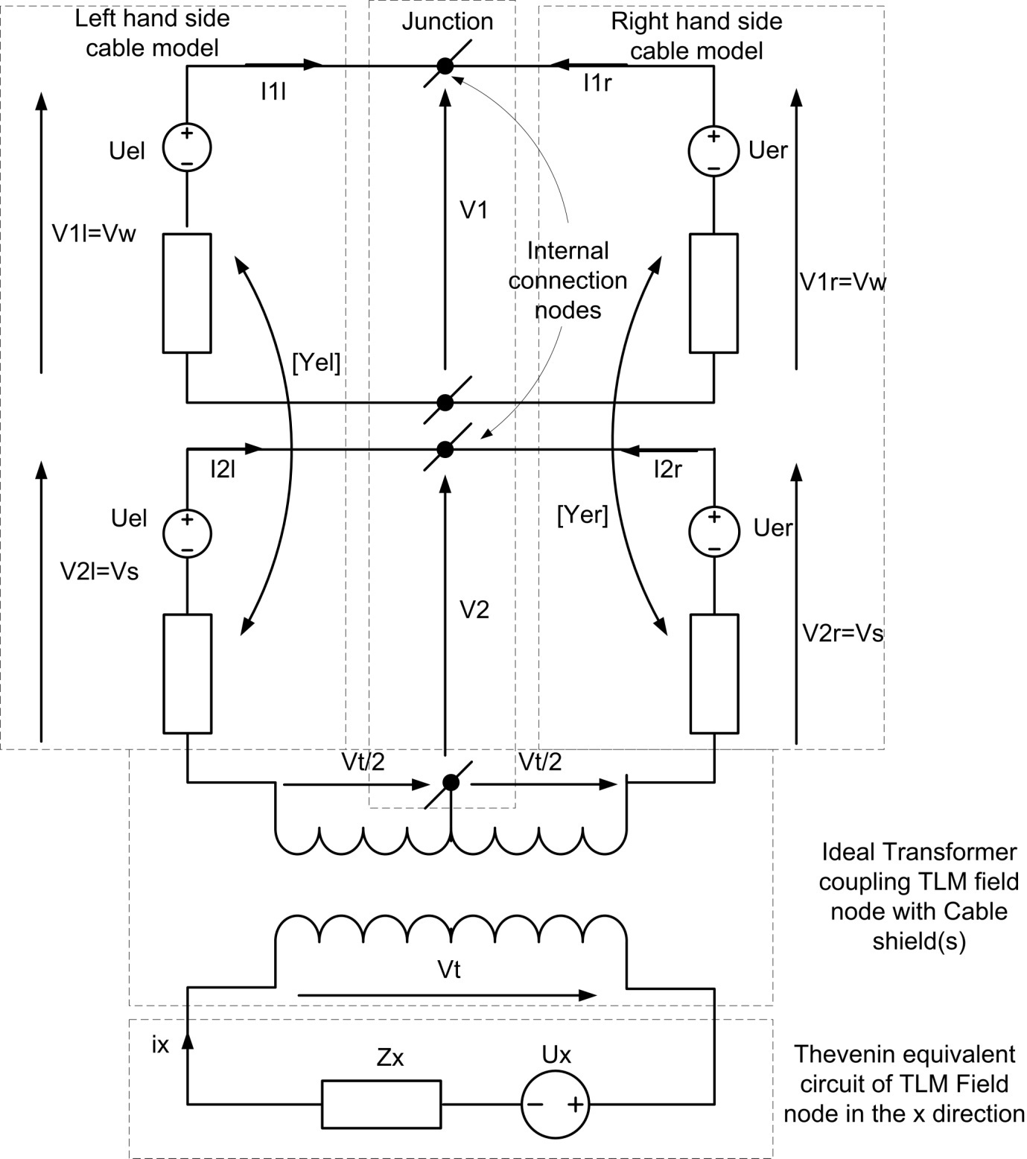
Figure 2.16.

Excitations

Excitations may be either hard or soft where a hard source imposes the source field in the mesh, whereas a soft source adds the source field to the field in the mesh.

Point excitation
A hard source at cell is imposed by setting the appropriate Voltage (for an E field source) or current (for a H field source). This voltage (current) is then used in the scattering equations 2.2.7 to 2.2.18.
If we wish to impose a field E_{x}=f then we set V_{x}=-fΔl. Of if we wish to set H_{x}=f then we set I_{x}=fΔl.
A soft source at a cell is imposed in a similar manner except that the source field is added to the cell centre field eg. If we wish to impose a field E_{x}=f then we set V_{x}=V_{x}-fΔl. Of if we wish to set H_{x}=f then we set I_{x}=I_{x}+fΔl.

Surface excitation
Excitations may be applied on the surface of a TLM cell as well as at the cell centre. Only field components tangential to the surface may be excited. The excitation is incorporated into the connection process.
At a surface normal to z for example we calculate Vx as:
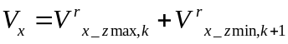
Then, as for the cell centre excitation we add on the source E field (soft source) V_{x}=V_{x}-fΔl or impose the E field (hard source) V_{x}=-fΔl
The scattered voltage pulses are then given by:
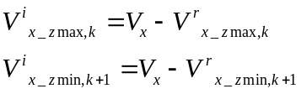
If we require an H field source then at a surface normal to z for example we calculate Iy as:
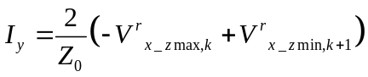
Then, as for the cell centre excitation we add on the source H field (soft source) I_{x}=I_{x}+fΔl or impose the H field (hard source) I_{x}=fΔl
The scattered voltage pulses are then given by:
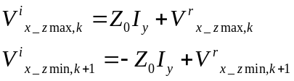

Huygens surface
GGI_TLM allows a plane wave with an arbitrary direction to be excited on a surface. Often the chosen surface will be a closed surface enclosing the object under test. The Huygens surface algorithm proceeds by calculating equivalent electric and magnetic surface current densities according to
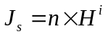
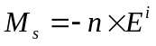
Where n is the unit outward normal to the surface and E^{i}, H^{i} are the illuminating electric and magnetic field.
The source terms are included in the connection process at cell faces as follows:
Faces normal to z:
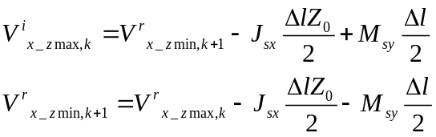
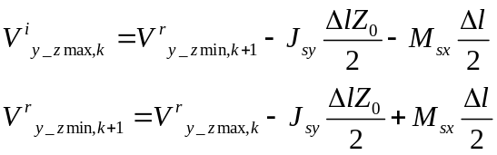
Faces normal to y:
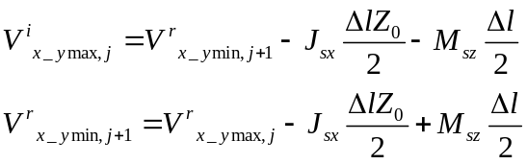
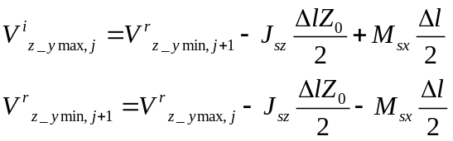
Faces normal to x:
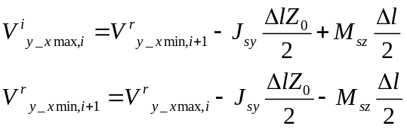
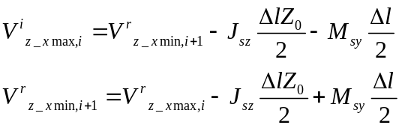

Mode excitation

A special case of the Huygens surface is the mode excitation in which a previously calculated field profile may be excited on a surface defined in the mesh. The previously calculated field must be on a grid of the same dimension and orientation as the excitation plane. As for the Huygens surface appropriate electric and magnetic current density terms are placed on cell faces so as to excite the required field.

Outputs

Field Output

We can obtain field quantities either at a cell centre or on a cell face. At the cell centre electric and magnetic fields are derived from the voltage and current calculated at the cell centre during the scattering calculation. Once we have V_{x}, V_{y}, V_{z}, I_{x}, I_{y} and I_{z} then the fields are given by
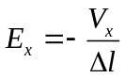
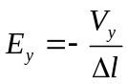
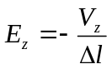
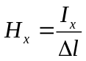
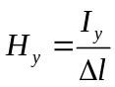
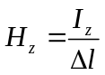
At a cell face the process is similar in that the voltage and current are calculated and the field equivalences in the above equations are then applied.
At a face normal to z
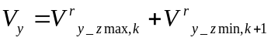
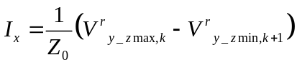
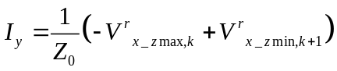
At a face normal to y
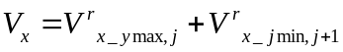
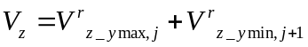
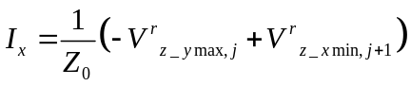
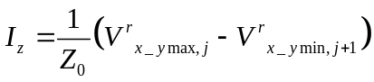
At a face normal to x
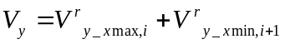
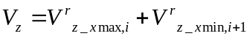
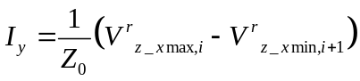
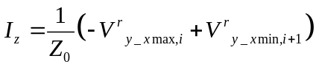

References
[1] C. Christopoulos, “The Transmission Line Modelling Method: TLM”, Piscataway, NY, IEEE Press, 1995.

[2] GGI_TLM Material model document “GGI_TLM_material_model_theory”
[3] GGI_TLM Cable model document “GGI_TLM_cable_model_theory”

