MAGNETIC FORCE CALCULATION

In this test case the forces on current carrying conductors is calculated using GGI_TLM. The conductors are modelled as volume materials with a specified electrical conductivity, σ.
The force per unit length on a current carrying conductor in a magnetic field is given by
We calculate the vector electric and magnetic fields the centre of TLM cells within the conductors. The current density vector in the TLM cell is calculated as
The current vector in the cell is
Assuming that the conductors are non magnetic
Then the force per unit length on the cell is
And the total force on the cell (length=dl)
The magnetic force vector calculation has been incorporated into the GGI_TLM post processor which generates a vector plot of the forces on each cell in the output volume.
In some lightning strike simulations for example the simulation time can become extremely large (hundreds of millions of timesteps). In order to reduce this in simulations which are dominated by magnetic diffusion we may use a technique referred to as ‘reduced c’ in which the speed of light is artificially reduced by a significant factor, p, (and hence the timestep is increased by the same factor) whilst keeping the magnetic diffusion time constant, τ=μσ. The reduced c algorithm has been implemented in GGI_TLM (although it has not been applied in this test case). Note that this should only be used for very slow transient current simulations as any wave dominated effects such as transmission line effects will be incorrect due to the reduction of the speed of light.
The magnetic force calculation test case consists of two parallel wires. The force between two infinite parallel wires carrying equal and opposite currents is found as
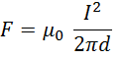

Where d is the distance between the wires.

Geometry description:
The problem geometry depicting two wires of length 0.4m and separated by a distance of 0.05m is shown below
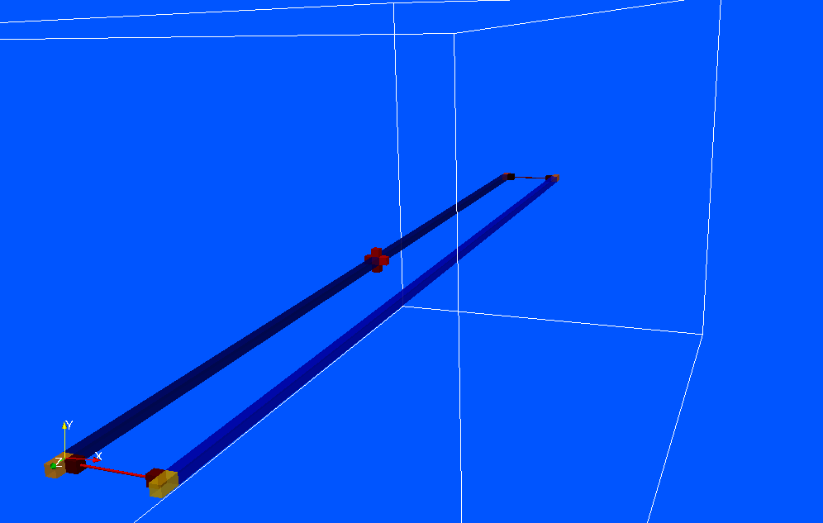

Material description:
The wires consist of conducting volume materials with free space permittivity and permeability and an electrical conductivity of 5x10⁷ S/m.

Mesh:
0.005m cell size

Excitation:
Gaussian step voltage sources on a thin wire at the zmin end of the problem space. The total source voltage is 100V. The thin wires have a resistance of 50 ohms on both the zmin and zmax ends thus the steady state current is 1A.

Output:
H fields are output on the surface of the wire at the output point half way along the xmin wire (z=0). Ex, Ey, Ez, Hx, Hy, and Hz are output at the cell centre at the centre of the xmin wire (z=0).

Runtime:

Other Notes:

Post processing:
- Calculate the current from the H fields surrounding the wire at z=0 from Ampere’s law.
- Calculate the current from the Ez field and electrical conductivity
- Calculate the force per unit length from the cell centre fields using the equation

- Calculate a vector plot of the force on cells along the xmin wire

Reference results:
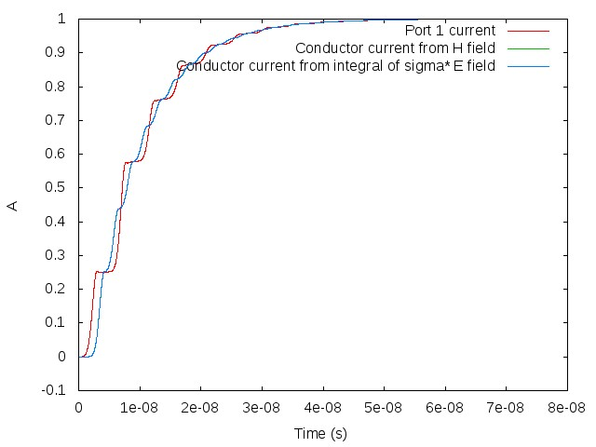
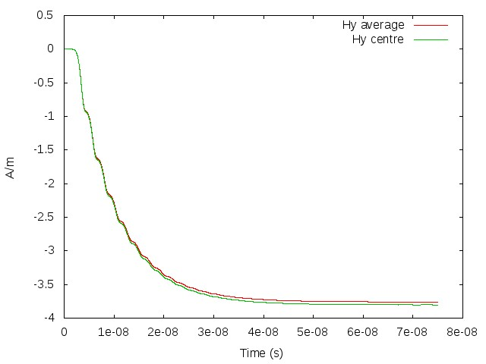
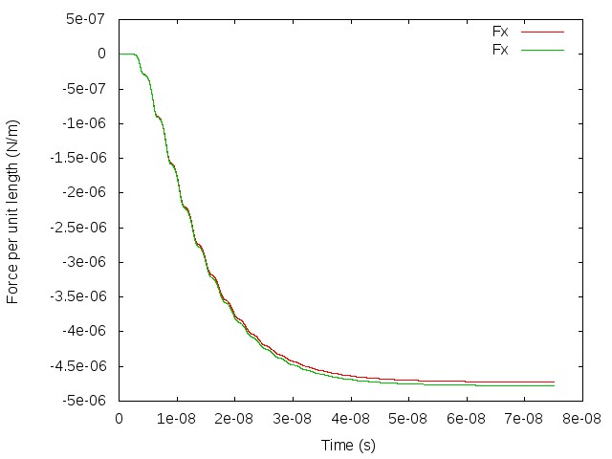
Note that the magnetic field at the centre of the wire is somewhat larger than expected due to the influence of the boundary conditions (which are rather too close for an accurate result) and the contribution to the field from the wires at the ends. This leads to a force which is also somewhat larger than that expected for infinite wires in free space

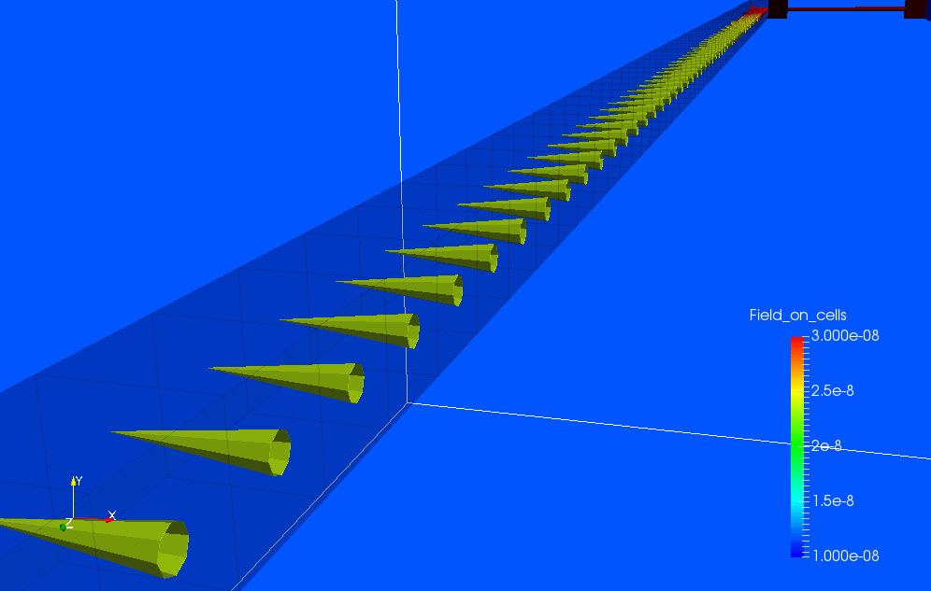

Note that the vector force plot shows force per cell, not force per unit length so in this case it is scaled from the force per unit length by the cell length, dl. Note also that the force is repulsive between the equal and opposite currents as expected.

GGI_TLM Input file:

