17. SAR_TEST

Geometry description:
The geometry consists of two material cylinders.
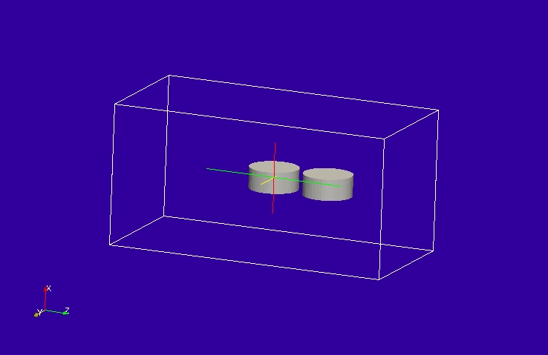

Material description:
The material is very close to free space so that we can assume that the field within the material is the same as the illuminating field, this allows us to check the SAR calculation analytically.
# dielectric permittivity 1.0, conductivity 1e-6 S/m
0.0 1e20 # frequency range of validity
# permittivity filter
1.0 # wnormalisation constant
0 # a order
1.0 # a coefficients
0 # b order
1.0 # b coefficients
1e-6 # electric conductivity
# permeability filter
1.0 # wnormalisation constant
0 # a order
1.0 # a coefficients
0 # b order
1.0 # b coefficients
0.0 # magnetic conductivity

Mesh:
2mm mesh

Excitation:
Gaussian pulse plane wave

Output:
Field at the centre of one of the material cylinders and SAR calculated over both of the material cylinders.

Runtime:
2ns

Other notes:

Post processing:
SAR is calculated as:
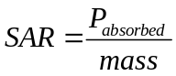
In the TLM process, the SAR calculated is not strictly the SAR as defined above, the output is the Energy absorbed divided by the mass (assuming a pulse excitation and a runtime sufficient for all the energy in the problem to be absorbed or radiated from the problem space). The TLM SAR may then be normalised to the excitation in such a way as to produce the desired result.
The Energy absorbed in a dielectric material with conductivity, σ is
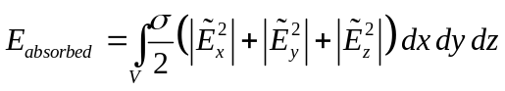
Where ~ denotes the field amplitude at the frequency of interest.
The SAR as output by GGI_TLM is then
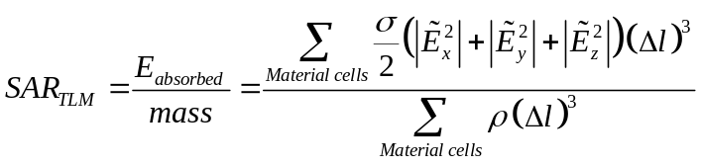
Where ρ is the material density (kg/m³).

Reference results
Fourier Transforming the incident E field gives E_{i}=1.636×10⁻¹⁰ V/m. If we assume that the field inside the material is equal to the incident field (the material properties are very close to those of a vacuum) then SAR_{TLM} is evaluated as 1.38×10⁻²⁹J/kg.

GGI_TLM Input file:
# SAR test

# Define the problem space
Mesh_outer_boundary_dimension
-0.02 0.02 -0.02 0.02 -0.04 0.04

# Specify the mesh dimensions
# (set to 1 for directions which do not exist in the problem space)
Mesh_cell_dimension
0.002 ( integer)

#specify the outer boundary conditions (6*real)
Outer_boundary_reflection_coefficient
0.0 0.0 0.0 0.0 0.0 0.0

Volume_list
2 Number of volumes (integer)
1 VOLUME_NUMBER : Sample 1
cylinder
0.007 0.006
0.0 90.0 0.0
0.0 0.0 0.0
2 VOLUME_NUMBER : Sample 1
cylinder
0.007 0.006
0.0 90.0 0.0
0.0 0.0 0.016

Point_list
1 Number of points (integer)
1 POINT_NUMBER (integer)
0.0 0.0 0.0 point coordinates (n*real)
0.0 0.0 0.0
0.0 0.0 0.0

Volume_material_list
2 Number of volume materials (integer)
1 VOLUME_MATERIAL_NUMBER
Dispersive
MATERIAL_DIRECTORY/SAR_test_material
1 number of volumes
1 volume list
2 VOLUME_MATERIAL_NUMBER
Dispersive
MATERIAL_DIRECTORY/SAR_test_material
1 number of volumes
2 volume list

SAR_volume_list
2 ! number of SAR volumes
1 ! SAR VOLUME NUMBER
1 ! material number
900E6 ! frequency
968.6 ! material density kg/m^3
2 ! SAR VOLUME NUMBER
2 ! material number
900E6 ! frequency
968.6 ! material density kg/m^3

Excitation_function_list
1 ! number of excitation functions
1 ! EXCITATION NUMBER
gaussian
1.0 1e-10 3e-10

Huygens_surface
0 surface number
1 excitation function number
0.0 0.0 wave vector Theta and Phi
1.0 0.0 Polarisation theta and Phi

Output_point_list
1 ! number of output points
1 ! OUTPUT NUMBER
1 ! output point
Ex
centre
output_timestep_information
1 ! first output timestep
20000 ! last output timestep
1 ! output timestep interval

Simulation_time
2e-9

GGI_TLM results
