Non Symmetric Surface Material Sphere: Radar Cross Section.

Geometry description:
1m radius sphere centred on the origin.

1m
1m
z
y
H_{y}
E_{x}
x

Material description:
The sphere material is a non-symmetric surface impedance boundary defined as follows:
# Asymmetric sheet
0.0 1e8 # frequency range of validity
# Z11 filter
1.0e8 # wnormalisation constant
0 # a order
1.0e-2 # a coefficients
0 # b order
1.0 # b coefficients
# Z12 filter
1.0e8 # wnormalisation constant
0 # a order
0.10 # a coefficients
0 # b order
1.0 # b coefficients
# Z21 filter
1.0e8 # wnormalisation constant
0 # a order
0.10 # a coefficients
0 # b order
1.0 # b coefficients
# Z22 filter
1.0e8 # wnormalisation constant
0 # a order
100.0 # a coefficients
0 # b order
1.0 # b coefficients

This material presents a different reflection coefficient depending on the orientation of the sheet. This test case can be used to demonstrate the reversal of surface normal directions.

Mesh:
Standard mesh: 40×40×40 cells

Excitation:
Plane wave in the +z direction with the E field polarised in the x direction. The plane wave has a Gaussian profile of width 1ns.

Output:
Monostatic Radar Cross Section in the backscattered direction as a function of frequency from 10 MHz to 300MHz.

Runtime:
70µs

Post processing:
None required

Reference results:
Mie series calculation

GGI_TLM Input file:

Mesh_outer_boundary_dimension
-2.0 2.0 -2.0 2.0 -2.0 2.0

Mesh_dimensions_in_cells
40 40 40 ( 3*integer)

Outer_boundary_reflection_coefficient
0.0 0.0 0.0 0.0 0.0 0.0

Surface_list
2 Number of surfaces (integer)
1 surface_number (integer)
sphere
1.0 surface parameters (n*real)
0.0 0.0 0.0
0.0 0.0 0.0
2 surface_number (integer)
rectangular_block
2.2 2.2 2.2 surface parameters (n*real)
0.0 0.0 0.0
0.0 0.0 0.0

Point_list
1 Number of points (integer)
1 point_number (integer)
1.0 1.0 1.0 point coordinates (n*real)
0.0 0.0 0.0
0.0 0.0 0.0

Surface_material_list
1 Number of surface materials (integer)
1 SURFACE MATERIAL NUMBER
DISPERSIVE
MATERIAL_DIRECTORY/asymmetric_sheet
1 number of surfaces
1 surface list
1 surface orientation list # set to -1 to reverse the material sheet

Excitation_function_list
1 ! number of excitations
1 ! EXCITATION NUMBER
gaussian
1.0 1e-9 3e-9

Huygens_surface
0 surface number
1 excitation function number
0.0 0.0 wave vector Theta and Phi
1.0 0.0 Polarisation theta and Phi

Output_point_list
1 ! number of output points
1 ! OUTPUT NUMBER
1 ! output point
Ex
centre
output_timestep_information
1 ! first output timestep
200 ! last output timestep
1 ! output timestep interval

RCS_surface
2 surface number
1 Side of surface for RCS output
0.1e8 3e8 0.01e8 frequency range for far field calculation
180.0 Theta
0.0 Phi

Simulation_time
7e-8

GGI_TLM results, non- reversed boundary

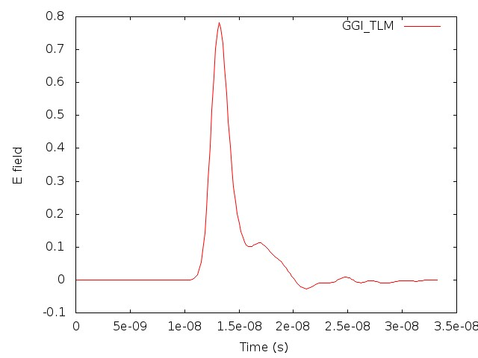
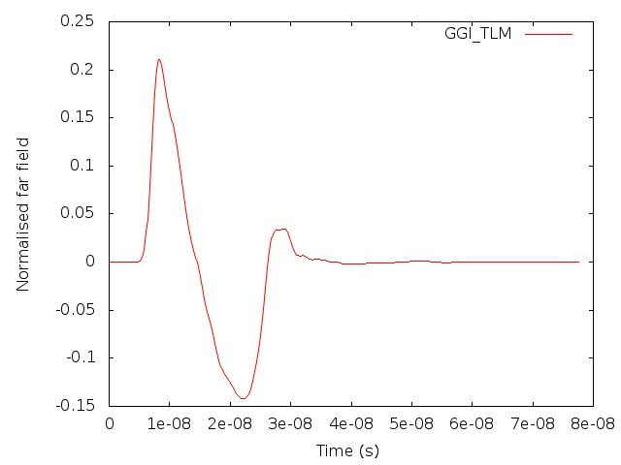

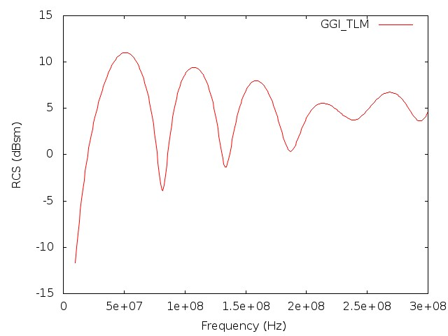

GGI_TLM results, reversed boundary
