Waveguide Resonator

Geometry description:
Rectangular waveguide resonator , waveguide width= 23mm (approximating WR90). This test case is used in order to calculate the mode shape for subsequent waveguide simulations.

2mm
x
23mmm

z
y
23mmm

Material description:
The waveguide is loaded with free space.

Mesh:
2×46×46 cells
Only two cells are modelled in the x direction as the structures and fields of interest are invariant in x.

Excitation:
Ex excited over the whole waveguide cross section

Output:
Ex at a single point for Fourier transformation and resonant frequency identification.
Ex output on a plane at the resonant frequency 9.217GHz.

Runtime:
0.01μs

Post processing:
Fourier transform of Ex point output in order to work out the resonant frequency.

Reference results:

GGI_TLM Input file:
# waveguide cavity for mode shape calculation

Mesh_outer_boundary_dimension
-0.0005 0.0005 -0.0115 0.0115 -0.0115 0.0115

Mesh_dimensions_in_cells
2 46 46 ( 3*integer) ! dl=0.0005

Outer_boundary_reflection_coefficient
-1.0 -1.0 -1.0 -1.0 -1.0 -1.0

Surface_list
2 Number of surfaces (integer)
1 SURFACE_NUMBER
zplane
-0.0005 -0.0115 -0.009 0.0005 0.0115 -0.009 ! surface parameters (n*real) ! excitation surface
0.0 0.0 0.0
0.0 0.0 0.0
2 SURFACE_NUMBER
zplane
-0.0005 -0.0115 0.0 0.0005 0.0115 0.0 surface parameters (n*real) ! mode output surface
0.0 0.0 0.0
0.0 0.0 0.0

Point_list
2 Number of points (integer)
1 POINT_NUMBER (integer)
0.00025 0.00025 0.00025 excitation point coordinates (cell 2 23 23)
0.0 0.0 0.0
0.0 0.0 0.0
2 POINT_NUMBER (integer)
0.00025 -0.00025 0.00025 excitation point coordinates (cell 2 23 23)
0.0 0.0 0.0
0.0 0.0 0.0

Excitation_function_list
1 ! number of excitation functions
1 ! EXCITATION NUMBER
gaussian
1.0 0.0025e-9 0.01e-9

Excitation_surface_list
1 ! number of excitation surfaces
1 ! EXCITATION SURFACE NUMBER
1 ! excitation function number
1 ! excitation surface
-1 ! side of surface for excitation
Ex
soft

Output_point_list
2 ! number of output points
1 ! OUTPUT NUMBER
1 ! output point
Ex
centre
output_timestep_information
1 ! first output timestep
100000 ! last output timestep
1 ! output timestep interval
2 ! OUTPUT NUMBER
2 ! output point
Ex
centre
output_timestep_information
1 ! first output timestep
100000 ! last output timestep
1 ! output timestep interval

Frequency_output_surface_list
1 ! number of Frequency output surfaces
1 ! FREQUENCY OUTPUT SURFACE NUMBER
2 ! surface number
-1 ! side of surface for output (+1 or -1)
9.217e9 ! frequency for output
Ex

Simulation_time
1.0e-8

Results:
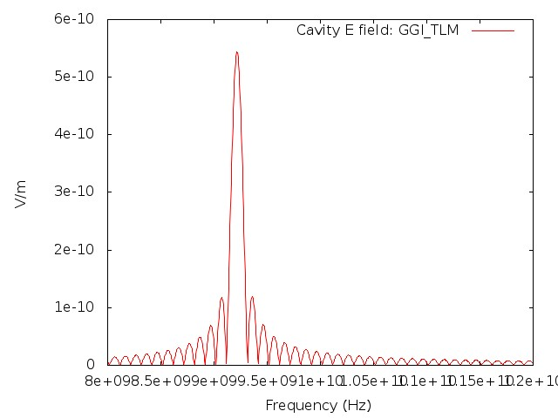
Frequency response of Ex point output
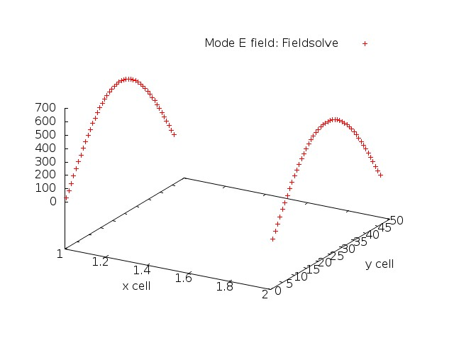
Ex mode profile over the x-y plane.

