Waveguide Straight Animation

Geometry description:
As for test case 20, the model is a straight length of rectangular waveguide waveguide width= 23mm (approximating WR90). This test case is used in order to test the output of fields on a surface and the subsequent post-processing to produce an animation of the vector field for visualisation in paraview.
2mm
x
23mmm

z
y
50mmm

Material description:
The waveguide is loaded with free space.
An absorbing boundary for rectangular waveguide modes has been implemented as a frequency dependent impedance boundary.
The impedance, Z_{c}, of the TE₁₀ mode of a rectangular waveguide as a function of frequency is given by
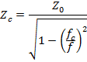
Where Z₀ is the impedance of free space, f_{c} is the cut off frequency of the waveguide mode.
The above expression for Z_{c} may be approximated as a rational function in complex frequency which is then suitable for implementation in GGI_TLM for use as a mode annihilation boundary condition.
The aim is to produce a function which is a good approximation around a specified working frequency, f₀.
The starting point is the approximation of the square root function:
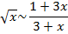
Where the approximation is centred on x=1 and is exact at this point.
If we require an approximation which is centred on x=a then we start by substituting x=ax’
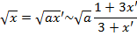
But using the definition of x’ we have
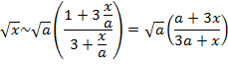
An approximation to centred at x=a is therefore
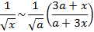
If we set 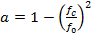 and 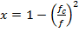 then we can approximate the original expression for Z_{c} as
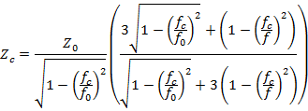
This expression is rearranged into the form
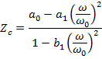
Where ω=2πf and ω₀ is an angular frequency normalisation constant and
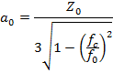
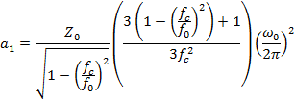
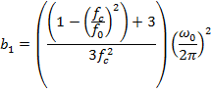
Substituting the dimensions of the WR90 waveguide into the above formulae gives the following specification for the required impedance boundary model.
# WR90 waveguide mode impedance
8e9 12e9 # frequency range of validity
# Z11 filter
75398223684.0000 # wnormalisation constant
2 # a order
176.954882553514 0.0 1499.38774569197 # a coefficients
2 # b order
1.00000000000000 0.0 3.94726504660646 # b coefficients
# Z12 filter
75398223684.0000 # wnormalisation constant
0 # a order
1.0e-12 # a coefficients
0 # b order
1.0 # b coefficients
# Z21 filter
75398223684.0000 # wnormalisation constant
0 # a order
1.0e-12 # a coefficients
0 # b order
1.0 # b coefficients
# Z22 filter
75398223684.0000 # wnormalisation constant
2 # a order
176.954882553514 0.0 1499.38774569197 # a coefficients
2 # b order
1.00000000000000 0.0 3.94726504660646 # b coefficients

The frequency responses of the impedance boundary matrix elements are shown below:
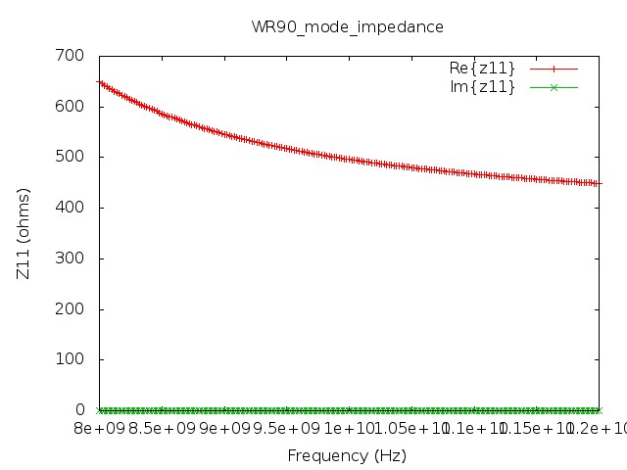
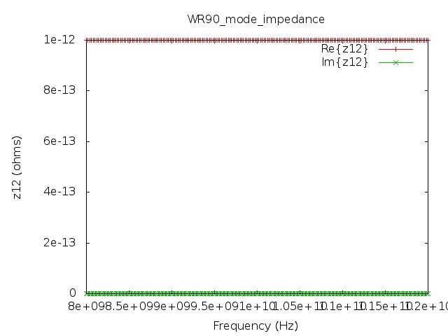
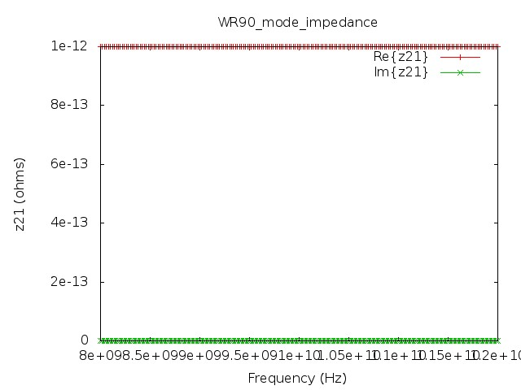
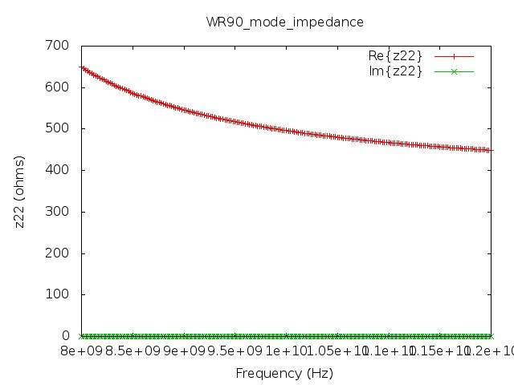

Mesh:
2×46×100 cells
Only two cells are modelled in the x direction as the structures and fields of interest are invariant in x.

Excitation:
Ex mode excited over the whole waveguide cross section at z=-12.5mm
The time domain profile is a sinusoidally modulated Gaussian pulse. This is a waveform with a frequency spectrum which approximates the single mode bandwidth of the waveguide.

Output:
Ex and Hy mode outputs on a two planes at z=-0.5 mm and z=+0.5mm (data for oneport analysis)

Runtime:
2ns

Post processing:
Oneport analysis for wave impedance, propagation constant and boundary reflection coefficient analysis.

Reference results:

GGI_TLM Input file:
# straight waveguide analysis

Mesh_outer_boundary_dimension
-0.0005 0.0005 -0.0115 0.0115 -0.025 0.025

Mesh_dimensions_in_cells
2 46 100 ( 3*integer) ! dl=0.0005

Outer_boundary_reflection_coefficient
-1.0 -1.0 -1.0 -1.0 0.0 0.0

Surface_list
6 ! number of surfaces
1 ! SURFACE NUMBER
rectangle
0.001 0.023
0.0 0.0 0.0
0.0 0.0 -0.024
2 ! SURFACE NUMBER
rectangle
0.001 0.023
0.0 0.0 0.0
0.0 0.0 0.024
3 SURFACE_NUMBER
zplane
-0.0005 -0.0115 -0.0125 0.0005 0.0115 -0.0125 surface parameters (n*real) ! mode excitation surface
0.0 0.0 0.0
0.0 0.0 0.0
4 SURFACE_NUMBER
zplane
-0.0005 -0.0115 -0.0005 0.0005 0.0115 -0.0005 surface parameters (n*real) ! mode output surface
0.0 0.0 0.0
0.0 0.0 0.0
5 SURFACE_NUMBER
zplane
-0.0005 -0.0115 0.0005 0.0005 0.0115 0.0005 surface parameters (n*real) ! mode output surface
0.0 0.0 0.0
0.0 0.0 0.0
6 SURFACE_NUMBER
xplane
0.0 -0.0115 -0.024 0.0 0.0115 0.024 surface parameters (n*real) ! field output surface
0.0 0.0 0.0
0.0 0.0 0.0

Point_list
2 Number of points (integer)
1 POINT_NUMBER (integer)
0.00025 0.00025 -0.00025 excitation point coordinates
0.0 0.0 0.0
0.0 0.0 0.0
2 POINT_NUMBER (integer)
0.00025 -0.00025 0.00975 excitation point coordinates
0.0 0.0 0.0
0.0 0.0 0.0

Surface_material_list
1 # number of surface materials
1 SURFACE_MATERIAL_NUMBER
Dispersive
MATERIAL_DIRECTORY/WR90_mode_impedance
2 # number of surfaces
1 2 # surface list
1 1 # surface orientation_list

Excitation_function_list
1 ! number of excitations
1 ! EXCITATION NUMBER
gaussian_sinusoid
1.0 0.25e-9 0.75e-9 10e9 0.0

Excitation_mode_list
1 ! number of excitation modes
1 ! EXCITATION MODE NUMBER
1 ! excitation function number
3 ! surface number
-1 ! side of surface for excitation
Ex
soft
WR90.mode
1 ! x column
2 ! y column
3 ! z column
6 ! data column to use

Output_point_list
2 ! number of output points
1 ! OUTPUT NUMBER
1 ! output point
Ex
centre
output_timestep_information
1 ! first output timestep
100000 ! last output timestep
1 ! output timestep interval
2 ! OUTPUT NUMBER
2 ! output point
Ex
centre
output_timestep_information
1 ! first output timestep
100000 ! last output timestep
1 ! output timestep interval

Output_mode_list
4 ! number of output modes
1 ! OUTPUT MODE NUMBER
4 ! surface number
1 ! side of surface for output
Ex
WR90.mode
1 ! x column
2 ! y column
3 ! z column
6 ! data column to use
2 ! OUTPUT MODE NUMBER
4 ! surface number
1 ! side of surface for output
Hy
WR90.mode
1 ! x column
2 ! y column
3 ! z column
6 ! data column to use
3 ! OUTPUT MODE NUMBER
5 ! surface number
1 ! side of surface for output
Ex
WR90.mode
1 ! x column
2 ! y column
3 ! z column
6 ! data column to use
4 ! OUTPUT MODE NUMBER
5 ! surface number
1 ! side of surface for output
Hy
WR90.mode
1 ! x column
2 ! y column
3 ! z column
6 ! data column to use

Frequency_output_surface_list
2 ! number of Frequency output surfaces
1 ! FREQUENCY OUTPUT SURFACE NUMBER
6 surface number
1 ! side of surface for output (+1 or -1)
10e9 frequency for output
Hy
2 ! FREQUENCY OUTPUT SURFACE NUMBER
6 surface number
1 ! side of surface for output (+1 or -1)
10e9 frequency for output
Hz

Simulation_time
2.0e-9

Results:
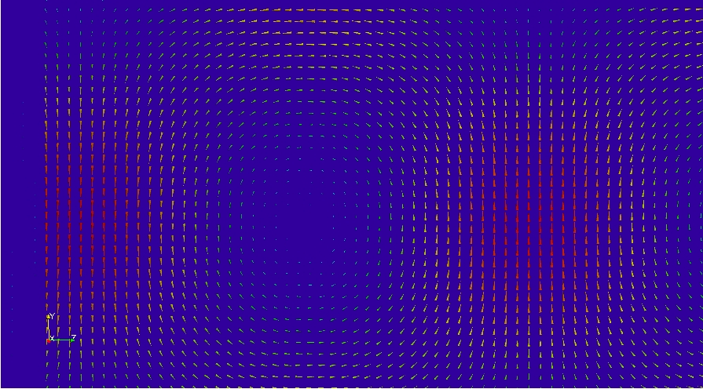
Single frame from waveguide vector H field animation at

