Wire Over Lossy Ground

Geometry description:
A cable is connected between PEC planes above a lossy dielectric ground volume.
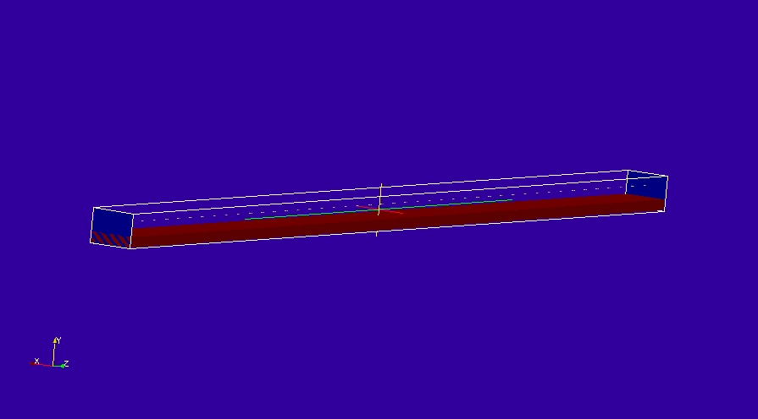
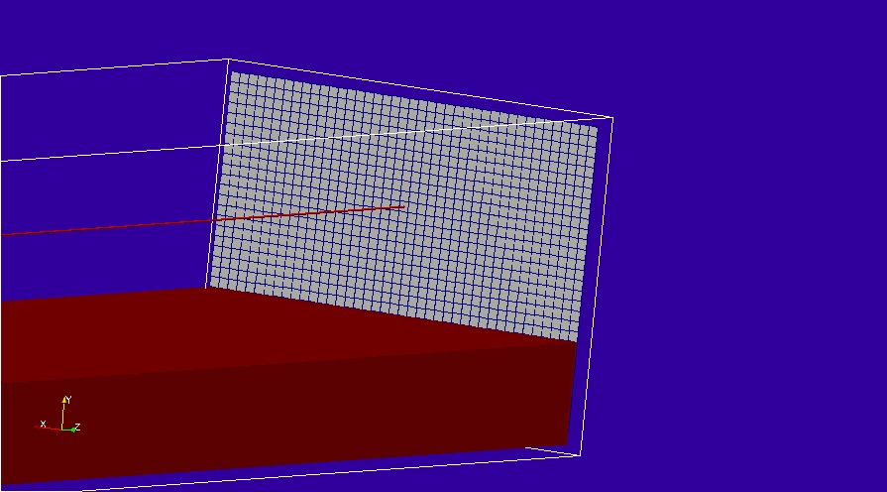

Material description:
The lossy ground has an electric conductivity of 0.01S/m
# sigma_e=0.01 material model
0.0 1e8 # frequency range of validity
# permittivity filter
1.0e8 # wnormalisation constant
0 # a order
1.0 # a coefficients
0 # b order
1.0 # b coefficients
0.01 # electric conductivity
# permeability filter
1.0e8 # wnormalisation constant
0 # a order
1.0 # a coefficients
0 # b order
1.0 # b coefficients
0.0 # magnetic conductivity

Mesh:
42×33×1002

Excitation:
Gaussian voltage source on the cable termination

Output:
Cable current at source end, two sample points at the cable centre and the load end.
Also E and H fields at sample points between the cable and ground at the midpoint of the cable

Runtime:
5μs

Post processing:
Oneport process

Reference results:

GGI_TLM Input file:
# Define the problem space
Mesh_outer_boundary_dimension
-21.5 21.5 -11.0 22.0 -1.0 1001.0

# Specify the mesh cell dimension
Mesh_cell_dimension
1.0 ( 3*integer)

#specify the outer boundary conditions (6*real)
Outer_boundary_reflection_coefficient
0.0 0.0 0.0 0.0 0.0 0.0

Volume_list
1 Number of volumes
1 VOLUME_NUMBER
rectangular_block2
-20.5 -10.0 0.0 20.5 0.0 1000.0 volume parameters (n*real) ! normal to z
0.0 0.0 0.0
0.0 0.0 0.0

volume_material_list
1 Number of volume materials (integer)
1 volume MATERIAL NUMBER
Dispersive
MATERIAL_DIRECTORY/sigma_e=0.01
1 number of volumes
1 volume list

Surface_list
3 Number of surfaces
1 SURFACE_NUMBER
zplane
-20.5 -10.0 0.0 20.5 21.0 0.0 surface parameters (n*real) ! normal to z
0.0 0.0 0.0
0.0 0.0 0.0
2 SURFACE_NUMBER
zplane
-20.5 -10.0 1000.0 20.5 21.0 1000.0 surface parameters (n*real) ! normal to z
0.0 0.0 0.0
0.0 0.0 0.0
3 SURFACE_NUMBER
zplane
-20.5 -10.0 500.0 20.5 21.0 500.0 surface parameters (n*real) ! normal to z
0.0 0.0 0.0
0.0 0.0 0.0

Surface_material_list
1 Number of surface materials (integer)
1 SURFACE MATERIAL NUMBER
PEC
2 number of surfaces
1 2 surface list
1 1 surface orientation list

#z directed cable
Line_list
1 Number of lines (integer)
1 LINE_NUMBER (integer)
straight_line2
0.0 10.5 0.0 0.0 10.5 1000.0 line parameters (n*real)
0.0 0.0 0.0
0.0 0.0 0.0

Point_list
6 Number of points (integer)
1 POINT_NUMBER (integer)
0.0 10.5 0.0 point coordinates (n*real)
0.0 0.0 0.0
0.0 0.0 0.0
2 POINT_NUMBER (integer)
0.0 10.5 1000.0 point coordinates (n*real)
0.0 0.0 0.0
0.0 0.0 0.0
3 POINT_NUMBER (integer)
0.0 10.5 499.5 point coordinates (n*real)
0.0 0.0 0.0
0.0 0.0 0.0
4 POINT_NUMBER (integer)
0.0 10.5 500.5 point coordinates (n*real)
0.0 0.0 0.0
0.0 0.0 0.0
5 POINT_NUMBER (integer)
0.0 5.5 499.5 point coordinates (n*real)
0.0 0.0 0.0
0.0 0.0 0.0
6 POINT_NUMBER (integer)
0.0 5.5 500.5 point coordinates (n*real)
0.0 0.0 0.0
0.0 0.0 0.0

Cable_geometry_list
1 number of cable geometries
1 cable geometry number, Cable geometry type (file name) follows:
CABLE_DIRECTORY/1cm_single_wire

Cable_list
1 number of cables
1 CABLE NUMBER
1 cable geometry number
1 number of lines on cable route
1 cable line list
1 end 1 junction number
2 end 2 junction number

Cable_output_list
4 number of cable_outputs
1 CABLE OUTPUT NUMBER
1 cable number
1 closest point number
2 CABLE OUTPUT NUMBER
1 cable number
2 closest point number
3 CABLE OUTPUT NUMBER
1 cable number
3 closest point number
4 CABLE OUTPUT NUMBER
1 cable number
4 closest point number

Cable_junction_list
2 number of junctions
1 JUNCTION NUMBER
1 junction point
1 number of internal connection nodes (n_int)
1 number of cables
1 cable list
1 corresponding cable end number list
1 Cable 1 number of external conductors (n_ext)
1 Cable 1 P matrix: matrix (n_int rows* n_ext columns)
1 Cable 1 voltage function source list
0.0 Cable 1 impedance list
0 Number of internal impedances
FACE
-1 boundary condition (-1 indicates V=0 i.e. connection to a surface)
2 JUNCTION NUMBER
2 junction point
1 number of internal connection nodes (n_int)
1 number of cables
1 cable list
2 corresponding cable end number list
1 Cable 1 number of external conductors (n_ext)
1 Cable 1 P matrix: matrix (n_int rows* n_ext columns)
0 Cable 1 voltage source function list
0.0 Cable 1 impedance list
0 Number of internal impedances
FACE
-1 boundary condition (-1 indicates V=0 i.e. connection to a surface)

Excitation_function_list
1 ! number of excitation functions
1 ! EXCITATION NUMBER
gaussian
1.0 0.5e-8 2e-8

Output_point_list
4 ! number of output points
1 ! OUTPUT NUMBER
5 ! output point
Ey
centre
2 ! OUTPUT NUMBER
5 ! output point
Hx
centre
3 ! OUTPUT NUMBER
6 ! output point
Ey
centre
4 ! OUTPUT NUMBER
6 ! output point
Hx
centre

Frequency_output_surface_list
3 ! number of Frequency output surfaces
1 ! FREQUENCY OUTPUT SURFACE NUMBER
3 ! surface number
-1 ! side of surface for output (+1 or -1)
0.333e7 ! frequency for output
Ey
2 ! FREQUENCY OUTPUT SURFACE NUMBER
3 ! surface number
-1 ! side of surface for output (+1 or -1)
1e7 ! frequency for output
Ey
3 ! FREQUENCY OUTPUT SURFACE NUMBER
3 ! surface number
-1 ! side of surface for output (+1 or -1)
3e7 ! frequency for output
Ey

Simulation_time
5e-6

GGI_TLM result
