Dielectric Filter

Geometry description:
The dielectric filter test case consists of a rectangular cavity with two dielectric resonators. There are two coaxial ports. The meshed model is shown in the figure below.
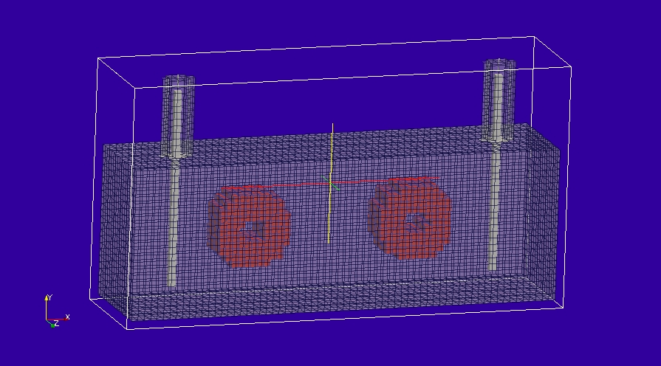

Material description
Three dielectric materials are used to build the filter model, they are all simple lossless dielectric materials with no loss. The relative permittivities are:
Air: ε_{r} = 1.0
ε_{r} = 2.4
ε_{r} = 38.0
Material files:
Air
# epsr=1.0 model i.e. air
0.0 1e8 # frequency range of validity
# permittivity filter
1.0e8 # wnormalisation constant
0 # a order
1.0 # a coefficients
0 # b order
1.0 # b coefficients
0.0 # electric conductivity
# permeability filter
1.0e8 # wnormalisation constant
0 # a order
1.0 # a coefficients
0 # b order
1.0 # b coefficients
0.0 # magnetic conductivity

ε_{r} = 2.4

# epsr=2.4 material model
0.0 1e8 # frequency range of validity
# permittivity filter
1.0e8 # wnormalisation constant
0 # a order
2.4 # a coefficients
0 # b order
1.0 # b coefficients
0.0 # electric conductivity
# permeability filter
1.0e8 # wnormalisation constant
0 # a order
1.0 # a coefficients
0 # b order
1.0 # b coefficients
0.0 # magnetic conductivity

ε_{r} = 38.0
# epsr=38.0 material model
0.0 1e8 # frequency range of validity
# permittivity filter
1.0e8 # wnormalisation constant
0 # a order
38.0 # a coefficients
0 # b order
1.0 # b coefficients
0.0 # electric conductivity
# permeability filter
1.0e8 # wnormalisation constant
0 # a order
1.0 # a coefficients
0 # b order
1.0 # b coefficients
0.0 # magnetic conductivity

Cable description
The cables are modelled as 0.1mm radius cylindrical wires.
cylindrical
1 # number of conductors
3 # NUMBER OF PARAMETERS
0.0001 # parameter 1: conductor radius
0.0001 # parameter 2: insulation radius
1.0 # parameter 3: permittivity of outer dielectric
0 # NUMBER OF FILTERS

Mesh:
68×37×18 cells

Excitation:
A gaussian voltage source is connected to the core wire of the cable at the source end of the cable

Output:
The core current at the centre of the cable and the field outside the coaxial cable.

Runtime:
0.1×10⁻⁶s (note this is too short a runtime for a good result, a runtime of 1×10⁻⁶s is really required.

Post processing:
Twoport process

Reference results:

GGI_TLM Input file:

# Two port filter

Mesh_outer_boundary_dimension
-0.001 0.067 -0.024 0.013 -0.001 0.017

Mesh_cell_dimension
0.001 # 1mm mesh

Outer_boundary_reflection_coefficient
0 0 0 0 0 0 # PEC outer boundary

Volume_list
7 Number of volumes
1 VOLUME_NUMBER
cylinder
0.00585 0.0056 # Dielectric ring 1
0.0 0.0 0.0
0.02045 -0.0115 0.008
2 VOLUME_NUMBER
cylinder
0.002 0.0056 # Centre free space volume ring 1
0.0 0.0 0.0
0.02045 -0.0115 0.008
3 VOLUME_NUMBER
cylinder
0.00585 0.0056 # Dielectric ring 2
0.0 0.0 0.0
0.04555 -0.0115 0.008
4 VOLUME_NUMBER
cylinder
0.002 0.0056 # Centre free space volume ring 2
0.0 0.0 0.0
0.04555 -0.0115 0.008
5 VOLUME_NUMBER
cylinder
0.002 0.012 # Coax feed 1 dielectric
90.0 0.0 0.0
0.0085 0.0065 0.008
6 VOLUME_NUMBER
cylinder
0.002 0.012 # Coax feed 2 dielectric
90.0 0.0 0.0
0.0585 0.0065 0.008
7 VOLUME_NUMBER
rectangular_block2
0.000 -0.023 0.0 0.066 0.000 0.016 # Field output volume
0.0 0.0 0.0
0.0 0.0 0.0

Volume_material_list
3 Number of volume materials
1 VOLUME MATERIAL NUMBER
DISPERSIVE
MATERIAL_DIRECTORY/epsr=38
2 number of volumes
1 3 volume list
2 VOLUME MATERIAL NUMBER
DISPERSIVE
MATERIAL_DIRECTORY/air
2 number of volumes
2 4 volume list
3 VOLUME MATERIAL NUMBER
DISPERSIVE
MATERIAL_DIRECTORY/epsr=2.4
2 number of volumes
5 6 volume list

Surface_list
8 Number of surfaces
1 SURFACE_NUMBER
rectangular_block2
0.000 -0.023 0.0 0.066 0.000 0.016 # Filter casing
0.0 0.0 0.0
0.0 0.0 0.0
2 SURFACE_NUMBER # Outer coax port 1
cylinder
0.002 0.012
90.0 0.0 0.0
0.0085 0.006 0.0085
3 SURFACE_NUMBER # Coax to filter connection port 1
circle
0.002
90.0 0.0 0.0
0.0085 0.00 0.0085
4 SURFACE_NUMBER # Inner coax port 1
cylinder
0.00065 0.030
90.0 0.0 0.0
0.0085 -0.005 0.0085
5 SURFACE_NUMBER # Outer coax port 2
cylinder
0.002 0.012
90.0 0.0 0.0
0.0585 0.006 0.0085
6 SURFACE_NUMBER # Coax to filter connection port 2
circle
0.002
90.0 0.0 0.0
0.0585 0.00 0.0085
7 SURFACE_NUMBER # Inner coax port 2
cylinder
0.00065 0.030
90.0 0.0 0.0
0.0585 -0.005 0.0085
8 SURFACE_NUMBER
zplane
0.000 -0.023 0.008 0.066 0.000 0.008 ! mode output surface
0.0 0.0 0.0
0.0 0.0 0.0

Surface_material_list
3 Number of surface materials
1 SURFACE MATERIAL NUMBER
PEC
3 number of surfaces
1 2 5 surface list
1 1 1 surface orientation list
2 SURFACE MATERIAL NUMBER
FREE_SPACE
2 number of surfaces
3 6 surface list
1 1 surface orientation list
3 SURFACE MATERIAL NUMBER
PEC
2 number of surfaces
4 7 surface list
1 1 surface orientation list

Line_list
2 Number of lines
1 LINE_NUMBER port 1 feed wire
straight_line2
0.008 0.010 0.008 0.008 0.012 0.008 line parameters
0.0 0.0 0.0
0.0 0.0 0.0
2 LINE_NUMBER port 2 feed wire
straight_line2
0.058 0.010 0.008 0.058 0.012 0.008 line parameters
0.0 0.0 0.0
0.0 0.0 0.0

Point_list
4 Number of points
1 POINT_NUMBER
0.008 0.010 0.008 point coordinates
0.0 0.0 0.0
0.0 0.0 0.0
2 POINT_NUMBER
0.008 0.012 0.008 point coordinates
0.0 0.0 0.0
0.0 0.0 0.0
3 POINT_NUMBER
0.058 0.010 0.008 point coordinates
0.0 0.0 0.0
0.0 0.0 0.0
4 POINT_NUMBER
0.058 0.012 0.008 point coordinates
0.0 0.0 0.0
0.0 0.0 0.0

Cable_geometry_list
1 number of cable geometries
1 CABLE GEOMETRY NUMBER, Cable geometry type (file name) follows:
CABLE_DIRECTORY/0.1mm_single_wire

Cable_list
2 number of cables
1 CABLE NUMBER
1 cable geometry number
1 number of lines on cable route
1 cable line list
1 end 1 junction number
2 end 2 junction number
2 CABLE NUMBER
1 cable geometry number
1 number of lines on cable route
2 cable line list
3 end 1 junction number
4 end 2 junction number

Cable_output_list
2 number of cable_outputs
1 CABLE OUTPUT NUMBER
1 cable number
2 closest point number
2 CABLE OUTPUT NUMBER
2 cable number
4 closest point number

Cable_junction_list
4 number of junctions
1 JUNCTION NUMBER
1 junction point
1 number of internal connection nodes (n_int)
1 number of cables
1 cable list
1 corresponding cable end number list
1 Cable 1 number of external conductors (n_ext)
1 Cable 1 P matrix: matrix (n_int rows* n_ext columns)
0 Cable 1 voltage function source list
0.0 Cable 1 impedance list
0 Number of internal impedances
FACE
-1 boundary condition (-1 indicates V=0 i.e. connection to a surface)
2 JUNCTION NUMBER
2 junction point
1 number of internal connection nodes (n_int)
1 number of cables
1 cable list
2 corresponding cable end number list
1 Cable 1 number of external conductors (n_ext)
1 Cable 1 P matrix: matrix (n_int rows* n_ext columns)
1 Cable 1 voltage function source list
50.0 Cable 1 impedance list
0 Number of internal impedances
FACE
-1 boundary condition (-1 indicates V=0 i.e. connection to a surface)
3 JUNCTION NUMBER
3 junction point
1 number of internal connection nodes (n_int)
1 number of cables
2 cable list
1 corresponding cable end number list
1 Cable 1 number of external conductors (n_ext)
1 Cable 1 P matrix: matrix (n_int rows* n_ext columns)
0 Cable 1 voltage function source list
0.0 Cable 1 impedance list
0 Number of internal impedances
FACE
-1 boundary condition (-1 indicates V=0 i.e. connection to a surface)
4 JUNCTION NUMBER
4 junction point
1 number of internal connection nodes (n_int)
1 number of cables
2 cable list
2 corresponding cable end number list
1 Cable 1 number of external conductors (n_ext)
1 Cable 1 P matrix: matrix (n_int rows* n_ext columns)
0 Cable 1 voltage function source list
50.0 Cable 1 impedance list
0 Number of internal impedances
FACE
-1 boundary condition (-1 indicates V=0 i.e. connection to a surface)

Excitation_function_list
1 number of excitation functions
1 EXCITATION FUNCTION NUMBER
gaussian
1.0 5e-11 20e-11

Frequency_output_surface_list
4 ! number of Frequency output surfaces
1 ! FREQUENCY OUTPUT SURFACE NUMBER
8 surface number
1 ! side of surface for output (+1 or -1)
4.51e9 frequency for output
Ex
2 ! FREQUENCY OUTPUT SURFACE NUMBER
8 surface number
1 ! side of surface for output (+1 or -1)
4.51e9 frequency for output
Ey
3 ! FREQUENCY OUTPUT SURFACE NUMBER
8 surface number
1 ! side of surface for output (+1 or -1)
3.88e9 frequency for output
Ex
4 ! FREQUENCY OUTPUT SURFACE NUMBER
8 surface number
1 ! side of surface for output (+1 or -1)
3.88e9 frequency for output
Ey

Frequency_output_volume_list
3 ! number of Frequency output volumes
1 ! FREQUENCY OUTPUT VOLUME NUMBER
7 volume number
4.51e9 frequency for output
Ex
2 ! FREQUENCY OUTPUT VOLUME NUMBER
7 volume number
4.51e9 frequency for output
Ey
3 ! FREQUENCY OUTPUT VOLUME NUMBER
7 volume number
4.51e9 frequency for output
Ez

Simulation_time
1e-7 # this is a short runtime for testing, we should really run for 1e-6s to get a good result.

GI_TLM result:
