Cable test

Geometry description:
This test case consists of a number of different cables running through the problem space in close proximity. The test case exercises the automatic creation of junctions and terminations in situations where separately defined cables are ‘snapped’ together into the same cell. The problem mesh is shown in the figure below.
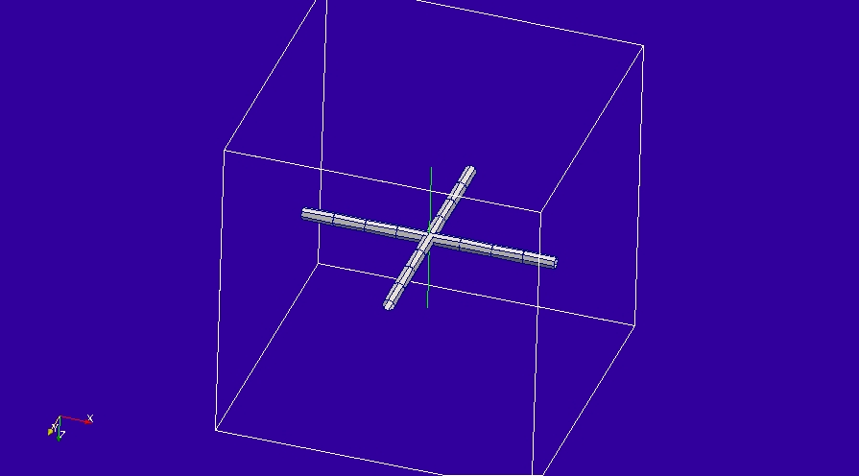

Cable description
The cable is a simple cylindrical cable with radius 1mm.
Cable file:
cylindrical
1 # number of conductors
3 # NUMBER OF PARAMETERS
0.001 # parameter 1: conductor radius
0.002 # parameter 2: insulation radius
1.0 # parameter 3: permittivity of outer dielectric
0 # NUMBER OF FILTERS

Mesh:
5×5×5 cells

Excitation:
A gaussian voltage source is connected to the core wire of the cable at the source end of the cable

Output:
The core current at the centre of the cable and the field outside the coaxial cable.

Runtime:
0.2×10⁻⁶s

Post processing:

Reference results:

GGI_TLM Input file:

# Define the problem space
Mesh_outer_boundary_dimension
-2.5 2.5 -2.5 2.5 -2.5 2.5

# Specify the mesh cell dimension
Mesh_cell_dimension
1.0 ( 3*integer)

#specify the outer boundary conditions (6*real)
Outer_boundary_reflection_coefficient
0.0 0.0 0.0 0.0 0.0 0.0

# Define the geometrical entities, 3D volumes, 2D surfaces, 1D lines. Note the ability to import
#geometry from a file means that this is a fairly general format for geometry specification

#line list designed to test the setup of cable models
Line_list
4 Number of lines (integer)
1 LINE_NUMBER (integer)
straight_line2
-2 0 0 2 0 0 line parameters (n*real)
0.0 0.0 0.0
0.0 0.0 0.0
2 LINE_NUMBER (integer)
straight_line2
0 -2 0 0 2 0 line parameters (n*real)
0.0 0.0 0.0
0.0 0.0 0.0
3 LINE_NUMBER (integer)
straight_line2
-1 0 0 2 0 0 line parameters (n*real)
0.0 0.0 0.0
0.0 0.0 0.0
4 LINE_NUMBER (integer)
straight_line2
-1 0 0 -2 0 0 line parameters (n*real)
0.0 0.0 0.0
0.0 0.0 0.0

Point_list
6 Number of points (integer)
1 POINT_NUMBER (integer)
-2 0 0 point coordinates (n*real)
0.0 0.0 0.0
0.0 0.0 0.0
2 POINT_NUMBER (integer)
2 0 0 point coordinates (n*real)
0.0 0.0 0.0
0.0 0.0 0.0
3 POINT_NUMBER (integer)
0 -2 0 point coordinates (n*real)
0.0 0.0 0.0
0.0 0.0 0.0
4 POINT_NUMBER (integer)
0 2 0 point coordinates (n*real)
0.0 0.0 0.0
0.0 0.0 0.0
5 POINT_NUMBER (integer)
-1 0 0 point coordinates (n*real)
0.0 0.0 0.0
0.0 0.0 0.0
6 POINT_NUMBER (integer)
-1 0 -1 point coordinates (n*real)
0.0 0.0 0.0
0.0 0.0 0.0

Cable_geometry_list
1 number of cable geometries
1 cable geometry number, Cable geometry type (file name) follows:
/home/chris/SOFTWARE/GGI_TLM/TEST_DATA/CABLE_DATA/1mm_single_wire

Cable_list
5 number of cables
1 CABLE NUMBER
1 cable geometry number
1 number of lines on cable route
1 cable line list
1 end 1 junction number
2 end 2 junction number
2 CABLE NUMBER
1 cable geometry number
1 number of lines on cable route
3 cable line list
3 end 1 junction number
2 end 2 junction number
3 CABLE NUMBER
1 cable geometry number
1 number of lines on cable route
4 cable line list
3 end 1 junction number
1 end 2 junction number
4 CABLE NUMBER
1 cable geometry number
1 number of lines on cable route
1 cable line list
4 end 1 junction number
5 end 2 junction number
5 CABLE NUMBER
1 cable geometry number
1 number of lines on cable route
2 cable line list
6 end 1 junction number
7 end 2 junction number

Cable_output_list
1 number of cable_outputs
1 CABLE OUTPUT NUMBER
1 cable number
1 closest point number

Cable_junction_list
7 number of junctions
1 JUNCTION NUMBER
1 junction point
1 number of internal connection nodes (n_int)
2 number of cables
1 3 cable list
1 2 corresponding cable end number list
1 Cable 1 number of external conductors (n_ext)
1 Cable 1 P matrix: matrix (n_int rows* n_ext columns)
0 Cable 1 voltage function source list
0.0 Cable 1 impedance list
1 Cable 3 number of external conductors (n_ext)
1 Cable 3 P matrix: matrix (n_int rows* n_ext columns)
0 Cable 3 voltage function source list
0.0 Cable 3 impedance list
0 Number of internal impedances
2 JUNCTION NUMBER
2 junction point
1 number of internal connection nodes (n_int)
2 number of cables
1 2 cable list
2 2 corresponding cable end number list
1 Cable 1 number of external conductors (n_ext)
1 Cable 1 P matrix: matrix (n_int rows* n_ext columns)
0 Cable 1 voltage function source list
0.0 Cable 1 impedance list
1 Cable 2 number of external conductors (n_ext)
1 Cable 2 P matrix: matrix (n_int rows* n_ext columns)
0 Cable 2 voltage function source list
0.0 Cable 2 impedance list
0 Number of internal impedances
3 JUNCTION NUMBER
5 junction point
1 number of internal connection nodes (n_int)
2 number of cables
2 3 cable list
1 1 corresponding cable end number list
1 Cable 2 number of external conductors (n_ext)
1 Cable 2 P matrix: matrix (n_int rows* n_ext columns)
0 Cable 2 voltage function source list
0.0 Cable 2 impedance list
1 Cable 3 number of external conductors (n_ext)
1 Cable 3 P matrix: matrix (n_int rows* n_ext columns)
1 Cable 3 voltage function source list
100.0 Cable 3 impedance list
0 Number of internal impedances
4 JUNCTION NUMBER
1 junction point
1 number of internal connection nodes (n_int)
1 number of cables
4 cable list
1 corresponding cable end number list
1 Cable 4 number of external conductors (n_ext)
1 Cable 4 P matrix: matrix (n_int rows* n_ext columns)
0 Cable 4 voltage function source list
0.0 Cable 4 impedance list
0 Number of internal impedances
5 JUNCTION NUMBER
2 junction point
1 number of internal connection nodes (n_int)
1 number of cables
4 cable list
2 corresponding cable end number list
1 Cable 4 number of external conductors (n_ext)
1 Cable 4 P matrix: matrix (n_int rows* n_ext columns)
0 Cable 4 voltage function source list
0.0 Cable 4 impedance list
0 Number of internal impedances
6 JUNCTION NUMBER
3 junction point
1 number of internal connection nodes (n_int)
1 number of cables
5 cable list
1 corresponding cable end number list
1 Cable 5 number of external conductors (n_ext)
1 Cable 5 P matrix: matrix (n_int rows* n_ext columns)
0 Cable 5 voltage function source list
0.0 Cable 5 impedance list
0 Number of internal impedances
7 JUNCTION NUMBER
4 junction point
1 number of internal connection nodes (n_int)
1 number of cables
5 cable list
2 corresponding cable end number list
1 Cable 5 number of external conductors (n_ext)
1 Cable 5 P matrix: matrix (n_int rows* n_ext columns)
0 Cable 5 voltage function source list
0.0 Cable 5 impedance list
0 Number of internal impedances

Excitation_function_list
1 ! number of excitation functions
1 ! EXCITATION NUMBER
step
1.0 0.0

Output_point_list
1 ! number of output points
1 ! OUTPUT NUMBER
6 ! output point
Ez
centre
output_timestep_information
1 ! first output timestep
2000 ! last output timestep
1 ! output timestep interval

Simulation_time
200e-8

GI_TLM result:
