Material Test

Geometry description:
A combination of four volume material blocks and four surface materials. This is used as a quick validation test case for any changes in the material modelling aspects of GGI_TLM. The meshed geometry is shown in the figure below.
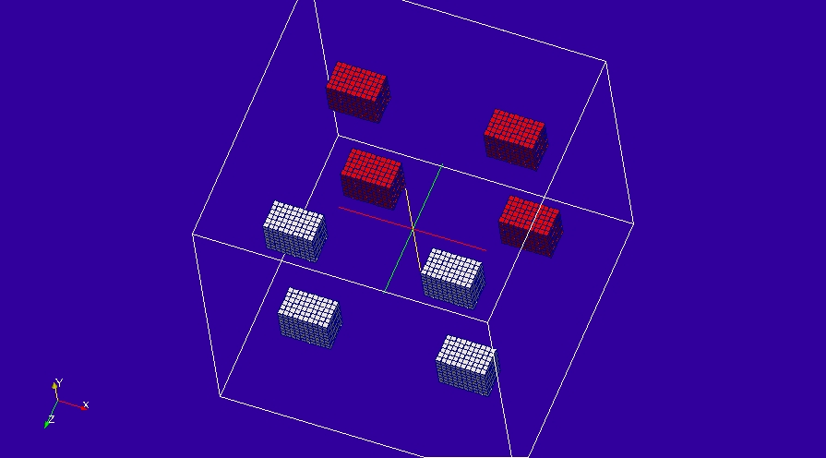

Material description:
Two volume materials.
Debye material:
# debye dielectric model
0.0 1e8 # frequency range of validity
# permittivity filter
1.0e8 # wnormalisation constant
1 # a order
4.0 0.75 # a coefficients
1 # b order
1.0 0.50 # b coefficients
1.0 # electric conductivity
# permeability filter
1.0e8 # wnormalisation constant
1 # a order
3.0 0.85 # a coefficients
1 # b order
1.0 0.45 # b coefficients
10000.0 # magnetic conductivity

Constant permittivity material:

# epsr=1.5 model
0.0 1e8 # frequency range of validity
# permittivity filter
1.0e8 # wnormalisation constant
0 # a order
1.5 # a coefficients
0 # b order
1.0 # b coefficients
0.0 # electric conductivity
# permeability filter
1.0e8 # wnormalisation constant
0 # a order
1.0 # a coefficients
0 # b order
1.0 # b coefficients
0.0 # magnetic conductivity

Surface materials.
1: PEC
2: Dispersive sheet.
# Sheet resistance 377 ohms/square
0.0 1e8 # frequency range of validity
# Z11 filter
1.0e8 # wnormalisation constant
1 # a order
377.0 100.0 # a coefficients
1 # b order
1.0 0.750 # b coefficients
# Z12 filter
1.0e8 # wnormalisation constant
1 # a order
377.0 100.0 # a coefficients
1 # b order
1.0 0.750 # b coefficients
# Z21 filter
1.0e8 # wnormalisation constant
1 # a order
377.0 100.0 # a coefficients
1 # b order
1.0 0.750 # b coefficients
# Z22 filter
1.0e8 # wnormalisation constant
1 # a order
377.0 100.0 # a coefficients
1 # b order
1.0 0.750 # b coefficients

Mesh:
60×60×60

Excitation:
Impulse E field excitation at a point in space

Output:
Electric field at a point in space

Runtime:
70ns

Other Notes:

Post processing:
None

GGI_TLM Input file:

Mesh_outer_boundary_dimension
-3.0 3.0 -3.0 3.0 -3.0 3.0

Mesh_dimensions_in_cells
60 60 60 ( 3*integer)

Outer_boundary_reflection_coefficient
0.0 0.0 0.0 0.0 0.0 0.0

volume_list
4 Number of volumes (integer)
1 volume_number (integer)
rectangular_block
1.0 0.8 0.6 volume parameters (n*real)
0.0 0.0 0.0
-1.6 -1.6 -1.6
2 volume_number (integer)
rectangular_block
1.0 0.8 0.6 volume parameters (n*real)
0.0 0.0 0.0
-1.6 1.6 -1.6
3 volume_number (integer)
rectangular_block
1.0 0.8 0.6 volume parameters (n*real)
0.0 0.0 0.0
1.6 1.6 -1.6
4 volume_number (integer)
rectangular_block
1.0 0.8 0.6 volume parameters (n*real)
0.0 0.0 0.0
1.6 -1.6 -1.6

Surface_list
4 Number of surfaces (integer)
1 surface_number (integer)
rectangular_block
1.0 0.8 0.6 volume parameters (n*real)
0.0 0.0 0.0
-1.6 -1.6 1.6
2 surface_number (integer)
rectangular_block
1.0 0.8 0.6 volume parameters (n*real)
0.0 0.0 0.0
-1.6 1.6 1.6
3 surface_number (integer)
rectangular_block
1.0 0.8 0.6 volume parameters (n*real)
0.0 0.0 0.0
1.6 1.6 1.6
4 surface_number (integer)
rectangular_block
1.0 0.8 0.6 volume parameters (n*real)
0.0 0.0 0.0
1.6 -1.6 1.6

Point_list
2 Number of points (integer)
1 point_number (integer)
1.0 1.0 1.0 point coordinates (n*real)
0.0 0.0 0.0
0.0 0.0 0.0
2 point_number (integer)
-1.0 -1.0 -1.0 point coordinates (n*real)
0.0 0.0 0.0
0.0 0.0 0.0

volume_material_list
2 Number of volume materials (integer)
1 volume MATERIAL NUMBER
Dispersive
MATERIAL_DIRECTORY/epsr=1.5
2 number of volumes
1 3 volume list
2 volume MATERIAL NUMBER
Dispersive
MATERIAL_DIRECTORY/debye_1
2 number of volumes
2 4 volume list

Surface_material_list
2 Number of surface materials (integer)
1 SURFACE MATERIAL NUMBER
PEC
1 number of surfaces
3 surface list
1 surface orientation list
2 SURFACE MATERIAL NUMBER
Dispersive
MATERIAL_DIRECTORY/Dispersive_sheet
3 number of surfaces
1 2 4 surface list
1 1 1 surface orientation list

Excitation_function_list
1 ! number of excitations
1 ! EXCITATION NUMBER
impulse
1.0

Excitation_point_list
1 ! number of output points
1 ! EXCITATION POINT NUMBER
1 ! excitation function number
2 ! excitation point
Ex
centre
soft

Output_point_list
1 ! number of output points
1 ! OUTPUT NUMBER
1 ! output point
Ex
centre
output_timestep_information
1 ! first output timestep
200 ! last output timestep
1 ! output timestep interval

Simulation_time
7e-8

GGI_TLM result with reference
