Nested_Mode Stirred Chamber

Geometry description:
Mode stirred chamber with inner chamber defined. The inner chamber has a rectangular aperture. This test case exercises the mode stirred boundary conditions – making the aperture open (Rsheet=1e8 material) links the two chambers.
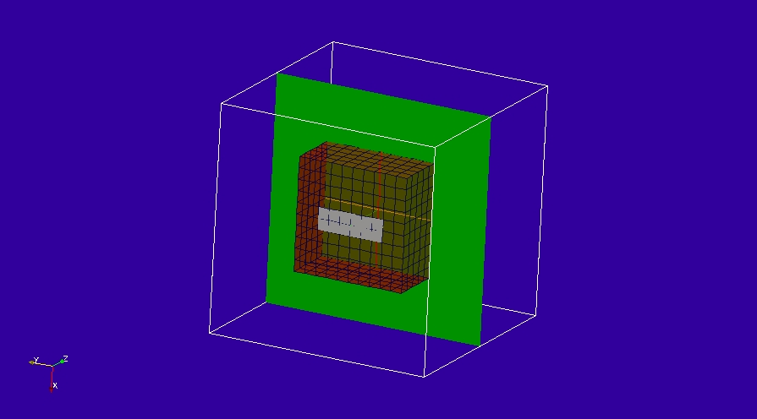

Material description:
PEC and free space materials only

Mesh:
Δl=0.1m

Excitation:
Random excitation on inner mode stirred boundary

Output:
Field at a point and over a surface ( for field animation)

Runtime:
0.05µs

Other Notes:

Post processing:
Fourier Transform the time domain field.

Reference results:

GGI_TLM Input file:
# Nested reverberation chamber for aperture shielding effectiveness calculation

Mesh_outer_boundary_dimension
-1.0 1.0 -1.0 1.0 -1.0 1.0

Mesh_cell_dimension
0.10

Outer_boundary_reflection_coefficient
-1.0 -1.0 -1.0 -1.0 -1.0 -1.0

Surface_list
3 Number of surfaces (integer)
1 surface_number (integer) ! inner mode stirred chamber
rectangular_block2
-0.5 -0.5 -0.5 0.5 0.5 0.5 surface parameters (n*real)
0.0 0.0 0.0
0.0 0.0 0.0
2 surface_number (integer) ! slot in PEC surface
rectangle
0.15 0.60 surface parameters (n*real)
0.0 0.0 0.0
0.0 0.0 -0.5
3 surface_number (integer) ! field output surface
rectangle
2.1 2.1 surface parameters (n*real)
0.0 0.0 0.0
0.0 0.0 0.0

Surface_material_list
2 Number of surface materials (integer)
1 SURFACE_MATERIAL_NUMBER
PEC
1 number of surfaces
1 surface list
1 surface orinetation list
2 SURFACE_MATERIAL_NUMBER
DISPERSIVE
/home/chris/SOFTWARE/GGI_TLM/TEST_DATA/MATERIAL_DATA/Rsheet=1e8
1 number of surfaces
2 surface list
1 surface orinetation list

Point_list
1 Number of points (integer)
1 POINT_NUMBER (integer)
0.0 0.0 0.0 excitation point coordinates (cell 3 6 17)
0.0 0.0 0.0
0.0 0.0 0.0

Mode_stir_surface_list
2 Number of mode_stir_surfaces (integer)
1 MODE_STIR_SURFACE NUMBER
0.999 ! boundary condition voltage reflection coefficient
0.0 ! amplitude of random impulse excitation on the boundary
1 ! number of geometric surfaces in this mode_stir_surface
0 ! surface list
1 ! surface orientation list
2 MODE_STIR_SURFACE NUMBER
0.999 ! boundary condition voltage reflection coefficient
1.0 ! amplitude of random impulse excitation on the boundary
1 ! number of geometric surfaces in this mode_stir_surface
1 ! surface list - surface 0 is the outer boundary
-1 ! surface orientation list

Excitation_function_list
1 ! number of excitation functions
1 EXCITATION FUNCTION NUMBER
gaussian_sinusoid
1.0 5e-9 2e-8 2.5e8 0.0

Output_point_list
1 ! number of output points
1 ! OUTPUT NUMBER
1 ! output point
Ey
centre

Output_surface_list
1 ! number of output surfaces
1 ! OUTPUT SURFACE NUMBER
3 surface number
1 ! side of surface for output (+1 or -1)
Ex
output_timestep_information
0 ! first output timestep
200 ! last output timestep
5 ! output timestep interval

Simulation_time
0.5e-7

GGI_TLM result
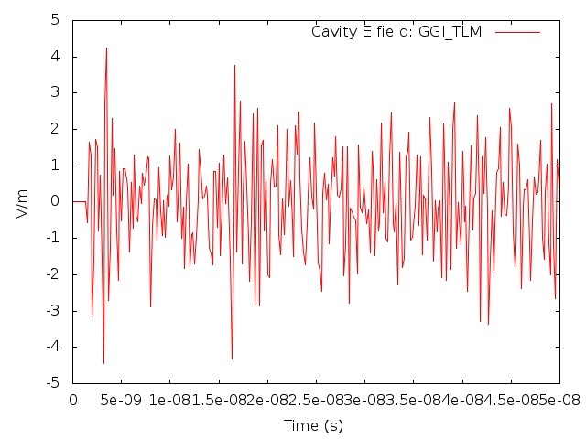
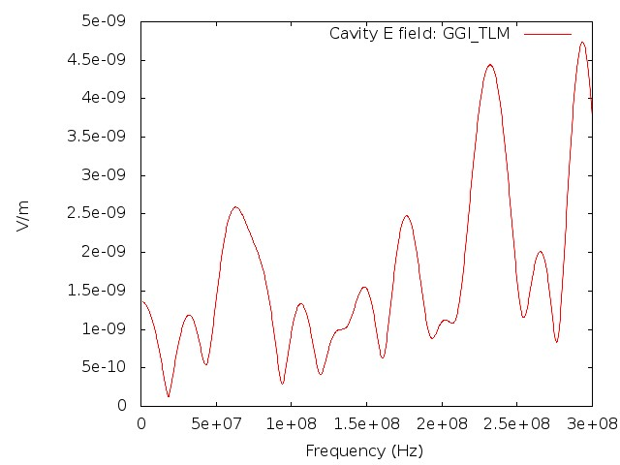
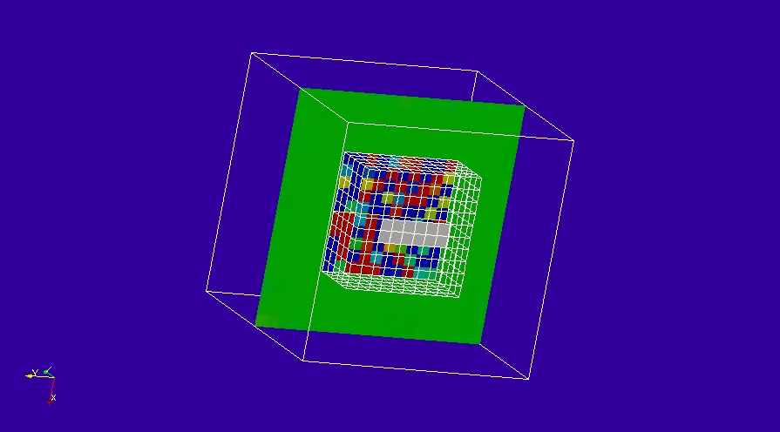
Field early in the simulation (field confined to inner chamber)
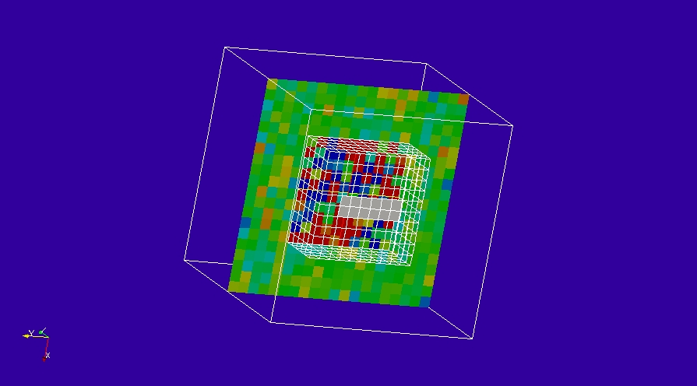
Field later in the simulation (field in both chambers)

