Power Calculations

Geometry description:

The problem space contains an internal Huygens surface for launching (and absorbing) an impulse plane wave. Frequency domain power through a surface is calculated and also post processed in order to calculate transmission cross section of the surface. The results may be compared with analytic solution in this case.
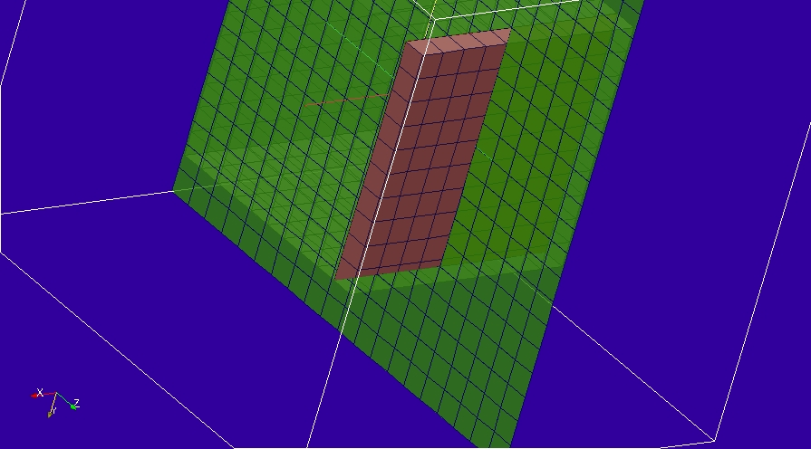

Material description:

Mesh:
Δl=0.1m

Excitation:
Impulse plane wave launched from a Huygens surface within the problem space

Output:
E field at a point, E field over a surface and power through a surface over a range of frequencies.

Runtime:
0.05µs

Other Notes:

Post processing:

Reference results:

GGI_TLM Input file:
# Power calculations

Mesh_outer_boundary_dimension
-1.0 1.0 -1.0 1.0 -1.0 1.0

Mesh_cell_dimension
0.10

Outer_boundary_reflection_coefficient
0.0 0.0 0.0 0.0 0.0 0.0

Surface_list
3 Number of surfaces (integer)
1 surface_number (integer) ! huygens surface
rectangular_block2
-0.5 -0.5 -0.5 0.5 0.5 0.5 surface parameters (n*real)
0.0 0.0 0.0
0.0 0.0 0.0
2 surface_number (integer) ! power calculation surface
rectangle
1.0 1.0 surface parameters (n*real)
0.0 0.0 0.0
0.0 0.0 0.4
3 surface_number (integer) ! field output surface
rectangle
2.0 2.0 surface parameters (n*real)
0.0 90.0 0.0
0.0 0.0 0.0

Point_list
1 Number of points (integer)
1 POINT_NUMBER (integer)
0.0 0.0 0.0 output point coordinates
0.0 0.0 0.0
0.0 0.0 0.0

Excitation_function_list
1 ! number of excitation functions
1 EXCITATION FUNCTION NUMBER
impulse
1.0

Huygens_surface
0 surface number
1 excitation function number
0.0 0.0 wave vector Theta and Phi
0.7071 0.7071 Polarisation theta and Phi

Output_point_list
1 ! number of output points
1 ! OUTPUT NUMBER
1 ! output point
Ex
zmax

Output_surface_list
1 ! number of output surfaces
1 ! OUTPUT SURFACE NUMBER
3 surface number
1 ! side of surface for output (+1 or -1)
Ex
output_timestep_information
0 ! first output timestep
200 ! last output timestep
5 ! output timestep interval

Frequency_domain_power_surface_list
1 ! number of frequency domain power surfaces
1 ! FREQUENCY DOMAIN POWER SURFACE NUMBER
2 ! geometric surface number
1 ! side of surface for output
1e6 600e6 100 ! fmin fmax n_frequencies for power output

Simulation_time
0.5e-7

GGI_TLM result
