Sphere Surface Output

Geometry description:
1.5m radius sphere in a 4m×4m×4m problem space.
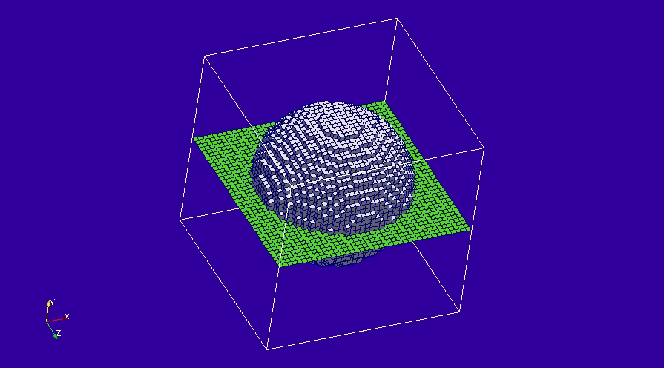

Material description:
The sphere is PEC

Mesh:
Δl=1m

Excitation:
Gaussian plane wave launched from the edge of the problem space.

Output:
E field at a point outside the sphere and Hy, |J| on the sphere outer surface

Runtime:
20ns

Other Notes:

Post processing:

Reference results:

GGI_TLM Input file:
Mesh_outer_boundary_dimension
-2.0 2.0 -2.0 2.0 -2.0 2.0

Mesh_dimensions_in_cells
40 40 40 ( 3*integer)

Outer_boundary_reflection_coefficient
0.0 0.0 0.0 0.0 0.0 0.0

Surface_list
2 Number of surfaces (integer)
1 SURFACE_NUMBER
sphere
1.5 surface parameters (n*real)
0.0 0.0 0.0
0.0 0.0 0.0
2 SURFACE_NUMBER
rectangle
4.0 4.0 surface parameters (n*real)
90.0 0.0 0.0
0.0 0.0 0.0

Point_list
1 Number of points (integer)
1 point_number (integer)
1.0 1.0 1.0 point coordinates (n*real)
0.0 0.0 0.0
0.0 0.0 0.0

Surface_material_list
1 Number of surface materials (integer)
1 SURFACE MATERIAL NUMBER
PEC
1 number of surfaces
1 surface list
1 surface orientation list

#Surface_material_list
1 Number of surface materials (integer)
1 SURFACE MATERIAL NUMBER
Dispersive
MATERIAL_DIRECTORY/Rsheet=10
1 number of surfaces
1 surface list
1 surface orientation list

Excitation_function_list
1 ! number of excitations
1 ! EXCITATION NUMBER
gaussian
1.0 1e-9 3e-9

Huygens_surface
0 surface number
1 excitation function number
0.0 0.0 wave vector Theta and Phi
1.0 0.0 Polarisation theta and Phi

Output_point_list
1 ! number of output points
1 ! OUTPUT NUMBER
1 ! output point
Ex
centre
output_timestep_information
1 ! first output timestep
200 ! last output timestep
1 ! output timestep interval

Output_surface_list
2 ! number of output surfaces
1 ! OUTPUT SURFACE NUMBER
1 surface number
1 ! side of surface for output (+1 or -1)
Hy
output_timestep_information
0 ! first output timestep
200 ! last output timestep
5 ! output timestep interval
2 ! OUTPUT SURFACE NUMBER
1 surface number
1 ! side of surface for output (+1 or -1)
Jmagnitude
output_timestep_information
0 ! first output timestep
200 ! last output timestep
5 ! output timestep interval

Simulation_time
2e-8

GGI_TLM result
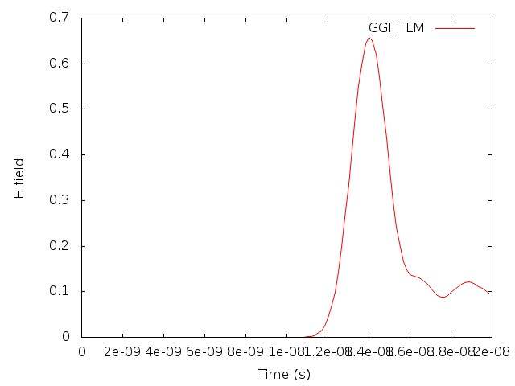
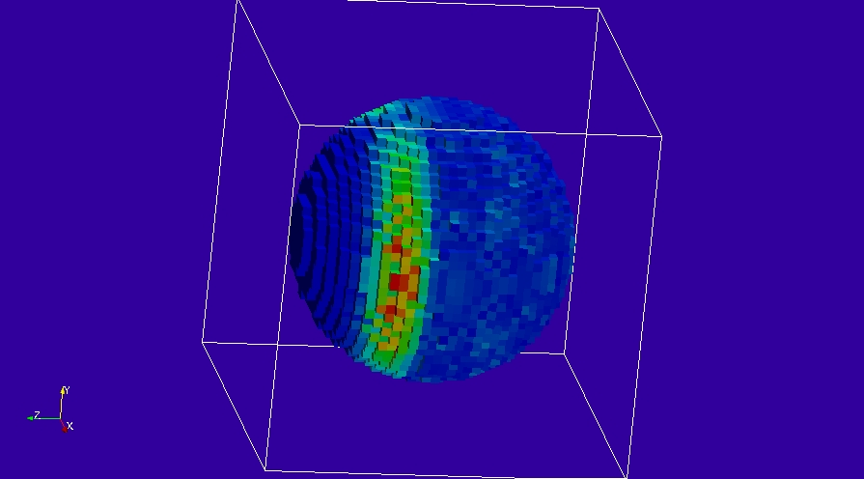
Surface output 1, Hy.
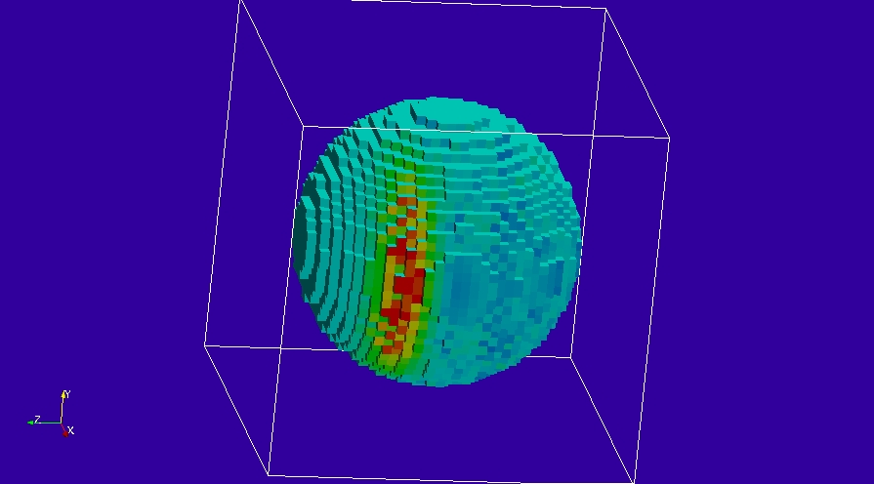
Surface output 2 |J|

