York box with straight wire including frequency warping process

Geometry description:
The box is made of conducting material (brass), it has one open face to allow control of the cavity Q factor and also to allow plane wave illumination of the interior. The top face has three N type connectors to ports A, B and C (see figure) to which a network analyser may be connected on the outside. In the validation test described here, port C is connected to a 42mm long monopole. Ports A and B are connected via a wire, the wire extends 22mm vertically down from port A, then extends horizontally to below port B before extending 22mm up to connect to the port. All wire diameters are 3mm and each port is matched to 50Ω.
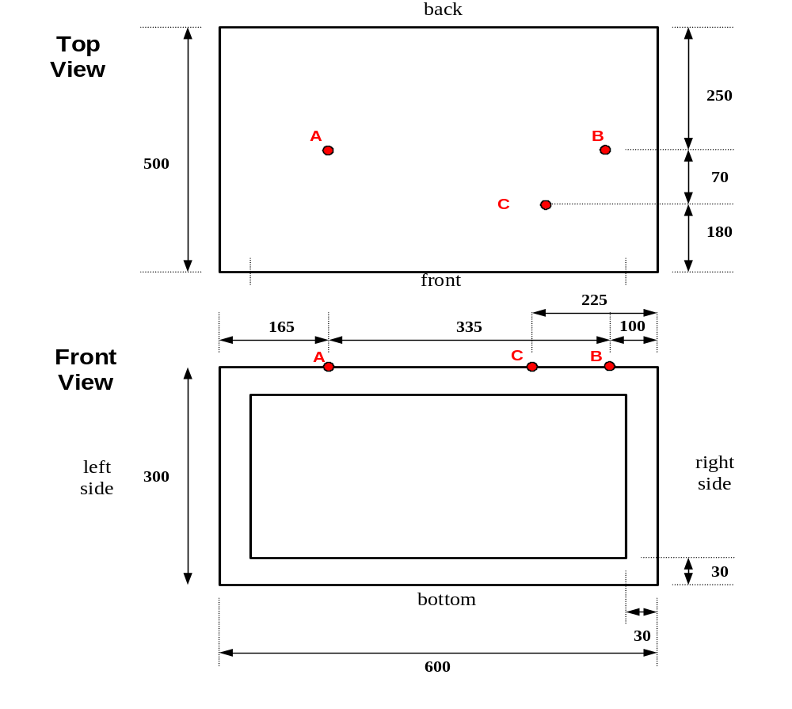
z
y

x

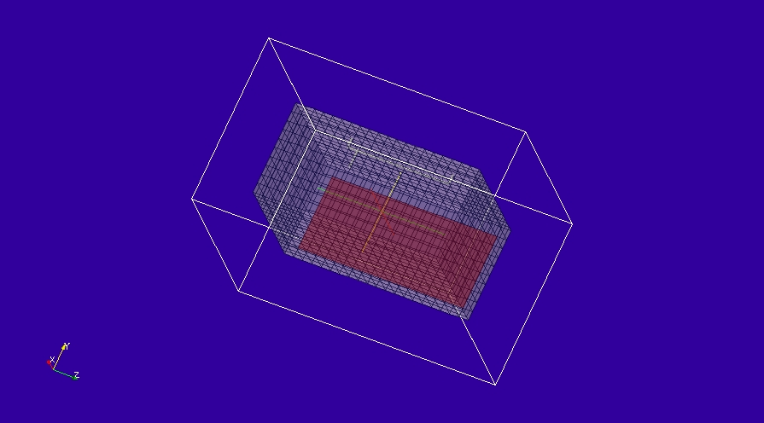
This test case tests the frequency warping post processing procedure.

Material description:
The box surfaces are modelled as PEC, the aperture is closed by a surface with sheet resistance of 1000Ω/.

Mesh:

Δl=3cm

Excitation:
Voltage source on the wire segment where the monopole connects to the box surface (port C)

Output:
Wire current on port A, wire voltage source function applied to port C.

Runtime:
0.25µs

Post processing:
Fourier transform the current on port A and the voltage source function applied to port C.
Calculate S21 as
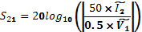
Where ~ denotes Fourier Transformed quantities.

Results are presented with the normal Fourier transform process from 0 to 6GHz and also with bicubic frequency warping from 0 to 6GHz.

Reference results:
Reference results take the form of measured S parameter results from the University of York.

GGI_M Input file:
# York box with straight wire - 3cm mesh and 1cm mesh for frequency warping tests

Mesh_outer_boundary_dimension
-0.36 0.36 -0.27 0.27 -0.42 0.42

Mesh_cell_dimension
0.03

Outer_boundary_reflection_coefficient
0.0 0.0 0.0 0.0 0.0 0.0

Surface_list
2 Number of surfaces
1 SURFACE_NUMBER
rectangular_block2
-0.24 -0.15 -0.30 0.24 0.15 0.30 surface parameters ! box
0.0 0.0 0.0
0.0 0.0 0.0
2 SURFACE_NUMBER
xplane
-0.24 -0.12 -0.27 -0.24 0.12 0.27 surface parameters ! front face material panel
0.0 0.0 0.0
0.0 0.0 0.0

Surface_material_list
2 Number of surface materials
1 SURFACE MATERIAL NUMBER
PEC
1 number of surfaces
1 surface list
1 surface orientation list
2 SURFACE MATERIAL NUMBER
DISPERSIVE
MATERIAL_DIRECTORY/Rsheet=1000
1 number of surfaces
2 surface list
1 surface orientation list

Line_list
4 Number of lines
1 LINE_NUMBER port C monopole
straight_line2
-0.045 0.15 -0.165 -0.045 0.105 -0.165 line parameters
0.0 0.0 0.0
0.0 0.0 0.0
2 LINE_NUMBER port A
straight_line2
0.045 0.15 -0.165 0.045 0.135 -0.165 line parameters
0.0 0.0 0.0
0.0 0.0 0.0
3 LINE_NUMBER
straight_line2
0.045 0.135 -0.165 0.045 0.135 0.165 line parameters
0.0 0.0 0.0
0.0 0.0 0.0
4 LINE_NUMBER port B
straight_line2
0.045 0.135 0.165 0.045 0.15 0.165 line parameters
0.0 0.0 0.0
0.0 0.0 0.0

Point_list
4 Number of points
1 POINT_NUMBER
-0.045 0.15 -0.165 point coordinates
0.0 0.0 0.0
0.0 0.0 0.0
2 POINT_NUMBER
-0.045 0.105 -0.165 point coordinates
0.0 0.0 0.0
0.0 0.0 0.0
3 POINT_NUMBER
0.045 0.15 -0.165 point coordinates
0.0 0.0 0.0
0.0 0.0 0.0
4 POINT_NUMBER
0.045 0.15 0.165 point coordinates
0.0 0.0 0.0
0.0 0.0 0.0

Cable_geometry_list
1 number of cable geometries
1 CABLE GEOMETRY NUMBER, Cable geometry type (file name) follows:
CABLE_DIRECTORY/0.5mm_single_wire

Cable_list
2 number of cables
1 CABLE NUMBER
1 cable geometry number
1 number of lines on cable route
1 cable line list
1 end 1 junction number
2 end 2 junction number
2 CABLE NUMBER
1 cable geometry number
3 number of lines on cable route
2 3 4 cable line list
3 end 1 junction number
4 end 2 junction number

Cable_output_list
1 number of cable_outputs
1 CABLE OUTPUT NUMBER
2 cable number
3 closest point number

Cable_junction_list
4 number of junctions
1 JUNCTION NUMBER
1 junction point
1 number of internal connection nodes (n_int)
1 number of cables
1 cable list
1 corresponding cable end number list
1 Cable 1 number of external conductors (n_ext)
1 Cable 1 P matrix: matrix (n_int rows* n_ext columns)
1 Cable 1 voltage function source list
50.0 Cable 1 impedance list
0 Number of internal impedances
FACE
-1 boundary condition (-1 indicates V=0 i.e. connection to a surface)
2 JUNCTION NUMBER
2 junction point
1 number of internal connection nodes (n_int)
1 number of cables
1 cable list
2 corresponding cable end number list
1 Cable 1 number of external conductors (n_ext)
1 Cable 1 P matrix: matrix (n_int rows* n_ext columns)
0 Cable 1 voltage function source list
0.0 Cable 1 impedance list
0 Number of internal impedances
3 JUNCTION NUMBER
3 junction point
1 number of internal connection nodes (n_int)
1 number of cables
2 cable list
1 corresponding cable end number list
1 Cable 1 number of external conductors (n_ext)
1 Cable 1 P matrix: matrix (n_int rows* n_ext columns)
0 Cable 1 voltage function source list
50.0 Cable 1 impedance list
0 Number of internal impedances
FACE
-1 boundary condition (-1 indicates V=0 i.e. connection to a surface)
4 JUNCTION NUMBER
4 junction point
1 number of internal connection nodes (n_int)
1 number of cables
2 cable list
2 corresponding cable end number list
1 Cable 1 number of external conductors (n_ext)
1 Cable 1 P matrix: matrix (n_int rows* n_ext columns)
0 Cable 1 voltage function source list
50.0 Cable 1 impedance list
0 Number of internal impedances
FACE
-1 boundary condition (-1 indicates V=0 i.e. connection to a surface)

Excitation_function_list
1 number of excitation functions
1 EXCITATION FUNCTION NUMBER
gaussian
1.0 5e-11 20e-11

Simulation_time
2.5e-7

GGI_TM result
