Aircraft surface current calculation

Geometry description:
The geometry consists of the outer skin of an aircraft (Boeing 767). The geometry is defined as a very crude triangulated surface mesh which is imported into GGI_TLM. The mesh has problems including the very low mesh density and occasional points in which the surface intersects itself.

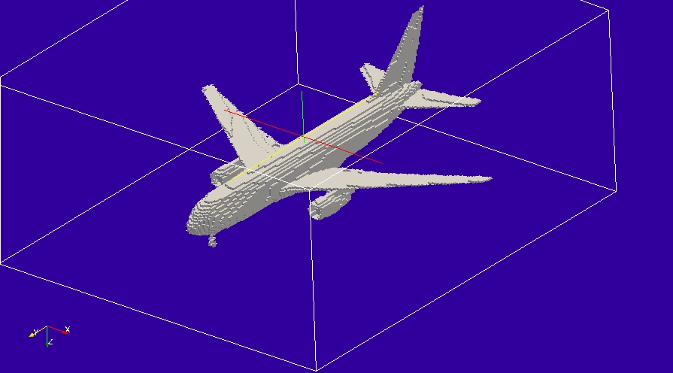

Material description:
The aircraft skin is modelled as PEC here.

Mesh:
Δl=0.25m

Excitation:
Pulse plane wave launched from the outer boundary of the mesh.

Output:
Surface current over the aircraft surface mesh plus Electric field over a plane through the problem space allowing visualisation of the incident pulse plane wave.

Runtime:
0.5μs

Other Notes:

Post processing:
The surface current output is post processed to produce animation data for visualisation in paraview.

Reference results:

GGI_TLM Input file:
Mesh_outer_boundary_dimension
-24.0 24.0 -28.0 28.0 -12.0 12.0

Mesh_cell_dimension
0.25

Outer_boundary_reflection_coefficient
0.0 0.0 0.0 0.0 0.0 0.0

Surface_list
4 Number of surfaces (integer)
1 SURFACE_NUMBER
triangulated_surface
Boeing_767.msh
0.002 1 surface parameters (scale, reverse normal direction)
10.0 12.0 0.0
0.0 2.0 8.0
2 SURFACE_NUMBER
xplane
0.0 -28.0 -12.0 0.0 28.0 12.0 surface parameters
0.0 0.0 0.0
0.0 0.0 0.0
3 SURFACE_NUMBER
zplane
-24.0 -28.0 0.0 24.0 28.0 0.0 surface parameters
0.0 0.0 0.0
0.0 0.0 0.0
4 SURFACE_NUMBER
yplane
-24.0 20.0 -12.0 24.0 20.0 12.0 surface parameters
0.0 0.0 0.0
0.0 0.0 0.0

Point_list
1 Number of points (integer)
1 point_number (integer)
-20.0 -25.0 -10.0 point coordinates (n*real)
0.0 0.0 0.0
0.0 0.0 0.0

Surface_material_list
1 Number of surface materials (integer)
1 SURFACE MATERIAL NUMBER
PEC
1 number of surfaces
1 surface list
1 surface orientation list

Excitation_function_list
1 ! number of excitations
1 ! EXCITATION NUMBER
gaussian
1.0 1e-8 3e-8

Huygens_surface
0 surface number
1 excitation function number
110.0 270.0 wave vector Theta and Phi
1.0 0.0 Polarisation theta and Phi

Output_point_list
1 ! number of output points
1 ! OUTPUT NUMBER
1 ! output point
Ez
centre

Output_surface_list
4 ! number of output surfaces
1 ! OUTPUT SURFACE NUMBER
1 surface number
-1 ! side of surface for output (+1 or -1)
Jmagnitude
output_timestep_information
0 ! first output timestep
600 ! last output timestep
20 ! output timestep interval
2 ! OUTPUT SURFACE NUMBER
2 surface number
1 ! side of surface for output (+1 or -1)
Emagnitude
output_timestep_information
0 ! first output timestep
600 ! last output timestep
20 ! output timestep interval
3 ! OUTPUT SURFACE NUMBER
3 surface number
1 ! side of surface for output (+1 or -1)
Emagnitude
output_timestep_information
0 ! first output timestep
600 ! last output timestep
20 ! output timestep interval
4 ! OUTPUT SURFACE NUMBER
4 surface number
1 ! side of surface for output (+1 or -1)
Emagnitude
output_timestep_information
0 ! first output timestep
600 ! last output timestep
20 ! output timestep interval

Simulation_time
0.5e-6

GGI_TLM result
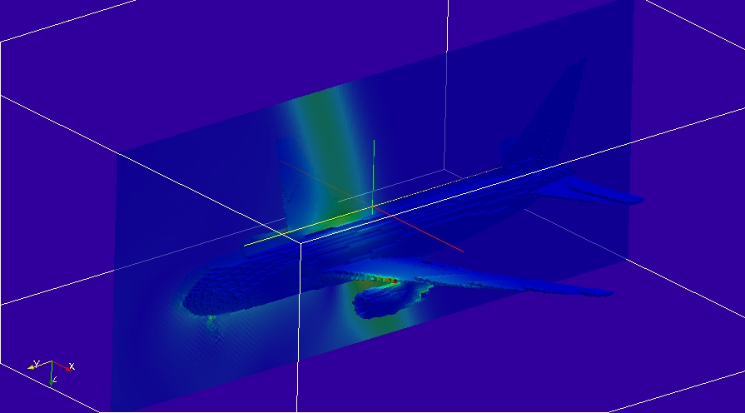
Frame from animation showing the electric field on a cutting plane through the problem space and the surface current.

