Aircraft direct current injection test

Geometry description:
The geometry consists of the outer skin of an aircraft (Boeing 767) plus a set of cables surrounding the aircraft which form the return conductor of a coaxial system with the aircraft as the centre conductor. The aircraft geometry is defined as a very crude triangulated surface mesh which is imported into GGI_TLM. The mesh has problems including the very low mesh density and occasional points in which the surface intersects itself.

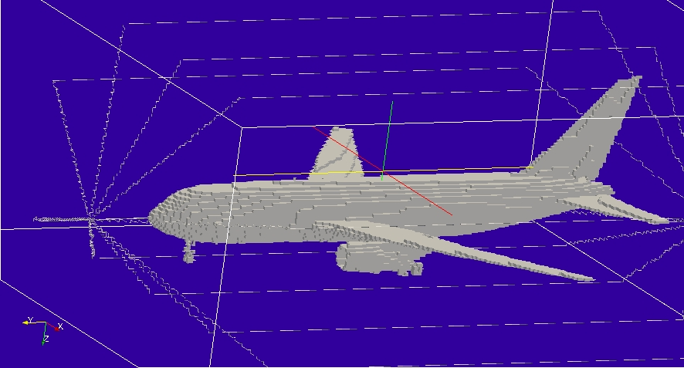

Material description:
The aircraft skin is modelled as PEC here.

Mesh:
Δl=0.25m

Excitation:
Pulse voltage source on the cable which connects to the nose of the aircraft

Output:
Surface current over the aircraft surface mesh.

Runtime:
0.4μs

Other Notes:

Post processing:
The surface current output is post processed to produce animation data for visualisation in paraview.

Reference results:

GGI_TLM Input file:
Mesh_outer_boundary_dimension
-24.0 24.0 -28.0 28.0 -12.0 12.0

Mesh_cell_dimension
0.25

Outer_boundary_reflection_coefficient
0.0 0.0 0.0 0.0 0.0 0.0

Surface_list
1 Number of surfaces (integer)
1 SURFACE_NUMBER
triangulated_surface
Boeing_767.msh
0.002 1 surface parameters (scale, reverse normal direction)
10.0 12.0 0.0
0.0 2.0 8.0

Line_list
32 number of lines
1 LINE_NUMBER (integer) nose wire
straight_line2
-0.5499 21.0 3.6499 -0.4999 26.499 3.6 line parameters (n*real)
0.0 0.0 0.0
0.0 0.0 0.0
2 LINE_NUMBER (integer) tail wire
straight_line2
8.701 -22.4 2.1 8.301 -26.499 2.4 line parameters (n*real)
0.0 0.0 0.0
0.0 0.0 0.0
3 LINE_NUMBER (integer) RETURN CONDUCTOR 1, NOSE END
straight_line2
-0.4999 26.499 3.6 -0.4999 20.0 -10.0 line parameters (n*real)
0.0 0.0 0.0
0.0 0.0 0.0
4 LINE_NUMBER (integer) return conductor 1, centre
straight_line2
-0.4999 20.0 -10.0 -0.4999 -24.0 -10.0 line parameters (n*real)
0.0 0.0 0.0
0.0 0.0 0.0
5 LINE_NUMBER (integer) return conductor 1, tail end
straight_line2
-0.4999 -24.0 -10.0 8.301 -26.499 2.4 line parameters (n*real)
0.0 0.0 0.0
0.0 0.0 0.0
6 LINE_NUMBER (integer) RETURN CONDUCTOR 2, NOSE END
straight_line2
-0.4999 26.499 3.6 9.8 20.0 -10.0 line parameters (n*real)
0.0 0.0 0.0
0.0 0.0 0.0
7 LINE_NUMBER (integer) return conductor 2, centre
straight_line2
9.8 20.0 -10.0 9.8 -24.0 -10.0 line parameters (n*real)
0.0 0.0 0.0
0.0 0.0 0.0
8 LINE_NUMBER (integer) return conductor 2, tail end
straight_line2
9.8 -24.0 -10.0 8.301 -26.499 2.4 line parameters (n*real)
0.0 0.0 0.0
0.0 0.0 0.0
9 LINE_NUMBER (integer) RETURN CONDUCTOR 3, NOSE END
straight_line2
-0.4999 26.499 3.6 19.8 20.0 -2.0 line parameters (n*real)
0.0 0.0 0.0
0.0 0.0 0.0
10 LINE_NUMBER (integer) return conductor 3, centre
straight_line2
19.8 20.0 -2.0 19.8 -24.0 -2.0 line parameters (n*real)
0.0 0.0 0.0
0.0 0.0 0.0
11 LINE_NUMBER (integer) return conductor 3, tail end
straight_line2
19.8 -24.0 -2.0 8.301 -26.499 2.4 line parameters (n*real)
0.0 0.0 0.0
0.0 0.0 0.0
12 LINE_NUMBER (integer) RETURN CONDUCTOR 4, NOSE END
straight_line2
-0.4999 26.499 3.6 19.8 20.0 10.0 line parameters (n*real)
0.0 0.0 0.0
0.0 0.0 0.0
13 LINE_NUMBER (integer) return conductor 4, centre
straight_line2
19.8 20.0 10.0 19.8 -24.0 10.0 line parameters (n*real)
0.0 0.0 0.0
0.0 0.0 0.0
14 LINE_NUMBER (integer) return conductor 4, tail end
straight_line2
19.8 -24.0 10.0 8.301 -26.499 2.4 line parameters (n*real)
0.0 0.0 0.0
0.0 0.0 0.0
15 LINE_NUMBER (integer) RETURN CONDUCTOR 5, NOSE END
straight_line2
-0.4999 26.499 3.6 9.8 20.0 10.0 line parameters (n*real)
0.0 0.0 0.0
0.0 0.0 0.0
16 LINE_NUMBER (integer) return conductor 5, centre
straight_line2
9.8 20.0 10.0 9.8 -24.0 10.0 line parameters (n*real)
0.0 0.0 0.0
0.0 0.0 0.0
17 LINE_NUMBER (integer) return conductor 5, tail end
straight_line2
9.8 -24.0 10.0 8.301 -26.499 2.4 line parameters (n*real)
0.0 0.0 0.0
0.0 0.0 0.0
18 LINE_NUMBER (integer) RETURN CONDUCTOR 6, NOSE END
straight_line2
-0.4999 26.499 3.6 -0.4999 20.0 10.0 line parameters (n*real)
0.0 0.0 0.0
0.0 0.0 0.0
19 LINE_NUMBER (integer) return conductor 6, centre
straight_line2
-0.4999 20.0 10.0 -0.4999 -24.0 10.0 line parameters (n*real)
0.0 0.0 0.0
0.0 0.0 0.0
20 LINE_NUMBER (integer) return conductor 6, tail end
straight_line2
-0.4999 -24.0 10.0 8.301 -26.499 2.4 line parameters (n*real)
0.0 0.0 0.0
0.0 0.0 0.0
21 LINE_NUMBER (integer) RETURN CONDUCTOR 7, NOSE END
straight_line2
-0.4999 26.499 3.6 -10.2 20.0 10.0 line parameters (n*real)
0.0 0.0 0.0
0.0 0.0 0.0
22 LINE_NUMBER (integer) return conductor 7, centre
straight_line2
-10.2 20.0 10.0 -10.2 -24.0 10.0 line parameters (n*real)
0.0 0.0 0.0
0.0 0.0 0.0
23 LINE_NUMBER (integer) return conductor 7, tail end
straight_line2
-10.2 -24.0 10.0 8.301 -26.499 2.4 line parameters (n*real)
0.0 0.0 0.0
0.0 0.0 0.0
24 LINE_NUMBER (integer) RETURN CONDUCTOR 8, NOSE END
straight_line2
-0.4999 26.499 3.6 -20.2 20.0 10.0 line parameters (n*real)
0.0 0.0 0.0
0.0 0.0 0.0
25 LINE_NUMBER (integer) return conductor 8, centre
straight_line2
-20.2 20.0 10.0 -20.2 -24.0 10.0 line parameters (n*real)
0.0 0.0 0.0
0.0 0.0 0.0
26 LINE_NUMBER (integer) return conductor 8, tail end
straight_line2
-20.2 -24.0 10.0 8.301 -26.499 2.4 line parameters (n*real)
0.0 0.0 0.0
0.0 0.0 0.0
27 LINE_NUMBER (integer) RETURN CONDUCTOR 9, NOSE END
straight_line2
-0.4999 26.499 3.6 -20.2 20.0 -2.0 line parameters (n*real)
0.0 0.0 0.0
0.0 0.0 0.0
28 LINE_NUMBER (integer) return conductor 9, centre
straight_line2
-20.2 20.0 -2.0 -20.2 -24.0 -2.0 line parameters (n*real)
0.0 0.0 0.0
0.0 0.0 0.0
29 LINE_NUMBER (integer) return conductor 9, tail end
straight_line2
-20.2 -24.0 -2.0 8.301 -26.499 2.4 line parameters (n*real)
0.0 0.0 0.0
0.0 0.0 0.0
30 LINE_NUMBER (integer) RETURN CONDUCTOR 10, NOSE END
straight_line2
-0.4999 26.499 3.6 -10.2 20.0 -10.0 line parameters (n*real)
0.0 0.0 0.0
0.0 0.0 0.0
31 LINE_NUMBER (integer) return conductor 2, centre
straight_line2
-10.2 20.0 -10.0 -10.2 -24.0 -10.0 line parameters (n*real)
0.0 0.0 0.0
0.0 0.0 0.0
32 LINE_NUMBER (integer) return conductor 2, tail end
straight_line2
-10.2 -24.0 -10.0 8.301 -26.499 2.4 line parameters (n*real)
0.0 0.0 0.0
0.0 0.0 0.0

Point_list
4 Number of points
1 POINT_NUMBER
-0.5499 21.0 3.6499 # Junction 1
0.0 0.0 0.0
0.0 0.0 0.0
2 POINT_NUMBER
8.701 -22.4 2.1 # Junction 2
0.0 0.0 0.0
0.0 0.0 0.0
3 POINT_NUMBER
-0.4999 26.499 3.6 # Junction 3
0.0 0.0 0.0
0.0 0.0 0.0
4 POINT_NUMBER
8.301 -26.499 2.4 # Junction 4
0.0 0.0 0.0
0.0 0.0 0.0

Surface_material_list
1 Number of surface materials (integer)
1 SURFACE MATERIAL NUMBER
PEC
1 number of surfaces
1 surface list
1 surface orientation list

Cable_geometry_list
1 number of cable geometries
1 CABLE GEOMETRY NUMBER, Cable geometry type (file name) follows:
CABLE_DIRECTORY/1cm_single_wire

Cable_list
12 number of cables
1 CABLE NUMBER, NOSE CONNECTION
1 cable geometry number
1 number of lines on cable route
1 cable line list
3 end 1 junction number
1 end 2 junction number
2 CABLE NUMBER, TAIL CONNECTION
1 cable geometry number
1 number of lines on cable route
2 cable line list
2 end 1 junction number
4 end 2 junction number
3 CABLE NUMBER, RETURN CONDUCTOR 1
1 cable geometry number
3 number of lines on cable route
3 4 5 cable line list
3 end 1 junction number
4 end 2 junction number
4 CABLE NUMBER, RETURN CONDUCTOR 2
1 cable geometry number
3 number of lines on cable route
6 7 8 cable line list
3 end 1 junction number
4 end 2 junction number
5 CABLE NUMBER, RETURN CONDUCTOR 3
1 cable geometry number
3 number of lines on cable route
9 10 11 cable line list
3 end 1 junction number
4 end 2 junction number
6 CABLE NUMBER, RETURN CONDUCTOR 4
1 cable geometry number
3 number of lines on cable route
12 13 14 cable line list
3 end 1 junction number
4 end 2 junction number
7 CABLE NUMBER, RETURN CONDUCTOR 5
1 cable geometry number
3 number of lines on cable route
15 16 17 cable line list
3 end 1 junction number
4 end 2 junction number
8 CABLE NUMBER, RETURN CONDUCTOR 6
1 cable geometry number
3 number of lines on cable route
18 19 20 cable line list
3 end 1 junction number
4 end 2 junction number
9 CABLE NUMBER, RETURN CONDUCTOR 7
1 cable geometry number
3 number of lines on cable route
21 22 23 cable line list
3 end 1 junction number
4 end 2 junction number
10 CABLE NUMBER, RETURN CONDUCTOR 8
1 cable geometry number
3 number of lines on cable route
24 25 26 cable line list
3 end 1 junction number
4 end 2 junction number
11 CABLE NUMBER, RETURN CONDUCTOR 9
1 cable geometry number
3 number of lines on cable route
27 28 29 cable line list
3 end 1 junction number
4 end 2 junction number
12 CABLE NUMBER, RETURN CONDUCTOR 10
1 cable geometry number
3 number of lines on cable route
30 31 32 cable line list
3 end 1 junction number
4 end 2 junction number

Cable_junction_list
4 number of junctions
1 JUNCTION NUMBER
1 junction point
1 number of internal connection nodes (n_int)
1 number of cables
1 cable list
2 corresponding cable end number list
1 Cable 1 number of external conductors (n_ext)
1 Cable 1 P matrix: matrix (n_int rows* n_ext columns)
1 Cable 1 voltage function source list
1E6 Cable 1 impedance list
0 Number of internal impedances
FACE
-1 boundary condition (-1 indicates V=0 i.e. connection to a surface)
2 JUNCTION NUMBER
2 junction point
1 number of internal connection nodes (n_int)
1 number of cables
2 cable list
1 corresponding cable end number list
1 Cable 1 number of external conductors (n_ext)
1 Cable 1 P matrix: matrix (n_int rows* n_ext columns)
0 Cable 1 voltage function source list
0.0 Cable 1 impedance list
0 Number of internal impedances
FACE
-1 boundary condition (-1 indicates V=0 i.e. connection to a surface)
3 JUNCTION NUMBER
3 junction point
1 number of internal connection nodes (n_int)
11 number of cables
1 3 4 5 6 7 8 9 10 11 12 cable list
1 1 1 1 1 1 1 1 1 1 1 corresponding cable end number list
1 Cable 1 number of external conductors (n_ext)
1 Cable 1 P matrix: matrix (n_int rows* n_ext columns)
0 Cable 1 voltage function source list
0.0 Cable 1 impedance list
1 Cable 3 number of external conductors (n_ext)
1 Cable 3 P matrix: matrix (n_int rows* n_ext columns)
0 Cable 3 voltage function source list
0.0 Cable 3 impedance list
1 Cable 4 number of external conductors (n_ext)
1 Cable 4 P matrix: matrix (n_int rows* n_ext columns)
0 Cable 4 voltage function source list
0.0 Cable 4 impedance list
1 Cable 5 number of external conductors (n_ext)
1 Cable 5 P matrix: matrix (n_int rows* n_ext columns)
0 Cable 5 voltage function source list
0.0 Cable 5 impedance list
1 Cable 6 number of external conductors (n_ext)
1 Cable 6 P matrix: matrix (n_int rows* n_ext columns)
0 Cable 6 voltage function source list
0.0 Cable 6 impedance list
1 Cable 7 number of external conductors (n_ext)
1 Cable 7 P matrix: matrix (n_int rows* n_ext columns)
0 Cable 7 voltage function source list
0.0 Cable 7 impedance list
1 Cable 8 number of external conductors (n_ext)
1 Cable 8 P matrix: matrix (n_int rows* n_ext columns)
0 Cable 8 voltage function source list
0.0 Cable 8 impedance list
1 Cable 9 number of external conductors (n_ext)
1 Cable 9 P matrix: matrix (n_int rows* n_ext columns)
0 Cable 9 voltage function source list
0.0 Cable 9 impedance list
1 Cable 10 number of external conductors (n_ext)
1 Cable 10 P matrix: matrix (n_int rows* n_ext columns)
0 Cable 10 voltage function source list
0.0 Cable 10 impedance list
1 Cable 11 number of external conductors (n_ext)
1 Cable 11 P matrix: matrix (n_int rows* n_ext columns)
0 Cable 11 voltage function source list
0.0 Cable 11 impedance list
1 Cable 12 number of external conductors (n_ext)
1 Cable 12 P matrix: matrix (n_int rows* n_ext columns)
0 Cable 12 voltage function source list
0.0 Cable 12 impedance list
0 Number of internal impedances
4 JUNCTION NUMBER
4 junction point
1 number of internal connection nodes (n_int)
11 number of cables
2 3 4 5 6 7 8 9 10 11 12 cable list
2 2 2 2 2 2 2 2 2 2 2 corresponding cable end number list
1 Cable 1 number of external conductors (n_ext)
1 Cable 1 P matrix: matrix (n_int rows* n_ext columns)
0 Cable 1 voltage function source list
0.0 Cable 1 impedance list
1 Cable 3 number of external conductors (n_ext)
1 Cable 3 P matrix: matrix (n_int rows* n_ext columns)
0 Cable 3 voltage function source list
0.0 Cable 3 impedance list
1 Cable 4 number of external conductors (n_ext)
1 Cable 4 P matrix: matrix (n_int rows* n_ext columns)
0 Cable 4 voltage function source list
0.0 Cable 4 impedance list
1 Cable 5 number of external conductors (n_ext)
1 Cable 5 P matrix: matrix (n_int rows* n_ext columns)
0 Cable 5 voltage function source list
0.0 Cable 5 impedance list
1 Cable 6 number of external conductors (n_ext)
1 Cable 6 P matrix: matrix (n_int rows* n_ext columns)
0 Cable 6 voltage function source list
0.0 Cable 6 impedance list
1 Cable 7 number of external conductors (n_ext)
1 Cable 7 P matrix: matrix (n_int rows* n_ext columns)
0 Cable 7 voltage function source list
0.0 Cable 7 impedance list
1 Cable 8 number of external conductors (n_ext)
1 Cable 8 P matrix: matrix (n_int rows* n_ext columns)
0 Cable 8 voltage function source list
0.0 Cable 8 impedance list
1 Cable 9 number of external conductors (n_ext)
1 Cable 9 P matrix: matrix (n_int rows* n_ext columns)
0 Cable 9 voltage function source list
0.0 Cable 9 impedance list
1 Cable 10 number of external conductors (n_ext)
1 Cable 10 P matrix: matrix (n_int rows* n_ext columns)
0 Cable 10 voltage function source list
0.0 Cable 10 impedance list
1 Cable 11 number of external conductors (n_ext)
1 Cable 11 P matrix: matrix (n_int rows* n_ext columns)
0 Cable 11 voltage function source list
0.0 Cable 11 impedance list
1 Cable 12 number of external conductors (n_ext)
1 Cable 12 P matrix: matrix (n_int rows* n_ext columns)
0 Cable 12 voltage function source list
0.0 Cable 12 impedance list
0 Number of internal impedances

#Excitation_function_list
1 ! Number of excitations
1 ! EXCITATION NUMBER
double_exponential
1.0 1e-8 0.25e-6 1.0

Excitation_function_list
1 ! Number of excitations
1 ! EXCITATION NUMBER
gaussian
1.0 1e-8 3e-8

Output_surface_list
1 ! number of output surfaces
1 ! OUTPUT SURFACE NUMBER
1 surface number
-1 ! side of surface for output (+1 or -1)
Jmagnitude
output_timestep_information
0 ! first output timestep
1000 ! last output timestep
10 ! output timestep interval

Simulation_time
4e-7

GGI_TLM result
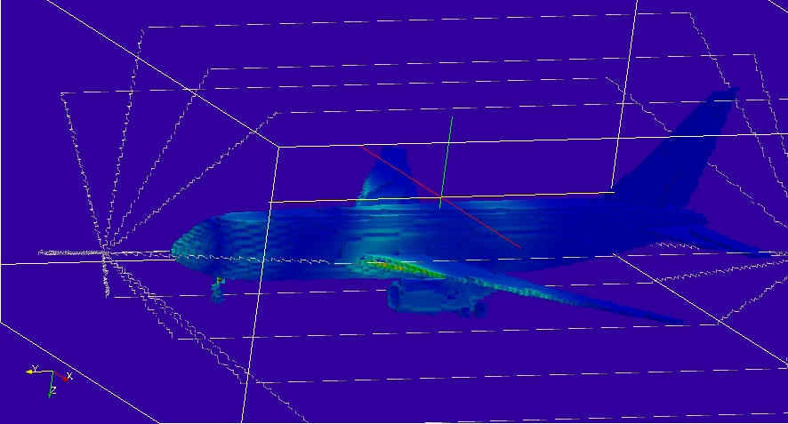
Frame from animation the surface current.

