RCS_COATED_SPHERE

Geometry description:
1m radius PEC sphere with 0.5m thick dielectric coating.
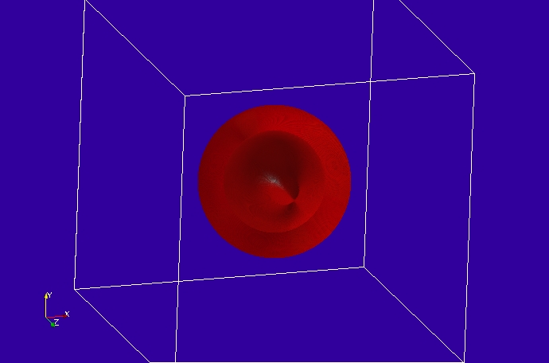

Material description:

The coating material is a Debye material defined below:
# debye dielectric model
0.0 1e8 # frequency range of validity
# permittivity filter
1.0e7 # wnormalisation constant
1 # a order
4.0 0.75 # a coefficients
1 # b order
1.0 0.50 # b coefficients
0.0 # electric conductivity
# permeability filter
1.0e7 # wnormalisation constant
0 # a order
1.0 # a coefficients
0 # b order
1.0 # b coefficients
0.0 # magnetic conductivity

Mesh:
5cm cell size

Excitation:
Gaussian plane wave launched from the external surface of the mesh

Output:
Radar Cross Section

Runtime:
1ns

Other Notes:

Post processing:

Reference results:
Analytic solution (Mie Series )

GGI_TLM Input file:

Mesh_outer_boundary_dimension
-3.0 3.0 -3.0 3.0 -3.0 3.0

Mesh_cell_dimension
0.05

Outer_boundary_reflection_coefficient
0.0 0.0 0.0 0.0 0.0 0.0

Volume_list
2 Number of volumes (integer)
1 VOLUME_NUMBER (integer)
sphere
1.0 volume parameters (n*real)
0.0 0.0 0.0
0.0 0.0 0.0
2 VOLUME_NUMBER (integer)
sphere
1.5 volume parameters (n*real)
0.0 0.0 0.0
0.0 0.0 0.0

Surface_list
1 Number of surfaces (integer)
1 SURFACE_NUMBER (integer)
rectangular_block
3.2 3.2 3.2 surface parameters (n*real)
0.0 0.0 0.0
0.0 0.0 0.0

Volume_material_list
2 Number of volume materials (integer)
1 VOLUME MATERIAL NUMBER
Dispersive
/home/chris/SOFTWARE/GGI_TLM/TEST_DATA/MATERIAL_DATA/debye_2
1 number of volumes
2 volume list
2 VOLUME MATERIAL NUMBER
PEC
1 number of volumes
1 volume list

Excitation_function_list
1 ! number of excitations
1 ! EXCITATION NUMBER
gaussian
1.0 1e-9 3e-9

Huygens_surface
0 surface number
1 side of surface for excitation
1 excitation function number
0.0 0.0 wave vector Theta and Phi
1.0 0.0 Polarisation theta and Phi

RCS_surface
1 surface number
1 Side of surface for RCS output
0.1e8 3e8 0.01e8 frequency range for far field calculation
180.0 Theta
0.0 Phi

Simulation_time
10e-8

GGI_TLM result
