DIELECTRIC_IBC_SPHERE

Geometry description:
1m radius dielectric sphere with Impedance Boundary surface on the outside.
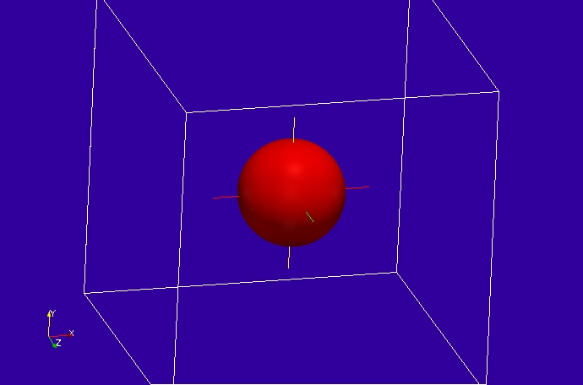

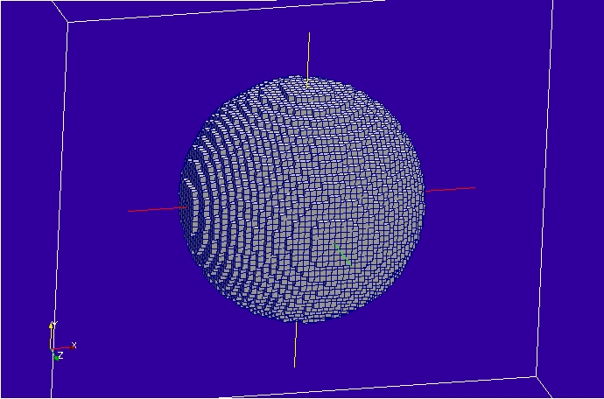

Material description:
The dielectric is a Debye material defined below:
# debye dielectric model
0.0 1e8 # frequency range of validity
# permittivity filter
1.0e7 # wnormalisation constant
1 # a order
4.0 0.75 # a coefficients
1 # b order
1.0 0.50 # b coefficients
0.0 # electric conductivity
# permeability filter
1.0e7 # wnormalisation constant
0 # a order
1.0 # a coefficients
0 # b order
1.0 # b coefficients
0.0 # magnetic conductivity

The impedance boundary is a simple resistive sheet of 377 ohms/square.

# Sheet resistance 377 ohms/square
0.0 1e8 # frequency range of validity
# Z11 filter
1.0e8 # wnormalisation constant
0 # a order
377.0 # a coefficients
0 # b order
1.0 # b coefficients
# Z12 filter
1.0e8 # wnormalisation constant
0 # a order
377.0 # a coefficients
0 # b order
1.0 # b coefficients
# Z21 filter
1.0e8 # wnormalisation constant
0 # a order
377.0 # a coefficients
0 # b order
1.0 # b coefficients
# Z22 filter
1.0e8 # wnormalisation constant
0 # a order
377.0 # a coefficients
0 # b order
1.0 # b coefficients

Mesh:
5cm cell size.

Excitation:
Gaussian plane wave launched from the external surface of the mesh

Output:
Radar Cross Section

Runtime:
1ns

Other Notes:

Post processing:

Reference results:
Analytic solution (Mie Series )

GGI_TLM Input file:

Mesh_outer_boundary_dimension
-3.0 3.0 -3.0 3.0 -3.0 3.0

Mesh_cell_dimension
0.05

Outer_boundary_reflection_coefficient
0.0 0.0 0.0 0.0 0.0 0.0

Volume_list
1 Number of volumes (integer)
1 VOLUME_NUMBER (integer)
sphere
1.0 volume parameters (n*real)
0.0 0.0 0.0
0.0 0.0 0.0

Surface_list
2 Number of surfaces (integer)
1 SURFACE_NUMBER (integer)
sphere
1.0 surface parameters (n*real)
0.0 0.0 0.0
0.0 0.0 0.0
2 SURFACE_NUMBER (integer)
rectangular_block
3.2 3.2 3.2 surface parameters (n*real)
0.0 0.0 0.0
0.0 0.0 0.0

Point_list
1 Number of points (integer)
1 point_number (integer)
0.0 0.0 0.0 point coordinates (n*real)
0.0 0.0 0.0
0.0 0.0 0.0

Volume_material_list
1 Number of volume materials (integer)
1 VOLUME MATERIAL NUMBER
Dispersive
/home/chris/SOFTWARE/GGI_TLM/TEST_DATA/MATERIAL_DATA/debye_2
1 number of volumes
1 volume list

Surface_material_list
1 Number of surface materials (integer)
1 SURFACE MATERIAL NUMBER
Dispersive
/home/chris/SOFTWARE/GGI_TLM/TEST_DATA/MATERIAL_DATA/Rsheet=377
1 number of surfaces
1 surface list
1 surface orientation list

Excitation_function_list
1 ! number of excitations
1 ! EXCITATION NUMBER
gaussian
1.0 1e-9 3e-9

Huygens_surface
0 surface number
1 side of surface for excitation
1 excitation function number
0.0 0.0 wave vector Theta and Phi
1.0 0.0 Polarisation theta and Phi

Output_point_list
1 ! number of output points
1 ! OUTPUT NUMBER
1 ! output point
Ex
centre
output_timestep_information
1 ! first output timestep
1000 ! last output timestep
1 ! output timestep interval

RCS_surface
2 surface number
1 Side of surface for RCS output
0.1e8 3e8 0.01e8 frequency range for far field calculation
180.0 Theta
0.0 Phi

Simulation_time
7e-8

GGI_TLM result
