TEM transmission line with frequency dependent impedance boundary layer

Geometry description:
Rectangular TEM transmission line, 0.1m×0.1m×60m with perfectly conducting walls on the ±y boundaries and perfect magnetic conductor walls on the ±x boundaries. The ±z boundaries are matched to the free space impedance, Z₀. The transmission line has an impedance boundary sheet placed at z=20m.

40m
IBC sheet
z
20m
y
0.1m
x
0.1m

Material description:
The transmission line is loaded with an IBC sheet at 20m in z.

Mesh:
1×1×600 cells

Excitation:
Ey over the xy cross section of the transmission line at z=0.1m.

Output:
Both Ey and Hx at two points either side of a defined observation reference plane. Here we output both Ey and Hx at z=9.95m and z=10.05m.

Runtime:
30e-8s

Post processing:
The post processing procedure ‘oneport analysis’ is used to calculate the complex wave impedance and propagation constant as a function of frequency in the TEM waveguide plus the reflection coefficient of the layer as a function of frequency. The frequency range extends to 300MHz in this analysis.

Reference results:
We would expect the propagation constant to be
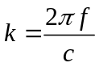
And the wave impedance
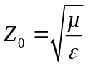

Material model
The dispersive sheet is a first order material model in which Z₁₁= Z₁₂ =Z₂₁= Z₂₂.
The material filter specification is:
# First order dispersive material sheet
0.0 1e8 # frequency range of validity
# Z11 filter
1.0e8 # wnormalisation constant
1 # a order
377.0 100.0 # a coefficients
1 # b order
1.0 0.750 # b coefficients
# Z12 filter
1.0e8 # wnormalisation constant
1 # a order
377.0 100.0 # a coefficients
1 # b order
1.0 0.750 # b coefficients
# Z21 filter
1.0e8 # wnormalisation constant
1 # a order
377.0 100.0 # a coefficients
1 # b order
1.0 0.750 # b coefficients
# Z22 filter
1.0e8 # wnormalisation constant
1 # a order
377.0 100.0 # a coefficients
1 # b order
1.0 0.750 # b coefficients

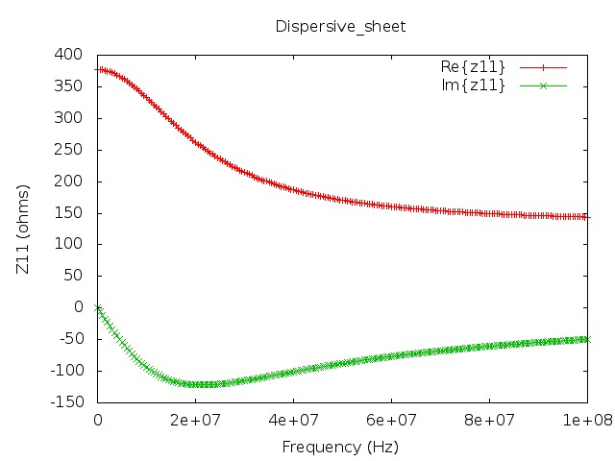

GGI_TLM Input file
# TEM cell model

Mesh_outer_boundary_dimension
-0.05 0.05 -0.05 0.05 0 60

Mesh_cell_dimension
0.1

Outer_boundary_reflection_coefficient
1.0 1.0 -1.0 -1.0 0.0 0.0

Surface_list
2 Number of surfaces
1 SURFACE_NUMBER
rectangle
0.1 0.1 surface parameters
0.0 0.0 0.0
0.0 0.0 0.1
2 SURFACE_NUMBER
rectangle
0.1 0.1 surface parameters
0.0 0.0 0.0
0.0 0.0 20.0

Point_list
2 Number of points
1 POINT_NUMBER
0.0 0.0 0.0 point coordinates
0.0 0.0 0.0
0.0 0.0 9.95
2 POINT_NUMBER
0.0 0.0 0.0 point coordinates
0.0 0.0 0.0
0.0 0.0 10.05

Surface_material_list
1 Number of surface materials
1 SURFACE MATERIAL NUMBER
DISPERSIVE
MATERIAL_DIRECTORY/Dispersive_sheet
1 number of surfaces
2 surface list
1 surface orientation list

Excitation_function_list
1 ! number of excitation functions
1 ! EXCITATION_FUNCTION_NUMBER
gaussian
1.0 2e-9 8e-9

Huygens_surface
1 surface number
1 excitation function number
0.0 90.0 wave vector Theta and Phi
1.0 0.0 Polarisation theta and Phi

Output_point_list
4 ! number of output points
1 ! OUTPUT NUMBER
1 ! output point
Ey
centre
2 ! OUTPUT NUMBER
1 ! output point
Hx
centre
3 ! OUTPUT NUMBER
2 ! output point
Ey
centre
4 ! OUTPUT NUMBER
2 ! output point
Hx
centre

Simulation_time
30e-8

GGI_TLM results
