WIRE_OVER_GROUND_PLANE

Geometry description:
Two wires over a ground plane illuminated by a plane wave.
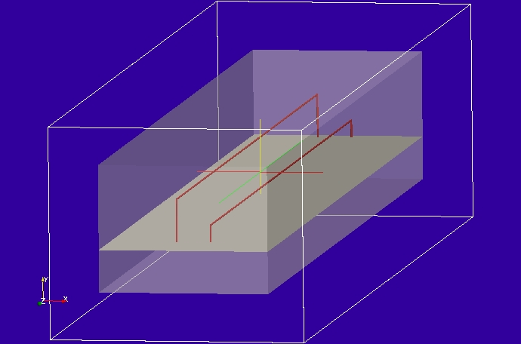

Material description:
All surfaces are PEC

cable description:
cylindrical
1 # number of conductors
3 # NUMBER OF PARAMETERS
2.54e-4 # parameter 1: conductor radius
2.55e-4 # parameter 2: insulation radius
1.0 # parameter 3: permittivity of outer dielectric
0 # NUMBER OF FILTERS

cylindrical
1 # number of conductors
3 # NUMBER OF PARAMETERS
7.62e-4 # parameter 1: conductor radius
7.63e-4 # parameter 2: insulation radius
1.0 # parameter 3: permittivity of outer dielectric
0 # NUMBER OF FILTERS

Mesh:
1cm cell size

Excitation:
Gaussian plane wave launched from an internal Huygens surface

Output:
Cable termination currents

Runtime:
0.1μs

Other Notes:

Post processing:
Fourier transform the termination currents, normalise to the incident field amplitude and scale by the resistance at each cable termination to give the termination voltage in mV.

Reference results:

GGI_TLM Input file:

# Two wires over a ground plane illuminated by a plane wave

Mesh_outer_boundary_dimension
0.0 0.3 0.0 0.25 0.0 1.20

Mesh_cell_dimension
0.01

Outer_boundary_reflection_coefficient
0.0 0.0 0.0 0.0 0.0 0.0

Surface_list
2 Number of surfaces
1 SURFACE_NUMBER
rectangle
0.20 1.10 surface parameters
90.0 0.0 0.0
0.15 0.10 0.60
2 SURFACE_NUMBER
rectangular_block2
0.05 0.05 0.05 0.25 0.20 1.15
0.0 0.0 0.0
0.0 0.0 0.0

Line_list
6 Number of lines
1 LINE_NUMBER
straight_line2
0.13 0.10 0.10 0.13 0.15 0.10 line parameters (n*real)
0.0 0.0 0.0
0.0 0.0 0.0
2 LINE_NUMBER
straight_line2
0.13 0.15 0.10 0.13 0.15 1.10 line parameters (n*real)
0.0 0.0 0.0
0.0 0.0 0.0
3 LINE_NUMBER
straight_line2
0.13 0.15 1.10 0.13 0.10 1.10 line parameters (n*real)
0.0 0.0 0.0
0.0 0.0 0.0
4 LINE_NUMBER
straight_line2
0.17 0.10 0.10 0.17 0.12 0.10 line parameters (n*real)
0.0 0.0 0.0
0.0 0.0 0.0
5 LINE_NUMBER
straight_line2
0.17 0.12 0.10 0.17 0.12 1.10 line parameters (n*real)
0.0 0.0 0.0
0.0 0.0 0.0
6 LINE_NUMBER
straight_line2
0.17 0.12 1.10 0.17 0.10 1.10 line parameters (n*real)
0.0 0.0 0.0
0.0 0.0 0.0

Point_list
4 Number of points (integer)
1 POINT_NUMBER (integer)
0.13 0.10 0.10 point coordinates (n*real)
0.0 0.0 0.0
0.0 0.0 0.0
2 POINT_NUMBER (integer)
0.13 0.10 1.10 point coordinates (n*real)
0.0 0.0 0.0
0.0 0.0 0.0
3 POINT_NUMBER (integer)
0.17 0.10 0.10 point coordinates (n*real)
0.0 0.0 0.0
0.0 0.0 0.0
4 POINT_NUMBER (integer)
0.17 0.10 1.10 point coordinates (n*real)
0.0 0.0 0.0
0.0 0.0 0.0

Surface_material_list
1 Number of surface materials
1 SURFACE MATERIAL NUMBER
PEC
1 number of surfaces
1 surface list
1 surface orientation list

Cable_geometry_list
2 number of cable geometries
1 cable geometry number, Cable geometry type (file name) follows:
/home/chris/SOFTWARE/GGI_TLM/TEST_DATA/CABLE_DATA/30_mil_single_wire
2 cable geometry number, Cable geometry type (file name) follows:
/home/chris/SOFTWARE/GGI_TLM/TEST_DATA/CABLE_DATA/10_mil_single_wire

cable_list
2 number of cables
1 CABLE NUMBER
1 cable geometry number
3 number of lines on cable route
1 2 3 cable line list
1 end 1 junction number
2 end 2 junction number
2 CABLE NUMBER
2 cable geometry number
3 number of lines on cable route
4 5 6 cable line list
3 end 1 junction number
4 end 2 junction number

Cable_output_list
4 number of cable_outputs
1 CABLE OUTPUT NUMBER
1 cable number
1 closest point number
2 CABLE OUTPUT NUMBER
1 cable number
2 closest point number
3 CABLE OUTPUT NUMBER
2 cable number
3 closest point number
4 CABLE OUTPUT NUMBER
2 cable number
4 closest point number

Cable_junction_list
4 number of junctions
1 JUNCTION NUMBER
1 junction point
1 number of internal connection nodes (n_int)
1 number of cables
1 cable list
1 corresponding cable end number list
1 Cable 1 number of external conductors (n_ext)
0 Cable 1 P matrix: matrix (n_int rows* n_ext columns)
0 Cable 1 voltage source function list
100.0 Cable 1 impedance list
0 Number of internal impedances
FACE
-1
2 JUNCTION NUMBER
2 junction point
1 number of internal connection nodes (n_int)
1 number of cables
1 cable list
2 corresponding cable end number list
1 Cable 1 number of external conductors (n_ext)
0 Cable 1 P matrix: matrix (n_int rows* n_ext columns)
0 Cable 1 voltage source function list
500.0 Cable 1 impedance list
0 Number of internal impedances
FACE
-1
3 JUNCTION NUMBER
3 junction point
1 number of internal connection nodes (n_int)
1 number of cables
2 cable list
1 corresponding cable end number list
1 Cable 1 number of external conductors (n_ext)
0 Cable 1 P matrix: matrix (n_int rows* n_ext columns)
0 Cable 1 voltage source function list
500.0 Cable 1 impedance list
0 Number of internal impedances
FACE
-1
4 JUNCTION NUMBER
4 junction point
1 number of internal connection nodes (n_int)
1 number of cables
2 cable list
2 corresponding cable end number list
1 Cable 1 number of external conductors (n_ext)
0 Cable 1 P matrix: matrix (n_int rows* n_ext columns)
0 Cable 1 voltage source function list
1000.0 Cable 1 impedance list
0 Number of internal impedances
FACE
-1

Excitation_function_list
1 ! number of excitation functions
1 ! EXCITATION NUMBER
gaussian
1.0 5e-11 20e-11

Huygens_surface
2 surface number
1 side of surface for excitation
1 excitation function number
90.0 -90.0 wave vector
1.0 0.0 polarisation

Simulation_time
1e-7

GGI_TLM result
