MTL_CROSSTALK

Geometry description:
Cable consisting of three wires in free space.
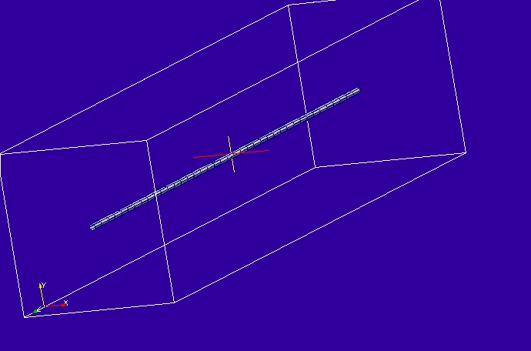

Material description:
No surface or volume materials present.

Cable description:
There are three cables in the model, each defined as follows:
FD_cylindrical
1 # number of conductors
3 # NUMBER OF PARAMETERS
1.905e-4 # parameter 1: conductor radius
2.56e-4 # parameter 2: insulation radius
3.5 # parameter 3: permittivity of outer dielectric
1 # NUMBER OF FILTERS
# Filter 1: Wire impedance filter, 0.19444b ohms/m series resistance
1.0e8 # w normalisation constant
0 # a order
0.19444 # a coefficients
0 # b order
1.0 # b coefficients

Mesh:
10cm cell size

Excitation:
Gaussian voltage source on cable 3, end 1.

Output:
Current on cable 2 end 1.

Runtime:
0.1μs

Other Notes:

Post processing:
Fourier transform the termination current, normalise to the voltage source amplitude and scale by the resistance at the cable termination to give the termination voltage in mV.

Reference results:

GGI_TLM Input file:
# 3 conductor cable for crosstalk test
# similar to RIBBON_CABLE_CROSSTALK but the cable is assembled from 3 individual cylindrical cables

Mesh_outer_boundary_dimension
-0.25 0.25 -0.25 0.25 -1.1 1.1

Mesh_dimensions_in_cells
5 5 22

Outer_boundary_reflection_coefficient
0.0 0.0 0.0 0.0 0.0 0.0

Line_list
1 Number of lines
1 LINE_NUMBER
straight_line2
0.0 0.0 -1.0 0.0 0.0 1.0 ! line parameters
0.0 0.0 0.0
0.0 0.0 0.0

Point_list
2 Number of points (integer)
1 POINT_NUMBER (integer)
0.0 0.0 -1.0 point coordinates (n*real)
0.0 0.0 0.0
0.0 0.0 0.0
2 POINT_NUMBER (integer)
0.0 0.0 1.0 point coordinates (n*real)
0.0 0.0 0.0
0.0 0.0 0.0

Cable_geometry_list
1 number of cable geometries
1 CABLE GEOMETRY NUMBER, Cable geometry type (file name) follows:
/home/chris/SOFTWARE/GGI_TLM/TEST_DATA/CABLE_DATA/7.5_mil_FD_insulated_single_wire

cable_list
3 number of cables
1 CABLE NUMBER
1 cable geometry number
1 number of lines on cable route
1 cable line list
1 end 1 junction number
2 end 2 junction number
2 CABLE NUMBER
1 cable geometry number
1 number of lines on cable route
1 cable line list
1 end 1 junction number
2 end 2 junction number
3 CABLE NUMBER
1 cable geometry number
1 number of lines on cable route
1 cable line list
1 end 1 junction number
2 end 2 junction number

Cable_output_list
1 number of cable_outputs
1 CABLE OUTPUT NUMBER
2 cable number
1 closest point number

Cable_junction_list
2 number of junctions
1 JUNCTION NUMBER
1 junction point
1 number of internal connection nodes (n_int)
3 number of cables
1 2 3 cable list
1 1 1 corresponding cable end number list
1 Cable 1 number of external conductors (n_ext)
1 Cable 1 P matrix: matrix (n_int rows* n_ext columns)
0 Cable 1 voltage source function list
0.0 Cable 1 impedance list
1 Cable 2 number of external conductors (n_ext)
1 Cable 2 P matrix: matrix (n_int rows* n_ext columns)
0 Cable 2 voltage source function list
50.0 Cable 2 impedance list
1 Cable 3 number of external conductors (n_ext)
1 Cable 3 P matrix: matrix (n_int rows* n_ext columns)
1 Cable 3 voltage source function list
0.0 Cable 3 impedance list
0 Number of internal impedances
2 JUNCTION NUMBER
2 junction point
1 number of internal connection nodes (n_int)
3 number of cables
1 2 3 cable list
2 2 2 corresponding cable end number list
1 Cable 1 number of external conductors (n_ext)
1 Cable 1 P matrix: matrix (n_int rows* n_ext columns)
0 Cable 1 voltage source function list
0.0 Cable 1 impedance list
1 Cable 2 number of external conductors (n_ext)
1 Cable 2 P matrix: matrix (n_int rows* n_ext columns)
0 Cable 2 voltage source function list
50.0 Cable 2 impedance list
1 Cable 3 number of external conductors (n_ext)
1 Cable 3 P matrix: matrix (n_int rows* n_ext columns)
0 Cable 3 voltage source function list
50.0 Cable 3 impedance list
0 Number of internal impedances

Excitation_function_list
1 ! number of excitation functions
1 ! EXCITATION NUMBER
gaussian
1.0 1e-9 3e-9

Simulation_time
1e-7

GGI_TLM result
