RESONANT_ABSORBER

Geometry description:
Resonant absorber consisting of FR4 board metallised on both sides but with a thin slot on the illuminated side.
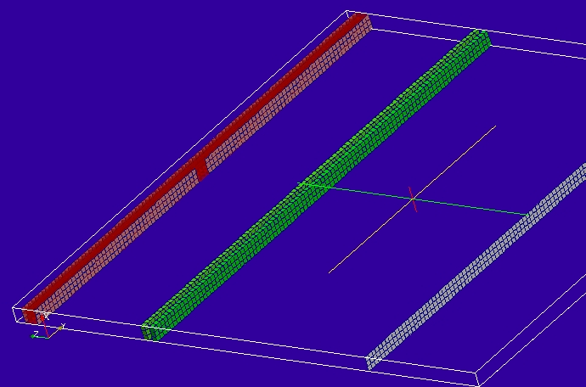

Material description:

The FR4 model is a simple frequency independent model including some loss.
# FR4 at 7GHz
0.0 1e20 # frequency range of validity
# permittivity filter
1.0 # wnormalisation constant
0 # a order
4.45056 # a coefficients
0 # b order
1.0 # b coefficients
0.036549 # electric conductivity
# permeability filter
1.0 # wnormalisation constant
0 # a order
1.0 # a coefficients
0 # b order
1.0 # b coefficients
0.0 # magnetic conductivity

Mesh:
0.1mm

Excitation:
Gaussian plane wave launched from an internal Huygens surface.

Output:
Electric and magnetic fields averaged over the width of the problem space at two output ports separated by a short distance. This output is suitable for post processing by the oneport process.

Runtime:
10ns

Other Notes:

Post processing:
Oneport analysis to give reflection coefficient of the absorber as a function of frequency.

Reference results:

GGI_TLM Input file:
# TEM cell model # 0.3mm X 10mm X 10.5mm

Mesh_outer_boundary_dimension
-0.15e-3 0.15e-3 -5.0e-3 5e-3 0.0 10.5e-3

Mesh_dimensions_in_cells
3 100 105 ( 3*integer)

Outer_boundary_reflection_coefficient
1.0 1.0 1.0 1.0 0.0 0.0

Wrapping_boundary_conditions
1 1 0

Volume_list
3 Number of volumes
1 VOLUME_NUMBER
rectangular_block
0.3e-3 10.0e-3 0.3e-3 volume parameters
0.0 0.0 0.0
0.0 0.0 10.15e-3
2 VOLUME_NUMBER ! Output volume 1
rectangular_block
0.3e-3 10.0e-3 0.1e-3 volume parameters
0.0 0.0 0.0
0.0 0.0 7.55e-3
3 VOLUME_NUMBER ! Output volume 2
rectangular_block
0.3e-3 10.0e-3 0.1e-3 volume parameters
0.0 0.0 0.0
0.0 0.0 7.35e-3

Surface_list
4 Number of surfaces
1 SURFACE_NUMBER
rectangle
0.3e-3 10.0e-3 surface parameters
0.0 0.0 0.0
0.0 0.0 10.3e-3
2 SURFACE_NUMBER
rectangle
0.3e-3 4.8e-3 surface parameters
0.0 0.0 0.0
0.0 -2.6e-3 10.0e-3
3 SURFACE_NUMBER
rectangle
0.3e-3 4.9e-3 surface parameters
0.0 0.0 0.0
0.0 2.55e-3 10.0e-3
4 SURFACE_NUMBER ! Huygens surface
rectangle
0.3e-3 10.0e-3 surface parameters
0.0 0.0 0.0
0.0 0.0 2.5e-3

Volume_material_list
1 Number of volume materials (integer)
1 VOLUME MATERIAL NUMBER
DISPERSIVE
/home/chris/SOFTWARE/GGI_TLM/TEST_DATA/MATERIAL_DATA/FR4_at_7GHz
1 number of volumes
1 volume list

Surface_material_list
1 Number of surface materials
1 SURFACE MATERIAL NUMBER
PEC
3 number of surfaces
1 2 3 surface list
1 1 1 surface orientation list

Excitation_function_list
1 ! number of excitation functions
1 ! EXCITATION_FUNCTION_NUMBER
gaussian
1.0 1e-11 5e-11

Huygens_surface
4 surface number
1 side of surface for excitation
1 excitation function number
0.0 90.0 wave vector Theta and Phi
1.0 0.0 Polarisation theta and Phi

Output_volume_average_list
4 ! number of output volume_averages
1 ! OUTPUT NUMBER
2 ! volume number for output
Ey
2 ! OUTPUT NUMBER
2 ! volume number for output
Hx
3 ! OUTPUT NUMBER
3 ! volume number for output
Ey
4 ! OUTPUT NUMBER
3 ! volume number for output
Hx

Simulation_time
1e-8

GGI_TLM result
