HUYGENS_SURFACE

Geometry description:
Empty space with internal Huygens surface for testing Huygens surface and also E and H field outputs on cell centres and faces.
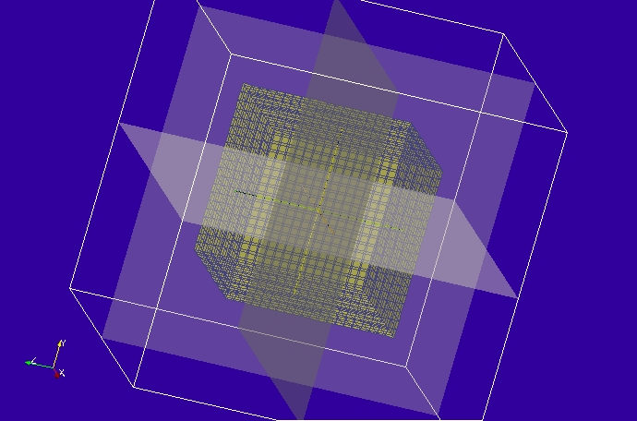

Material description:
None

Mesh:
0.1m cell size

Excitation:
Gaussian plane wave launched from internal Huygens surface

Output:
E and H fields on cell centres and faces plus surface field output for animation of fields.

Runtime:
20ns

Other Notes:

Post processing:
Create animations from surface field outputs

Reference results:

Huygens surface

K vector= 0.577310 0.577310 0.577430
E vector= 0.110775 0.645266 -0.755884
H vector= -0.002147 0.001328 0.000819

GGI_TLM Input file:

Mesh_outer_boundary_dimension
-2.0 2.0 -2.0 2.0 -2.0 2.0

Mesh_dimensions_in_cells
40 40 40 ( 3*integer)

Outer_boundary_reflection_coefficient
0.0 0.0 0.0 0.0 0.0 0.0

Surface_list
4 Number of surfaces
1 SURFACE_NUMBER
rectangular_block
2.0 2.0 2.0 surface parameters
0.0 0.0 0.0
0.0 0.0 0.0
2 SURFACE_NUMBER
xplane
0.0 -2.0 -2.0 0.0 2.0 2.0 surface parameters
0.0 0.0 0.0
0.0 0.0 0.0
3 SURFACE_NUMBER
yplane
-2.0 0.0 -2.0 2.0 0.0 2.0 surface parameters
0.0 0.0 0.0
0.0 0.0 0.0
4 SURFACE_NUMBER
zplane
-2.0 -2.0 0.0 2.0 2.0 0.0 surface parameters
0.0 0.0 0.0
0.0 0.0 0.0

Point_list
1 Number of points (integer)
1 point_number (integer)
0.0 0.0 0.0 point coordinates (n*real)
0.0 0.0 0.0
0.0 0.0 0.0

Excitation_function_list
1 ! number of excitations
1 ! EXCITATION NUMBER
gaussian
1.0 2e-9 6e-9

Huygens_surface
1 surface number
1 side of surface for excitation
1 excitation function number
54.73 45.0 wave vector Theta and Phi
1.0 0.5 Polarisation theta and Phi

Output_point_list
30 ! number of output points
1 ! OUTPUT NUMBER
1 ! output point
Ex
centre
2 ! OUTPUT NUMBER
1 ! output point
Ex
ymin
3 ! OUTPUT NUMBER
1 ! output point
Ex
ymax
4 ! OUTPUT NUMBER
1 ! output point
Ex
zmin
5 ! OUTPUT NUMBER
1 ! output point
Ex
zmax
6 ! OUTPUT NUMBER
1 ! output point
Ey
centre
7 ! OUTPUT NUMBER
1 ! output point
Ey
xmin
8 ! OUTPUT NUMBER
1 ! output point
Ey
xmax
9 ! OUTPUT NUMBER
1 ! output point
Ey
zmin
10 ! OUTPUT NUMBER
1 ! output point
Ey
zmax
11 ! OUTPUT NUMBER
1 ! output point
Ez
centre
12 ! OUTPUT NUMBER
1 ! output point
Ez
xmin
13 ! OUTPUT NUMBER
1 ! output point
Ez
xmax
14 ! OUTPUT NUMBER
1 ! output point
Ez
ymin
15 ! OUTPUT NUMBER
1 ! output point
Ez
ymax
16 ! OUTPUT NUMBER
1 ! output point
Hx
centre
17 ! OUTPUT NUMBER
1 ! output point
Hx
ymin
18 ! OUTPUT NUMBER
1 ! output point
Hx
ymax
19 ! OUTPUT NUMBER
1 ! output point
Hx
zmin
20 ! OUTPUT NUMBER
1 ! output point
Hx
zmax
21 ! OUTPUT NUMBER
1 ! output point
Hy
centre
22 ! OUTPUT NUMBER
1 ! output point
Hy
xmin
23 ! OUTPUT NUMBER
1 ! output point
Hy
xmax
24 ! OUTPUT NUMBER
1 ! output point
Hy
zmin
25 ! OUTPUT NUMBER
1 ! output point
Hy
zmax
26 ! OUTPUT NUMBER
1 ! output point
Hz
centre
27 ! OUTPUT NUMBER
1 ! output point
Hz
xmin
28 ! OUTPUT NUMBER
1 ! output point
Hz
xmax
29 ! OUTPUT NUMBER
1 ! output point
Hz
ymin
30 ! OUTPUT NUMBER
1 ! output point
Hz
ymax

Output_surface_list
3 ! number of output surfaces
1 ! OUTPUT SURFACE NUMBER
2 surface number
-1 ! side of surface for output (+1 or -1)
Emagnitude
output_timestep_information
0 ! first output timestep
120 ! last output timestep
4 ! output timestep interval
2 ! OUTPUT SURFACE NUMBER
3 surface number
-1 ! side of surface for output (+1 or -1)
Emagnitude
output_timestep_information
0 ! first output timestep
120 ! last output timestep
4 ! output timestep interval
3 ! OUTPUT SURFACE NUMBER
4 surface number
-1 ! side of surface for output (+1 or -1)
Emagnitude
output_timestep_information
0 ! first output timestep
120 ! last output timestep
4 ! output timestep interval

Simulation_time
2e-8

GGI_TLM result
