WRAPPING_BOUNDARY

Geometry description:
Empty space with internal source point for testing wrapping boundary conditions.
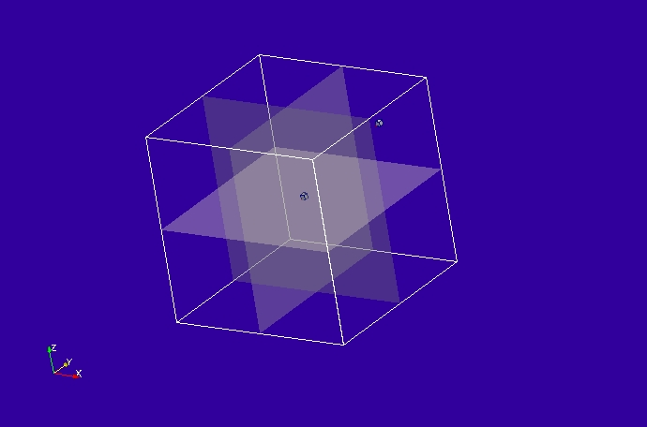

Material description:
None

Mesh:
0.1m cell size

Excitation:
Gaussian E field source at a point.

Output:
Field at an observation point plus fields on surfaces for visualisation

Runtime:
20ns

Other Notes:

Post processing:
Create animations from surface field outputs

Reference results:

GGI_TLM Input file:

Mesh_outer_boundary_dimension
-2.0 2.0 -2.0 2.0 -2.0 2.0

Mesh_cell_dimension
0.10

Outer_boundary_reflection_coefficient
1.0 1.0 1.0 1.0 1.0 1.0

Wrapping_boundary_conditions
1 1 1

Surface_list
3 Number of surfaces
1 SURFACE_NUMBER
xplane
0.0 -2.0 -2.0 0.0 2.0 2.0 surface parameters
0.0 0.0 0.0
0.0 0.0 0.0
2 SURFACE_NUMBER
yplane
-2.0 0.0 -2.0 2.0 0.0 2.0 surface parameters
0.0 0.0 0.0
0.0 0.0 0.0
3 SURFACE_NUMBER
zplane
-2.0 -2.0 0.0 2.0 2.0 0.0 surface parameters
0.0 0.0 0.0
0.0 0.0 0.0

Point_list
2 Number of points (integer)
1 point_number (integer)
1.2 1.2 1.2 point coordinates (n*real)
0.0 0.0 0.0
0.0 0.0 0.0
2 point_number (integer)
0.0 0.0 0.0 point coordinates (n*real)
0.0 0.0 0.0
0.0 0.0 0.0

Excitation_function_list
1 ! number of excitations
1 ! EXCITATION NUMBER
gaussian_sinusoid
1.0 1e-9 3e-9 1e8 0.0

Excitation_point_list
1 ! number of output points
1 ! EXCITATION POINT NUMBER
1 ! excitation function number
1 ! excitation point
Ex
centre
soft

Output_point_list
1 ! number of output points
1 ! OUTPUT NUMBER
1 ! output point
Ex
centre

Output_surface_list
3 ! number of output surfaces
1 ! OUTPUT SURFACE NUMBER
1 surface number
-1 ! side of surface for output (+1 or -1)
Emagnitude
output_timestep_information
0 ! first output timestep
120 ! last output timestep
4 ! output timestep interval
2 ! OUTPUT SURFACE NUMBER
2 surface number
-1 ! side of surface for output (+1 or -1)
Emagnitude
output_timestep_information
0 ! first output timestep
120 ! last output timestep
4 ! output timestep interval
3 ! OUTPUT SURFACE NUMBER
3 surface number
-1 ! side of surface for output (+1 or -1)
Emagnitude
output_timestep_information
0 ! first output timestep
120 ! last output timestep
4 ! output timestep interval

Simulation_time
2e-8

GGI_TLM result
