SHIELDING_EFFECTIVENESS_BOX_SLOT

Geometry description:
Rectangular box with a slot in the front face for shielding effectiveness calculation.
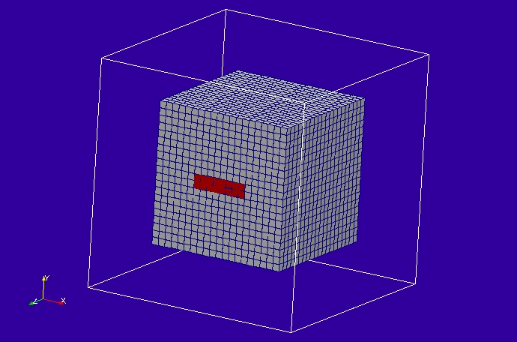

Material description:
All surfaces are PEC

Mesh:
0.1m

Excitation:
Gaussian plane wave launched from the outer boundary of the problem space.

Output:
Ey field component at the centre of the box

Runtime:
5μs

Other Notes:

Post processing:
Fourier transform the incident field amplitude (excitation function) and the the field at the centre of the box and divide to give the shielding effectiveness.

Reference results:

GGI_TLM Input file:
# Box with slot for shielding effectiveness calculation

Mesh_outer_boundary_dimension
-1.60 1.60 -1.60 1.60 -1.60 1.60

# Specify the mesh dimensions
Mesh_cell_dimension
0.10

Outer_boundary_reflection_coefficient
0.0 0.0 0.0 0.0 0.0 0.0

Surface_list
2 Number of surfaces
1 SURFACE_NUMBER
rectangular_block
2.0 2.0 2.0 surface parameters (n*real)
0.0 0.0 0.0
0.0 0.0 0.0
2 SURFACE_NUMBER
rectangle
0.8 0.2 surface parameters (n*real)
0.0 0.0 0.0
0.0 0.0 1.0

Point_list
1 Number of points (integer)
1 POINT_NUMBER (integer)
0.0 0.0 0.0 point coordinates (n*real)
0.0 0.0 0.0
0.0 0.0 0.0

Surface_material_list
2 Number of surface materials
1 SURFACE MATERIAL NUMBER
PEC
1 number of surfaces
1 surface list
1 surface orientation list
2 SURFACE MATERIAL NUMBER
FREE_SPACE
1 number of surfaces
2 surface list
1 surface orientation list

Excitation_function_list
1 ! number of excitation functions
1 ! EXCITATION NUMBER
gaussian
1.0 1e-9 5e-9

Huygens_surface
0 surface number
1 side of surface for excitation
1 excitation function number
180.0 90.0 wave vector
1.0 0.0 polarisation

Output_point_list
1 ! number of output points
1 ! OUTPUT NUMBER
1 ! output point
Ey
centre

Simulation_time
5e-6

GGI_TLM result
