HUMAN_HEAD_MODEL

Geometry description:
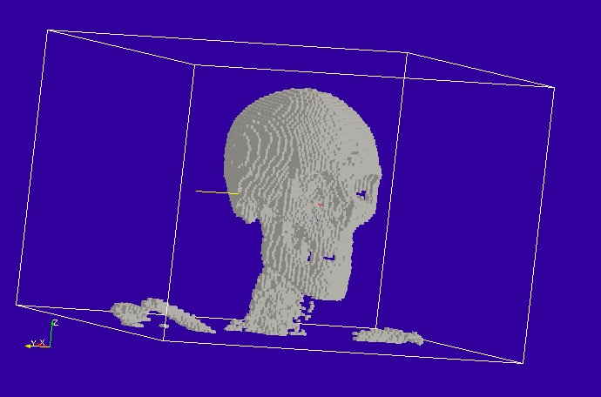
Bone
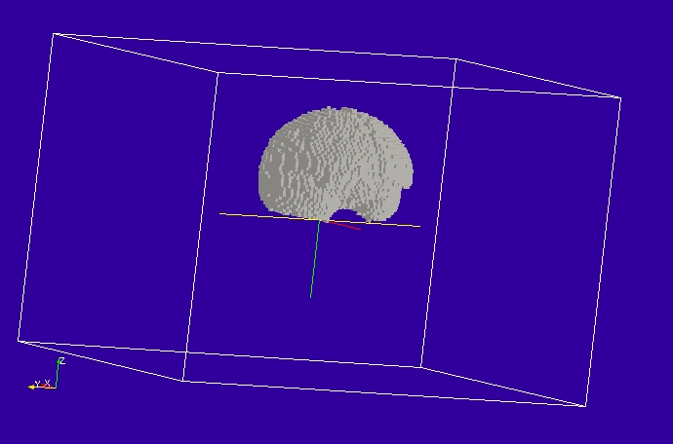
Grey matter
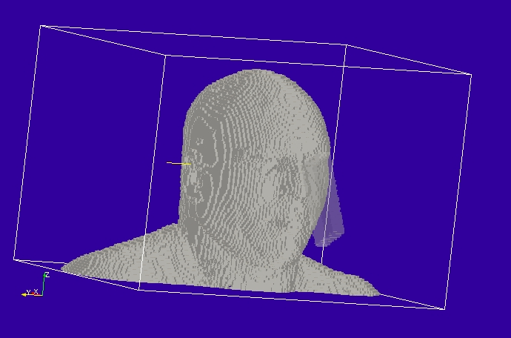
Fat and mobile phone model

Material description:

There are 15 materials in the model.
blood
bone
cartilage
csf
eyelens
eyevitreous
fat
ganglia
greymatter
marrow
mucousmembrane
muscle
neuron
skin
whitematter

Each is modelled using a 4th order dispersion relation represented as four Debye poles. These materials models are described in the reference:
J.Paul, C.Christopoulos, D.W.P.Thomas, “Modelling The Dielectric Properties of Biological Tissues Using Debye Relations,” ******NEED TO COMPLETE REFERENCE*******
For example the Debye representation of the dispersion relation of blood is represented as:
Eps_inf= 6.30755

Chi_1= 32.1491 Tau_1= 6.13337E-12s
Chi_2= 19.8835 Tau_2= 14.6686E-12
Chi_3= 12.0503 Tau_3= 235.489E-12
Chi_4= 16289.4 Tau_4= 123.394E-9
Sigma_e: 0.0

This pole-residue form has been transformed into the rational function form used by GGI_TLM giving the volume material file:
# blood
10000000. 2.00000000E+10 # frequency range of validity
# permittivity filter
1000000000000.0000 w normalisation constant
4 # a order, a coefficients follow below:
16359.790450000000 12875299.192196969 1897037955.7779787 21608626265.938667 16489716937.238459
4 # b order, b coefficients follow below:
1.0000000000000000 123650.29097000000 31629756.555244513 615584873.00524962 2614282397.6406779
0.0000000000000000 # electric conductivity
# permeability filter
1.0000000000000000 # w normalisation constant
0 # a order, a coefficients follow below:
1.0000000000000000
0 # b order, b coefficients follow below:
1.0000000000000000
0.0000000000000000 # magnetic conductivity

The frequency response of this material model is shown in the figure below.
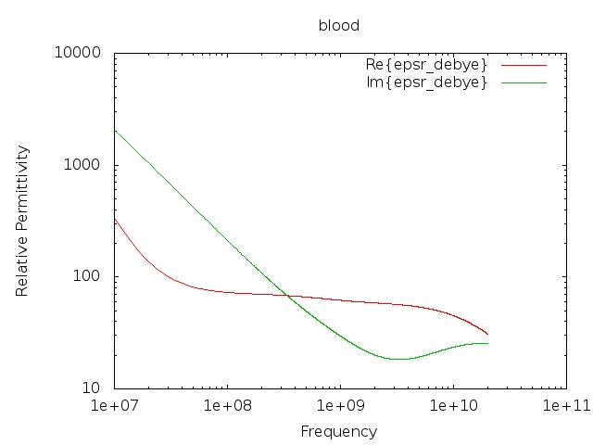
Frequency domain relative permittivity of blood model.

The other materials in the model have been modelled in a similar manner.

Mesh:

Excitation:

Output:

Runtime:

Other Notes:

Post processing:

Reference results:

GGI_TLM Input file:

Mesh_outer_boundary_dimension
0.0e-3 303.0e-3 0.0e-3 465.0e-3 0.0e-3 303.0e-3

Mesh_cell_dimension
0.003 ! 3mm mesh

Outer_boundary_reflection_coefficient
0.0 0.0 0.0 0.0 0.0 0.0

Point_list
4 Number of points (integer)
1 POINT_NUMBER
-18.0e-3 0.0e-3 50e-3
0.0 -30.0 0.0
0.120 0.126 0.120
2 POINT_NUMBER
0.0e-3 0.0e-3 50e-3
0.0 -30.0 0.0
0.120 0.126 0.120
3 POINT_NUMBER
18.0e-3 0.0e-3 50e-3
0.0 -30.0 0.0
0.120 0.126 0.120
4 point_number (integer)
101.5e-3 232.5e-3 101.5e-3 point coordinates
0.0 0.0 0.0
0.0 0.0 0.0

Line_list
2 Number of lines
1 LINE_NUMBER
straight_line2
-18.0e-3 0.0e-3 50e-3 0.0e-3 0.0e-3 50e-3 line parameters
0.0 -30.0 0.0
0.120 0.126 0.120
2 LINE_NUMBER
straight_line2
0.0e-3 0.0e-3 50e-3 18.0e-3 0.0e-3 50e-3 line parameters
0.0 -30.0 0.0
0.120 0.126 0.120

Surface_list
4 Number of surfaces
1 SURFACE_NUMBER
xplane
151.5e-3 0.0e-3 0.0e-3 151.5e-3 465.0e-3 303.0e-3 surface parameters
0.0 0.0 0.0
0.0 0.0 0.0
2 SURFACE_NUMBER
yplane
0.0e-3 232.5e-3 0.0e-3 303.0e-3 232.5e-3 303.0e-3 surface parameters
0.0 0.0 0.0
0.0 0.0 0.0
3 SURFACE_NUMBER
zplane
0.0e-3 0.0e-3 151.5e-3 303.0e-3 465.0e-3 151.5e-3 surface parameters
0.0 0.0 0.0
0.0 0.0 0.0
4 SURFACE_NUMBER
rectangular_block
44e-3 16e-3 110e-3 surface parameters
0.0 -30.0 0.0
0.120 0.126 0.120

Volume_list
15 Number of volumes
1 VOLUME_NUMBER
tet_volume_mesh
blood.msh
1.0 volume parameters (scale factor)
0.0 0.0 0.0
0.0 0.0 0.0
2 VOLUME_NUMBER
tet_volume_mesh
bone.msh
1.0 volume parameters (scale factor)
0.0 0.0 0.0
0.0 0.0 0.0
3 VOLUME_NUMBER
tet_volume_mesh
cartilage.msh
1.0 volume parameters (scale factor)
0.0 0.0 0.0
0.0 0.0 0.0
4 VOLUME_NUMBER
tet_volume_mesh
csf.msh
1.0 volume parameters (scale factor)
0.0 0.0 0.0
0.0 0.0 0.0
5 VOLUME_NUMBER
tet_volume_mesh
eyelens.msh
1.0 volume parameters (scale factor)
0.0 0.0 0.0
0.0 0.0 0.0
6 VOLUME_NUMBER
tet_volume_mesh
eyevitreous.msh
1.0 volume parameters (scale factor)
0.0 0.0 0.0
0.0 0.0 0.0
7 VOLUME_NUMBER
tet_volume_mesh
fat.msh
1.0 volume parameters (scale factor)
0.0 0.0 0.0
0.0 0.0 0.0
8 VOLUME_NUMBER
tet_volume_mesh
ganglia.msh
1.0 volume parameters (scale factor)
0.0 0.0 0.0
0.0 0.0 0.0
9 VOLUME_NUMBER
tet_volume_mesh
greymatter.msh
1.0 volume parameters (scale factor)
0.0 0.0 0.0
0.0 0.0 0.0
10 VOLUME_NUMBER
tet_volume_mesh
marrow.msh
1.0 volume parameters (scale factor)
0.0 0.0 0.0
0.0 0.0 0.0
11 VOLUME_NUMBER
tet_volume_mesh
mucousmembrane.msh
1.0 volume parameters (scale factor)
0.0 0.0 0.0
0.0 0.0 0.0
12 VOLUME_NUMBER
tet_volume_mesh
muscle.msh
1.0 volume parameters (scale factor)
0.0 0.0 0.0
0.0 0.0 0.0
13 VOLUME_NUMBER
tet_volume_mesh
neuron.msh
1.0 volume parameters (scale factor)
0.0 0.0 0.0
0.0 0.0 0.0
14 VOLUME_NUMBER
tet_volume_mesh
skin.msh
1.0 volume parameters (scale factor)
0.0 0.0 0.0
0.0 0.0 0.0
15 VOLUME_NUMBER
tet_volume_mesh
whitematter.msh
1.0 volume parameters (scale factor)
0.0 0.0 0.0
0.0 0.0 0.0

Volume_material_list
15 Number of volume materials (integer)
1 VOLUME MATERIAL NUMBER
DISPERSIVE
MATERIAL_DIRECTORY/blood
1 number of volumes
1 volume list
2 VOLUME MATERIAL NUMBER
DISPERSIVE
MATERIAL_DIRECTORY/bone
1 number of volumes
2 volume list
3 VOLUME MATERIAL NUMBER
DISPERSIVE
MATERIAL_DIRECTORY/cartilage
1 number of volumes
3 volume list
4 VOLUME MATERIAL NUMBER
DISPERSIVE
MATERIAL_DIRECTORY/csf
1 number of volumes
4 volume list
5 VOLUME MATERIAL NUMBER
DISPERSIVE
MATERIAL_DIRECTORY/eyelens
1 number of volumes
5 volume list
6 VOLUME MATERIAL NUMBER
DISPERSIVE
MATERIAL_DIRECTORY/eyevitreous
1 number of volumes
6 volume list
7 VOLUME MATERIAL NUMBER
DISPERSIVE
MATERIAL_DIRECTORY/fat
1 number of volumes
7 volume list
8 VOLUME MATERIAL NUMBER
DISPERSIVE
MATERIAL_DIRECTORY/ganglia
1 number of volumes
8 volume list
9 VOLUME MATERIAL NUMBER
DISPERSIVE
MATERIAL_DIRECTORY/greymatter
1 number of volumes
9 volume list
10 VOLUME MATERIAL NUMBER
DISPERSIVE
MATERIAL_DIRECTORY/marrow
1 number of volumes
10 volume list
11 VOLUME MATERIAL NUMBER
DISPERSIVE
MATERIAL_DIRECTORY/mucousmembrane
1 number of volumes
11 volume list
12 VOLUME MATERIAL NUMBER
DISPERSIVE
MATERIAL_DIRECTORY/muscle
1 number of volumes
12 volume list
13 VOLUME MATERIAL NUMBER
DISPERSIVE
MATERIAL_DIRECTORY/neuron
1 number of volumes
13 volume list
14 VOLUME MATERIAL NUMBER
DISPERSIVE
MATERIAL_DIRECTORY/skin
1 number of volumes
14 volume list
15 VOLUME MATERIAL NUMBER
DISPERSIVE
MATERIAL_DIRECTORY/whitematter
1 number of volumes
15 volume list

Cable_geometry_list
1 number of cable geometries
1 cable geometry number, Cable geometry type (file name) follows:
CABLE_DIRECTORY/0.1mm_single_wire

Cable_list
2 number of cables
1 CABLE NUMBER
1 cable geometry number
1 number of lines on cable route
1 cable line list
1 end 1 junction number
2 end 2 junction number
2 CABLE NUMBER
1 cable geometry number
1 number of lines on cable route
2 cable line list
2 end 1 junction number
3 end 2 junction number

Cable_output_list
1 number of cable_outputs
1 CABLE OUTPUT NUMBER
1 cable number
2 closest point number

Cable_junction_list
3 number of junctions
1 JUNCTION NUMBER
1 junction point
1 number of internal connection nodes (n_int)
1 number of cables
1 cable list
1 corresponding cable end number list
1 Cable 1 number of external conductors (n_ext)
1 Cable 1 P matrix: matrix (n_int rows* n_ext columns)
0 Cable 1 voltage function source list
0.0 Cable 1 impedance list
0 Number of internal impedances
2 JUNCTION NUMBER
2 junction point
1 number of internal connection nodes (n_int)
2 number of cables
1 2 cable list
2 1 corresponding cable end number list
1 Cable 1 number of external conductors (n_ext)
1 Cable 1 P matrix: matrix (n_int rows* n_ext columns)
1 Cable 1 voltage source function list
25.0 Cable 1 impedance list
1 Cable 2 number of external conductors (n_ext)
1 Cable 2 P matrix: matrix (n_int rows* n_ext columns)
1 Cable 2 voltage source function list
25.0 Cable 2 impedance list
0 Number of internal impedances
3 JUNCTION NUMBER
3 junction point
1 number of internal connection nodes (n_int)
1 number of cables
2 cable list
2 corresponding cable end number list
1 Cable 2 number of external conductors (n_ext)
1 Cable 2 P matrix: matrix (n_int rows* n_ext columns)
0 Cable 2 voltage function source list
0.0 Cable 2 impedance list
0 Number of internal impedances

Excitation_function_list
1 ! number of excitations
1 ! EXCITATION NUMBER
gaussian_step_sinusoid
1.0 1e-9 3e-9 900e6 0.0 ! period 1.111ns

Output_point_list
1 ! number of output points
1 ! OUTPUT NUMBER
4 ! output point
Ez
centre

Output_surface_list
3 ! number of output surfaces
1 ! OUTPUT SURFACE NUMBER
1 surface number
1 ! side of surface for output (+1 or -1)
Emagnitude
output_timestep_information
0 ! first output timestep
2000 ! last output timestep
20 ! output timestep interval
2 ! OUTPUT SURFACE NUMBER
2 surface number
1 ! side of surface for output (+1 or -1)
Emagnitude
output_timestep_information
0 ! first output timestep
2000 ! last output timestep
20 ! output timestep interval
3 ! OUTPUT SURFACE NUMBER
3 surface number
1 ! side of surface for output (+1 or -1)
Emagnitude
output_timestep_information
0 ! first output timestep
2000 ! last output timestep
20 ! output timestep interval

Simulation_time
10e-9

GGI_TLM result
