Thin layer stability test

Geometry description:
Rectangular TEM transmission line, 2.0m×2.0m×2.0m with perfectly conducting walls on the ±y and ±z boundaries and perfect magnetic conductor walls on the ±x boundaries.

Thin layer Material
2m
z
y
2m
x
2m

Material description:
The transmission line is loaded with a 0.6m×0.6m thin layer material surface at the centre of the cavity.

Mesh:
20×20×20 cells

Excitation:
Impulse Ey over the xy cross section of the transmission line at z=-0.5m.

Output:
Both Ey at the centre of the cavity i.e. inside the material volume.

Runtime:
1µs

Post processing:
None

Material data

The dispersive sheet is a first order material model in which Z₁₁= Z₁₂ =Z₂₁= Z₂₂.
The material filter specification is:
# First order dispersive material sheet
0.0 1e8 # frequency range of validity
# Z11 filter
1.0e8 # wnormalisation constant
1 # a order
377.0 100.0 # a coefficients
1 # b order
1.0 0.750 # b coefficients
# Z12 filter
1.0e8 # wnormalisation constant
1 # a order
377.0 100.0 # a coefficients
1 # b order
1.0 0.750 # b coefficients
# Z21 filter
1.0e8 # wnormalisation constant
1 # a order
377.0 100.0 # a coefficients
1 # b order
1.0 0.750 # b coefficients
# Z22 filter
1.0e8 # wnormalisation constant
1 # a order
377.0 100.0 # a coefficients
1 # b order
1.0 0.750 # b coefficients

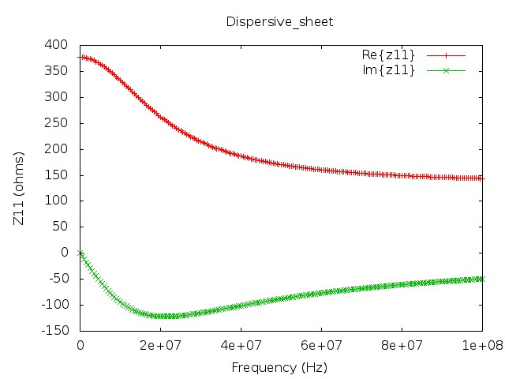

GGI_TLM Input file
# TEM cell model

Mesh_outer_boundary_dimension
-1.0 1.0 -1.0 1.0 -1.0 1.0

Mesh_cell_dimension
0.1

Outer_boundary_reflection_coefficient
1.0 1.0 -1.0 -1.0 -1.0 -1.0

Surface_list
2 Number of surfaces
1 SURFACE_NUMBER
rectangle
1.0 1.0 surface parameters
0.0 0.0 0.0
0.0 0.0 -0.5
2 SURFACE_NUMBER
rectangle
0.6 0.6 surface parameters
0.0 0.0 0.0
0.0 0.0 0.0

Point_list
1 Number of points
1 POINT_NUMBER
0.0 0.0 0.0 point coordinates
0.0 0.0 0.0
0.0 0.0 0.0

Surface_material_list
1 Number of surface materials
1 SURFACE MATERIAL NUMBER
DISPERSIVE
MATERIAL_DIRECTORY/Dispersive_sheet
1 number of surfaces
2 surface list
1 surface orientation list

Excitation_function_list
1 ! number of excitation functions
1 ! EXCITATION_FUNCTION_NUMBER
impulse
1.0 0.0

Huygens_surface
1 surface number
1 excitation function number
0.0 90.0 wave vector Theta and Phi
1.0 0.0 Polarisation theta and Phi

Output_point_list
1 ! number of output points
1 ! OUTPUT NUMBER
1 ! output point
Ey
centre

Simulation_time
1e-6

GGI_TLM results

