# Mlayer

Calculate the S parameters and impedance parameters of a multi-layer stack of materials. The materials may be dielectric/ magnetic material layers or impedance boundaries. Layers may have frequency dependent properties. The stack is illuminated by a plane wave at a specified angle and polarisation.

All materials are characterised by frequency dependent properties which are defined in appropriate files.

A dielectric/ magnetic material is specified by its properties and a thickness, impedance boundary layers have no physical thickness and are specified by the impedance matrix alone.

The polarisation is specified as either transverse electric (TE) or transverse magnetic (TM) to the normal direction of plane of the problem. The figures below show polarisation where the plane of the problem is defined to be the xz plane.

## Geometry description, TE polarisation.

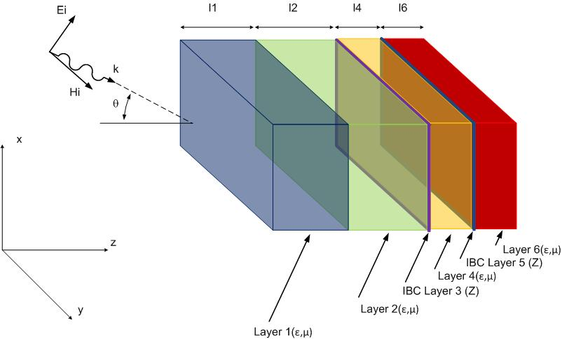

## Geometry description, TM polarisation.

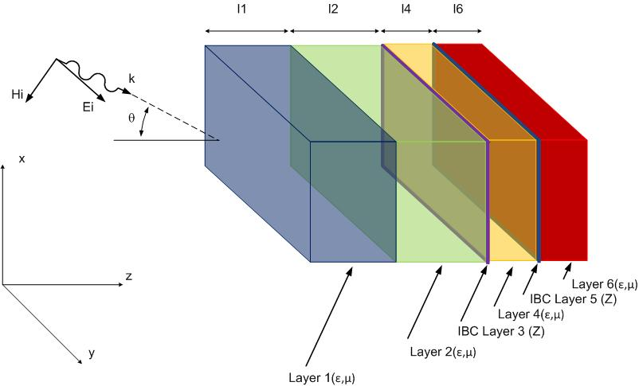

Run with the command:

**Mlayer**

inputs:

The Mlayer program accepts the structure data in an input file. The program prompts the user for the filename containing the structure data without the **.inp** extension.

The **.inp** file has the following structure:

number of layers

incident angle (measured from normal) in degrees

polarisation: either **TE** or **TM**

minimum frequency maximum frequency frequency step

for each layer:

layer number

layer type: either **MATERIAL** or **THIN_LAYER**

if the layer type is **MATERIAL** then layer thickness (metres)

example: A three layer structure consisting of two IBC layers separated by a region of air.

**3**  : number of layers

**0.0** : incident angle (measured from normal)

**TE** : incident polarisation (TE/TM)

**0.1e6 300e6 1e6** : fmin,fmax fstep

**1**  : LAYER NUMBER

**THIN_LAYER** : layer type (MATERIAL or THIN_LAYER)

**/home/cs/EM_MODEL_DATA/MATERIAL_DATA/three_layer_half_IBC**

**2**  : LAYER NUMBER

**MATERIAL** : layer type (MATERIAL or THIN_LAYER)

**0.20** : Thickness of material layer

**/home/cs/EM_MODEL_DATA/MATERIAL_DATA/air**

**3**  : LAYER NUMBER

**THIN_LAYER** : layer type (MATERIAL or THIN_LAYER)

**/home/cs/EM_MODEL_DATA/MATERIAL_DATA/three_layer_half_IBC**

Outputs:

Mlayer outputs S parameter data, Z parameter data and scattered energy data. If the structure is defined in a file **NAME.inp** then the S parameterdata is written to the files:

**NAME.S11**

**NAME.S12**

**NAME.S21**

**NAME.S22**

The format of these files is:

Frequency real{S} Imag{S} Magnitude{S} Phase{S}

The impedance parameters are written to the files:

**NAME.Z11**

**NAME.Z12**

**NAME.Z21**

**NAME.Z22**

The format of these files is:

Frequency real{Z} Imag{Z} Magnitude{Z} Phase{Z}

The scattered power when waves are incident from left and right is written to the file:

**NAME.Pout**

The format of this file is:

Frequency Scattered power (incident from side 1) Scattered Power (incident from side 2)