**Revisiting afro-alpine Lake Garba Guracha in the Bale Mountains of Ethiopia - rationale, chronology, geochemistry, and paleoenvironmental implications**

L. Bittner1,2, M. Bliedtner3, D. Grady4, G. Gil-Romera4,5, C. Martin-Jones6,7, B. Lemma1, B. Mekonnen8,1,

H. Lamb4, H. Yang9, B. Glaser1, S. Szidat10, G. Salazar10, N. Rose9, L. Opgenoorth11, G. Miehe12, W. Zech8,

M. Zech2

-Supplementary Data-

_

Table S1. Chronology BAL-GGU17-AB. Uncertainties of 14C ages refer to 68% probabilities (1σ), whereas ranges of calendar ages represent 95% probabilities (2σ). 14C ages were calibarated with IntCal13

|  |  |  |  |  |  |  |  |
| --- | --- | --- | --- | --- | --- | --- | --- |
| **Lab. Name** | **Dating lab code** | **IPE-CSIC/**  **UH code** | **Dating method** | **Depth (cm)** |  | **Uncertainty (yr)** | **Calendar ages (cal BP)** |
|  |  | **14C age (BP)** |
|  | BAL0 | BAL0 |  | 0 |  | 1 | -67 |
|  | BAL1.5 | BAL1.5 |  | 1.5 |  | 2 | -64 |
|  | BAL4.5 | BAL4.5 |  | 4.5 |  | 2 | -47 |
|  | BAL6.5 | BAL6.5 |  | 6 |  | 3 | -26 |
|  | BAL7.5 | BAL7.5 |  | 7 |  | 5 | -13 |
|  | BAL8.5 | BAL8.5 |  | 8 |  | 5 | -10 |
|  | BAL9.5 | BAL9.5 |  | 9 |  | 5 | -8 |
|  | BAL10.5 | BAL10.5 |  | 10 |  | 5 | -6 |
|  | BAL12.5 | BAL12.5 |  | 12 |  | 5 | -1 |
|  | BAL14.5 | BAL14.5 |  | 14 |  | 5 | 4 |
|  | BAL16.5 | BAL16.5 |  | 16 |  | 6 | 8 |
| ECRC-  UCL | BAL18.5 | BAL18.5 | 210Pb-137Cs | 18 |  | 6 | 13 |
|  | BAL20.5 | BAL20.5 |  | 20 |  | 6 | 17 |
|  | BAL22.5 | BAL22.5 |  | 22 |  | 7 | 21 |
|  | BAL24.5 | BAL24.5 |  | 24 |  | 7 | 26 |
|  | BAL26.5 | BAL26.5 |  | 26 |  | 8 | 31 |
|  | BAL28.5 | BAL28.5 |  | 28 |  | 9 | 34 |
|  | BAL31.5 | BAL31.5 |  | 31 |  | 10 | 40 |
|  | BAL34.5 | BAL34.5 |  | 34 |  | 11 | 46 |
|  | BAL38.5 | BAL38.5 |  | 38 |  | 13 | 56 |
|  | BAL42.5 | BAL42.5 |  | 42 |  | 14 | 68 |
|  | BAL46.5 | BAL46.5 |  | 46 |  | 15 | 78 |
|  | BAL51.5 | BAL51.5 |  | 51 |  | 18 | 94 |
|  | BE-7931.1.1 | GG1B1 | 14C-Bulk Sediment | 105 | 935 | 118 | 662-1081 |
|  | BE-8273.1.1 | GG1B1A | 14C-n-alkane | 105 | 1076 | 79 | 892-1180 |
|  | BE-8282.1.1 | 2L15.16 | 14C-Charcoal | 185 | 2124 | 129 | 1779-2366 |
|  | BE-7930.1.1 | GG1B2 | 14C-Bulk Sediment | 205 | 2323 | 111 | 2110-2722 |
|  | BE-8272.1.1 | GG1B2A | 14C-n-alkane | 205 | 2399 | 101 | 2302-2743 |
|  | BE-8271.1.1 | GG1B3A | 14C-n-alkane | 303 | 3476 | 89 | 3556-3979 |
| LARA  Bern | BE-7929.1.1 | GG1B3 | 14C-Bulk Sediment | 303 | 3517 | 111 | 3555-4091 |
| BE-8270.1.1 | GG1B5A | 14C-n-alkane | 503 | 5789 | 109 | 6391-6804 |
|  | BE-7928.1.1 | GG1B5 | 14C-Bulk Sediment | 503 | 5794 | 135 | 6305-6903 |
|  | BE-8269.1.1 | GG1B6A | 14C-n-alkane | 602 | 6967 | 123 | 7589-8003 |
|  | BE-7927.1.1 | GG1B6 | 14C-Bulk Sediment | 602 | 7320 | 144 | 7922-8404 |
|  | BE-8268.1.1 | GG1B7A | 14C-n-alkane | 700 | 8267 | 137 | 8973-9535 |
|  | BE-7926.1.1 | GG1B7 | 14C-Bulk Sediment | 700 | 8753 | 156 | 9516-10201 |
|  | BE-8279.1.1 | 7L35.36 | 14C-Charcoal | 705 | 8753 | 162 | 9496-10206 |

|  |  |  |  |  |  |  |  |
| --- | --- | --- | --- | --- | --- | --- | --- |
|  | BE-7925.1.1* | GG1B8 | 14C-Bulk Sediment | 794 | 10214 | 203 | 11267-12531 |
|  | BE-8267.1.1* | GG1B8A | 14C-n-alkane | 794 | 9301 | 273 | 9740-11235 |
|  | BE-8266.1.1 | GG1B9A | 14C-n-alkane | 898 | 9650 | 155 | 10545-11368 |
|  | BE-7924.1.1 | GG1B9 | 14C-Bulk Sediment | 898 | 9706 | 175 | 10563-11640 |
|  | BE-8276.1.1 | 9L55.56 | 14C-Charcoal | 925 | 10925 | 364 | 11823-13567 |
|  | D-AMS 033974* | GG1B015 |  | 15 | 180 | 23 | 140-289 |
|  | D-AMS 033975* | GG1B025 |  | 25 | 310 | 23 | 304-456 |
|  | D-AMS 033976* | GG1B045 |  | 45 | 524 | 26 | 510-624 |
|  | D-AMS 033977* | GG1B8C |  | 821 | 10243 | 46 | 11773-12140 |
| Direct AMS | D-AMS 029493 | GG1B10 |  | 998 | 11110 | 48 | 12828- 13082 |
|  |  | 14C Bulk Sediment |  |  |  |  |
| D-AMS 029494 | GG1B11 |  | 1108 | 11377 | 50 | 13102- 13313 |
|  | D-AMS 029495 | GG1B12 |  | 1218 | 12181 | 51 | 13906-14230 |
|  | D-AMS 027899 | GG1B15 |  | 1493 | 12977 | 53 | 15291-15740 |
|  | D-AMS 029496 | GG1B15b |  | 1528 | 12997 | 57 | 15304-15772 |
|  | D-AMS 029497 | GG1B15c |  | 1548 | 13294 | 59 | 15772-16193 |

* Not considered for the age depth model

Table S2. 210Pb concentrations in core BAL-GGU17-1A-1L taken from Lake Garba Guracha, Ethiopia

|  |  |  |  |  |  |  |  |  |  |
| --- | --- | --- | --- | --- | --- | --- | --- | --- | --- |
| Depth | Dry Mass |  |  | Pb-210 |  |  |  | Cum Unsupported | |
|  |  | Total |  | Supported | | Unsupp | | Pb-210 | |
| cm | g cm-2 | Bq Kg-1 | ± | Bq Kg-1 | ± | Bq Kg-1 | ± | Bq m-2 | ± |
| 1.5 | 0.0661 | 1293.51 | 26.68 | 35.51 | 3.12 | 1258 | 26.86 | 855 | 44.6 |
| 4.5 | 0.4389 | 1008.99 | 31.88 | 36.56 | 4.04 | 972.43 | 32.13 | 4989.7 | 228.4 |
| 6.5 | 0.7642 | 709.4 | 29.51 | 34.71 | 4.45 | 674.69 | 29.84 | 7639.3 | 285.4 |
| 7.5 | 0.9188 | 665.94 | 29.15 | 26.44 | 3.94 | 639.5 | 29.42 | 8654.9 | 295.5 |
| 8.5 | 1.0774 | 537.72 | 27.79 | 34.6 | 4.2 | 503.12 | 28.11 | 9556.7 | 302.5 |
| 9.5 | 1.2495 | 377.38 | 15.46 | 41.52 | 2.92 | 335.86 | 15.73 | 10269 | 307.6 |
| 10.5 | 1.4216 | 373.38 | 26.47 | 33.25 | 4.18 | 340.13 | 26.8 | 10850.7 | 310.8 |
| 12.5 | 1.8091 | 291.27 | 15.35 | 42.58 | 2.84 | 248.69 | 15.61 | 11982.3 | 325.3 |
| 14.5 | 2.184 | 210.3 | 14.48 | 38.03 | 2.98 | 172.27 | 14.78 | 12762.6 | 332.8 |
| 16.5 | 2.5007 | 173.6 | 13.65 | 41.31 | 2.9 | 132.29 | 13.95 | 13242.1 | 337.2 |
| 18.5 | 2.8881 | 105.53 | 12.48 | 31.15 | 2.71 | 74.38 | 12.77 | 13631.7 | 341.5 |
| 20.5 | 3.3863 | 98.8 | 8.5 | 32.29 | 1.85 | 66.51 | 8.7 | 13982.3 | 346.4 |
| 22.5 | 3.8918 | 91.72 | 10.6 | 31.87 | 2.54 | 59.85 | 10.9 | 14301.4 | 349.9 |
| 24.5 | 4.3597 | 87.72 | 9.94 | 39.39 | 2.56 | 48.33 | 10.26 | 14553.5 | 353.9 |
| 26.5 | 4.7295 | 65.03 | 7.72 | 32.82 | 2.35 | 32.21 | 8.07 | 14700.4 | 356.1 |
| 28.5 | 5.017 | 83.85 | 8.88 | 39.53 | 2.24 | 44.32 | 9.16 | 14809.5 | 357 |
| 31.5 | 5.5316 | 59.6 | 9.1 | 33.97 | 2.15 | 25.63 | 9.35 | 14985.1 | 359.6 |
| 34.5 | 6.0403 | 72.58 | 6.75 | 39.99 | 1.71 | 32.59 | 6.96 | 15132.5 | 362.5 |
| 38.5 | 6.742 | 54.55 | 10.91 | 38.02 | 2.64 | 16.53 | 11.22 | 15298.5 | 366.7 |
| 42.5 | 7.4532 | 61.55 | 8.65 | 40.91 | 2.29 | 20.64 | 8.95 | 15430.2 | 374.5 |
| 46.5 | 8.1826 | 42.22 | 5.05 | 34.6 | 1.35 | 7.62 | 5.23 | 15525.5 | 379.2 |
| 51.5 | 9.1197 | 40.76 | 5.73 | 35.4 | 1.54 | 5.36 | 5.93 | 15600.3 | 382.3 |

Table S3. Artificial fallout radionuclide concentrations in core BAL-GGU17-1A-1L

|  |  |  |  |  |
| --- | --- | --- | --- | --- |
| Depth | Cs-137 |  | Am-241 | |
| cm | Bq Kg-1 | ± | Bq Kg-1 | ± |
| 1.5 | 50.26 | 2.46 | 0 | 0 |
| 4.5 | 89.11 | 4.22 | 0 | 0 |
| 6.5 | 113.64 | 4.86 | 0 | 0 |
| 7.5 | 140.75 | 5.08 | 2.82 | 1.7 |
| 8.5 | 102.63 | 4.67 | 0 | 0 |
| 9.5 | 42.19 | 2.16 | 0 | 0 |
| 10.5 | 38.21 | 3.22 | 0 | 0 |
| 12.5 | 21.79 | 1.86 | 0 | 0 |
| 14.5 | 21.3 | 1.87 | 0 | 0 |
| 16.5 | 11.01 | 1.37 | 0 | 0 |
| 18.5 | 8.5 | 1.36 | 0 | 0 |
| 20.5 | 8.87 | 0.92 | 0 | 0 |
| 22.5 | 9.52 | 1.34 | 0 | 0 |
| 24.5 | 7.28 | 1.24 | 0 | 0 |
| 26.5 | 3.75 | 1.21 | 0 | 0 |
| 28.5 | 4.49 | 1 | 0 | 0 |
| 31.5 | 2.68 | 0.99 | 0 | 0 |
| 34.5 | 3.41 | 0.71 | 0 | 0 |
| 38.5 | 3.01 | 1.14 | 0 | 0 |
| 42.5 | 0 | 0 | 0 | 0 |
| 46.5 | 0 | 0 | 0 | 0 |
| 51.5 | 0 | 0 | 0 | 0 |

10000

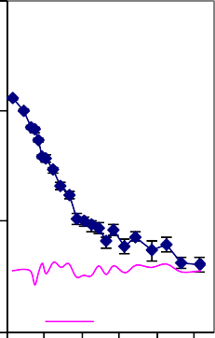

a

sup po rte d 210Pb

1000

Total 210Pb activity (Bq kg -1)

100

10

0

10 20

30 40 50

10000

1000

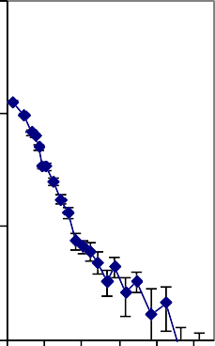

b

Unsupported 210Pb activity (Bq kg -1)

100

10

0

10 20 30 40 50

140

120

137Cs activity (Bq kg-1)

100

80

60

40

20

0

0

20

15

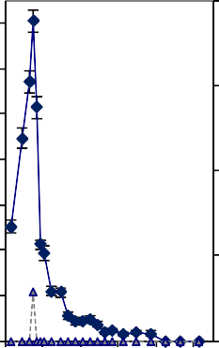

c

241Am activity (Bq kg-1)

10

5

0

10 20 30 40 50

Depth (cm)

Depth (cm)

Depth (cm)

Figure S4. Fallout radionuclide concentrations in core BAL-GGU17-1A-1L taken from Lake Garba Guracha, Ethiopia, showing (a) total 210Pb, (b) unsupported 210Pb, and (c) 137Cs and 241Am concentrations versus depth

Age (yr)

0 20 40 60 80 100 120 140 160 180

0

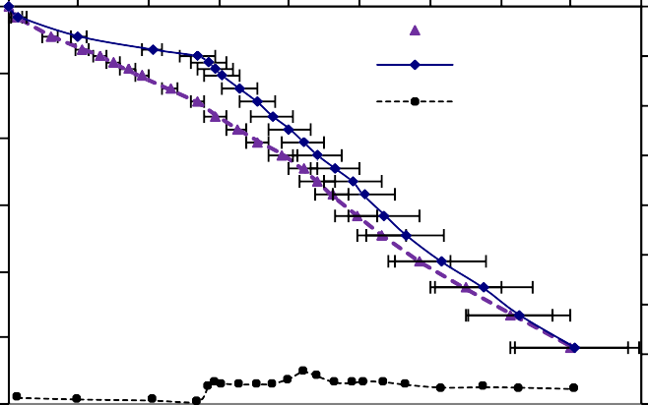

Simple CRS dates

Corrected CRS dates

Sedimentation rates

10

20

Depth (cm)

30

40

50

60

1.6

1.4

Sedimentation rate (g cm -2 y-1)

1.2

1

0.8

0.6

0.4

0.2

0

Figure S5. Radiometric chronology of core BAL-GGU17-1A-1L taken from Lake Garba Guracha, Ethiopia, showing the CRS model 210Pb dates and sedimentation rates

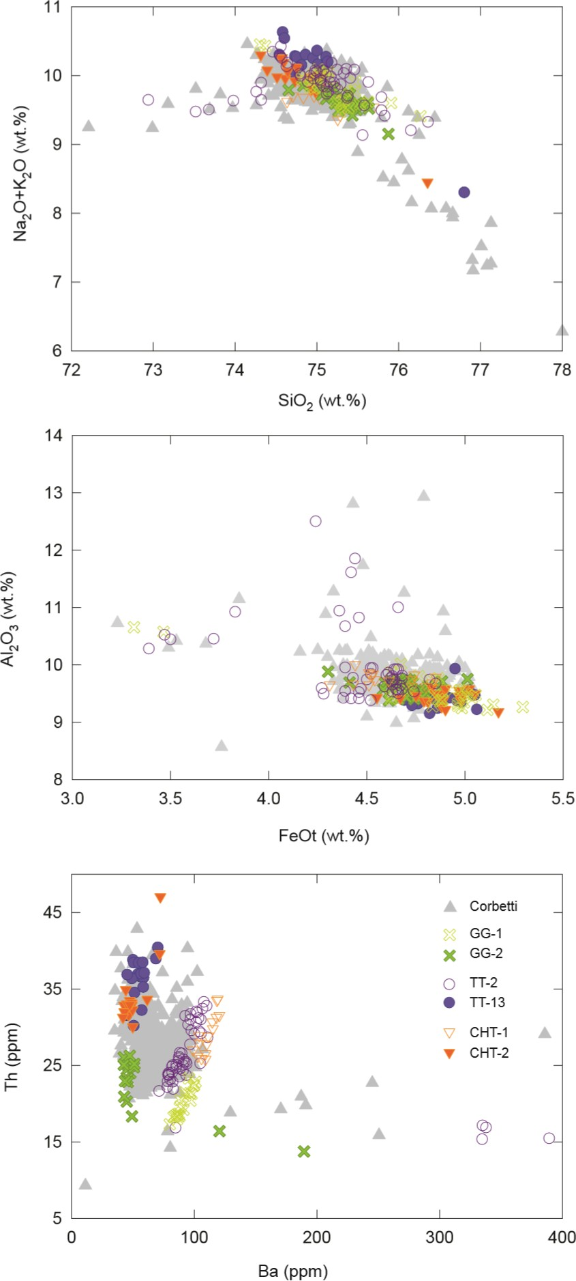

Fig S6. Bi-plots showing the concentrations of major and trace elements in glass shards within the Garba Gurache tephras. The compositions of rocks erupted from the Corbetti is shown in grey for comparison, alongside the composition tephra deposits from two of its largest Holocene eruptions, found at lakes Tilo and Chamo in the central Main Ethiopian Rift. Concentrations of Ba and Th clearly differentiate the tephras. The similarity in Ba/Th ratios suggests that GG-1 correlates to the Tilo tephra TT-2 and CHT-1 at Chamo, whilst GG-2 correlates to TT-13 and CHT-2