NeuraX Hackathon 3.0
Domain 2 · AI in Industry and Automation
NEXORA
Visual Inspection & Defect Root-Cause Assistant
A confidence-aware decision-support system connecting vision, process and profit

RESEARCH BRIEF — CHECKPOINT 1
Team NEXORA
Team Leader: T. Saigeethika
Team Size: 3 Members

Table of Contents
1. Executive Summary
2. Problem Understanding
3. Research Objectives
4. Proposed System Architecture
5. Data Sources
6. Computer Vision Methodology
7. Defect Detection and Localization
8. Confidence-Aware AI
9. Root-Cause Correlation Engine
10. Bottleneck Detection
11. Economic Impact Engine
12. Throughput Analysis
13. What-If Simulation
14. Explainability Layer
15. Proposed Dashboard
16. Technology Stack
17. Evaluation Strategy
18. Robustness to Unseen Conditions
19. Research Reference Dataset
20. Limitations and Assumptions
21. Responsible AI and Industrial Safety
22. Expected System Output
23. Key Innovation
24. Proposed Team Implementation
25. Proposed Development Workflow
26. Conclusion
27. References

1. Executive Summary
Manufacturing plants generate huge volumes of inspection, production and cost data — but quality, process and economics are usually analyzed separately, making it hard to see how one defect affects throughput and profit.
NEXORA is a unified decision-support system that combines computer vision, production analytics, root-cause correlation, bottleneck detection and economic impact estimation into one explainable workflow, answering five questions:
- What is wrong with the product?
- Where is the defect located?
- What process conditions may be contributing to it?
- Where is the production flow constrained?
- What is the resulting impact on throughput, cost and profitability?

The system is confidence-aware — uncertain cases are flagged for review — and all recommendations are simulated/advisory, never direct machine control.

2. Problem Understanding
Product quality, capacity, process conditions and economics are interconnected: a defect is rarely just an image-level problem — it may trace back to a machine, station, batch or process condition. Most industrial AI stops at a single link:
IMAGE → DEFECT

NEXORA extends this to a full evidentiary chain:
IMAGE → DEFECT → LOCATION → PROCESS CONTEXT → ROOT-CAUSE → BOTTLENECK → ECONOMIC IMPACT → RECOMMENDATION

3. Research Objectives
- Defect Detection — classify products via computer vision.
- Defect Localization — identify defect region where data supports it.
- Uncertainty Handling — flag low-confidence / novel cases for review.
- Root-Cause Correlation — link defects to process conditions.
- Bottleneck Identification — flag stations that constrain throughput.
- Economic Impact Estimation — quantify scrap, rework, downtime cost.
- Advisory Recommendations — evidence-based, simulated suggestions.

4. Proposed System Architecture
Five cooperating layers take raw inspection, production and economic data through to an explainable, decision-ready output.
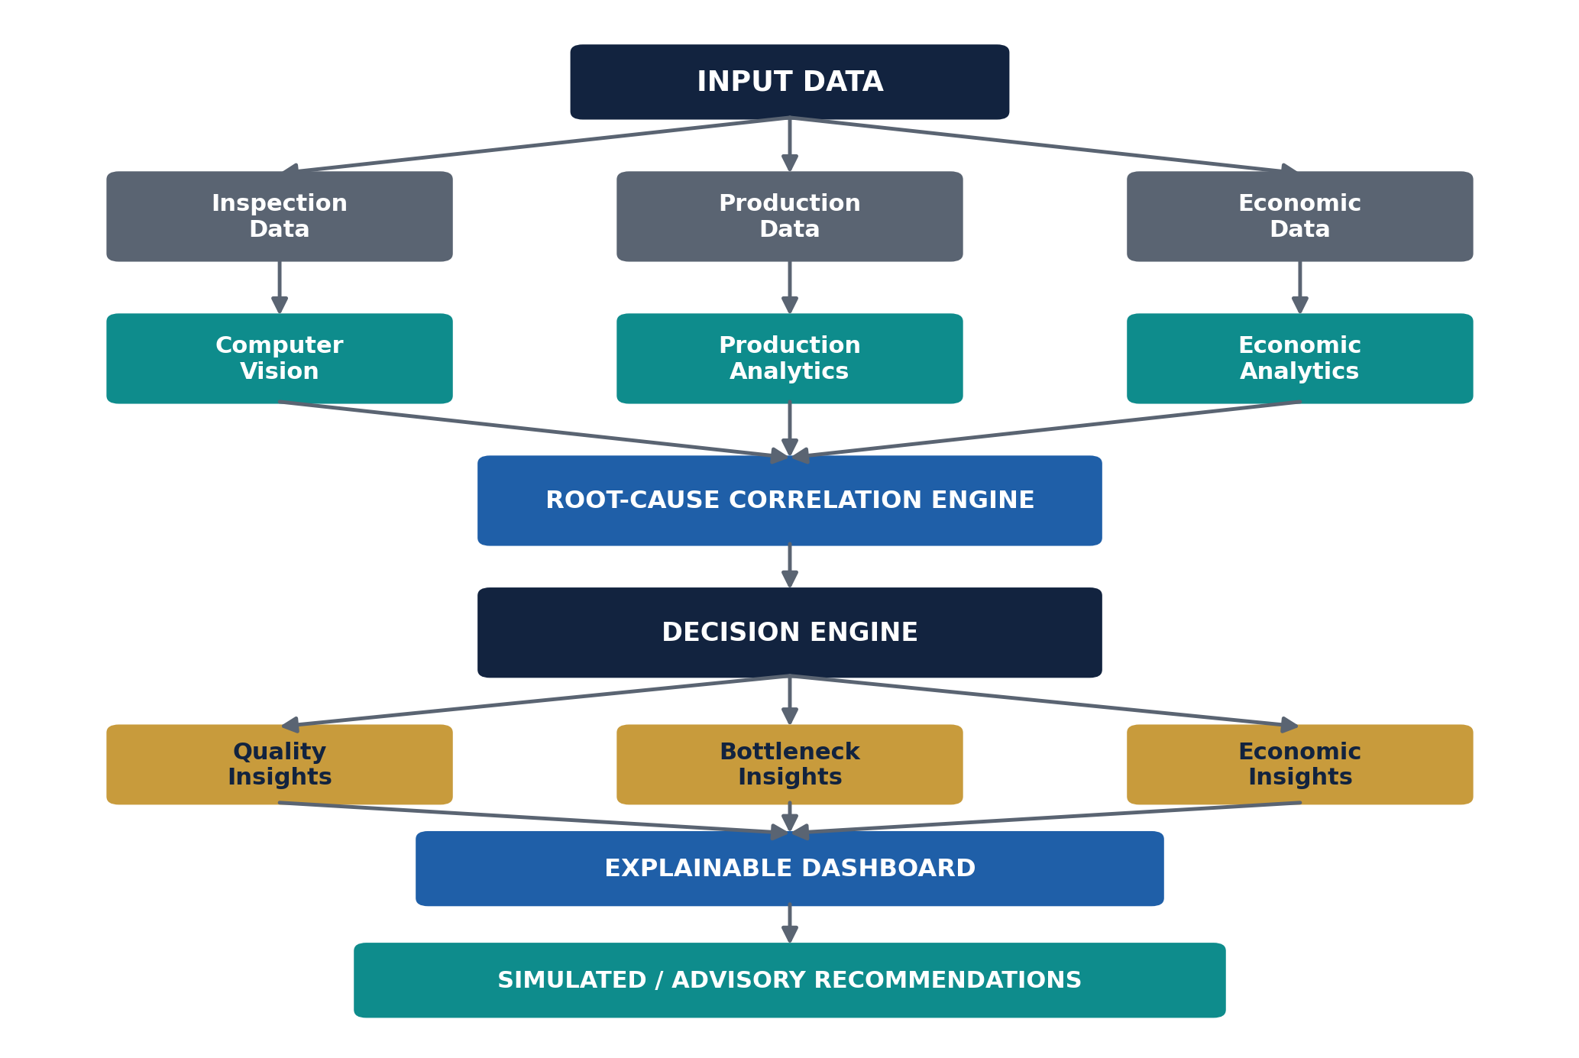
Figure 1 — End-to-end system architecture.

5. Data Sources

5.1 Inspection Data
Product ID, image, defect label, defect location, batch ID, timestamp, confidence.

5.2 Production Data
Station ID, machine ID, batch ID, cycle time, downtime, WIP, utilization, changeover time, throughput.

5.3 Economic Data
Unit production cost, scrap cost, rework cost, downtime cost, revenue per acceptable product, production loss, batch cost, margin.

6. Computer Vision Methodology
The vision module understands the visual condition of each product, producing structured, evidence-backed output — not just a pass/fail verdict.

7. Defect Detection and Localization
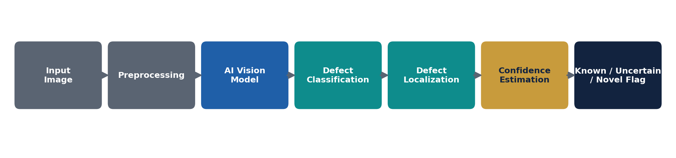
Figure 2 — Defect detection and localization pipeline.
{ "product_id": "P001", "status": "defective", "defect_type": "scratch", "confidence": 0.94, "location": [120, 80, 240, 160] }

8. Confidence-Aware AI
Predictions above threshold are accepted automatically; predictions below it are routed to a human reviewer instead of being forced into a guess.
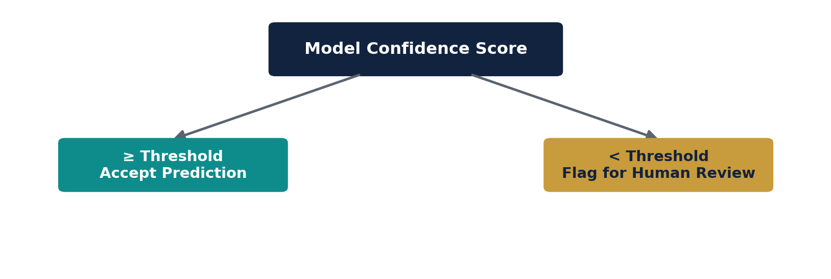
Figure 3 — Confidence-based routing.

9. Root-Cause Correlation Engine
Links visual defects back to the machine, station, batch and operating conditions active at the time — surfacing statistically associated factors.

10. Bottleneck Detection
Tracks processing time, cycle time, waiting time, WIP, downtime and utilization per station, combining them into one interpretable bottleneck indicator.
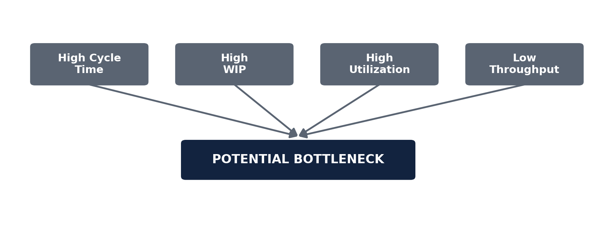
Figure 4 — Bottleneck signal combination.

11. Economic Impact Engine
Total Loss ≈ Scrap + Rework + Downtime Cost + Est. Lost Production Value

12. Throughput Analysis
Metric | Value
Expected output | 1,000 units
Acceptable output | 910 units
Effective yield | 91%

13. What-If Simulation
Metric | Current | Simulated
Cycle Time | 12 sec | 10 sec
Defect Rate | 8% | 5%
Expected Throughput / Loss / Margin | X | Y

14. Explainability Layer
Every output shows prediction, evidence, confidence, process context, economic impact and recommendation — never a black-box verdict.

15. Proposed Dashboard
- Quality Intelligence — image, defect type/location, confidence, status.
- Root-Cause Intelligence — defect frequency & process associations.
- Production Intelligence — utilization, cycle time, WIP, bottlenecks.
- Economic Intelligence — scrap/rework/downtime cost, margin impact.
- Decision / What-If View — current state vs. simulated outcome.

16. Technology Stack
Layer | Tools
Language | Python
Computer Vision | OpenCV, PyTorch, YOLO/Ultralytics
Analytics | Pandas, NumPy, Scikit-learn
Visualization / Dashboard | Plotly, Matplotlib, Streamlit
Dev & Version Control | VS Code, Jupyter, Git/GitHub

17. Evaluation Strategy
Area | Metrics
Classification | Accuracy, Precision, Recall, F1, Confusion Matrix
Localization | IoU, precision/recall, mAP
Robustness | Lighting, quality variants, unseen patterns
Errors | False accept / false reject, both reported
Explainability | Evidence, confidence, context, recommendation

18. Robustness to Unseen Conditions
Vision model is stress-tested against lighting, batch and material conditions that differ from the training data.

19. Research Reference Dataset
Manufacturing Data Shared Facility — Discrete-Event Simulation dataset (Mendeley Data, v2, DOI 10.17632/3rw227zxt7.2), used as a conceptual reference for production-flow analysis only — not assumed to contain organizer inspection images or economic variables.

20. Limitations and Assumptions
- Model performance depends on organizer-provided data quality and labeling.
- Correlation between process and defect does not establish causality.
- Economic figures depend on accurate cost/revenue data.
- What-if results are estimates, not guaranteed outcomes.

21. Responsible AI and Industrial Safety
Decision-support only — displays confidence, flags uncertainty, shows evidence, distinguishes correlation from causation, and avoids direct machine control.

22. Expected System Output
PRODUCT: P001
QUALITY Defective · Surface Scratch · 94% confidence · Region 1
PROCESS Station S3 · Machine M03 · Batch B17
ROOT-CAUSE Associated with Machine M03 / Station S3
IMPACT Bottleneck S3 · Est. loss ₹X · Throughput -X%
RECOMMENDATION Evaluate simulated process adjustment (advisory only).

23. Key Innovation
Not just computer vision — the connective chain linking visual quality, process context, root-cause evidence, bottleneck analysis, economic impact and explainable decision support into one narrative.

24. Proposed Team Implementation
Member | Responsibilities
1 — Computer Vision | Preprocessing, classification, localization, confidence
2 — Analytics | Production flow, bottleneck, root-cause, economics
3 — Integration & Dashboard | Backend, decision engine, dashboard, what-if UI

25. Proposed Development Workflow
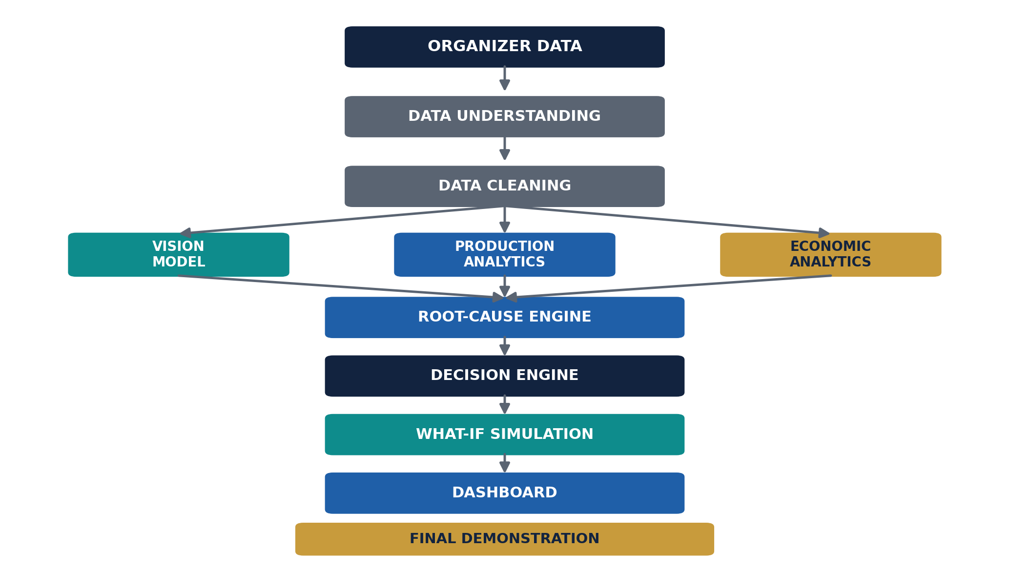
Figure 5 — Development workflow.

26. Conclusion
NEXORA connects visual inspection, process analytics and economic reasoning into a confidence-aware, explainable, advisory decision-support system — turning disconnected manufacturing data into one structured workflow.

27. References
- NeuraX Hackathon 3.0 — Domain 2: AI in Industry and Automation, Problem Statement.
- Manufacturing Data Shared Facility — Discrete-Event Simulation, Mendeley Data, DOI: 10.17632/3rw227zxt7.2.

