CS457lab Homework 1

19615 Gayatri Kolekar

INSERT INTO STATION VALUES (13, 'Austin', 'TX', 'US', 78613);

INSERT INTO STATION VALUES (44, 'Nashville', 'TN', 'US', 37011);

INSERT INTO STATION VALUES (66, 'St Louis', 'MO', 'US', 63110);

INSERT INTO STATION VALUES (14, 'Los Angeles', 'CA', 'US', 90004);

INSERT INTO STATION VALUES (42, 'Santa Cruz', 'CA', 'US', 95060);

INSERT INTO STATION VALUES (61, 'Miami', 'FL', 'US', 33101);

INSERT INTO STATION VALUES (12, 'Yosemiti', 'CA', 'US', 95389);

INSERT INTO STATION VALUES (45, 'San Rafael', 'CA', 'US', 94901);

INSERT INTO STATION VALUES (67, 'San Fransisco', 'CA', 'US', 94105);

INSERT INTO STATION VALUES (65, 'Fremont', 'CA', 'US', 94555);

SELECT * FROM STATION

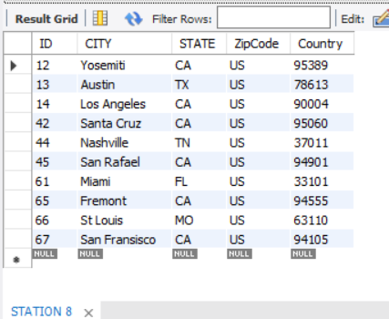

INSERT INTO STATS VALUES (13, 68, 35.22);

INSERT INTO STATS VALUES (44, 61, 82);

INSERT INTO STATS VALUES (66, 69, 42.2);

INSERT INTO STATS VALUES (14, 68, 96);

INSERT INTO STATS VALUES (42, 68, 14.25);

INSERT INTO STATS VALUES (61, 79, 57.18);

INSERT INTO STATS VALUES (12, 62, 7);

INSERT INTO STATS VALUES (45, 56, 23.62);

INSERT INTO STATS VALUES (67, 58, 23.62);

INSERT INTO STATS VALUES (65, 59, 16.68);

SELECT * FROM STATS

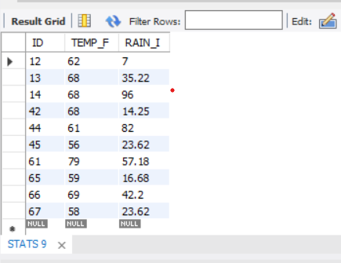

select avg(TEMP_F) from stats;

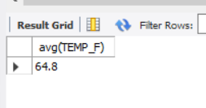

select max(TEMP_F) from stats;

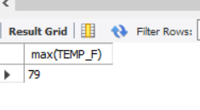

select sum(TEMP_F) from stats;

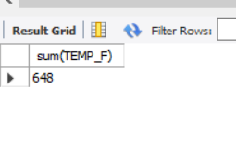

select min(TEMP_F) from stats;

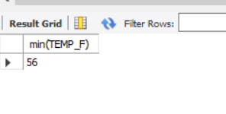

select avg(RAIN_I) from stats;

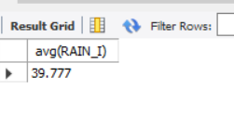

select max(RAIN_i) from stats;

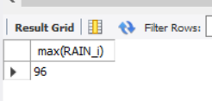

select sum(RAIN_i) from stats;

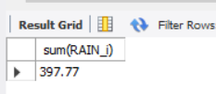

select min(RAIN_i) from stats;

