Homework 3B

SELECT Fname, Lname FROM EMPLOYEE WHERE super_ssn IS NULL;

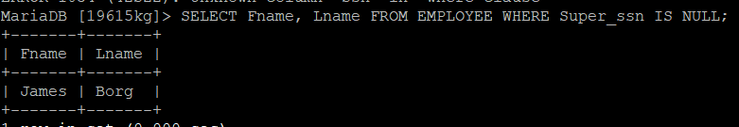

SELECT DISTINCT Pnumber FROM PROJECT WHERE Pnumber IN (SELECT Pnumber FROM PROJECT, DEPARTMENT, EMPLOYEE WHERE Dnum=Dnumber AND Mgr_Ssn AND Lname=’Smith’)OR Pnumber IN (SELECT Pno FROM WORKS_ON,EMPLOYEE WHERE Essn=Ssn AND Lname=’Smith’);

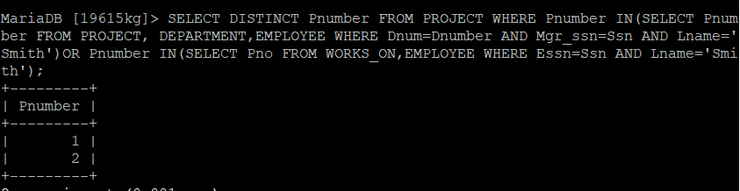

SELECT DISTINCT Essn FROM WORKS_ON WHERE (Pno, Hours)IN(SELECT Pno, Hours FROM WORKS_ON WHERE Essn='123456789');

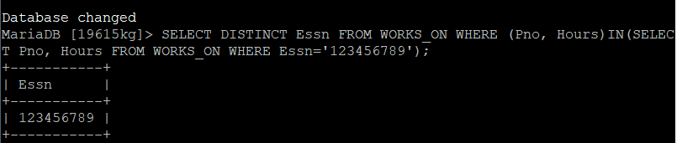

SELECT E.Fname, E.Lname FROM EMPLOYEE AS E WHERE E.Ssn IN(SELECT Essn FROM DEPENDENT AS D WHERE E.Fname=D.Dependent_name AND E.sex=D.Sex);



SELECT E.Fname, E.Lname FROM EMPLOYEE AS E,DEPENDENT AS D WHERE E.Ssn=D.Essn AND E.Sex=D.Sex AND E.Fname=D.Dependent_name;



SELECT Fname, Lname FROM EMPLOYEE WHERE EXISTS(SELECT * FROM DEPENDENT WHERE Ssn=Essn)AND EXISTS(SELECT * FROM DEPARTMENT WHERE Ssn=Mgr_Ssn);

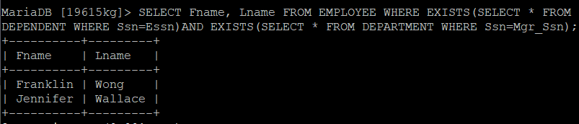

SELECT Lname, Fname FROM EMPLOYEE WHERE NOT EXISTS(SELECT * FROM WORKS_ON B WHERE B.Pno IN(SELECT Pnumber FROM PROJECT WHERE Dnum=5 AND NOT EXISTS(SELECT * FROM WORKS_ON C WHERE C.Essn=Ssn AND C.Pno=B.Pno)));

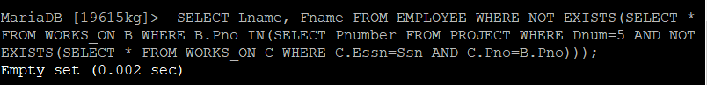

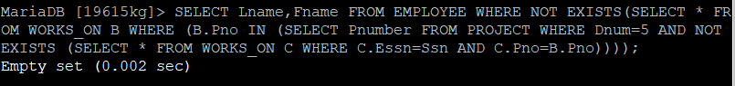

SELECT Fname, Lname FROM EMPLOYEE E WHERE NOT EXISTS (SELECT Pnumber FROM PROJECT WHERE Dno=5) EXCEPT (SELECT Fname, Lname FROM WORKS_ON W,EMPLOYEE E WHERE E.Ssn=Essn);

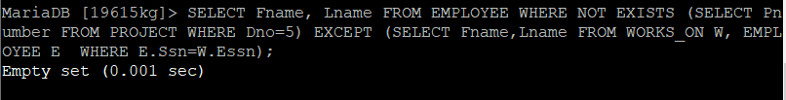

SELECT E.Lname AS EMPLOYEE_name, S.Lname AS Supervisor_name FROM EMPLOYEE AS E, EMPLOYEE AS S WHERE E.SUPER_ssn=S.Ssn;

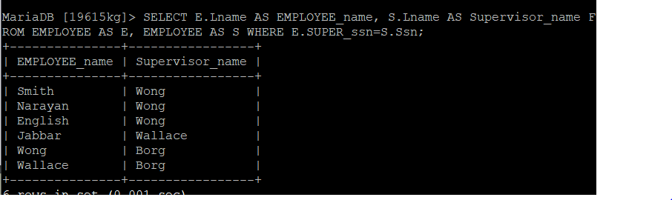

SELECT DISTINCT Essn FROM WORKS_ON WHERE Pno IN (1,2,3);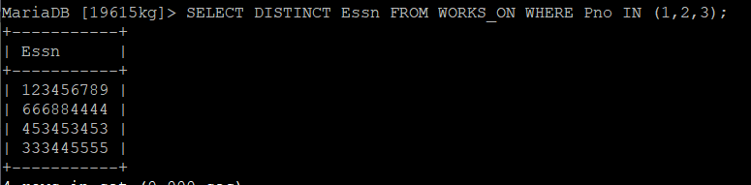

SELECT E.Lname AS EMPLOYEE_name, S.Lname AS Supervisor_name FROM EMPLOYEE AS E, EMPLOYEE AS S WHERE E.Super_ssn=S.Ssn;

