labHomework4B

Work on 3-way

1. Inner join

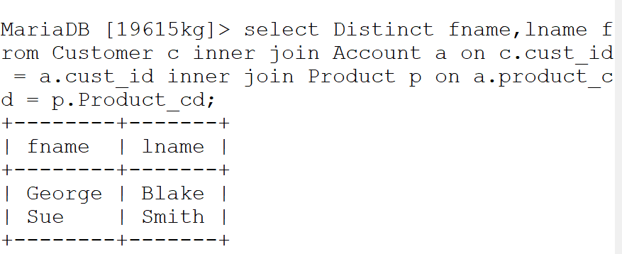

* Discription: Here in mySQL request, I have used inner join by checking match of cust_id from 2 tables Customer and Account. Then I used second inner join by checking match of product_cd from 2 tables Account and Product.

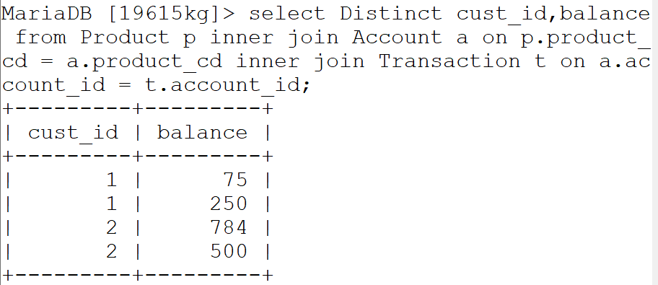

* Discription: Here in mySQL request, I have used inner join by checking matching datavalues that are same with product_cd from 2 tables Product and Account. Then I used second inner join by checking matching datavalues that are same with account_id from 2 tables Account and Transaction.

1. left outer join

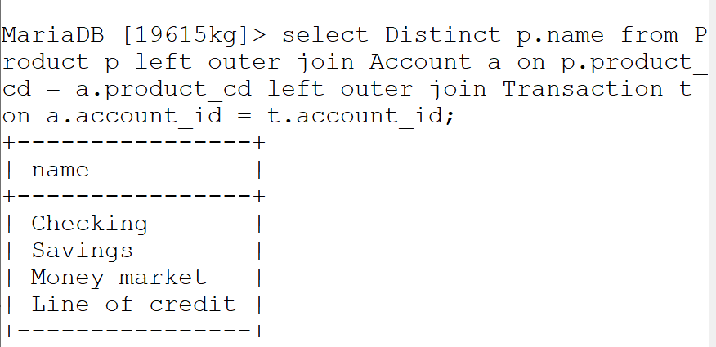

* => Discription : Here in mySQL request, I have used left outer join by checking match on product_cd from 2 tables Product and Account. And here left table which is Product is refered before right table Account. Then I used second left outer join by checking match on account_id from 2 tables Account and Transaction. Same as before, left table Account is refered before right table Trasaction.

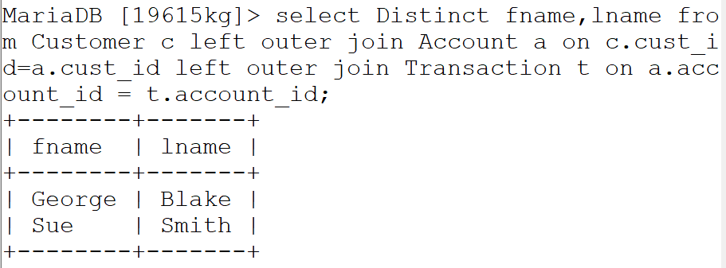

* =>Discription: Here in mySQL request, I have used left outer join by checking matching datavalues that are same with cust_id from 2 tables Customer and Account. And here left table which is Customer is refered before right table Account. Then I used second left outer join by checking matching datavalues that are same with cust_id from 2 tables Account and Transaction. Same as before, left table Account is refered before right table Trasaction.

1. right outer join

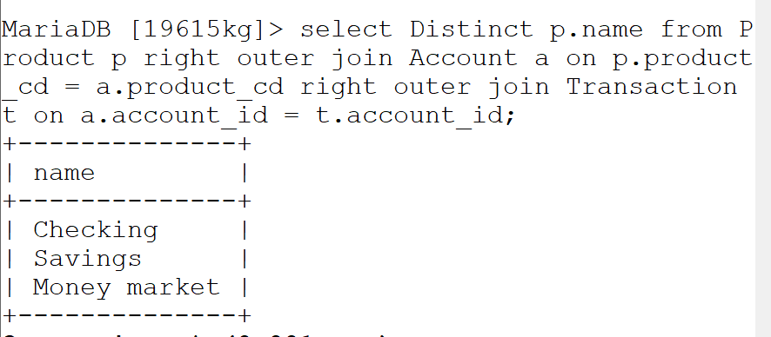

* Discription: Here in mySQL request, I have used right outer join by checking matching that are same with product_cd from 2 tables Product and Account. And here right table Account is refered before left table Customer. Then I used second right outer join by checking matching datavalues that are same with account_id from 2 tables Account and Transaction. Same as before, right table Transaction is refered before left table Account.

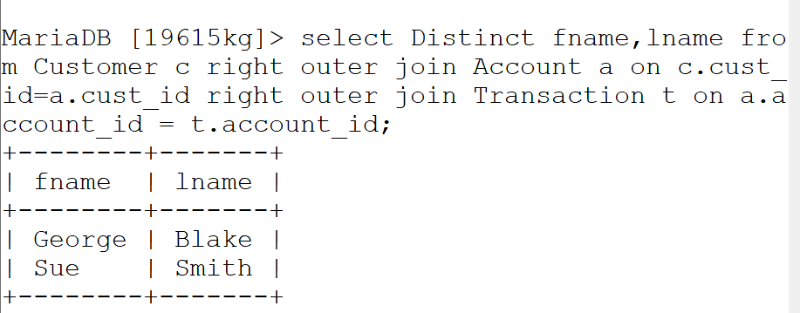

* Discription: Here in mySQL request, I have used right outer join by checking matching customar names from tables with same account_id from 2 tables Customer and Account. And here right table Account is refered before left table Customer. Then I used second right outer join by checking matching data that are same with account_id from 2 tables Account and Transaction. Same as before, right table Transaction is refered before left table Account.

1. Equijoins

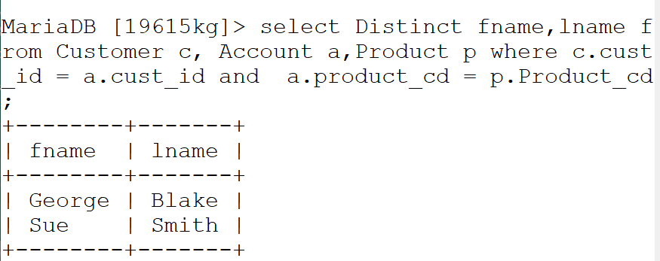

* Discription: Here in mySql request, I have used equijoin to filter the data from table list Customer, Account, Product Where checking match on cust_Id and product_cd with ‘=’ oprator.

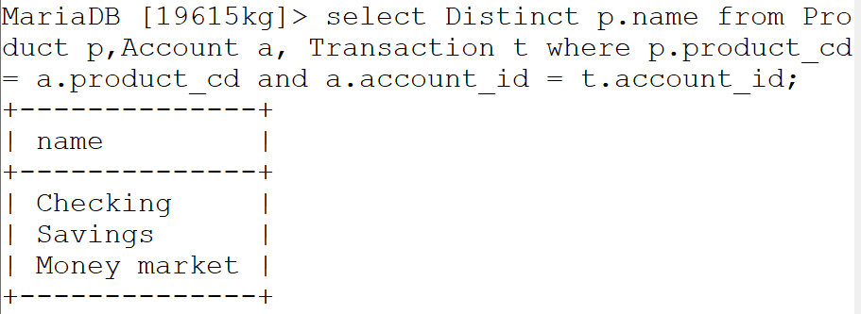

* Discription: Here in mySql request, I have used equijoin to filter the data from table list Product , Account, Transaction Where checking matching datavalues from table that are same with product_cd and account_id with ‘=’ oprator.

1. non equijoins

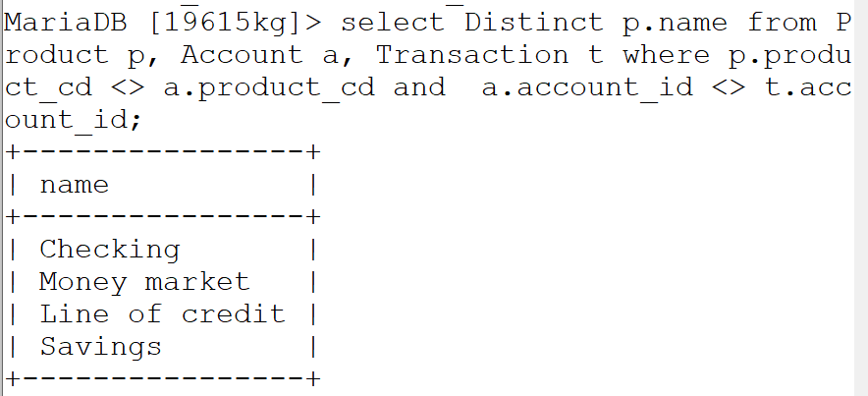

* Discription: Here in mySql request, I have used non equijoin to filter the data from table list Account, Product, Transactions Where checking match on product_cd and account_id with non equal ‘<>’ oprator.
* 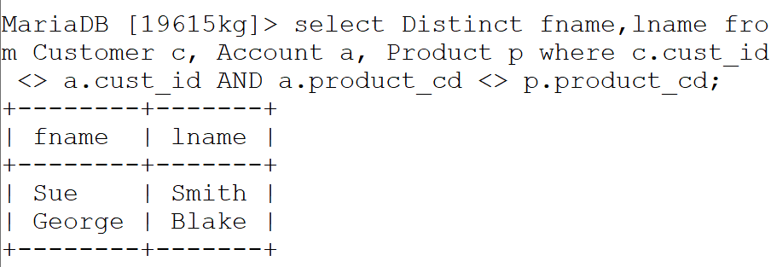
* Discription: Here in mySql request, I have used non equijoin to filter the data from table list Customer, Account, Product Where checking matching fname,lname from Customer that are not same with product_cd and account_id with non equal ‘<>’ oprator.

1. self joins

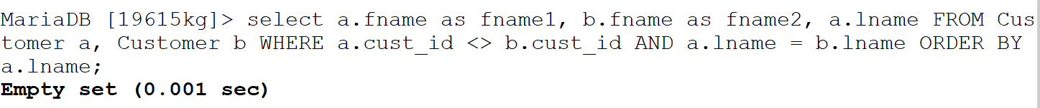

* => Discription: Here in mySql request, I have used selfjoin to filter the data from table Customer itself, checking matches Customers that are with same lname and with no same cust_id.

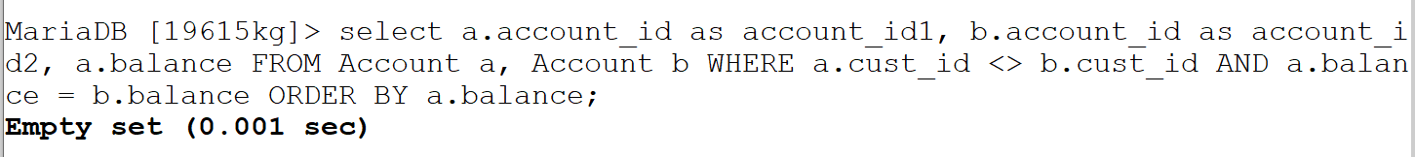

* Discription: Here in mySql request, I have used selfjoin to filter the data from table Account itself, checking matches Account that are with same balance and with no same cust_id

1. natural joins

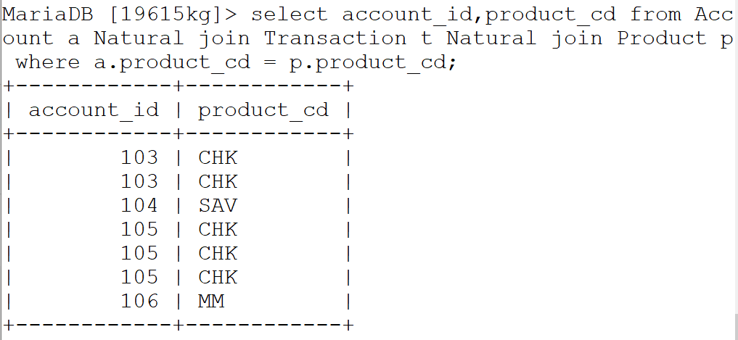

* Discription: Here in mySQL request, I have used Natural join to combine tables Account, Transaction, Product, by checking match Accounts that are with same product_cd from 2 tables Account and Product.

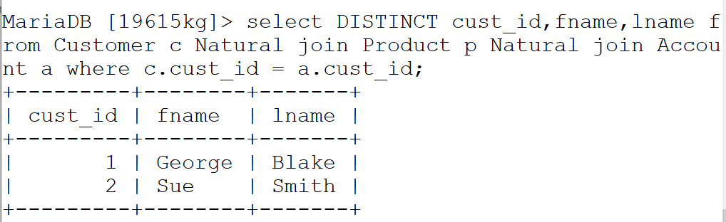

* Discription: Here in mySQL request, I have used Natural join to combine tables Customer, Product, Account by checking matching Accounts that are with same cust_id from 2 tables Customer and Account .

for the customer, account, transaction and product tables using

1. union

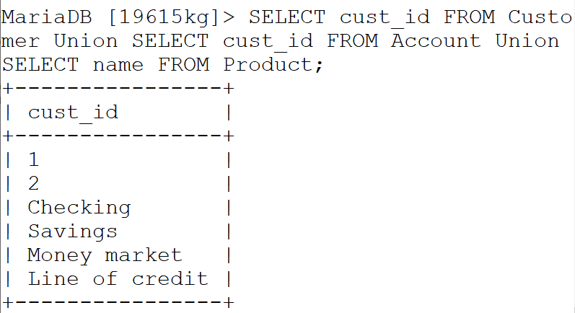

* Discription: Here in mySQL request, I have used Union to combine tables Customer,account, Product.

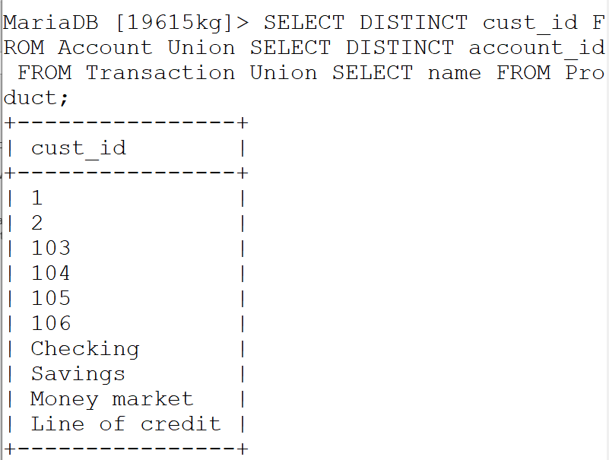

* Discription: Here in mySQL request, I have used Union to combine tables Account,Transaction, Product.

ii) union all

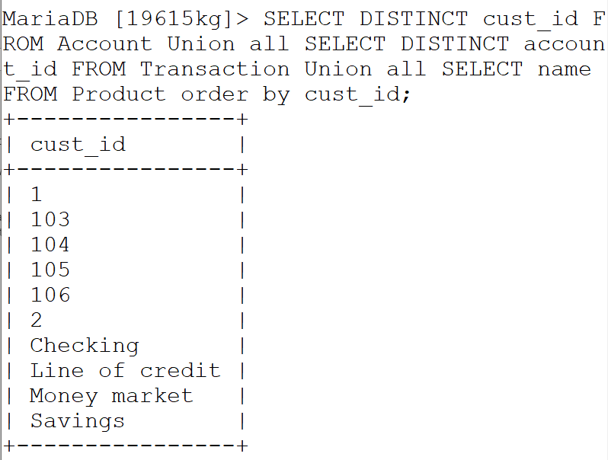

* Discription: Here in mySQL request, I have used Union all to combine tables Account,Transaction, Product ordered by cust_id.

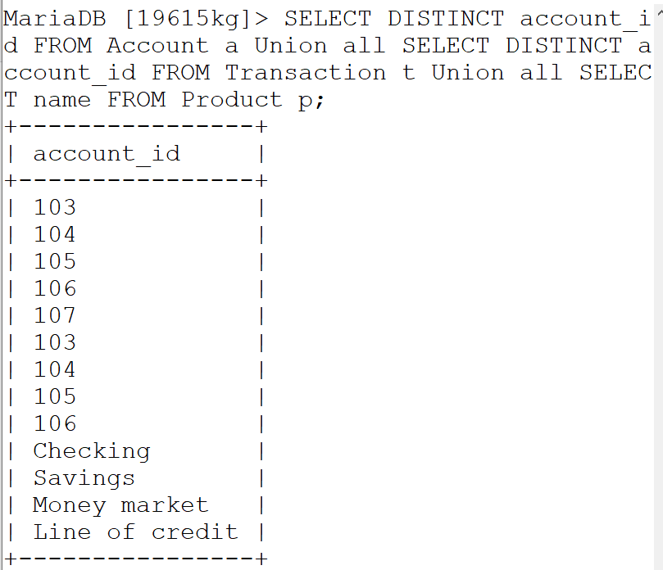

* Discription: Here in mySQL request, I have used Union all to combine tables Account,Transaction, Product ordered by cust_id.

iii) intersect and

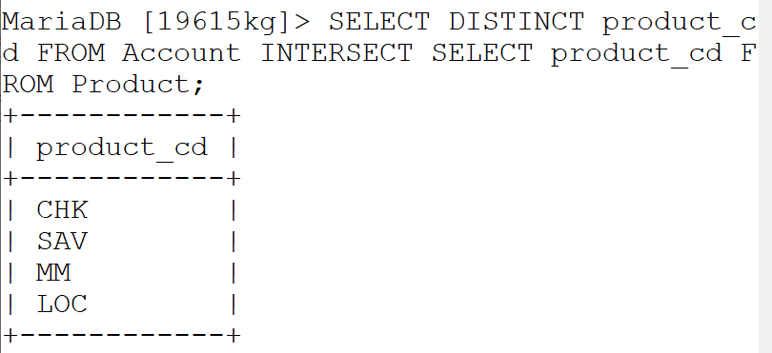

* Discription: Here in mySQL request, I have used Intersect to filter common datavalue from tables Account, Product .

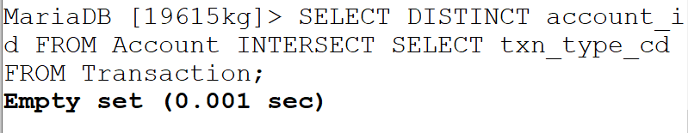

* Discription: Here in mySQL request, I have used Intersect to filter common datavalues from tables Account, Transaction .

iv) except clauses.

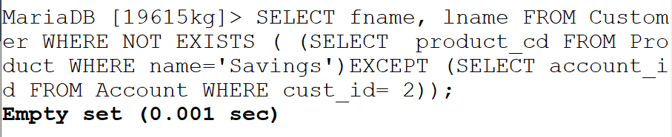

* Discription: Here in mySQL request, I have used Except and Not exist(double negation) to filter common datavalues from tables Customer, Product,Account .

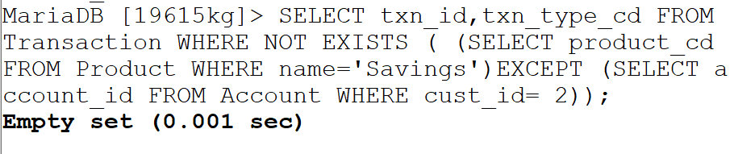

* Description: Here in mySQL request, I have used Except and Not exist(double negation) to filter common datavalues from tables Transaction, Product, Account .