Database Technologies Lab

Homework1B

Data = 9/16/2021

1. CREATE TABLE teachers(

First_name varchar(25),

Last_name varchar(50),

School varchar(50),

Salary numeric);

1. insert into teachers (first_name, last_name, school, hire_date, salary)

values(‘Janet’, ‘Smith’, ‘F.D.Roosevelt HS’, ‘2011-10-30’, 36200),

(‘Lee’, ‘Reynods’, ‘F.D.Roosevelt HS’,’1993-05-22’,65000),

(‘Samual’, ‘Cole’, ‘Myers Middle School’,’2005-08-01’,43500),

(‘Betty’,’Diaz’,’ Myers Middle School’,’2005-08-30’,43500),

(‘Kathleen’,’Diaz’,’ F.D.Roosevelt HS’,2010-10-22’,38500);

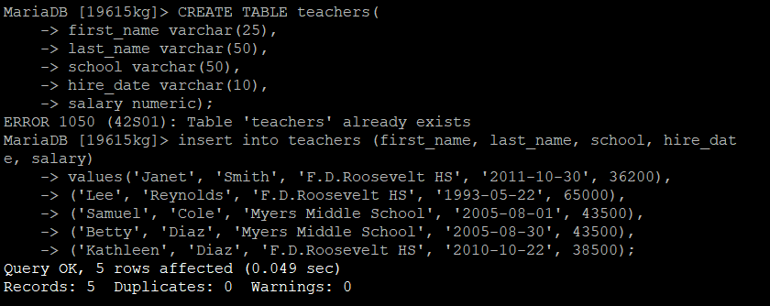

1. select * from teacher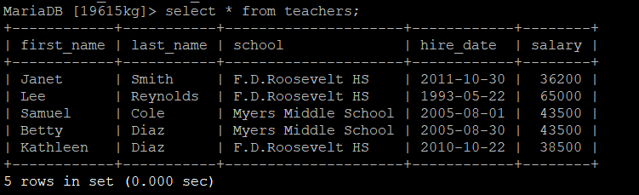
2. select last_name, first_name,salary from teachers;

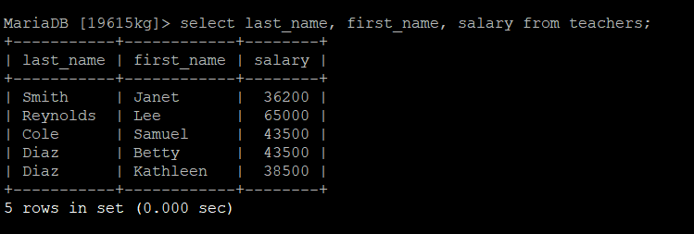

1. select last_name, hire_date, salary from teachers;

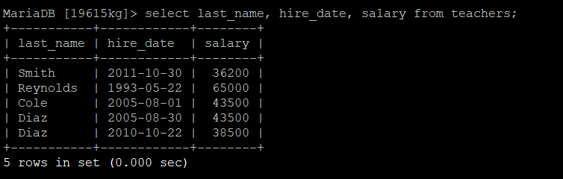

1. select hire_date, salary from teachers;

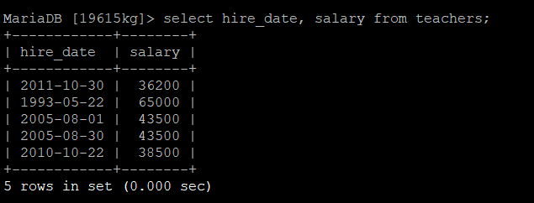

1. select distinct school from teachers;

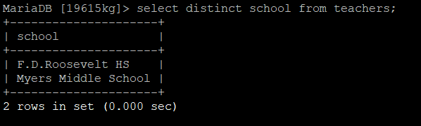

1. select distinct school, salary from teachers;

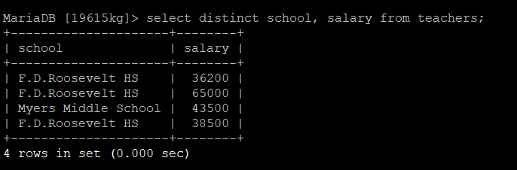

1. select first_name, last_name,salary from teachers order by salary desc;

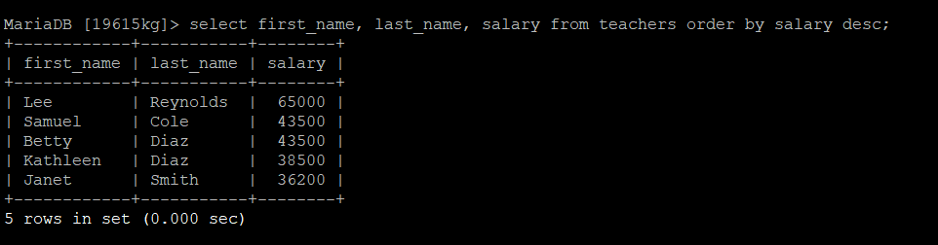

1. select last_name,school,hire_date from teachers order by school asc,hire_date desc;

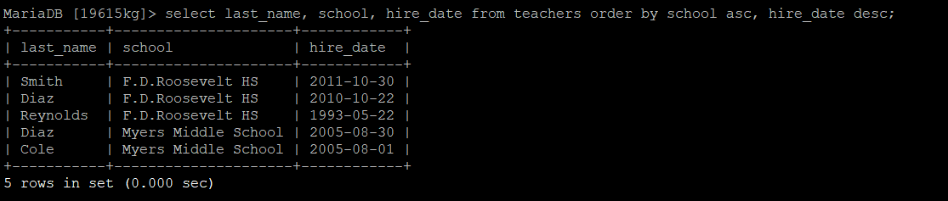

1. select first_name, last_name, school from teachers where first_name=’Janet’;

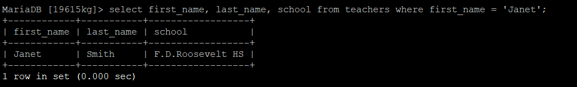

1. select school from teachers where school!=’F.D.Roosevelt HS’;

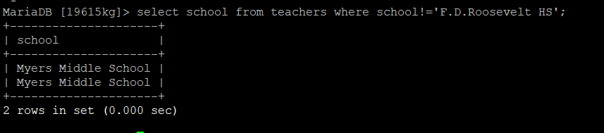

1. select first_name, last_name, hire_date from teachers where hire_date <’2000-01-01’;

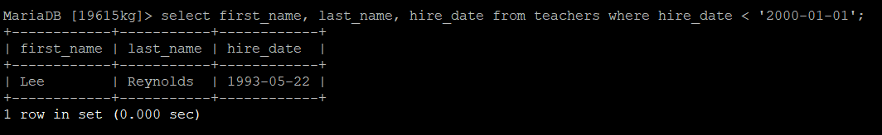

1. select first_name, last_name, salary from teachers where salary>= 43500;

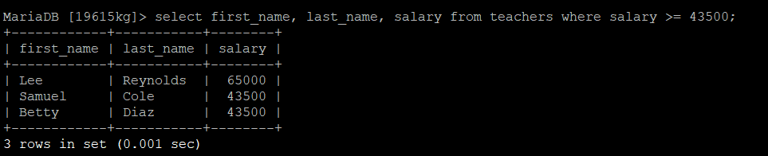

select first_name from teachers where first_name like ‘sam%’;

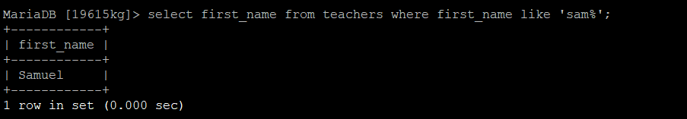

1. select first_name from teachers where first_name like ‘%et’;

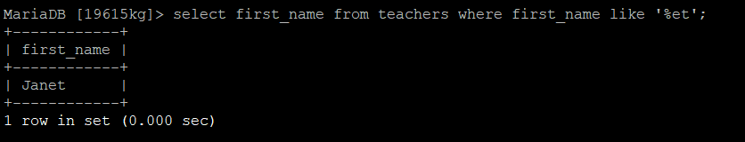

1. select last_name from teachers where last_name like ‘%ia%’;

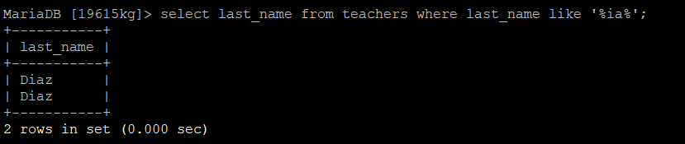

1. select last_name from teachers where first_name like ‘J___t’;

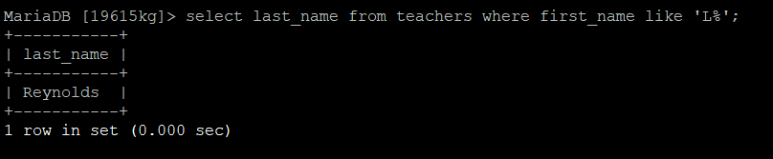

1. select last_name from teachers where first_name like ’Le_’;

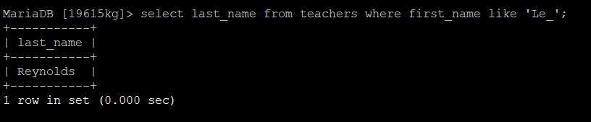

1. select last_name, school, hire_date from teachers where school= ‘Myers Middle School’;

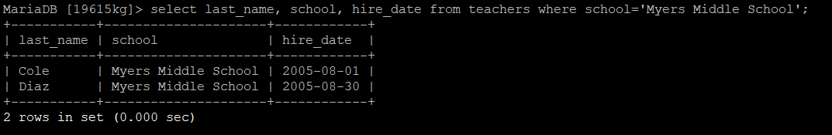

1. select first_name,last_name, school from teachers where first_name=’janet’;

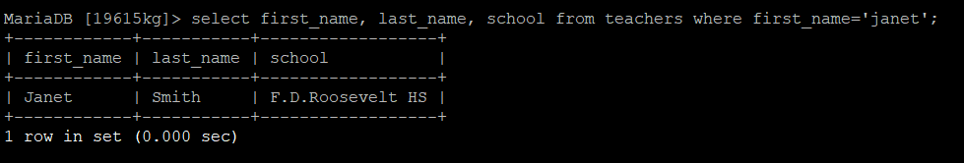

1. select school from teachers where school!=’F.D.Roosevelt HS’;

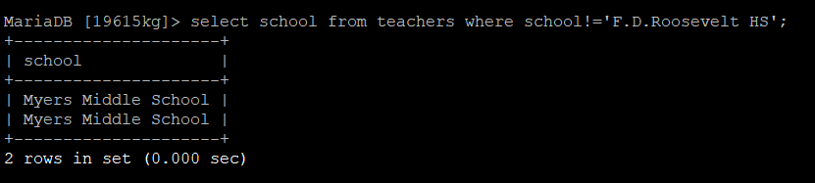

1. select * from teachers where school = ‘Myers Middle School’ and salary < 40000;



1. select * from teachers where last_name=’Cole’ or last_name=’Bush’;

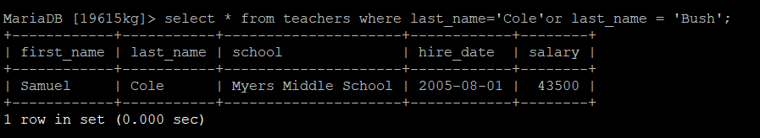

1. select * from teachers where school =’F.D. Roosevelt HS’ and(salary < 38000 or salary > 40000);

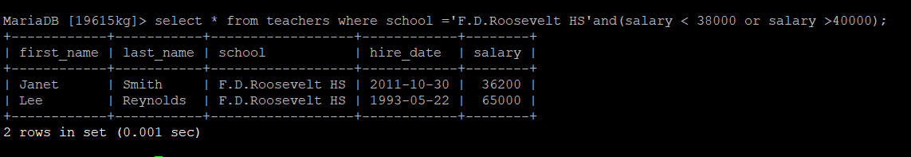

1. select first_name, last_name, school, hire_date, salary from teachers where school like ‘%Roos%’ order by hire_date desc;

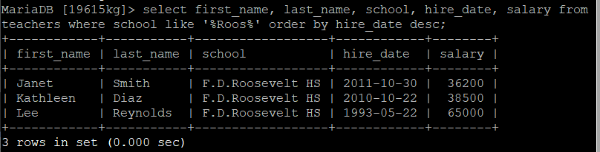

CREATE TABLE STATION(

ID INTEGER PRIMARY KEY,

CITY CHAR(20),

STATE CHAR(2),

COUNTRY CHAR,

ZIPCODE INTEGER);

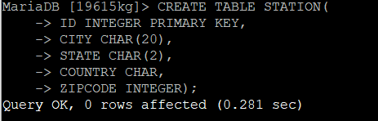

INSERT INTO STATION VALUES (13, 'Austin', 'TX', 'US', 78613);

INSERT INTO STATION VALUES (44, 'Nashville', 'TN', 'US', 37011);

INSERT INTO STATION VALUES (66, 'St Louis', 'MO', 'US', 63110);

INSERT INTO STATION VALUES (14, 'Los Angeles', 'CA', 'US', 90004);

INSERT INTO STATION VALUES (42, 'Santa Cruz', 'CA', 'US', 95060);

INSERT INTO STATION VALUES (61, 'Miami', 'FL', 'US', 33101);

INSERT INTO STATION VALUES (12, 'Yosemiti', 'CA', 'US', 95389);

INSERT INTO STATION VALUES (45, 'San Rafael', 'CA', 'US', 94901);

INSERT INTO STATION VALUES (67, 'San Fransisco', 'CA', 'US', 94105);

INSERT INTO STATION VALUES (65, 'Fremont', 'CA', 'US', 94555);

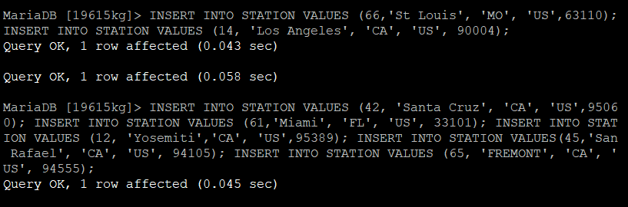

SELECT * from STATION

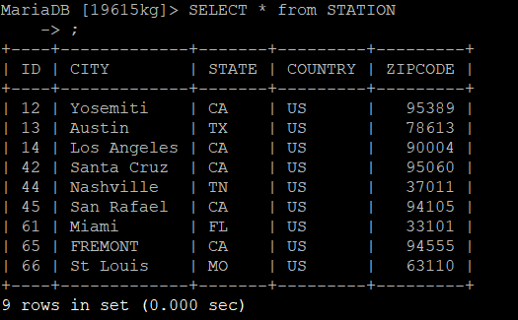

CREATE TABLE STATS(

ID INTEGER REFERENCES STATION(ID),

TEMP_F REAL CHECK (TEMP_F BETWEEN -80 AND 150),

RAIN_I REAL CHECK(RAIN_I BETWEEN 0 AND 100),

PRIMARY KEY (ID));

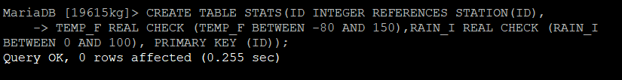

INSERT INTO STATS VALUES (13, 68, 35.22);

INSERT INTO STATS VALUES (44, 61, 82);

INSERT INTO STATS VALUES (66, 69, 42.2);

INSERT INTO STATS VALUES (14, 68, 96);

INSERT INTO STATS VALUES (42, 68, 14.25);

INSERT INTO STATS VALUES (61, 79, 57.18);

INSERT INTO STATS VALUES (12, 62, 7);

INSERT INTO STATS VALUES (45, 56, 23.62);

INSERT INTO STATS VALUES (67, 58, 23.62);

INSERT INTO STATS VALUES (65, 59, 16.68);

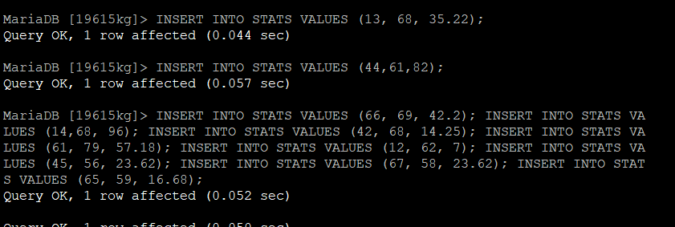

SELECT * FROM STATS;

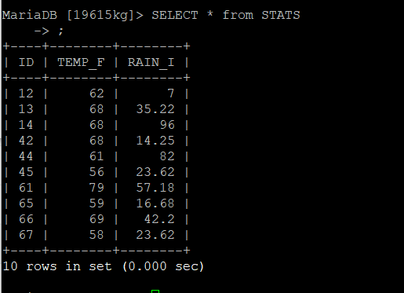

SELECT * FROM STATION, STATS WHERE STATION.ID = STATS.ID;

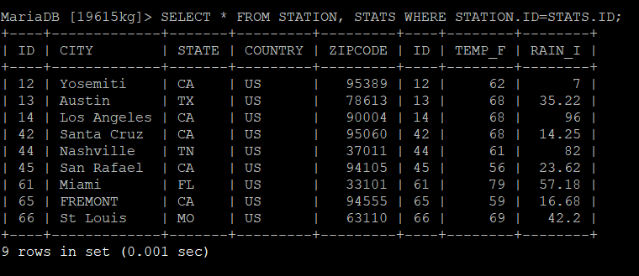

CREATE VIEW METRIC_STATS (ID, TEMP_C, RAIN_C) AS SELECT ID, (TEMP_F – 32)* 5/6, RAIN_I * 0.3937 FROM STATS;



SELECT * FROM METRIC_STATS;

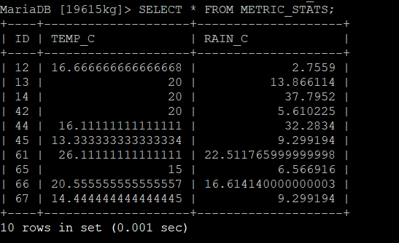

OUT OF RANGE=>

SELECT * FROM METRIC_STATS WHERE TEMP_C < 0 AND ID < 14 ORDER BY RAIN_C;

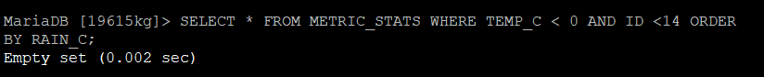

OUT OF RANGE VALUE =>

SELECT INTO STATS VALUES (44, 160, 7.1);



UPDATE COLUMN VALUES=>

UPDATE STATS SET RAIN_I = RAIN_I + 0.01;



SELECT * FROM STATS;

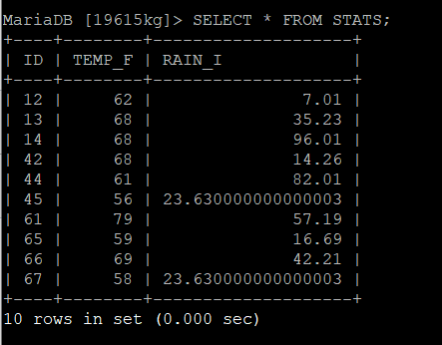

UPDATE=>

UPDATE STATS SET TEMP_F=74.9

WHERE ID = 44

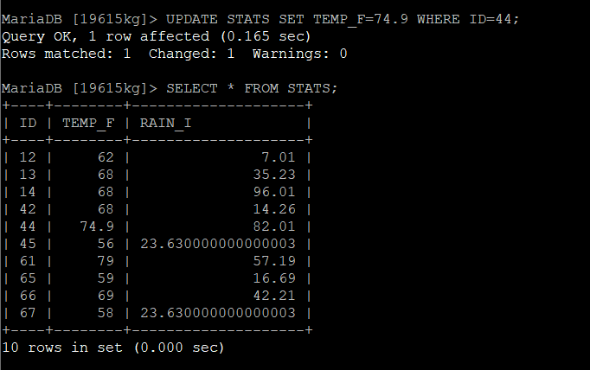

`

UPDATE TWO ROWS WITH NESTED QUERIES =>

UPDATE STATS SET RAIN_I = 23.63 WHERE RAIN_I = 23.630000000000003;

