Database lab Homework2A

CREATE TABLE Customer(cust_id numeric, fname varchar(25), lname varchar(50));



Select * from Customer;

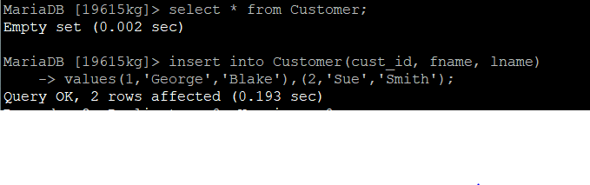

CREATE TABLE Product(product_cd varchar(25), name varchar(50));

Insert into Product(product_cd,name)

Values(‘CHK’, ‘Checking’), (‘SAV’, ‘Savings’), (‘MM’, ‘Money Market’), (‘LOC’, ‘Line of credit’);

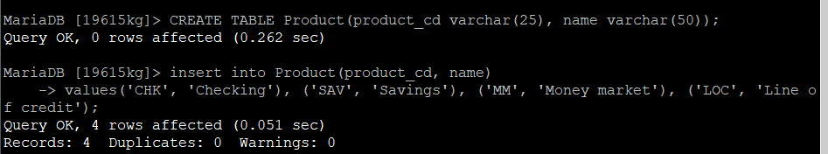

Insert into Account(account_id, product_id, cust_id,balance)

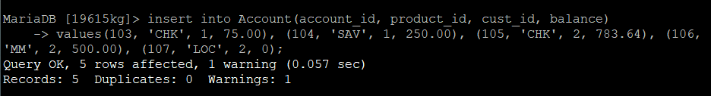

CREATE TABLE Transaction (txn_id numeric, txn_type_cd varchar (25), _id numeric, amount numeric,date varchar(10));

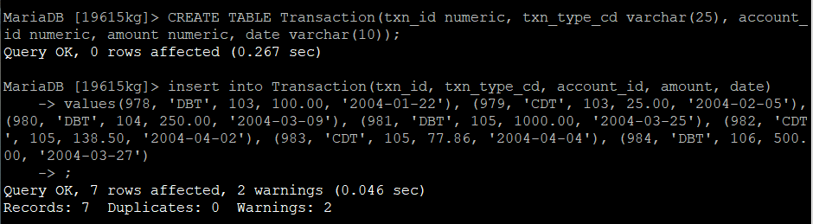

select * from Transaction;

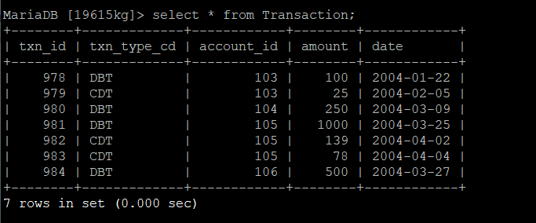

select lname, fname from Customer;

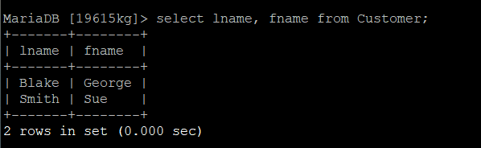

select distinct from txn_type_cd from Transaction;

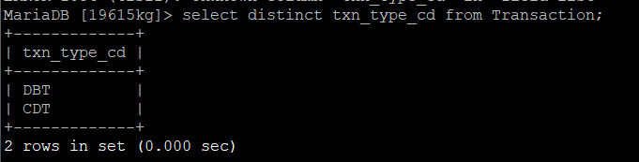

select account_id, amount, date from Transaction order by amount desc;

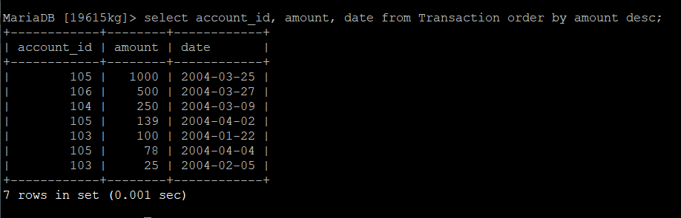

select account_id, amount, date from Transaction order by amount asc, account_id desc;

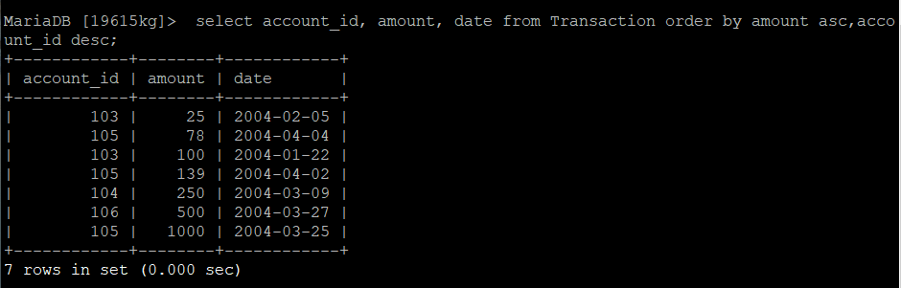

select * from Account;

select * from Product;

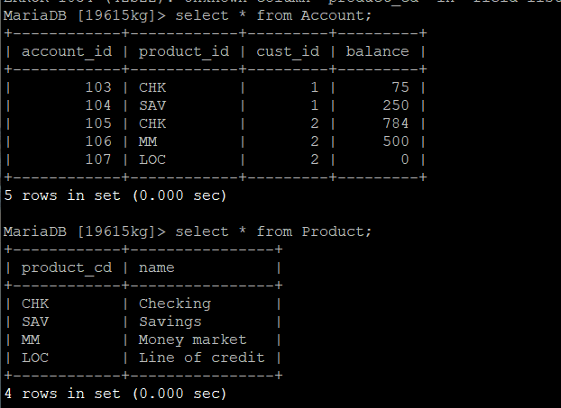

select name from Product where name like ‘Chec%’;

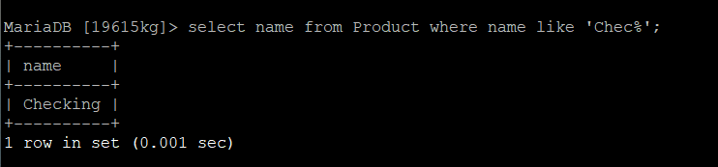

select name from Product where name like ‘Sav___s’;

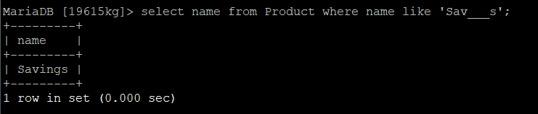

select name from Product where name like ‘%ket’;

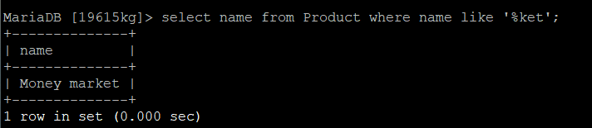

select * from Transaction where txn_type_cd = ‘CDT’ and account_id<105;

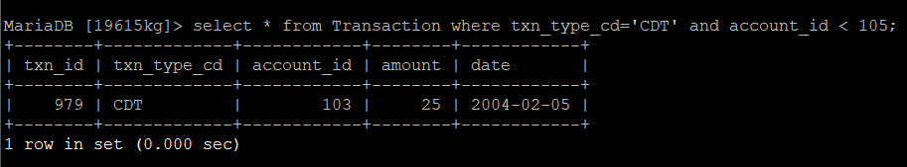

select * from Transaction where account_id=104 or account_id = 105;

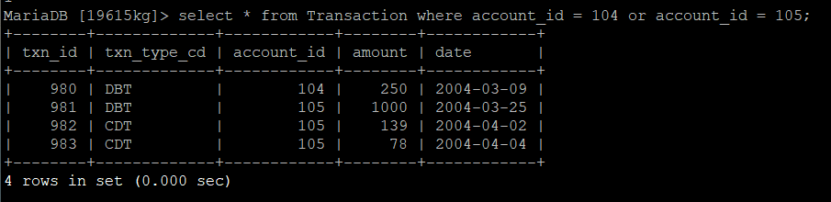

aggregate functions like max, min, count, avg, sum, round, abs=>

select max(account_id) from Transaction;

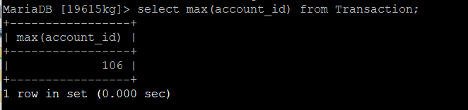

select min(account_id)from Transaction;

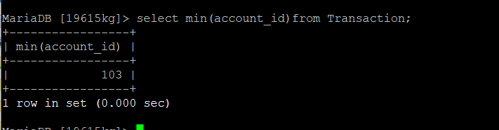

select avg(amount)from Transaction;

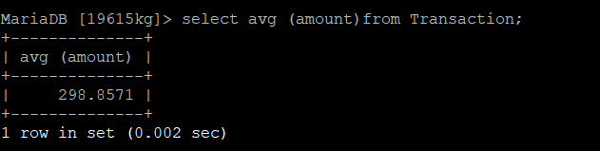

select count(txn_id)from Transaction;

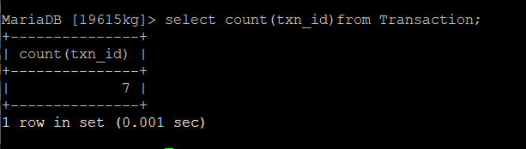

select sum(amount)from Transaction;

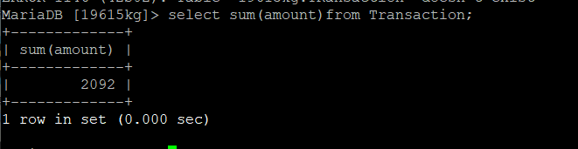

select round(avg(amount))from Transaction;

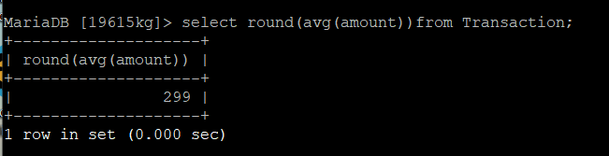

select abs(amount)from Transation;

