Database Technologies lab Homework2B

1. Create table number_data_types(

Numeric_column numeric(20,5),

Real_column real,

Double_column double precision);

1. Insert into number_data_types values(0.7, 0.7, 0.7);
2. Insert into number_data_types values(2.1357987654,

2.1357987654, 2,1357987654);

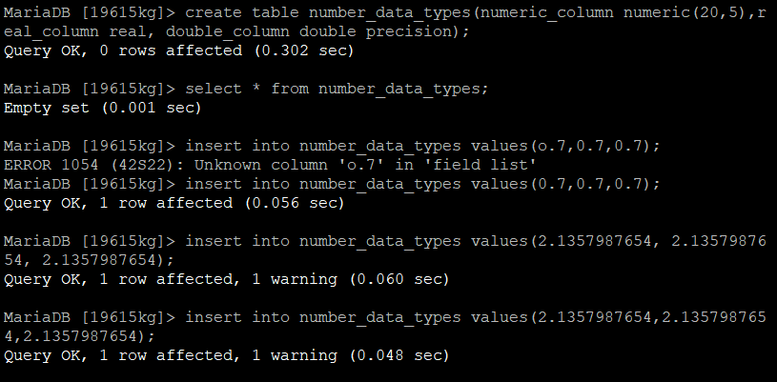

Explanation about SQL Queries =>

=>Basically here we are creating a empty table number_data_types with columns and datatypes

Syntax=> create table XYZ(col1 datatype, col2 datatype, col3 datatype);

=>This is where we put datavalues in the table

=> insert into table values(value1, value2, value3);

1. Select * from number_data_types;

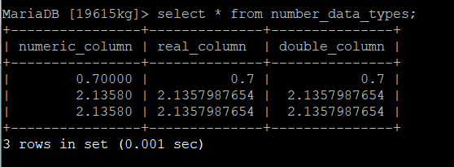

=>This is where we can display values from table number_data_types

* Select * from table

1. Select numeric_column * 10000000 as “fixed”, real_column *10000000 as “float” from number_data_types where numeric_column=0.7;

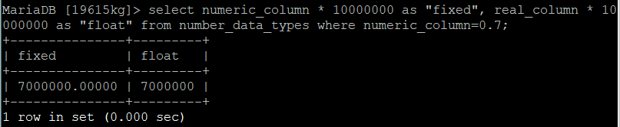

=>This is where we select numeric_column value, multiply with 10000000 and store in alias column name with “fixed”. Similary , select real_column value, multiply with 10000000 and store in alias column name with “float” display in tabular form

=>select col1+ calculation as “alias1”, col2 + calculations as “alias2” from table where column= value;

1. Create table percent_change(

department varchar(20),

spend_2014 numeric (10,2),

spend_2017 numeric(10,2));

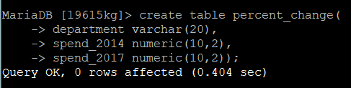

=>This is where we create another table percent_change with columns and datatypes.

=>create table tablename(col1 datatype, col2 datatype, col3 datatype)

7)insert into percent_change values(‘Building’, 250000, 289000);

insert into percent_change values(‘Accessor’, 178556, 179500);

insert into percent_change values(‘Library’, 87777, 90001);

insert into percent_change values(‘Clerk’, 451980, 650000);

insert into percent_change values(‘Police’, 250000, 223000);

insert into percent_change values(‘Recreation’, 199000, 195000)

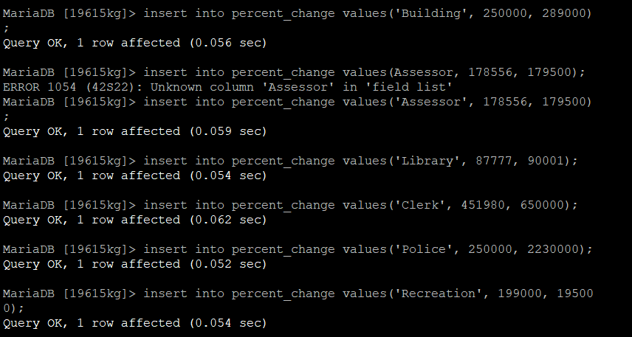

=>This is where we put values in table percent_change

8)select * from percent_change;

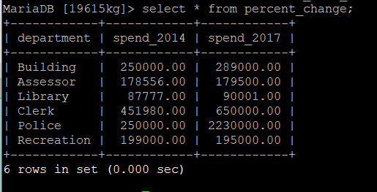

=>This is where we can display datavalues in tabular form

9)select department, spend_2014, spend_2014, spend_2017, round(spend_2017 – spend_2014 *100,1)as “pct_change” from percent_change;

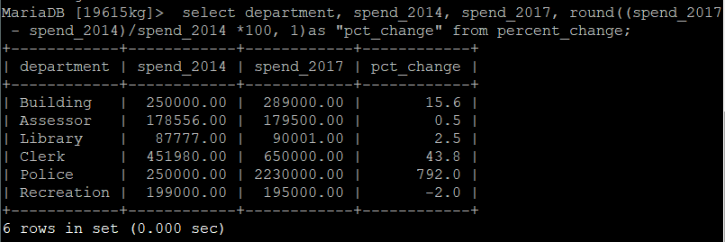

This is where we select department column, spend_2014, spend_2017 from table and do round figure of sum calculations and store in new column “pct_change”

10)Select sum(spend_2014) as “total_spend_2014”, round(avg(spend_2017),0) as “approx._spend_2017” from percent_change;

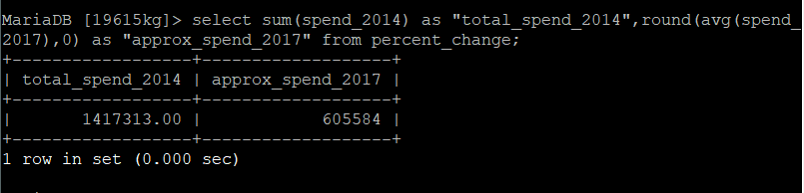

=>This is where we select values from column spend_2014, make a sum and store in new column “total_spend_2014”, also make average of values from spend_2017 and store in new column “approx._spend_2017” from table percent_change and display in tabular form.

11)create table departments(dept_id integer, dept varchar(100), city varchar(100), constraint dept_key primary key(dept_id), constraint dept_city_unique unique(dept, city));

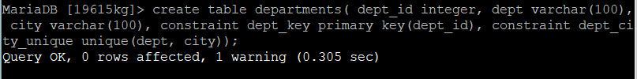

=>This is where create new table named departments with columns and datatypes.

12)Create table employees(

emp_id integer,

first_name varchar(100),

last_name varchar(100),

salary integer,

dept_id integer references departments(dept_id),

constraint emp_dept_unique unique(emp_id, dept_id));

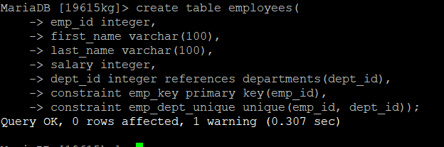

=>This is where we create table employees with columns and datatypes including constaints to limit type of datavalues in the columns.

13)Insert into departments values(1, ‘Tax’, ‘Atlanta’);

Insert into departments values(2, ‘IT’, ‘Boston’);

Insert into employees values(1, ‘Nancy’, ‘Jones’,62500, 1);

Insert into employees values(2, ‘Lee’, ‘Smith’,59300, 1);

Insert into employees values(3, ‘Soo’, ‘Nguyen’, 83000, 2);

Insert into employees values(4, ‘Janet’, ‘King’, 95000, 2);

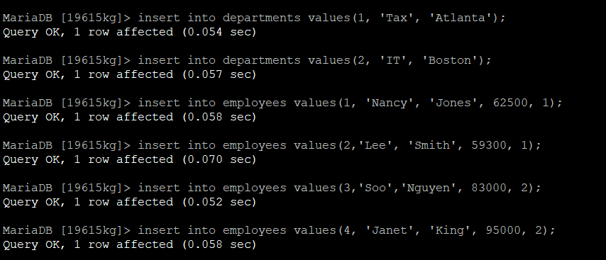

=>This is where we put values in table employees

14) Select * from departments;

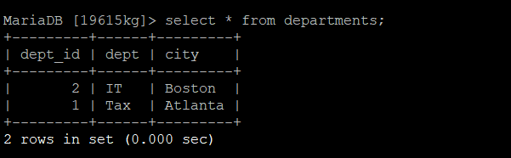

=>This is where we display values from table departments

15)select * from employees;

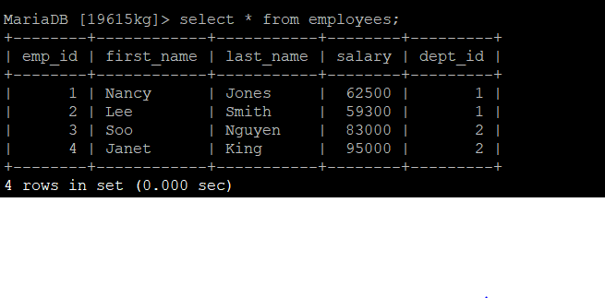

=>This is where we display datavalues from table employees