Homework 3A

1)ALL

1a) SELECT lname, fname

FROM Customer C inner join Account A

on C.cust_id = A.cust_id

WHERE A.balance > ALL(SELECT balance

FROM Account

WHERE balance < 100);

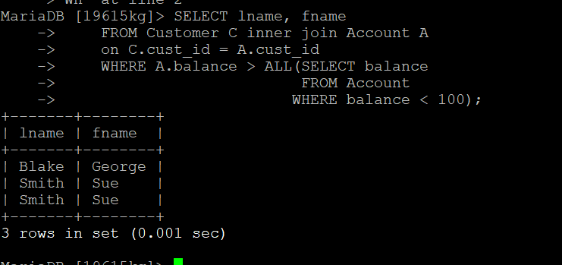

1b) SELECT product_id

FROM Account A inner join Transaction T

on A.account_id = T.account_id

WHERE T.amount > ALL(SELECT amount

FROM Transaction

WHERE amount < 100);

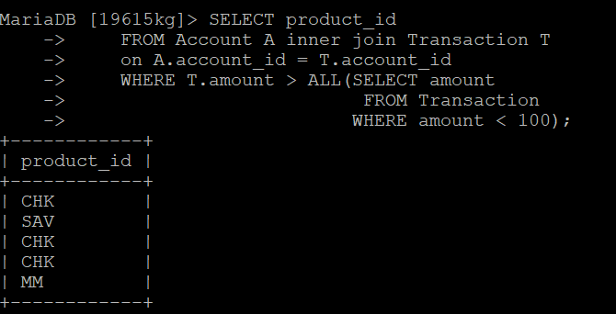

2)IN

2a) SELECT *

FROM Account A

inner join Transaction T

On A.account_id = T.account_id

WHERE A.account_id IN (SELECT account_id

FROM Account

WHERE balance=500);

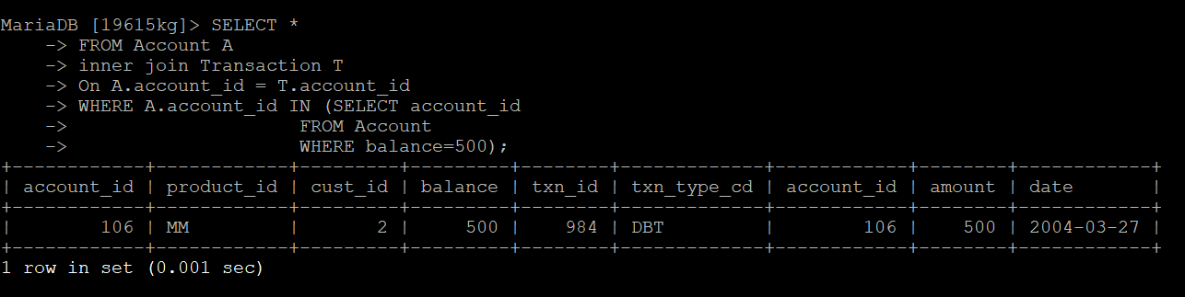

2b)Select account_id, product_id, cust_id, balance from Account Where product_id IN (Select product_id From Product Where product_id=’CHK’);

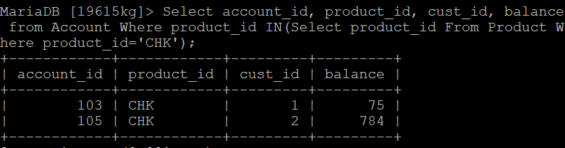

3)ANY

3a)Select *

From Account A

Inner join Transaction T

On A.account_id = ANY(Select account_id

From Account

Where balance < 100);

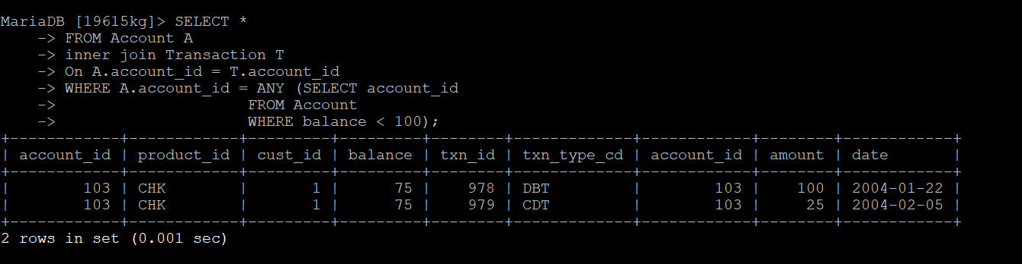

3b)Select * from Customer C inner join Account A

on A.cust_id=ANY(Select cust_id From Account Where balance < 100);

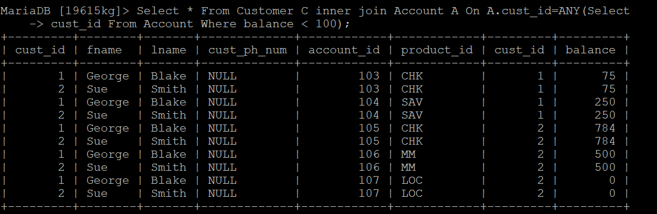

4)SOME

4a)Select *

From Account A

Inner join Transaction T

On A.account_id = T.account_id

WHERE A.account_id = SOME(Select account_id

From Account

Where balance < 100);

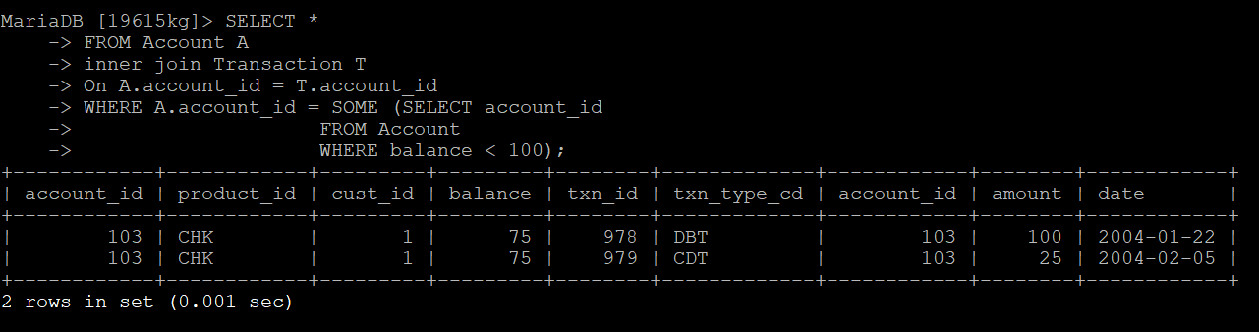

4b)Select C.cust_id, fname, lname From Customer C

Inner join Account A On C.cust_id = A.cust_id

Where C.cust_id Where C.cust_id= SOME(Select C.cust_id

From Account Where balance < 100);

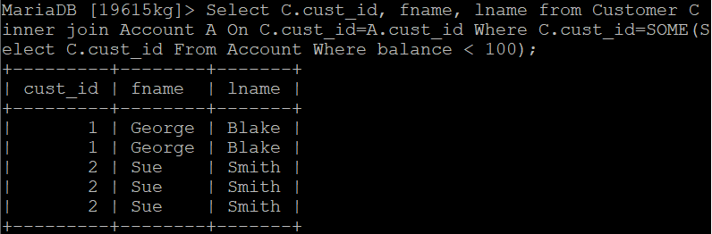

5) NOT IN 5a)Select account_id, product_id, cust_id, balance from Account Where product_id NOT IN (‘CHK’,’SAV’);

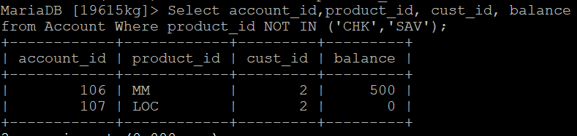

5b) Select account_id, amount, txn_id, txn_type_cd From Transaction Where account_id NOT IN(104);

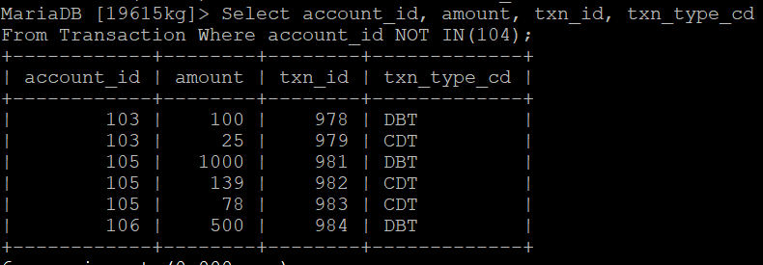

6)EXIST

6a) SELECT fname, lname

FROM Customer

WHERE EXISTS(SELECT *

FROM Account

WHERE balance < 100);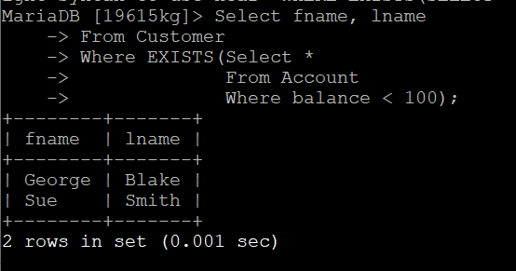

6b) SELECT account_id, amount, txn_id, txn_type_cd

FROM Transaction

WHERE EXISTS(SELECT amount

FROM Account

WHERE balance < 100);

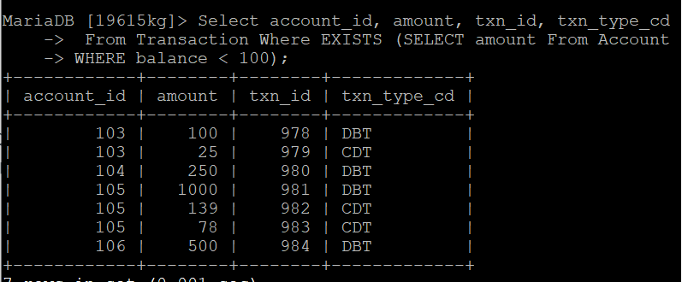

7)NOT EXISTS

7a) Select fname, lname

From Customer

Where NOT EXISTS (Select cust_id

From Account

WHERE cust_id=1);

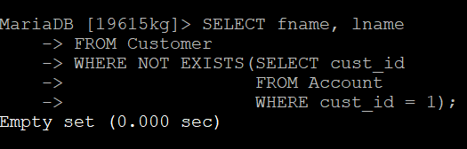

7b) Select cust_id, balance

From Account

Where NOT EXISTS (Select fname

From Customer

WHERE fname=’Smith’);

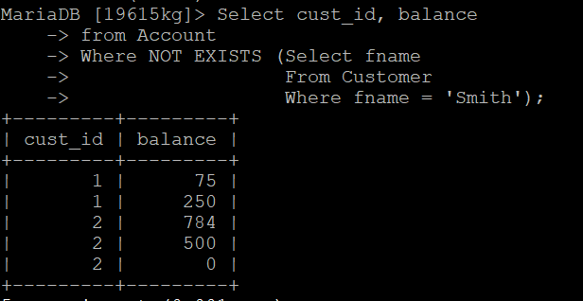

9)DISTINCT

9a)Select Distinct cust_id from Customer;

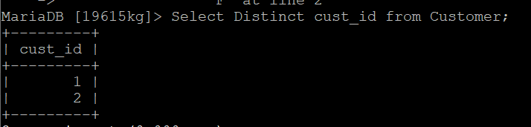

9b) Select Distinct account_id from Account;

