Homework 4A

Discription: Create table food with entities name, price ,expiry date, ssn and put in values in the table food.

Create table food(name varchar (50), price real, expiry_date varchar(50), ssn varchar(50));

Insert into food (name, price, expiry_date, ssn) values(‘apple’,2,’2021-11-16’,’111111111’);

Insert into food (name, price, expiry_date, ssn) values(‘orange’,3,’2021-11-17’,’111111111’);

Insert into food (name, price, expiry_date, ssn) values(‘chocolate’,4,’2021-11-18’,’111111111’);

Insert into food (name, price, expiry_date, ssn) values(‘gummy bear’,5,’2021-11-06’,);

Insert into food (name, price, expiry_date, ssn) values(‘french bread’,6,’2021-11-05’,’123456789’);

Insert into food (name, price, expiry_date, ssn) values(‘cake’,7,’2021-11-06’,’123456789’);

Insert into food (name, price, expiry_date, ssn) values(‘chocolate cake’,8,’2021-11-08’);

Insert into food (name, price, expiry_date, ssn) values(‘grapes’,2.5,’2021-11-10’);

Insert into food (name, price, expiry_date, ssn) values(‘Big Mac Combo’,3.5,’2021-11-11’);

Insert into food (name, price, expiry_date, ssn) values(‘Watermelon’,4.5,’2021-11-12’);

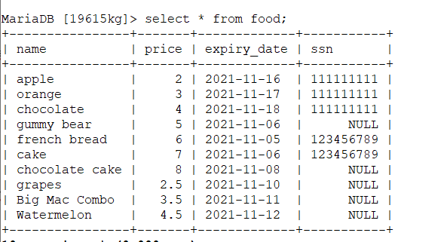

Discription: Here I am updating ssn values where ssn is null in food table











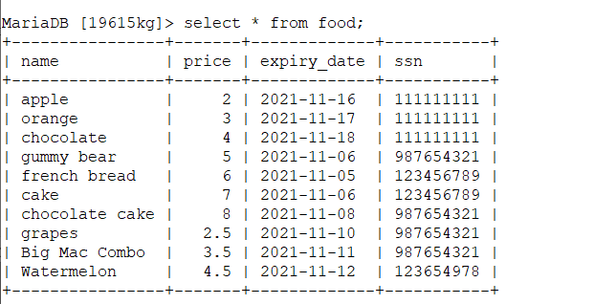



Here we can create table person with attributes ssn, fname, lname and gender. And put values in table.

Create table person (ssn varchar(50), fname varchar(50), lname varchar(50), gender varchar(10));

Insert into person(ssn, fname, lname, gender) values(‘111111111’, ‘Franklin’, ‘Wong’,’M’);

Insert into person(ssn, fname, lname, gender) values(‘111222333’, ‘Ramesh’, ‘Narayan’,’M’);

Insert into person(ssn, fname, lname, gender) values(‘123123234’, ‘Ahamad’, ‘Jabbar’,’M’);

Insert into person(ssn, fname, lname, gender) values(‘123456784’, ‘John’, ‘Smith’,’M’);

Insert into person(ssn, fname, lname, gender) values(‘124587123’, ‘Jennifer’, ‘Wallace’,’F’);

Insert into person(ssn, fname, lname, gender) values(‘128736524’, ‘Jessie’, ‘Karleon’,’F’);

Insert into person(ssn, fname, lname, gender) values(‘987398472’, ‘Joyes’, ‘English’,’M’);

Insert into person(ssn, fname, lname, gender) values(‘987652412’, ‘Alice’, ‘Zelya’,’F’);

Insert into person(ssn, fname, lname, gender) values(‘998877665’, ‘James’, ‘Borg’,’M’);

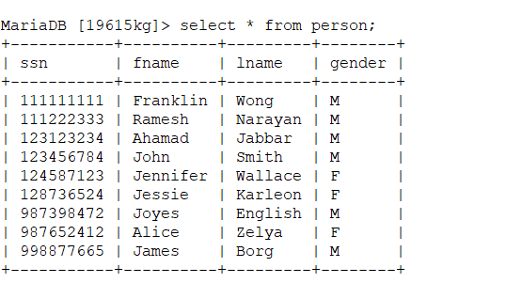

Discription: Here I am joining all columns from table person and food with inner join on condition of ssn match from both tables

Select * from person p inner join food f on p.ssn= f.ssn;

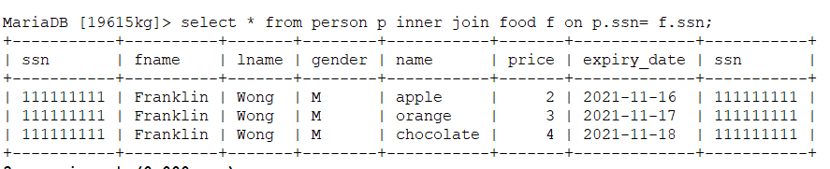

Discription: Here I am joining column ssn, fname, lname, gender from person table and column name, price and expiry_date from table food with inner join on condition of ssn match from both the tables and group by ssn from table food.

select f.ssn, p.fname, p.lname, p.gender, f.name, f.price, f. expiry_date from person p inner join food f on p.ssn= f.ssn group by f.ssn;

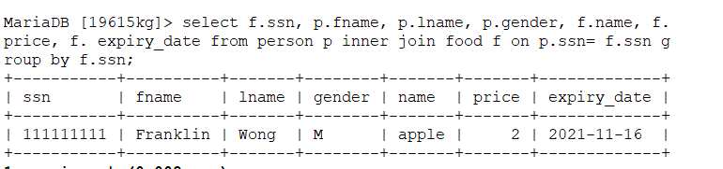

Discription: Here I am joining columns from table person and columns of table food with inner join on condition of ssn match from both tables and group by condition of ssn from table food ( group_concat with condition name from table person)

select f.ssn, p.fname, p.lname, p.gender, group_concat(f.name)from person p inner join food f on p.ssn = f.ssn group by f.ssn;

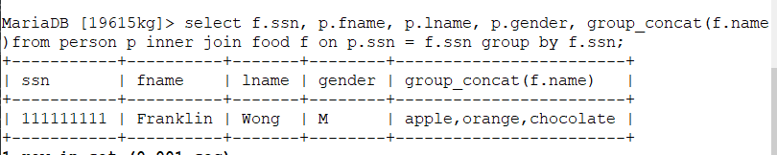

Discription: Here we can join all columns of table person and food with left join on condition match of ssn from both the tables. By the reference of left table common values where ssn is same are filtered and all values from table person are retrieved and which values are not same in table food are maped as null.

select * from person p left join food f on p.ssn = f.ssn;

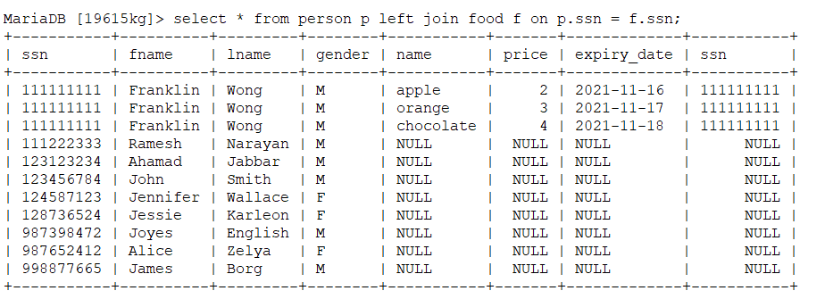

Discription: Here we can join both the tables with inner join with condition of ssn match from both the tables.

Inner join is intersection i.e common values from both tables.

Select * from person p inner join food f on p.ssn = f.ssn;

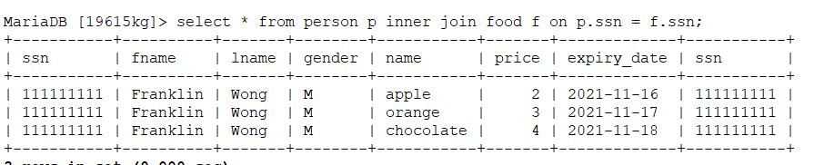

Discription: Here we can join both the tables with right join on condition of ssn match from both the tables.

all values from Right side table food is referenced first and and common values referenced from left table person are retrieved.

select * from person p right join food f on p.ssn = f.ssn;

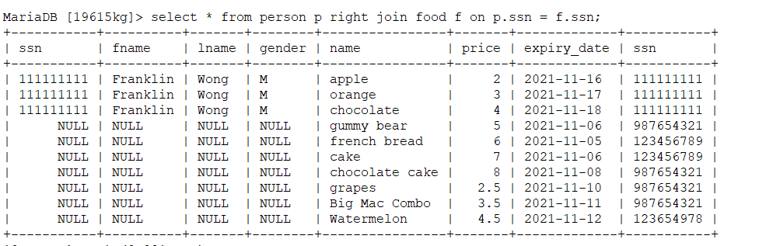

Discription: Here we can filter the data from nested query first with the condition of ssn from food table where expiry_date is in between ‘2021-11-08’ and ‘2021-11-08’ and second from that ssn , fname and lname from person table is retrieved.

select fname, lname from person where ssn in (select ssn from food where expiry_date >= '2021-11-08' and expiry_date <= '2021-11-08');



Discription: Here initially filterd ssn from table food where expiry date is greater than 2021-11-08 and second from filtered ssn, matching fname, lname from table person is retrieved.

select fname, lname from person where ssn in (select ssn from food where expiry_date >= '2021-11-08');

