ClassHomework5A

8.24. Specify queries a, b, c, e, f, i, and j of Exercise 8.16 in both tuple and domain relational calculus

Ans):

(a) Retrieve the names of employees in department 5 who work more than 10 hours per

week on the 'ProductX' project.

Tuple relational Calculus:

{ e.LNAME, e.FNAME | EMPLOYEE(e) AND e.DNO=5 AND (EXISTS p) (EXISTS w)

(

WORKS_ON(w) AND PROJECT(p) AND e.SSN=w.ESSN AND

w.PNO=p.PNUMBER AND

p.PNAME='ProductX' AND w.HOURS>10 ) }

Domain relational Calculus:

{ qs | EMPLOYEE(qrstuvwxyz) AND z=5 AND (EXISTS a) (EXISTS b) (EXISTS e)

(EXISTS f)

(EXISTS g) ( WORKS_ON(efg) AND PROJECT(abcd) AND t=e AND f=b AND

a='ProductX' AND

g>10 ) }

(b) List the names of employees who have a dependent with the same first name as

themselves.

Tuple relational Calculus:

{ e.LNAME, e.FNAME | EMPLOYEE(e) AND (EXISTS d) ( DEPENDENT(d) AND

e.SSN=d.ESSN

AND e.FNAME=d.DEPENDENT_NAME ) }

Domain relational Calculus:

{ qs | (EXISTS t) (EXISTS a) (EXISTS b) ( EMPLOYEE(qrstuvwxyz) AND

DEPENDENT(abcde)

AND a=t AND b=q ) }

(c) Find the names of employees that are directly supervised by 'Franklin Wong'.

Tuple relational Calculus:

{ e.LNAME, e.FNAME | EMPLOYEE(e) AND (EXISTS s) ( EMPLOYEE(s) AND

s.FNAME='Franklin' AND s.LNAME='Wong' AND e.SUPERSSN=s.SSN ) }

Domain relational Calculus:

{ qs | (EXISTS y) (EXISTS a) (EXISTS c) (EXISTS d) ( EMPLOYEE(qrstuvwxyz) AND

EMPLOYEE(abcdefghij) AND a='Franklin' AND c='Wong' AND y=d ) }

(e) Retrieve the names of employees who work on every project.

Tuple relational Calculus:

{ e.LNAME, e.FNAME | EMPLOYEE(e) AND (FORALL p) ( NOT(PROJECT(p)) OR

(EXISTS w) (

WORKS_ON(w) AND p.PNUMBER=w.PNO AND w.ESSN=e.SSN ) ) }

Domain relational Calculus:

{ qs | (EXISTS t) ( EMPLOYEE(qrstuvwxyz) AND (FORALL b) (

NOT(PROJECT(abcd)) OR

(EXISTS e) (EXISTS f) (WORKS_ON(efg) AND e=t AND f=b) ) }

(f) Retrieve the names of employees who do not work on any project.

Tuple relational Calculus:

{ e.LNAME, e.FNAME | EMPLOYEE(e) AND NOT(EXISTS w) ( WORKS_ON(w)

AND

w.ESSN=e.SSN ) }

Domain relational Calculus:

{ qs | (EXISTS t) ( EMPLOYEE(qrstuvwxyz) AND NOT(EXISTS a) (

WORKS_ON(abc) AND a=t )

) }

(i) Find the names and addresses of employees who work on at least one project located

in Houston but whose department has no location in Houston.

Tuple relational Calculus:

{ e.LNAME, e.FNAME, e.ADDRESS | EMPLOYEE(e) AND (EXISTS p) (EXISTS w) (

WORKS_ON(w) AND PROJECT(p) AND e.SSN=w.ESSN AND

w.PNO=p.PNUMBER AND

p.PLOCATION='Houston' AND NOT(EXISTS l) ( DEPT_LOCATIONS(l) AND

e.DNO=l.DNUMBER

AND l.DLOCATION<>'Houston' ) ) }

Domain relational Calculus:

{ qsv | (EXISTS t) (EXISTS z) ( EMPLOYEE(qrstuvwxyz) AND (EXISTS b) (EXISTS c)

(EXISTS e)

(EXISTS f) ( WORKS_ON(efg) AND PROJECT(abcd) AND t=e AND f=b AND

c='Houston' AND

NOT(EXISTS h) NOT(EXISTS i) ( DEPT_LOCATIONS(hi) AND z=h AND i='Houston'

) ) }

(j) List the last names of department managers who have no dependents.

Tuple relational Calculus:

{ e.LNAME | EMPLOYEE(e) AND (EXISTS d) ( DEPARTMENT(d) AND

e.SSN=d.MGRSSN AND

NOT(EXISTS x) (DEPENDENT(x) AND e.SSN=x.ESSN) ) }

Domain relational Calculus:

{ s | (EXISTS t) ( EMPLOYEE(qrstuvwxyz) AND (EXISTS c) ( DEPARTMENT(abcd)

AND t=c

AND NOT(EXISTS e) (DEPENDENT(efghi) AND e=t) ) }

8.28. Rewrite the domain relational calculus queries that followed Q0 in Section 8.7 in the style of the abbreviated notation of Q0A, where the objective is to minimize the number of domain variables by writing constants in place of variables wherever possible

Q1A: {quv | (EXISTS z) (EXISTS m)(EMPLOYEE(q,r,s,t,u,v,w,x,y,z) AND

DEPARTMENT(‘Research’,m,n,o) AND m=z)}

Q2A: { iksuv | (EXISTS m)(EXISTS n)(EXISTS t)(PROJECT(h,I,’Stafford’,k)

AND

EMPLOYEE(q,r,s,t,u,v,w,x,y,z) AND DEPARTMENT(l,m,n,o)

AND k=m AND n=t)

The other queries have no constants (no selection conditions; only join condition expressions) and wont be different.

8.32. A nested query is a query within a query. More specifically, a nested query is a parenthesized query whose result can be used as a value in a number of places, such as instead of a relation. Specify the following queries on the database specified in Figure 5.5 using the concept of nested queries and the relational operators discussed in this chapter. Also show the result of each query as it would apply to the database state in Figure 5.6.

a. List the names of all employees who work in the department that has the employee with the highest salary among all employees

Ans:{Fname, Lname | EMPLOYEES(t,u,v,w,’Salary’,y,’Dno’) AND DEPARTMENT (‘Dnumber’,a,b) AND Dnumber=’5’ AND Salary=max(Salary) }

ANS: OUTPUT 🡨 PI Fname Lname(Sigma Dno=(PI Dno (Sigma SALARY = MAX(SALARY)EMPLOYEE) )EMPLOYEE )

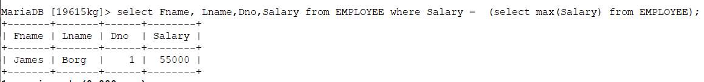

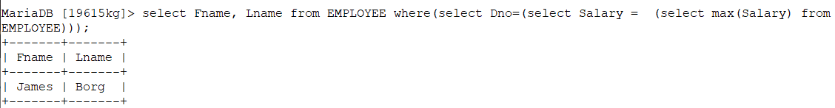

b. List the names of all employees whose supervisor’s supervisor has ‘888665555’ for Ssn.

Ans:

{Fname, Lname | EMPLOYEE(t,u,v,w,x,y,z) AND ssn=’888665555’}

ANS: OUTPUT 🡨 PI Fname Lname (Sigma SUPERSSN=(PI SSN (SIGMA SUPERSSN= ’888665555’ EMPLOYEE)) EMPLOYEE)

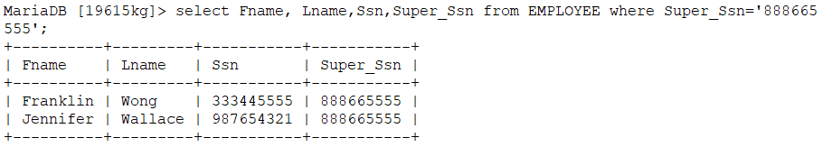

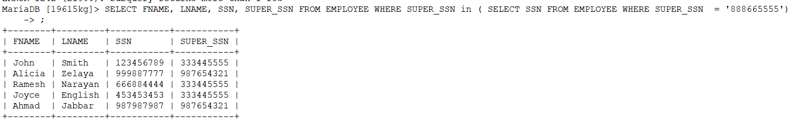

c. List the names of employees who make at least $10,000 more than the employee who is paid the least in the company

Ans: {Fname, Lname | EMPLOYEES (t,u,v,w,x,y,z) AND Salary >= 10000+ min(Salary)}

ANS: OUTPUT 🡨 PI Fname Lname (Sigma SALARY <= 10000 + PI SALARY(Sigma SALARY =MIN(SALARY)EMPLOYEE)EMPLOYEE)

