CS 457 – Data modeling and Implementation Techniques

Instructor: Dr. Vidhyacharan Bhaskar

Homework 3B: (Due: Oct. 23, 2021 before 3 pm)

Elmasri book (7th edition):

HW 3B problems are from Chapter 7 (More SQLs) of the 7th edition of Elmasri book.

1. Exercise 7.5

Specify the following queries on the database in Figure 5.5 in SQL. Show the query results if each query is applied to the database state in Figure 5.6.

a. For each department whose average employee salary is more than

$30,000, retrieve the department name and the number of employees

working for that department.

Ans=> Select Dname, COUNT(E.salary)

From DEPARTMENT D INNER JOIN EMPLOYEE E

On D.Dnumber = E.Dno

group by Dname having avg(E.Salary) > 30000;

b. Suppose that we want the number of *male* employees in each department

making more than $30,000, rather than all employees (as in Exercise

7.5a). Can we specify this query in SQL? Why or why not?

Select Dname, COUNT(E.salary)

From DEPARTMENT D INNER JOIN EMPLOYEE E

On D.Dnumber = E.Dno

Where E.sex = ‘M’

group by Dname having avg(E.Salary) > 30000;

1. Exercise 7.6

Specify the following queries in SQL on the database schema in Figure 1.2.

a. Retrieve the names and major departments of all straight-A students

(students who have a grade of A in all their courses).

* Ans=> SELECT Name, Major

FROM STUDENT S

Inner join GRADE_REPORT G

On S.Student_number = G.Student_number

Where G.Grade=A(Select G.Grade

From GRADE_REPORT);

b. Retrieve the names and major departments of all students who do not

have a grade of A in any of their courses.

* Ans=> SELECT Name, Major

FROM STUDENT S

Inner join GRADE_REPORT G

On S.Student_number = G.Student_number

Where G.Grade !=A(Select G.Grade

From GRADE_REPORT);

1. Exercise 7.7

In SQL, specify the following queries on the database in Figure 5.5 using the

concept of nested queries and other concepts described in this chapter.

1. Retrieve the names of all employees who work in the department that has the employee with the highest salary among all employees.

* Ans => SELECT Fname, Lname

FROM EMPLOYEE

WHERE Salary = (SELECT MAX( SALARY)

FROM EMPLOYEE

WHERE Dno = 5);

b. Retrieve the names of all employees whose supervisor’s supervisor has

‘888665555’ for Ssn.

* Ans => SELECT Fname, Lname

FROM EMPLOYEE

WHERE Ssn= (Select Ssn

From Supervisor

Where supervisor.supervisor.Ssn=’888665555’);

c. Retrieve the names of employees who make at least $10,000 more than

the employee who is paid the least in the company.

* Ans => SELECT Fname, Lname

FROM EMPLOYEE

Where Salary > ALL(Select MIN(Salary)+ 10000

From EMPLOYEE);

The following set of questions are from the handout slides discussed in regard to Oracle network services:

1. Describe what are the categories of Oracle data dictionary Views.

ANS=> The Data dictionary consists of three main sets of static views distinguished from each other by their scope:

DBA: What is in all the schema

ALL: What the user can access

USER: What is in the user’s schema

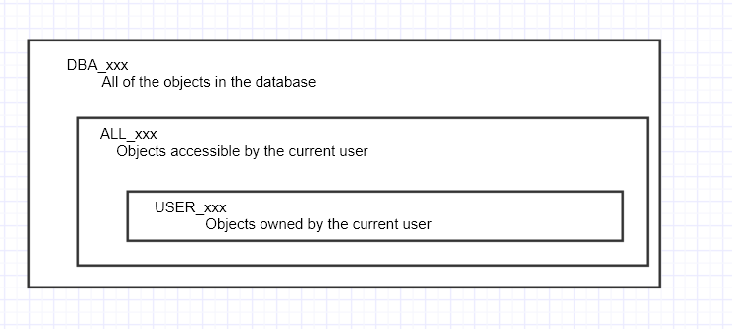

1. Describe Oracle dynamic performance tables.

Ans=> a) Dynamic performance views record current database activity

b) views are continually updated while the database is operational.

c) information is accessed from Memory, control file

d) DBA uses dynamic views to monitor and tune the database

e) Dynamic views are owned SYS user

f) DML is not allowed

1. Describe Oracle control file

Ans => The Control file is a binary file that defines the current state of the physical database

1)loss of control file requires recovery

2)Is linked to a single database

3) maintains integrity of database

4)Sized initially by CREATE DATABASE

5) Should be multiplexes

.7) Describe what are current Network Environment Challenges.

Ans=> 1) Configuring the network environment

2) Maintaining the network

3)Tuning, troubleshooting, and monitoring the network

4) Implementing security in the network

5) Integrating legacy systems