***Find perfect pet***



***MADE BY***

**Georgi Kotakov**

**TABLE OF CONTENT**

**TABLE OF CONTENT** 2

**PROJECT IDEA** 3

**STAGES OF THE PROJECT** 3

**BLOCK DIAGRAM** 3

**FUTURE IDEAS** 4

**PROJECT IDEA**

**The idea of the project is to help pet owners by providing them with information about different shops, clinics or shelters. They can post an advertisement about keeping their pet. Those who don't have one can look at various pet listings and purchase one.**

**STAGES OF THE PROJECT**

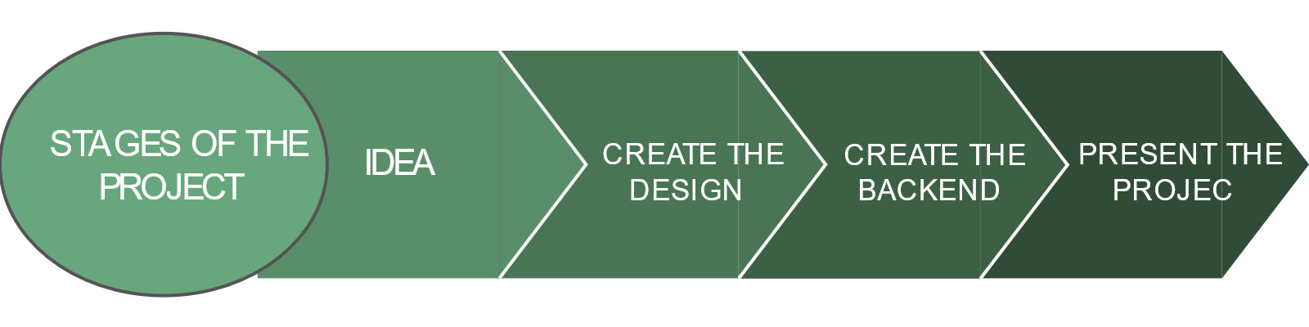

**BLOCK DIAGRAM**

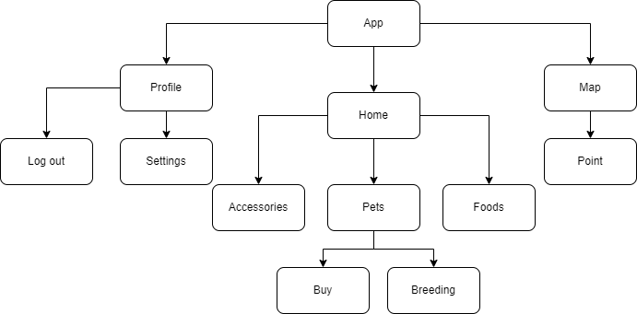

**FUTURE IDEAS**

|  |  |
| --- | --- |
|  | Future ideas |
| 1 | Create “Create page” |
| 2 | Create loading image |
| 3 | Create “Edit button” in profile |