add fund:  
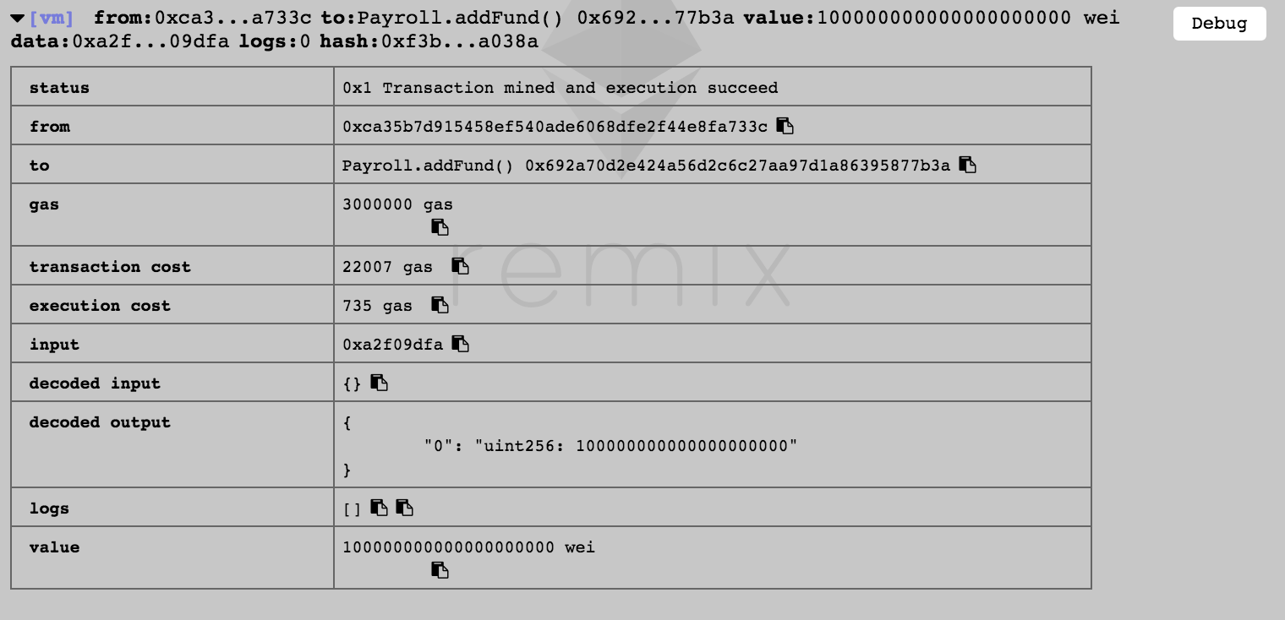

add employee:

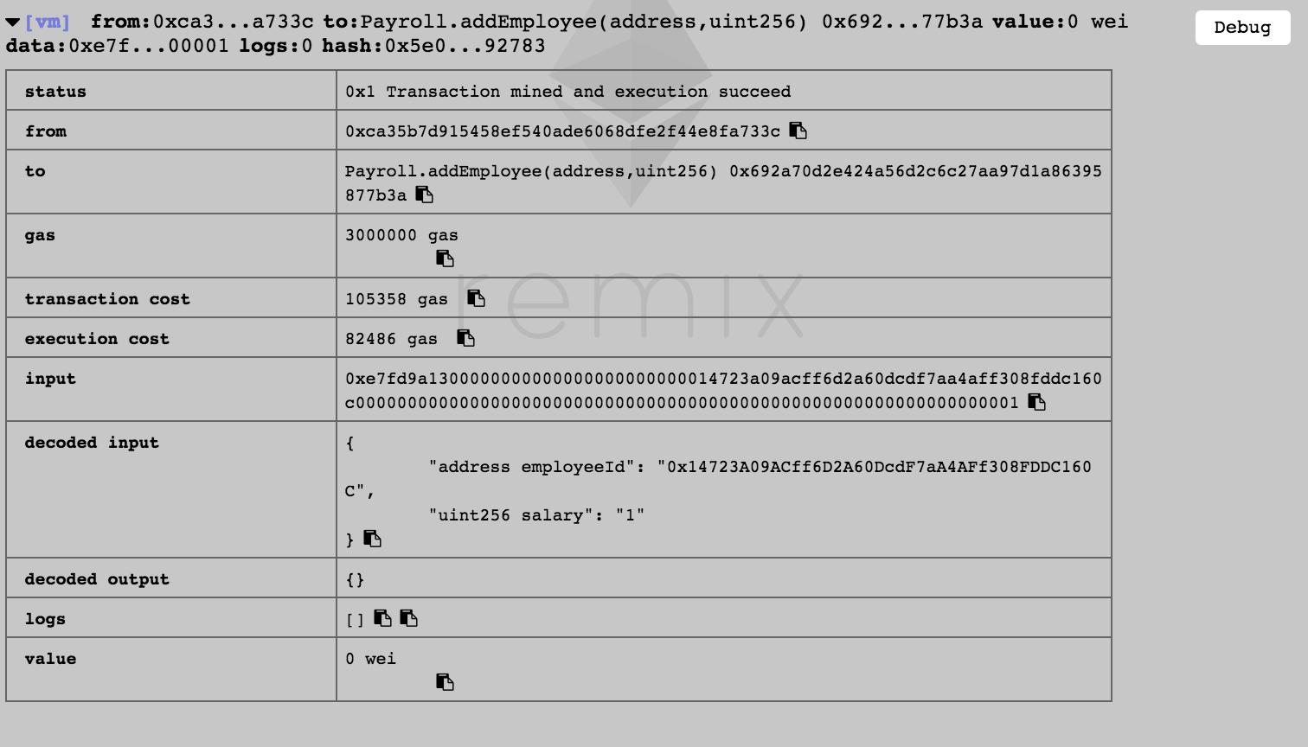

remove employee:

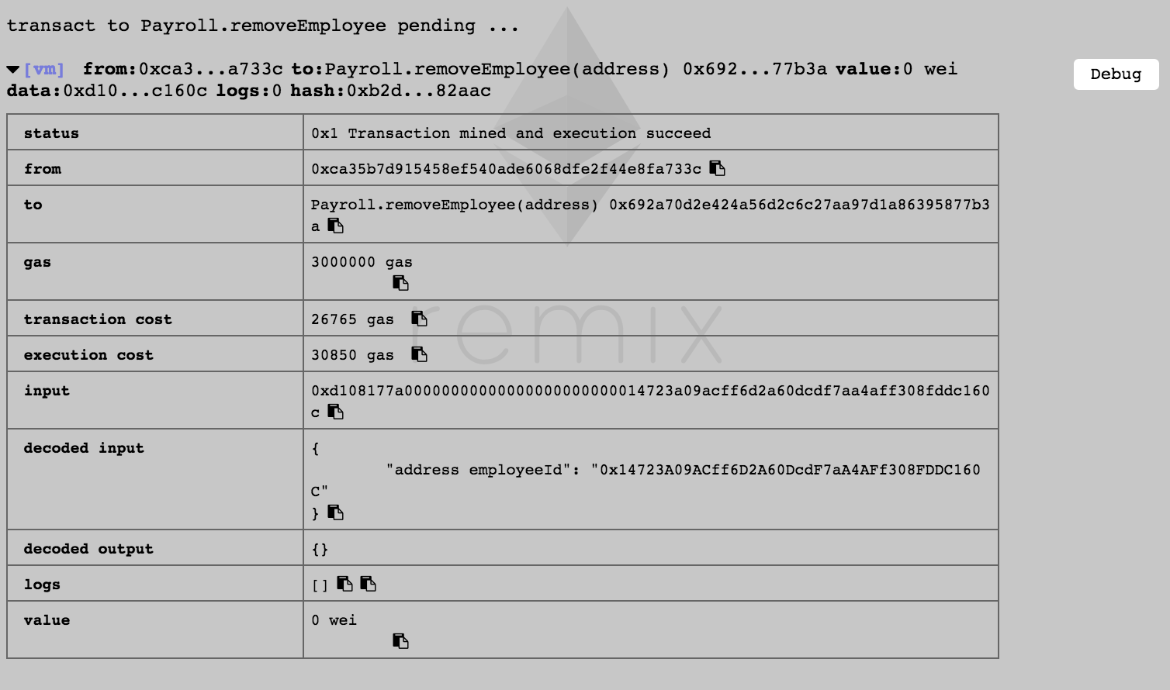

add employee again:  
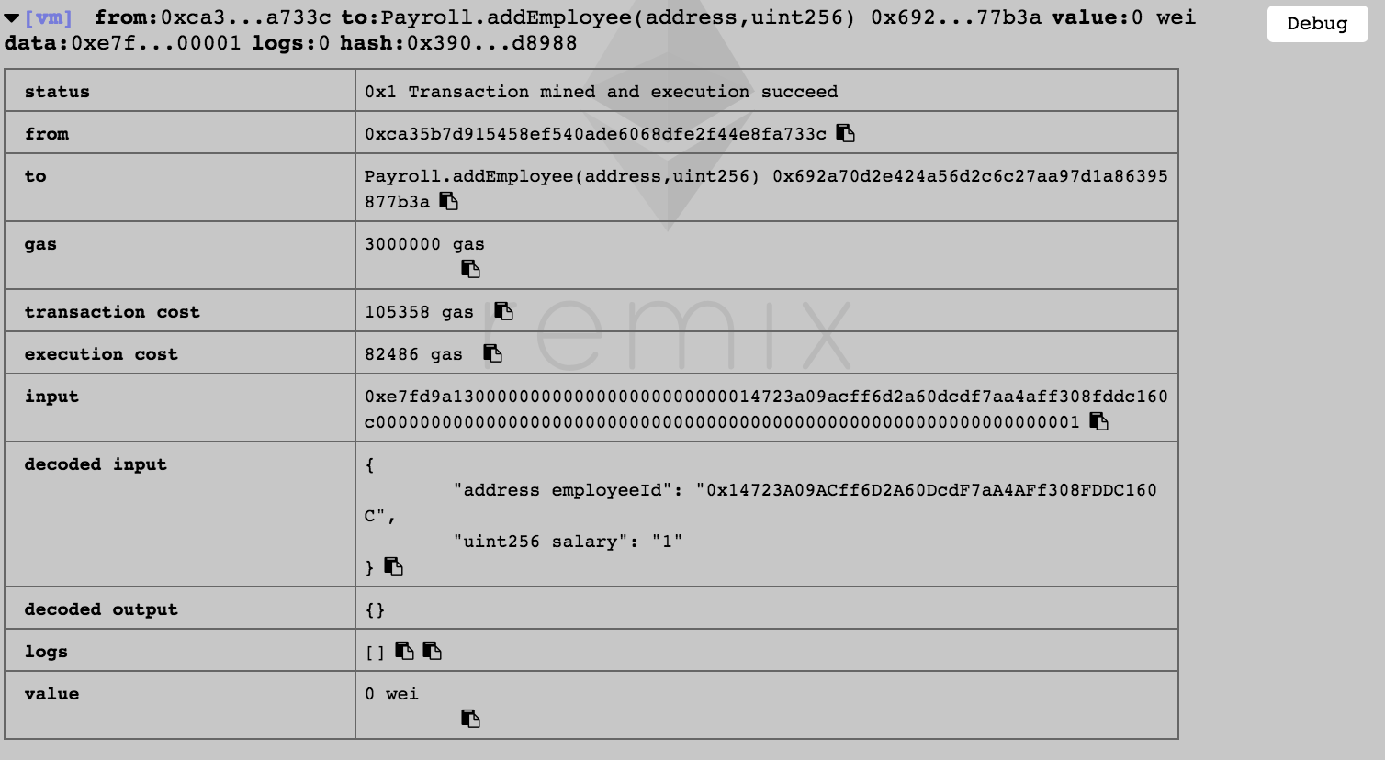

update employee:

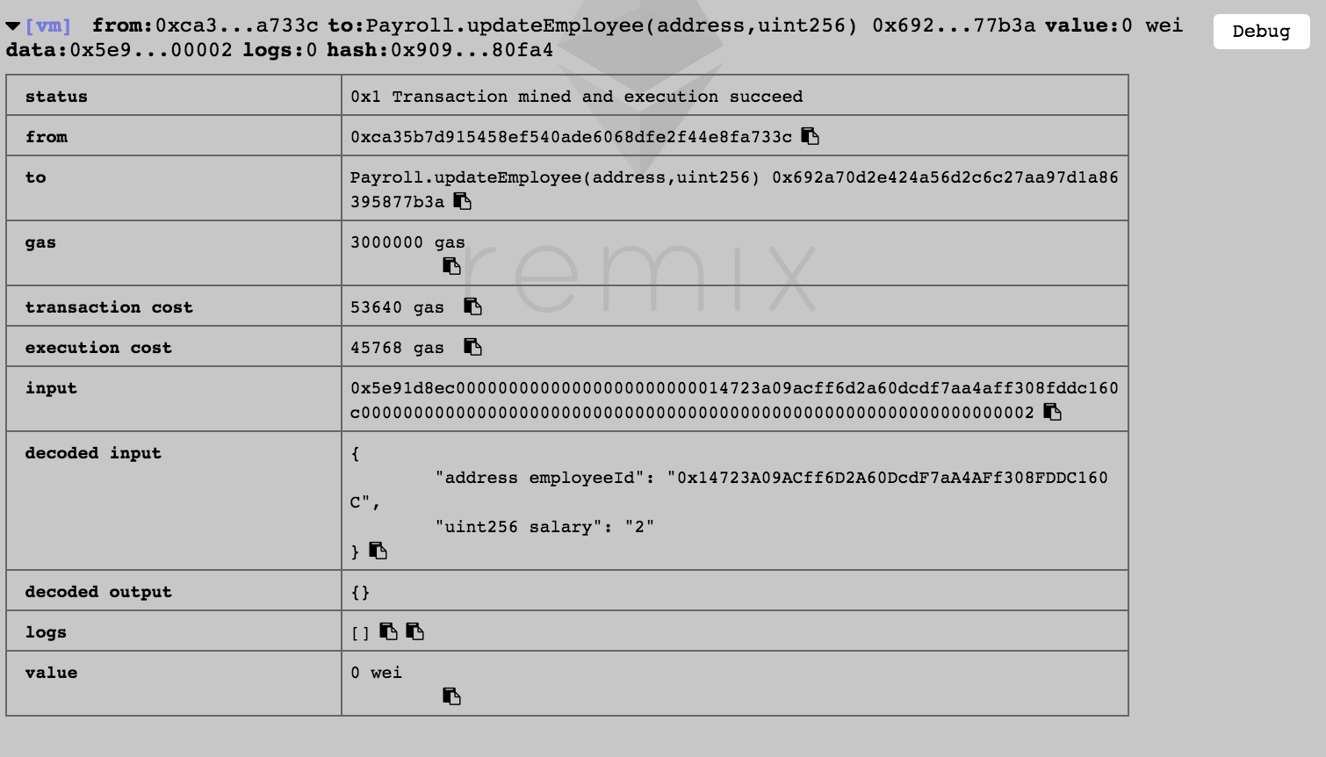

calculate runway:

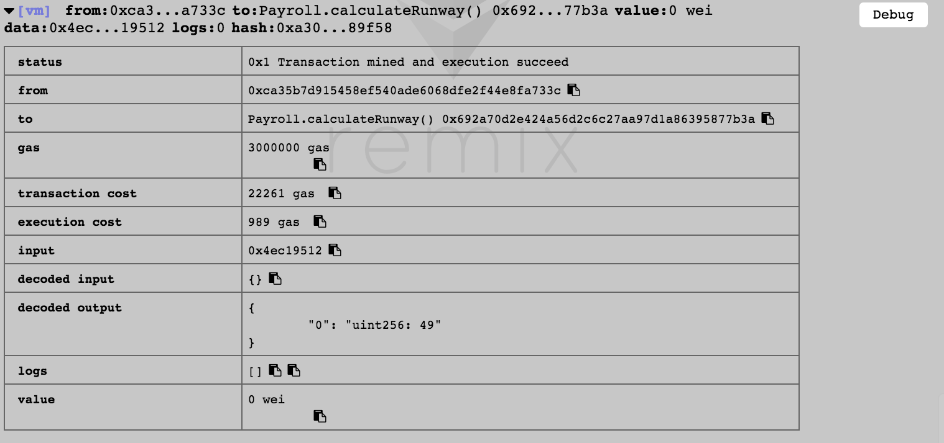

has enough fund:  
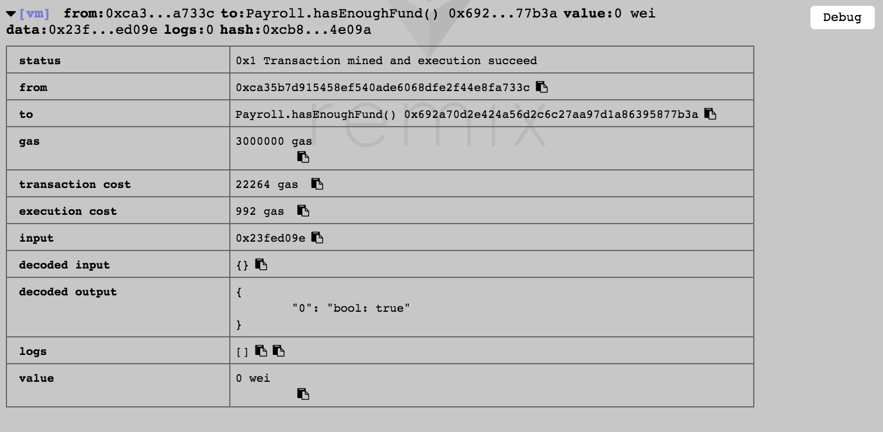

get paid:

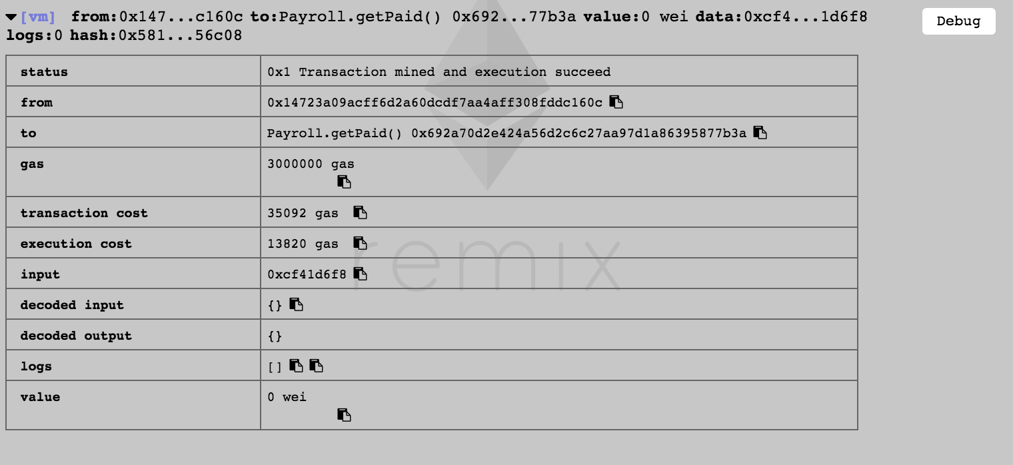

update address:

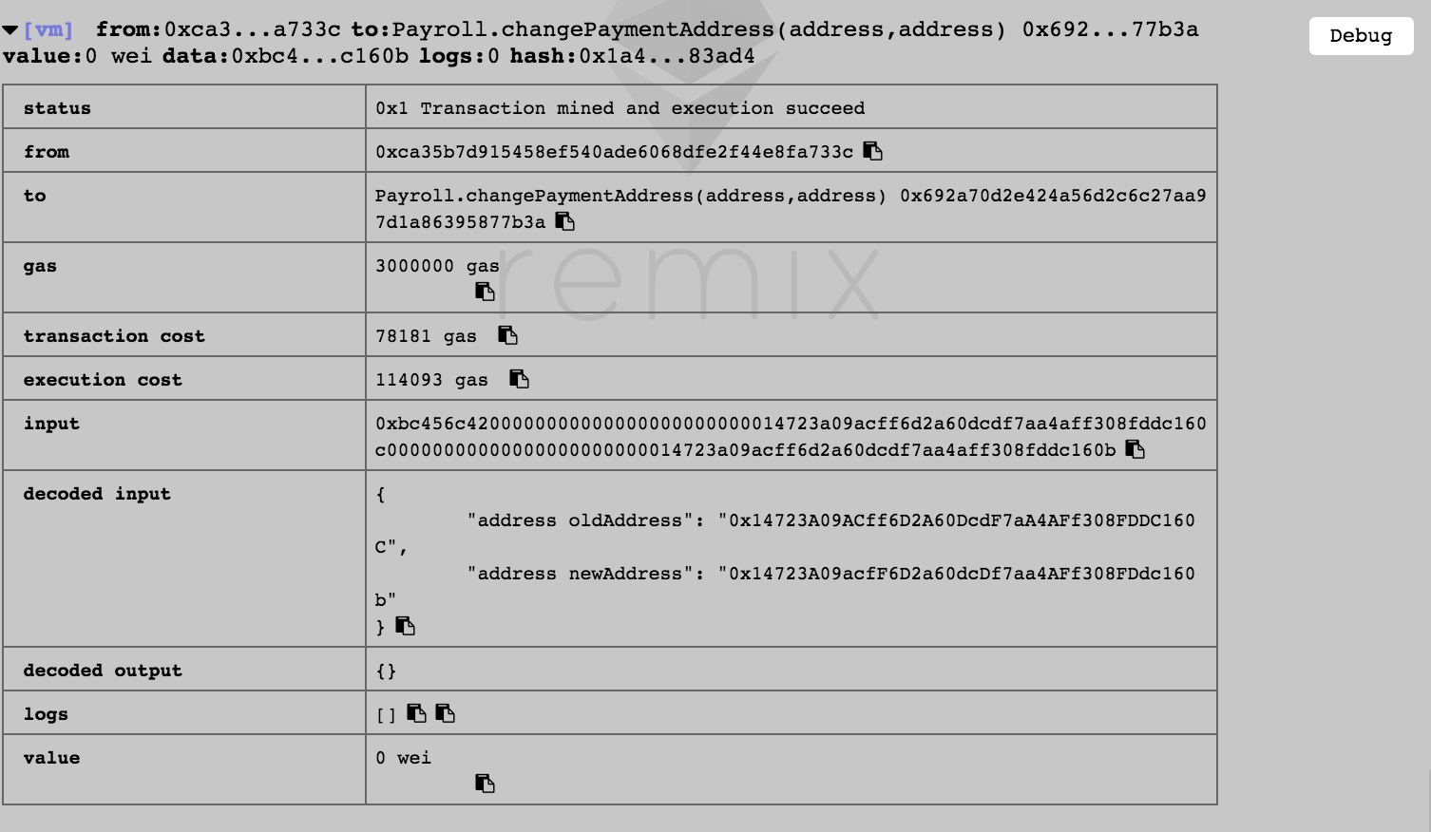

3.

contract O

contract A is O

contract B is O

contract C is O

contract K1 is A, B

contract K2 is A, C

contract Z is K1, K2

L[O] : = [O]

L[A] : = [A, O]

L[B] : = [B, O]

L[C] : = [C, O]

L[K1] : = [K1] + merge([A, O], [B, O], [A, B])

= [K1, A, B, O]

L[K2] : = [K2, A, C, O]

L[Z] := [Z] + merge([K1, A, B, O], [K2, A, C, O], [K1, K2])

= [Z, K1, K2, A, B, C, O]