1. 导入PayRoll.sol并部署：

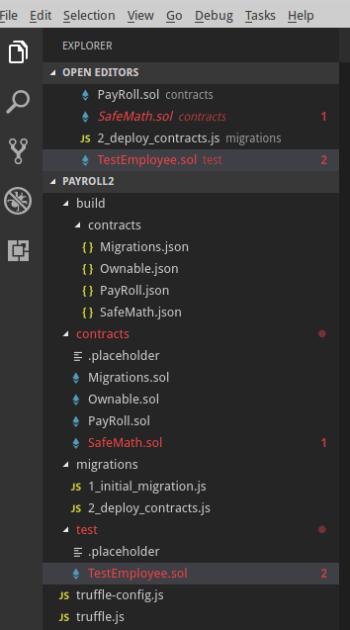

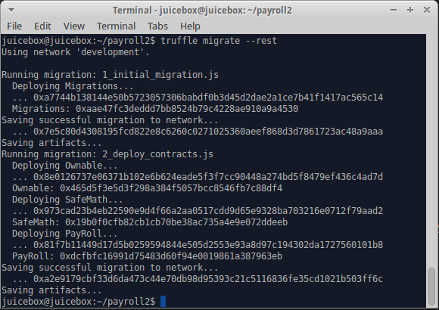

1. 对addEmployee和removeEmployee进行单元测试：

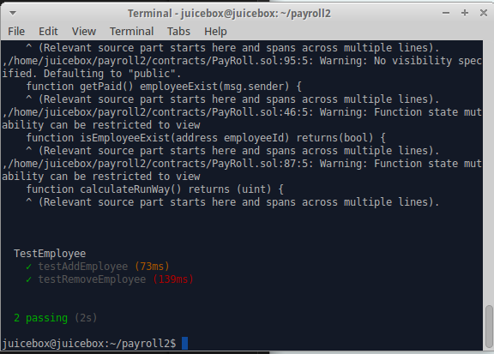

单元测试代码：

pragma solidity ^0.4.2;

import "truffle/Assert.sol";

import "truffle/DeployedAddresses.sol";

import "../contracts/PayRoll.sol";

contract TestEmployee {

function testAddEmployee() public {

PayRoll payroll = new PayRoll();

bool expected = true;

payroll.addEmployee(0xca35b7d915458ef540ade6068dfe2f44e8fa733c,1);

Assert.equal(payroll.isEmployeeExist(0xca35b7d915458ef540ade6068dfe2f44e8fa733c), expected, "employee should be added correctly");

}

function testRemoveEmployee() public {

PayRoll payroll = new PayRoll();

bool expected = true;

payroll.addEmployee(0xca35b7d915458ef540ade6068dfe2f44e8fa733c,1);

Assert.equal(payroll.isEmployeeExist(0xca35b7d915458ef540ade6068dfe2f44e8fa733c), expected, "employee should be added correctly");

payroll.removeEmployee(0xca35b7d915458ef540ade6068dfe2f44e8fa733c);

expected = false;

Assert.equal(payroll.isEmployeeExist(0xca35b7d915458ef540ade6068dfe2f44e8fa733c), expected, "employee should be added correctly");

}

}