1. addFund

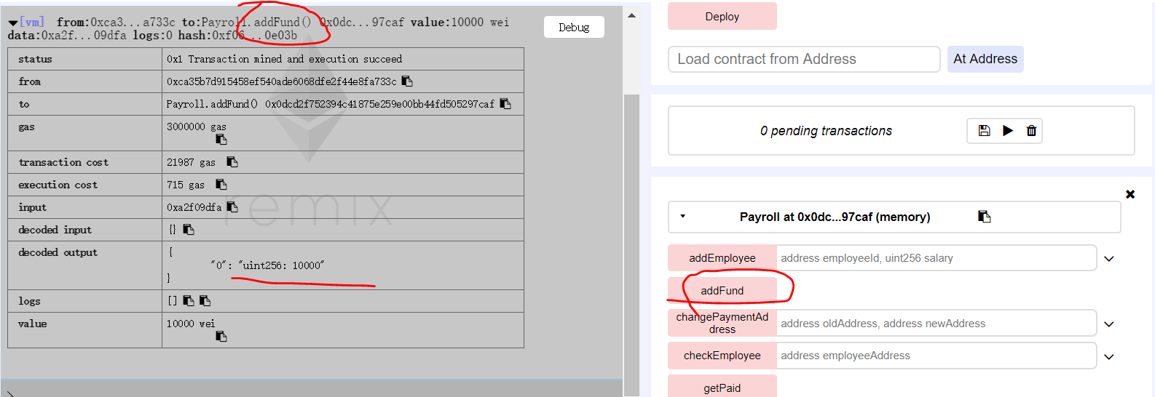

1. addEmployee

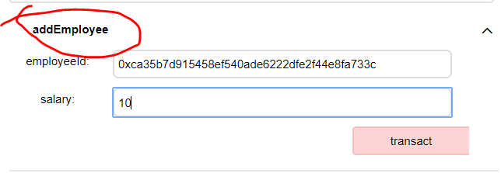

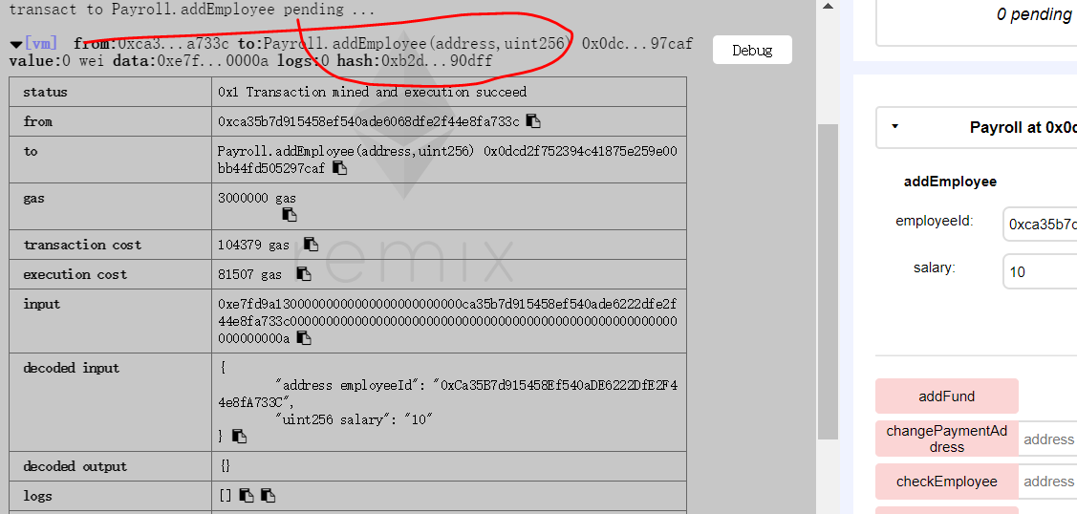

1. **checkEmployee**

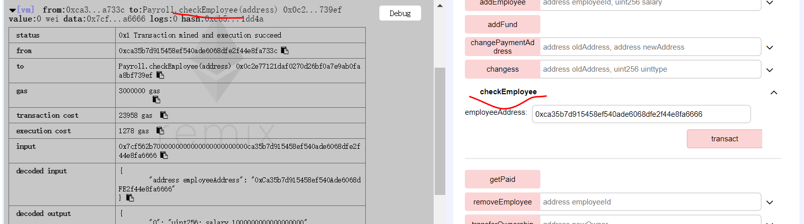

1. getPaid

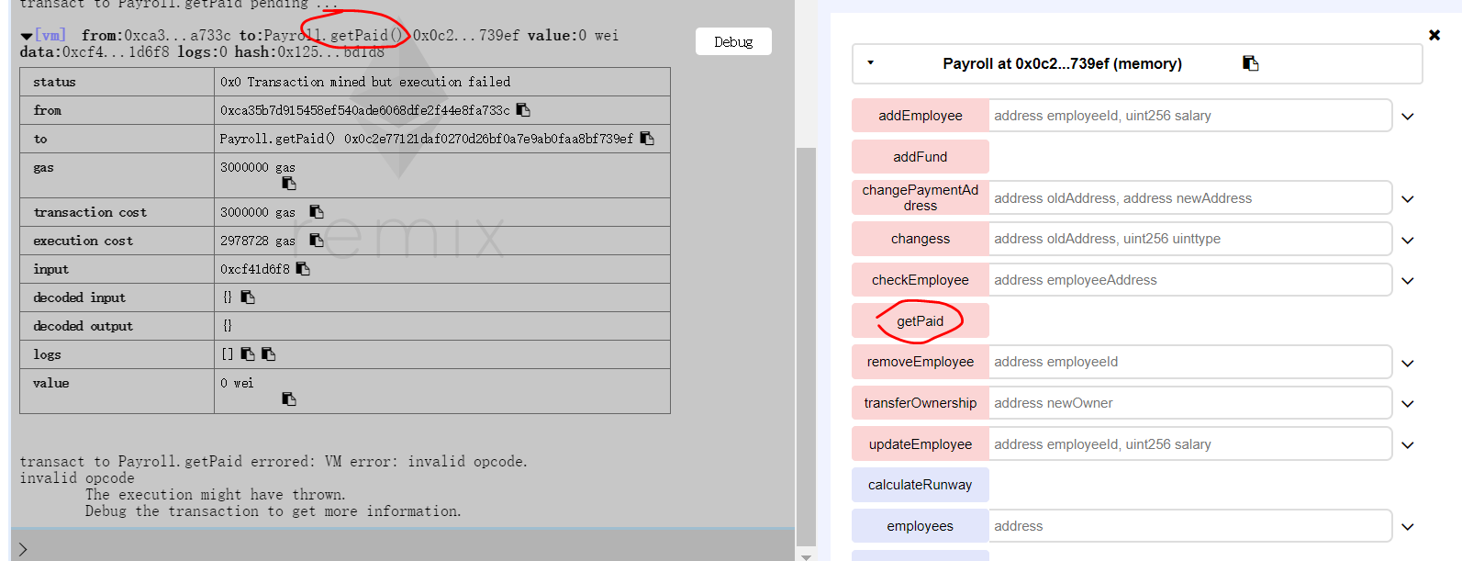

1. removeEmployee

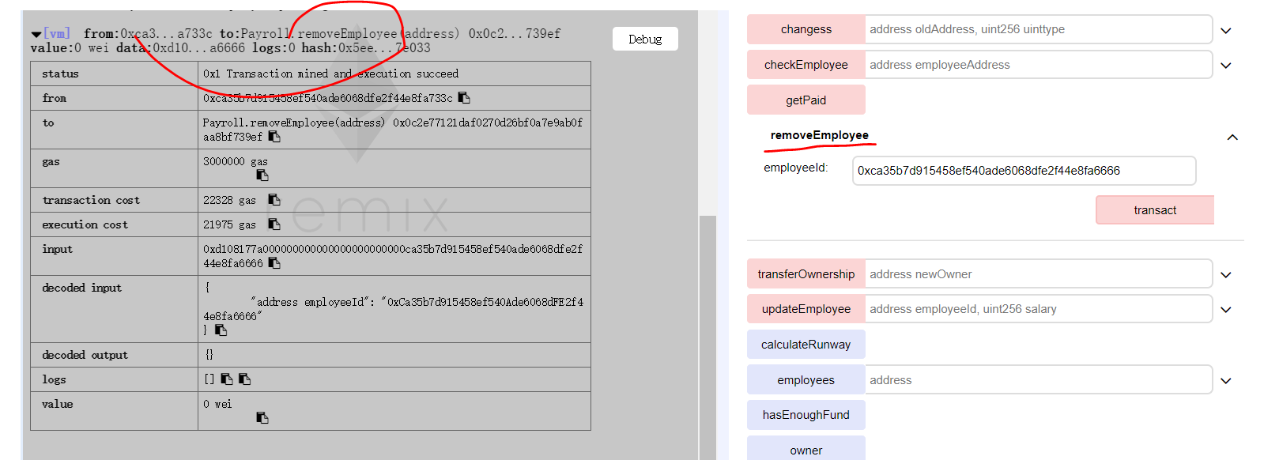

1. transferOwnership

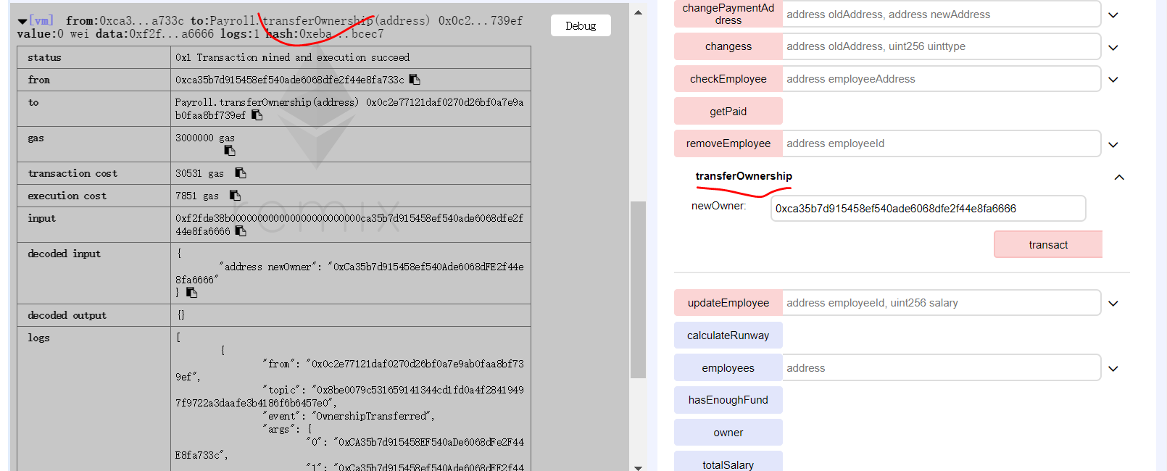

1. updateEmployee

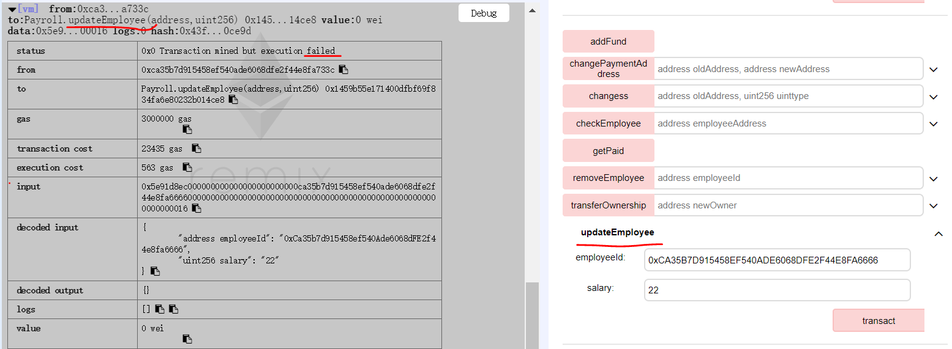

1. calculateRunway

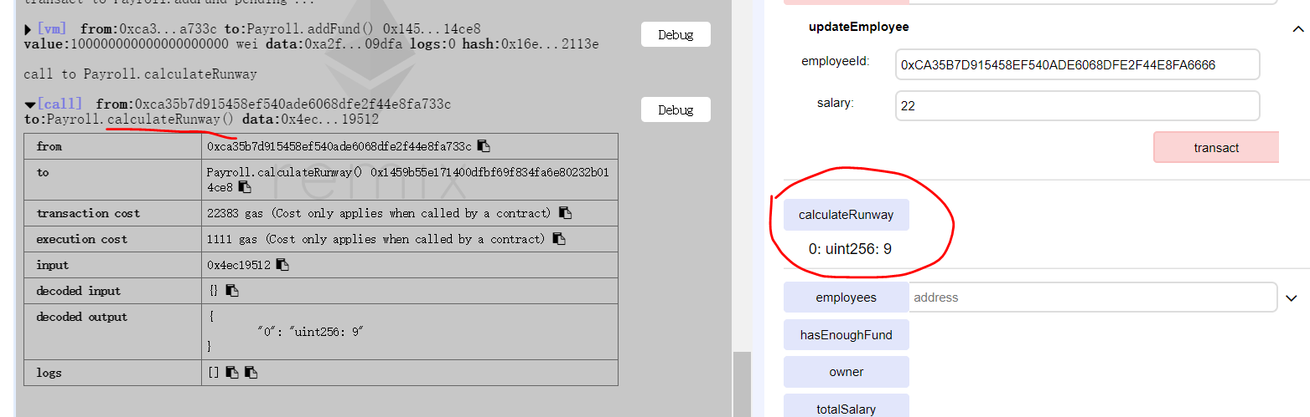

1. employees

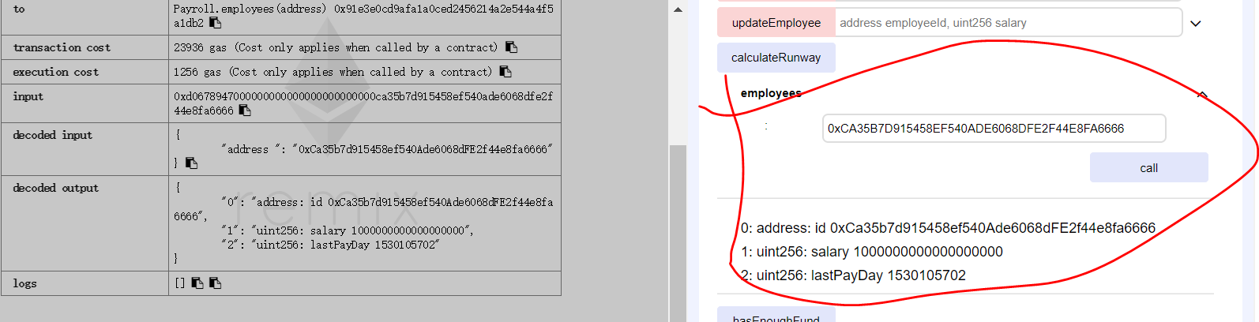

1. hasEnoughFund

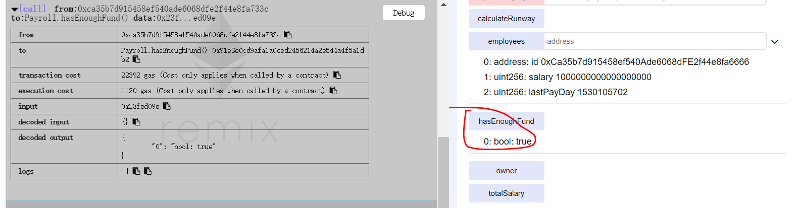

1. owner

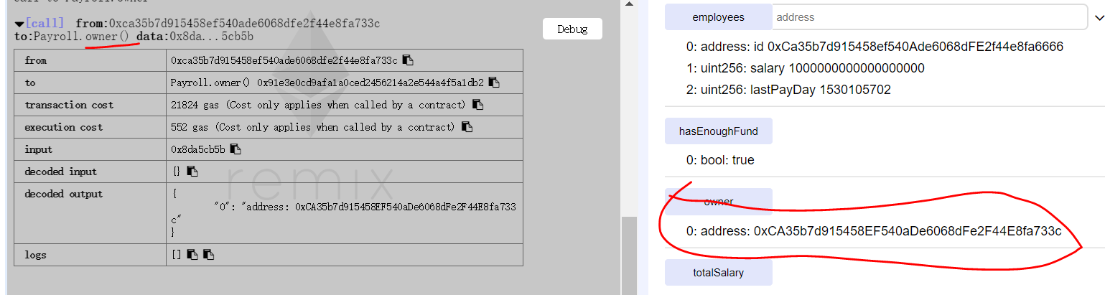

1. totalSalary

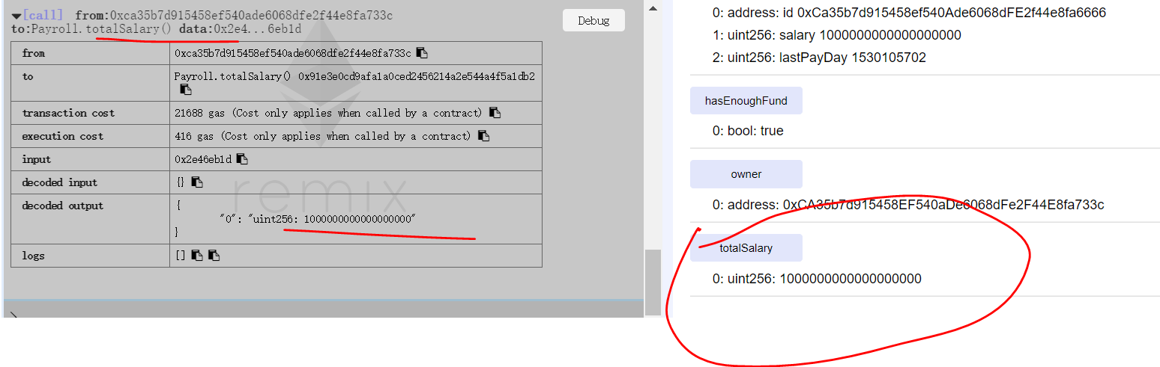

1. **changePaymentAddress**

