quarto-01

## Quarto

*italics*

**bold**

superscript2

subscript2

~~strikethrough~~

verbatim code

# Header 1

## Header 2

### Header 3

#### Header 4

##### Header 5

###### Header 6

<https://quarto.org>

[Quarto](https://quarto.org)

|  |
| --- |
| Caption |

|  |
| --- |
| Caption |

|  |
| --- |
| Caption |

|  |
| --- |
|  |

* unordered list
  + sub-item 1
  + sub-item 2
    - sub-sub-item 1
* item 2
  + Continued
  + Continued

1. ordered list
2. item 2
   1. sub-item 1
   2. test 2
      1. sub-sub-item 1
      2. This

Continues after

term

definition

This is $b_{0}$ math.

| Right | Left | Default | Center |
| --- | --- | --- | --- |
| 12 | 12 | 12 | 12 |
| 123 | 123 | 123 | 123 |
| 1 | 1 | 1 | 1 |

code

1 + 1

[1] 2

$E=mc^{2}$

$$E=mc^{2}$$

$$
\def\RR{{\bf R}}
\def\bold#1{{\bf #1}}
$$

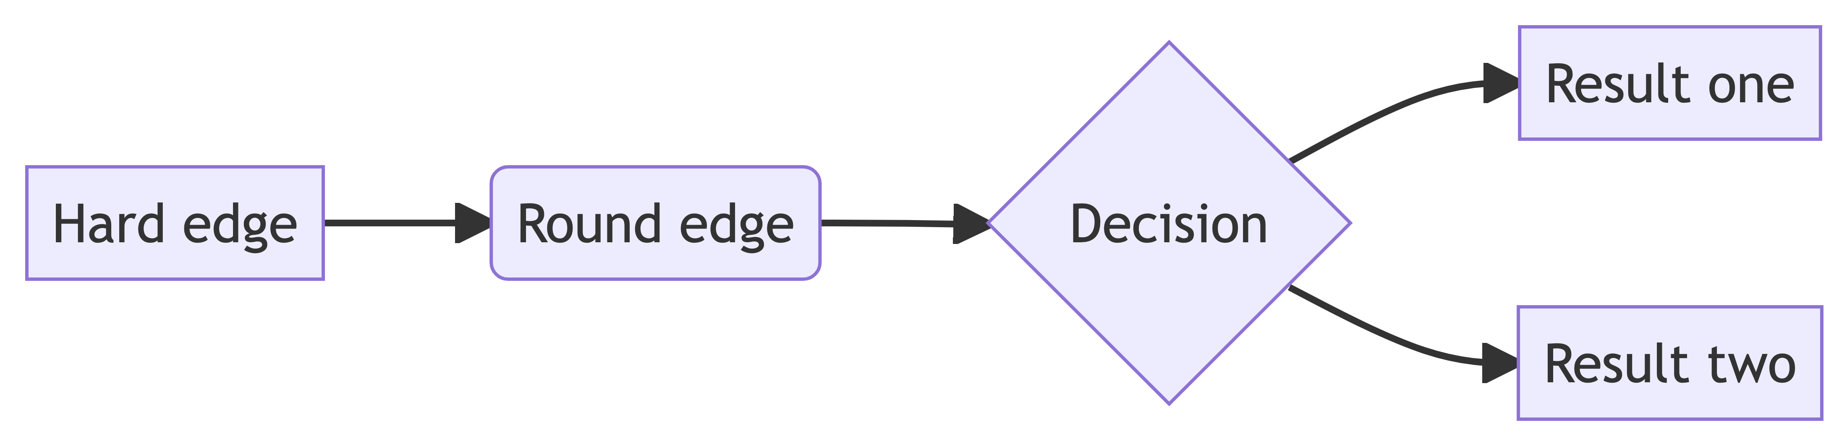

page 1

page 2

page 3